RfTrack, TVWS Monitoring System
User’s manual

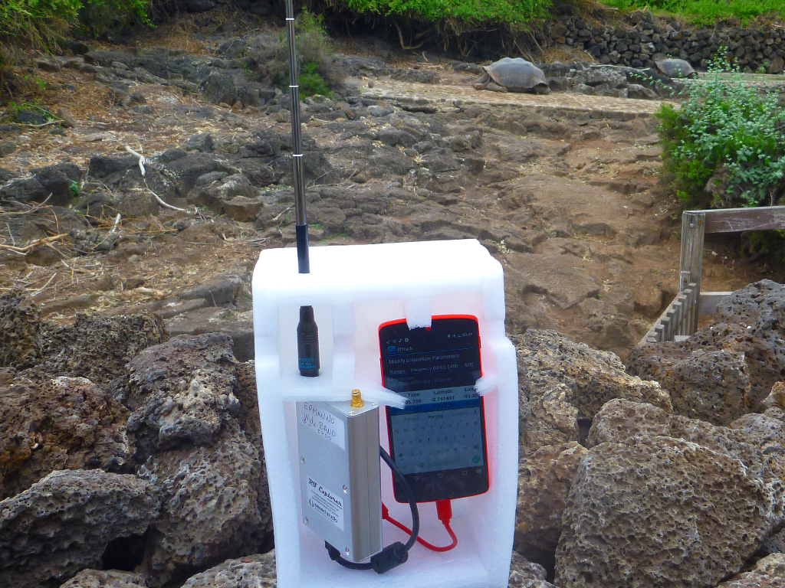
© Ermanno Pietrosemoli. Galapagos, August 2015
Creative Commons Attribution-NonCommercial-NoDerivatives Intl. Lic. See http://creativecommons.org/licenses/by-nc-nd/4.0/

Monitoring system requirements 4
Features of the Android Unit 4
The Android USB Host Mode 4
How to verify the Android version installed in your system 6
How to verify that the Android device supports“USB host mode” 7
Install the RfTrack application 8
Install RfTrack using the APK downloaded from Internet 8
Install RfTrack from Google Play Store 10
Run RfTrack 11
Steps to run RfTrack automatically 13
RfTrack Main Menu 14
Start New Campaign 15
The data acquisition display 16
Modify the acquisition parameters 17
Stop the data acquisition and Exit 18
Open a previous campaign and continue the acquisition 19
Sending data to the Analysis Server 21
Check GPS 23
Android Device Info 25
Program Info 25
The Analysis Server 26
The html report 29
Other plots 30
Additional material of the measurement campaign 33
Two videos 33
Other files that can be downloaded 35
Technical information about the database used by RtfTrack 36
Some tools to manage SQlite databases 37
Project on github 40

RTfTrack is a monitoring system for the TVWS frequencies, composed of these main elements:
- RFExplorer, a low cost spectrum analyzer.
- An Android device (tablet or smartphone) equipped with GPS running RfTrack, the app for logging management. Must be connected through an OTG cable to the RFExplorer.
- The Analysis Server, accessible via Web: receives data from measurement campaigns sent from the app, analyzes the data and generates spectrum measurements reports.

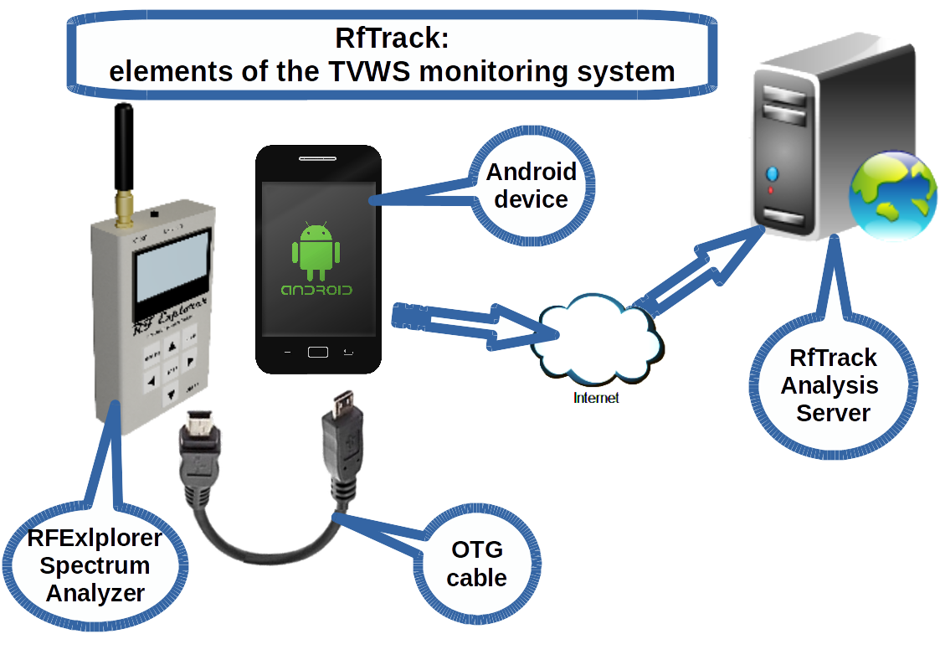

Monitoring system requirements
Before installing the RfTrack application on your Android device, you must verify that the Android unit meets certain requirements.

Features of the Android Unit

The Android USB Host Mode
USB On-The-Go (USB OTG or OTG) is a specification first used in late 2001 that allows USB devices (such as mobile phones) to act as a ‘host’:
- The ‘host’, or master device, sets up communications with the slave device (the RFExplorer, in this case).
- The software on the host enables the operations needed for data handling
- The host is responsible for all data transfers on the USB bus

To connect the RFExplorer to your Android, these requirements must be satisfied:
- Use a USB OTG (USB On-The-Go) cable to connect the Android to the RFExplorer. This cable costs a few Euros. It can be found in computer or phones stores, or on eBay, for example. It has a mini USB connector on one end, to connect to the RFExplorer and a micro USB type B connector to connect your Android device at the other end. You can also join two cables with the proper connectors to achieve the same goal.
- The unit must have built-in the hardware support for the “USB Host Mode” The host mode might not be supported at the hardware level, for istance by constraints imposed by the hardware design.
- The Operating System must support the USB Host Mode. USB Host Mode support was introduced in Android version 3.1 (Honeycomb), so if you have Android 3.1 or newer installed, you should have the necessary support for it in your OS.
- Software Drivers: the system must have installed the USB Host Mode drivers and the drivers for the USB device that is plugged in.
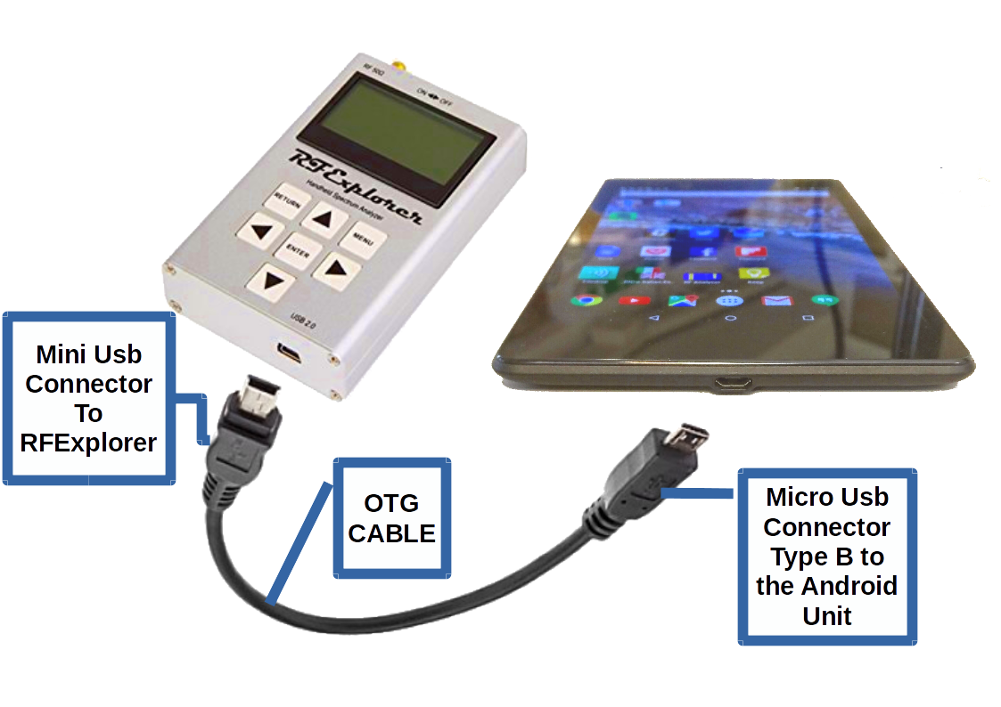

How to verify the Android version installed in your system
- Select “Settings”
- Choose the last menu item, “About Phone”
- In the “About phone” entry, find the “Android Version” field. This example shows that Android 6 (Marshmallow) is installed.
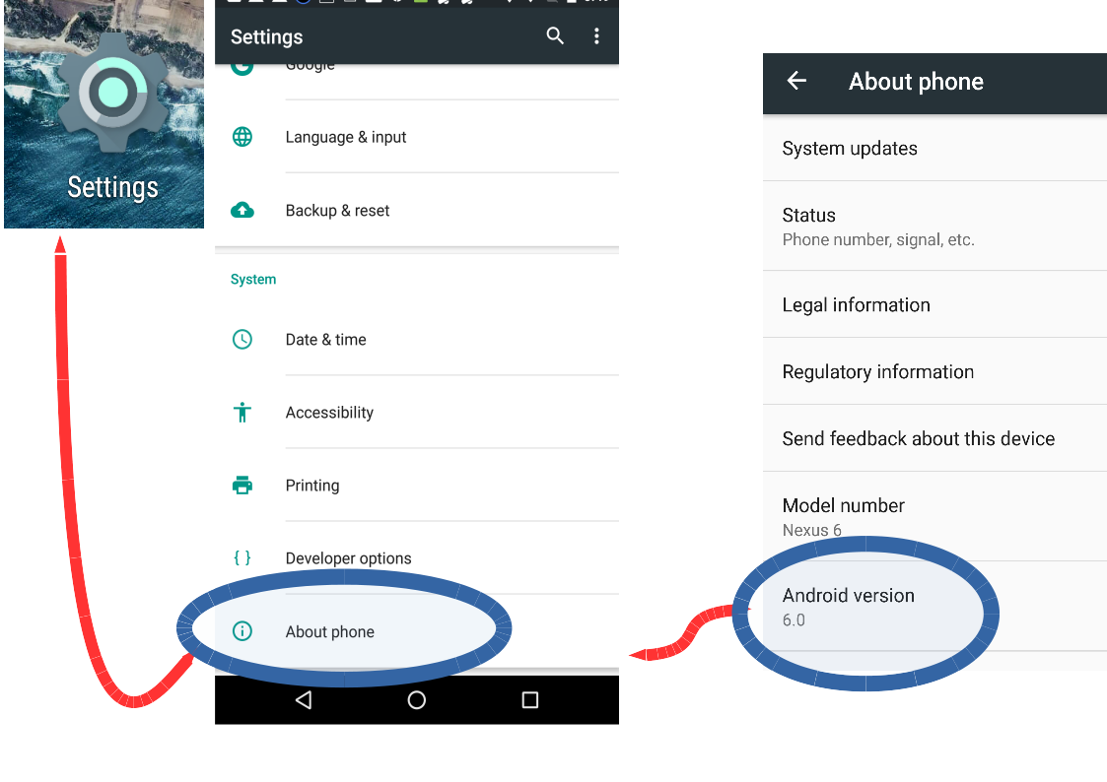

How to verify that the Android device supports“USB host mode”
- Launch the “Play Store” app
- Search for “usb host”
- Several applications will result that can determines if your device has USB host capabilities.
- Install one of these applications to verify the usb host capability of your device.

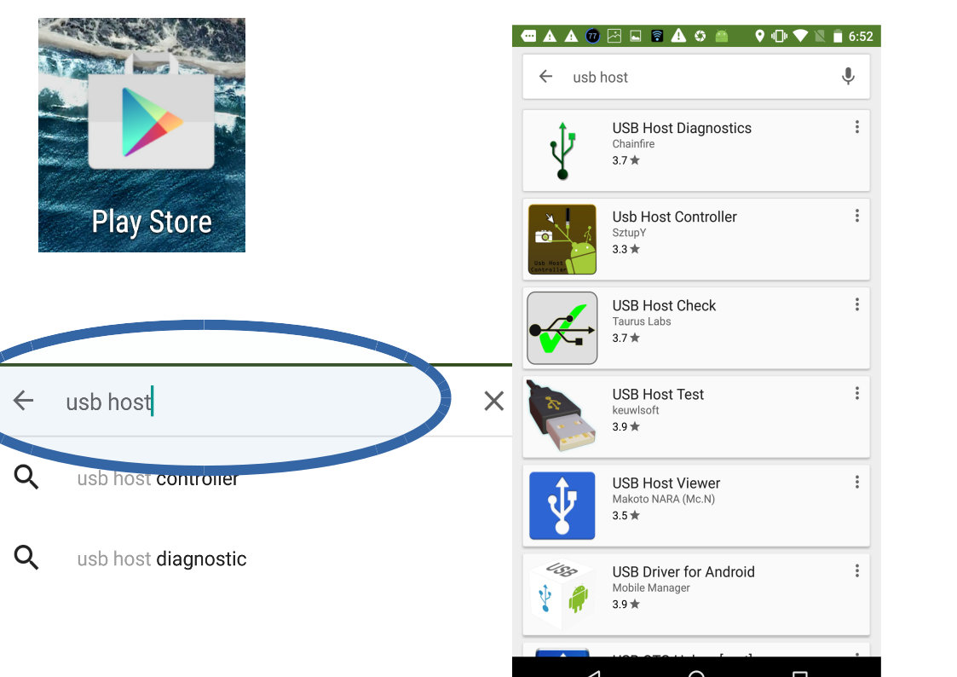

Install the RfTrack application
Just like any Android application, RTfTrack can be installed in several ways:
- The apk file can be obtained from Internet (received by email or downloaded from GitHub) and then executed.
- Search the Google Play Store for RFTrack, download and install.

Install RfTrack using the APK downloaded from Internet
By default, Android saves the files downloaded in the Download folder.
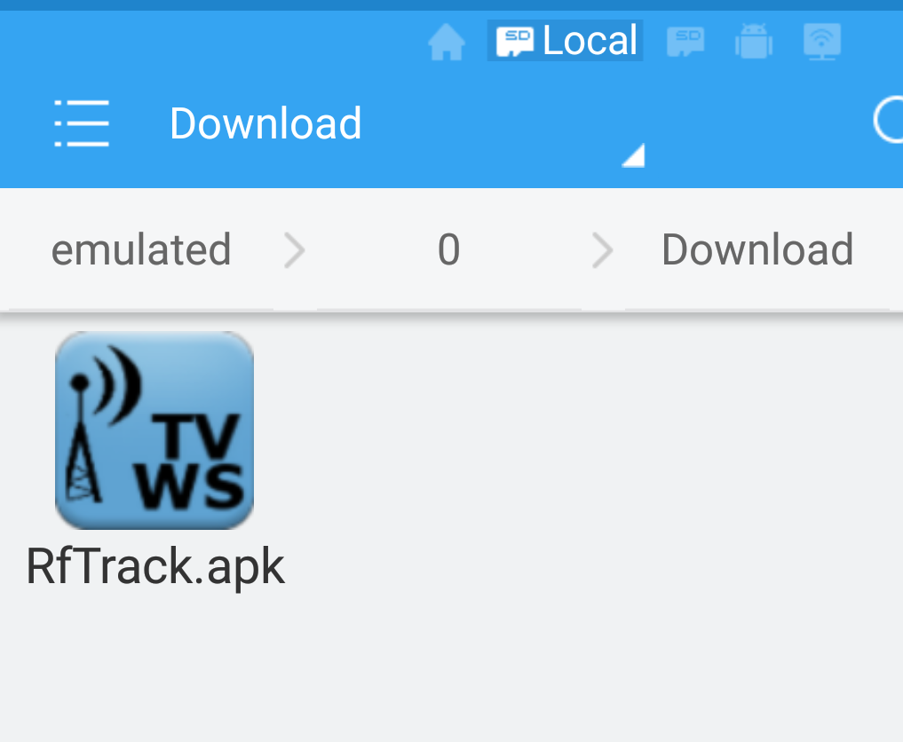
To install the application, “tap” on the APK file.

If Android warns that RfTrack cannot be installed for security reasons, you must go to Settings and enable installation from unknown sources.
- Tap on Settings
- Select Security
- Switch ON the “Unknown sources” installation flag.
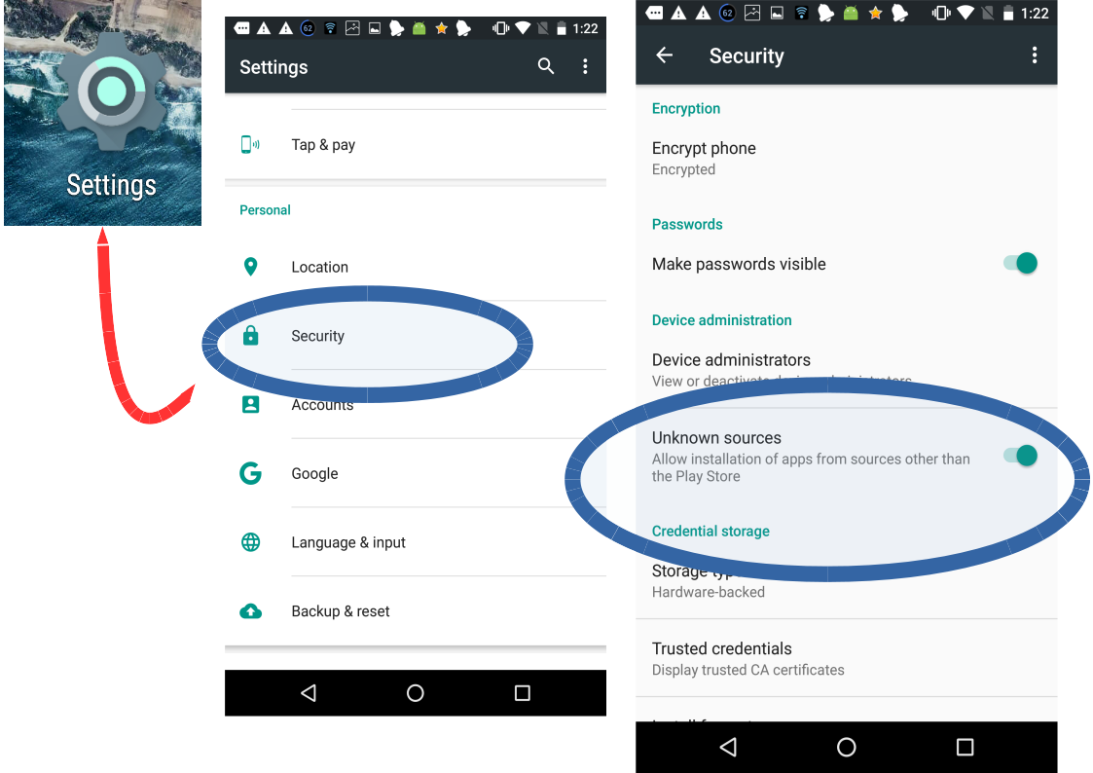

Install RfTrack from Google Play Store
- Tap on “Play Store”
- Search the word “rftrack”
- Select the application proposed: “RfTrack: TVWS frequency logger”
- Tap on “Install”
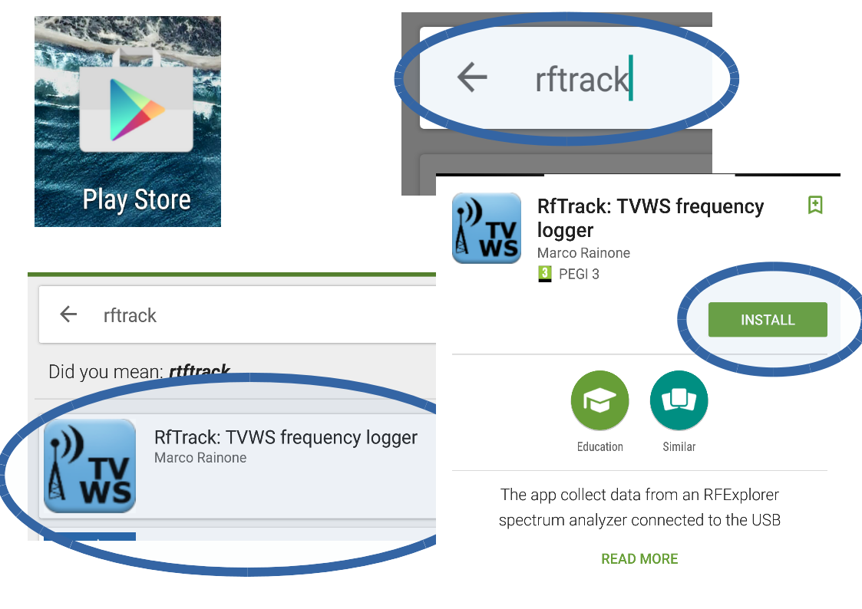

Run RfTrack
The execution of the RfTrack application takes advantage of a useful feature in Android, enabled if "USB host mode" is active:
as soon as you plug in a new device on USB port using an OTG cable, the operating system displays a dialog offering a list of applications that might be able to handle that unit.
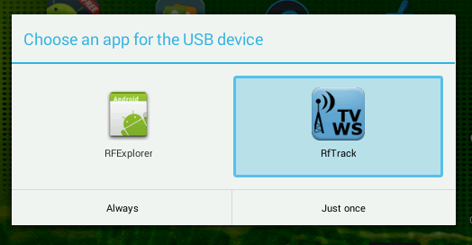
In this example, Android shows the list of installed applications that can be chosen to handle communication with the RFExplorer.
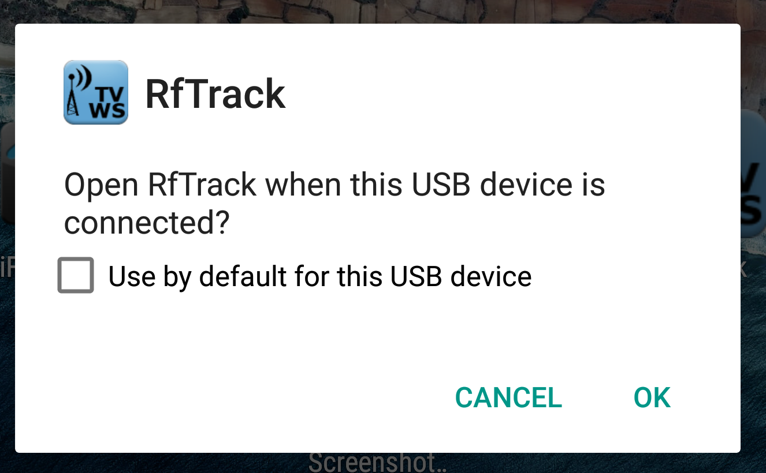
In this example, connecting RFExplorer using the OTG cable, Android proposes the launch of RfTrack.
Press OK to execute the application.
Even if ithe spectrum analyzer is not connected, RfTrack can be launched in a classical way as any other Android application.
In this case, all the features associated with the real time data acquisition are automatically disabled (they require the presence of the RFExplorer), but you can still do data maintenance, for example send previously recorded measurement campaigns to the remote analysis server.

Steps to run RfTrack automatically
- It is recommended to turn on the spectrum analyzer before connecting it to the Android, sliding the microswitch placed near the antenna jack to the ON position. This will avoid increased discharge of your smartphone's battery by additionally powering the RFExplorer.
- Connect the mini USB connector of the OTG cable to the RFExplorer
- Connect the micro USB type B connector of the OTG cable to the Android unit
- If “USB host mode support” works in your Android System, the message: “Open RfTrack when this USB device is connected ?” will show. Press OK to accept.
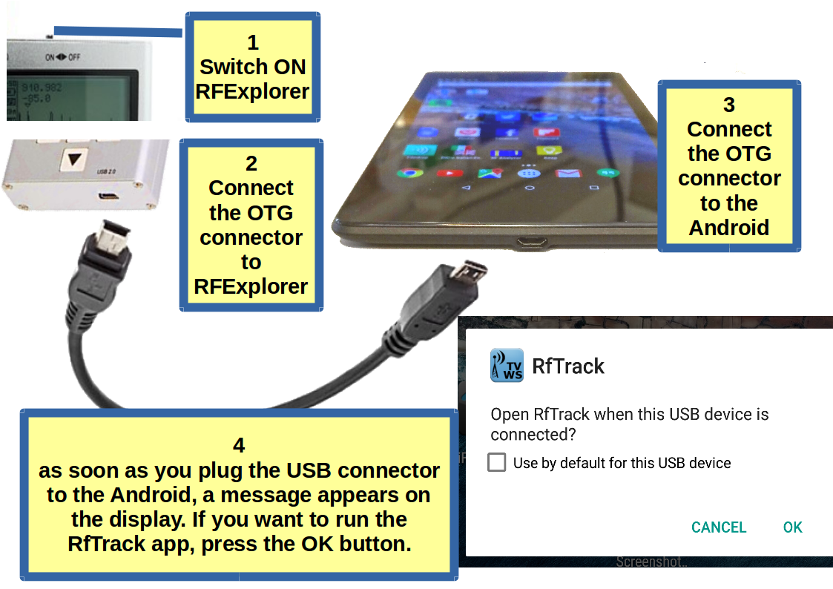

RfTrack Main Menu

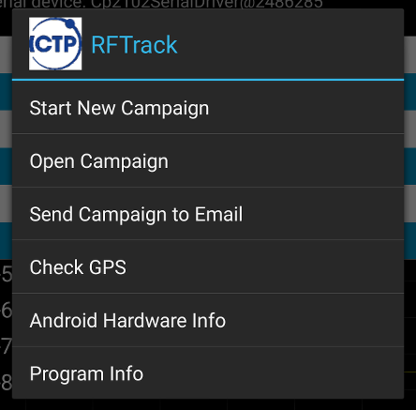
Begin choosing the option Start New Campaign or alternatively Open Campaign, if you wish to add data to an existing campaign.

- All the data collected in a campaign are saved in a specific SqLite database
- The name of the database created is the name of the campaign provided by the user
- The database is stored in the local memory of the Android device: either the internal user memory or the Secure Digital card if present.

To permit the geolocation of the acquired measurements from the RFExplorer spectrum analyzer, RfTrack saves the data provided by the built in GPS in the database:
- Latitude and Longitude, Altitude (in meters above the sea level), speed (in meters / second), Accuracy (estimate of the GPS position reliability), time provided by the GPS, etc.

The Rftrack program can be used even if your device does not have a GPS.
In this case, the user can manually enter longitude, latitude and height above ground level before proceeding to the measurement campaign.

Start New Campaign
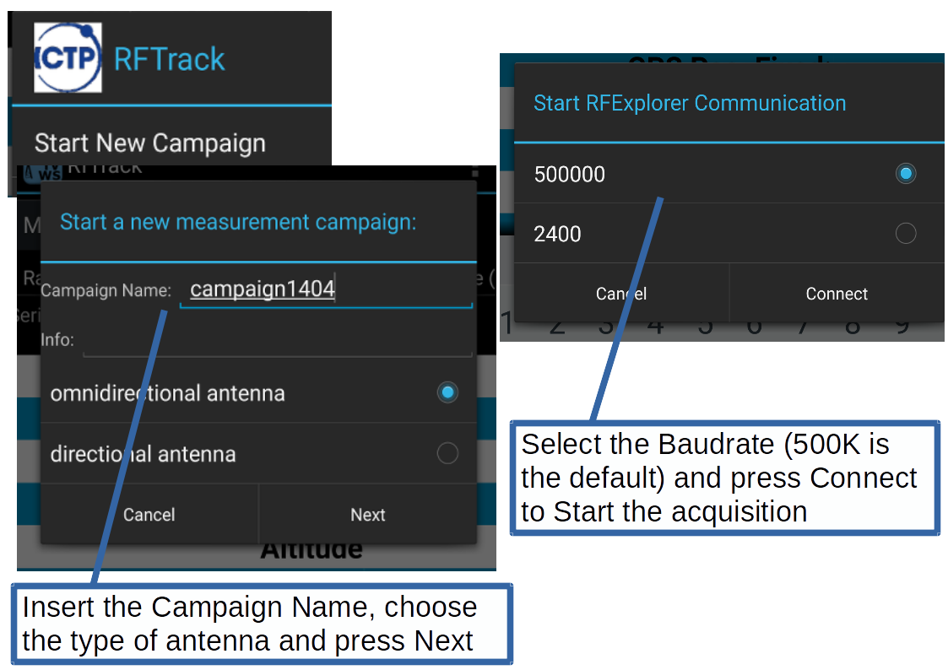

The data acquisition display
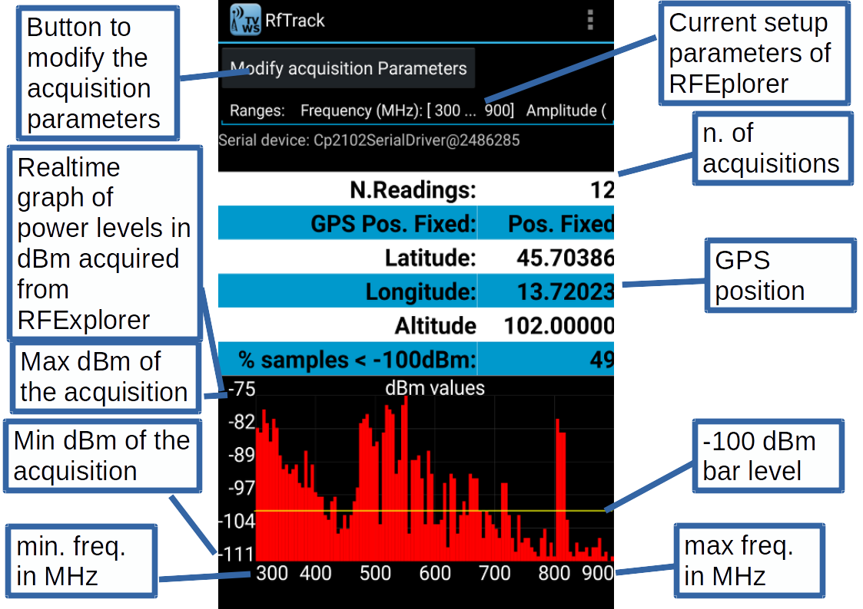

Modify the acquisition parameters
Pressing the “Modify acquisition Parameters” button, the user can modify the configuration parameters previously sent to RFExplorer and restart the measurement campaign.
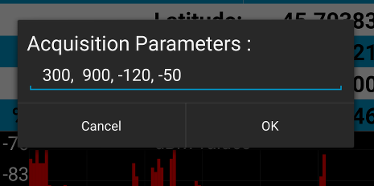

N. | Parameter | Example
1 | RFExplorer Frequency Setting, lower limit in MHz | 300
2 | RFExplorer Frequency Setting, upper limit in MHz | 900
3 | RFExplorer dBm Setting, lower limit | -120
4 | RFExplorer dBm Setting, upper limit | -50

These parameters have limits that depend on the RFExplorer model type.
To find these limits, see the documentation provided with your spectrum analyzer.

Stop the data acquisition and Exit
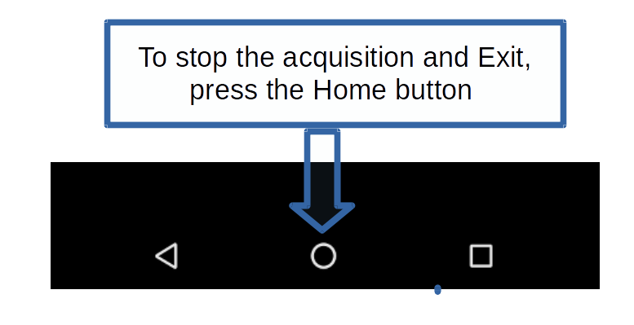

Open a previous campaign and continue the acquisition
In Main menu, press Open Campaign
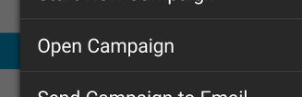

RFTrack shows a list with the names of the measurement campaigns currently stored.
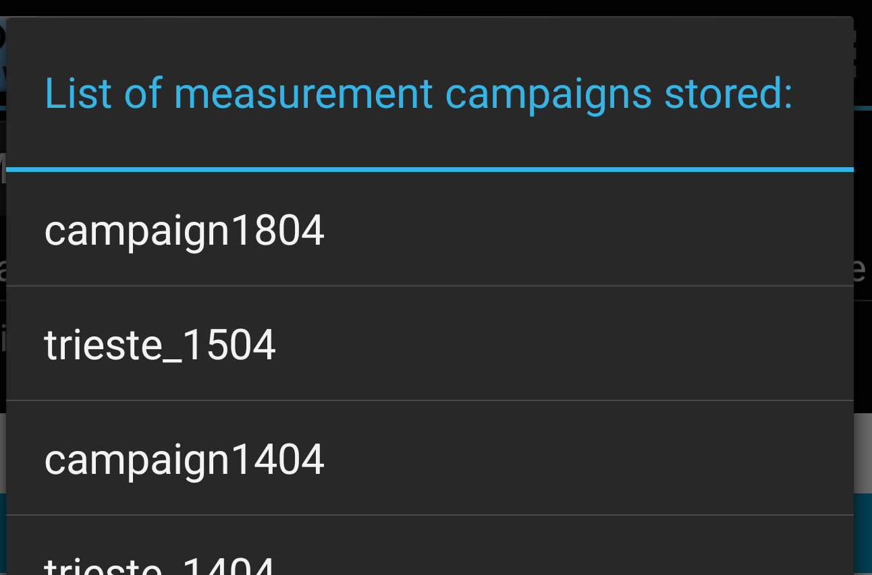

To select the campaign, click on its name.

During the previous measurements the instrument configuration parameters might have changed. A list of parameters that the user can choose before proceeding with new acquisitions is shown
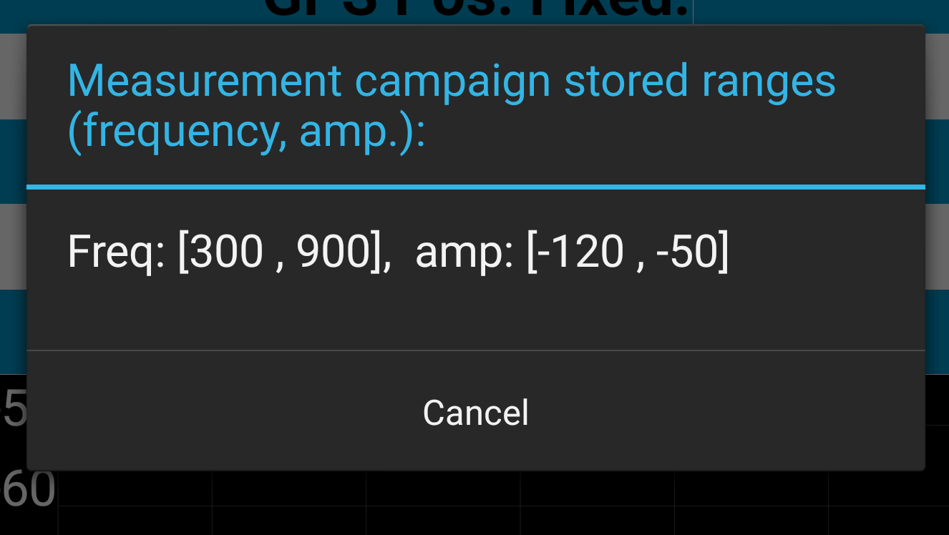

Select the Baud Rate and start the acquisition.
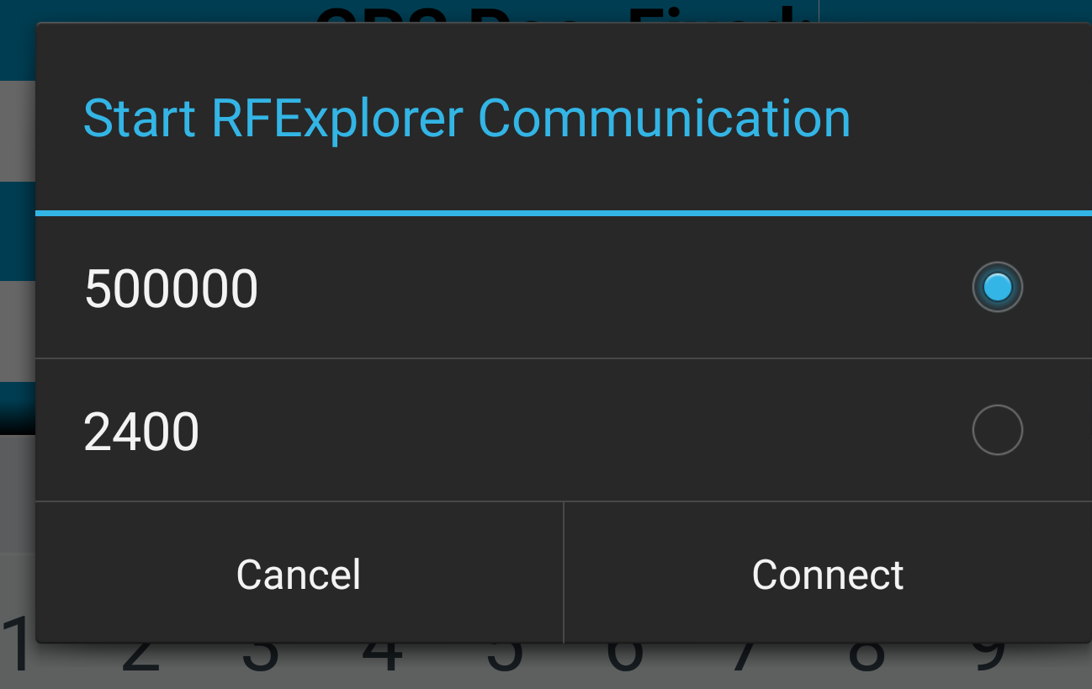

Sending data to the Analysis Server
In main menu press Send Campaign to Email
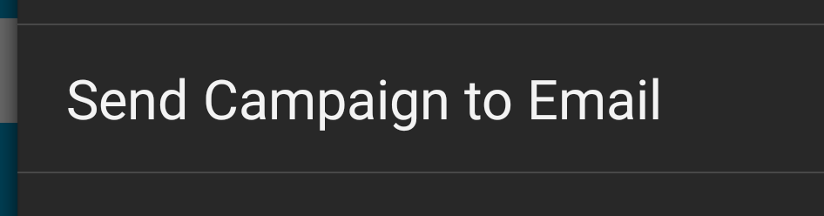

RFTrack shows a list with the names of the measurement campaigns currently stored.

To select a campaign, click on its name.

A list of programs that can be used for sending data is presented
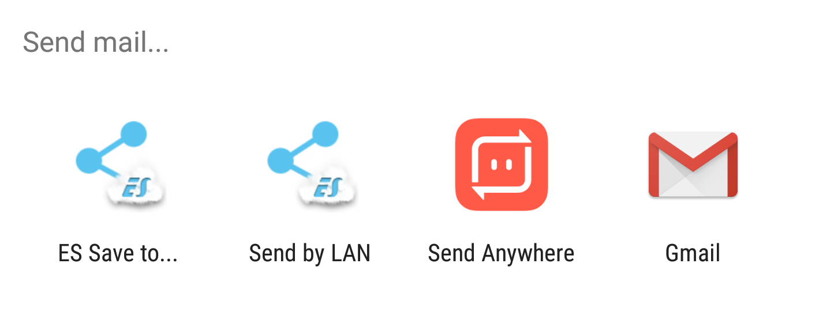

Pressing Gmail, the precompiled form for sending the mail is offered.
The database with the measurements will be sent as an attachment.
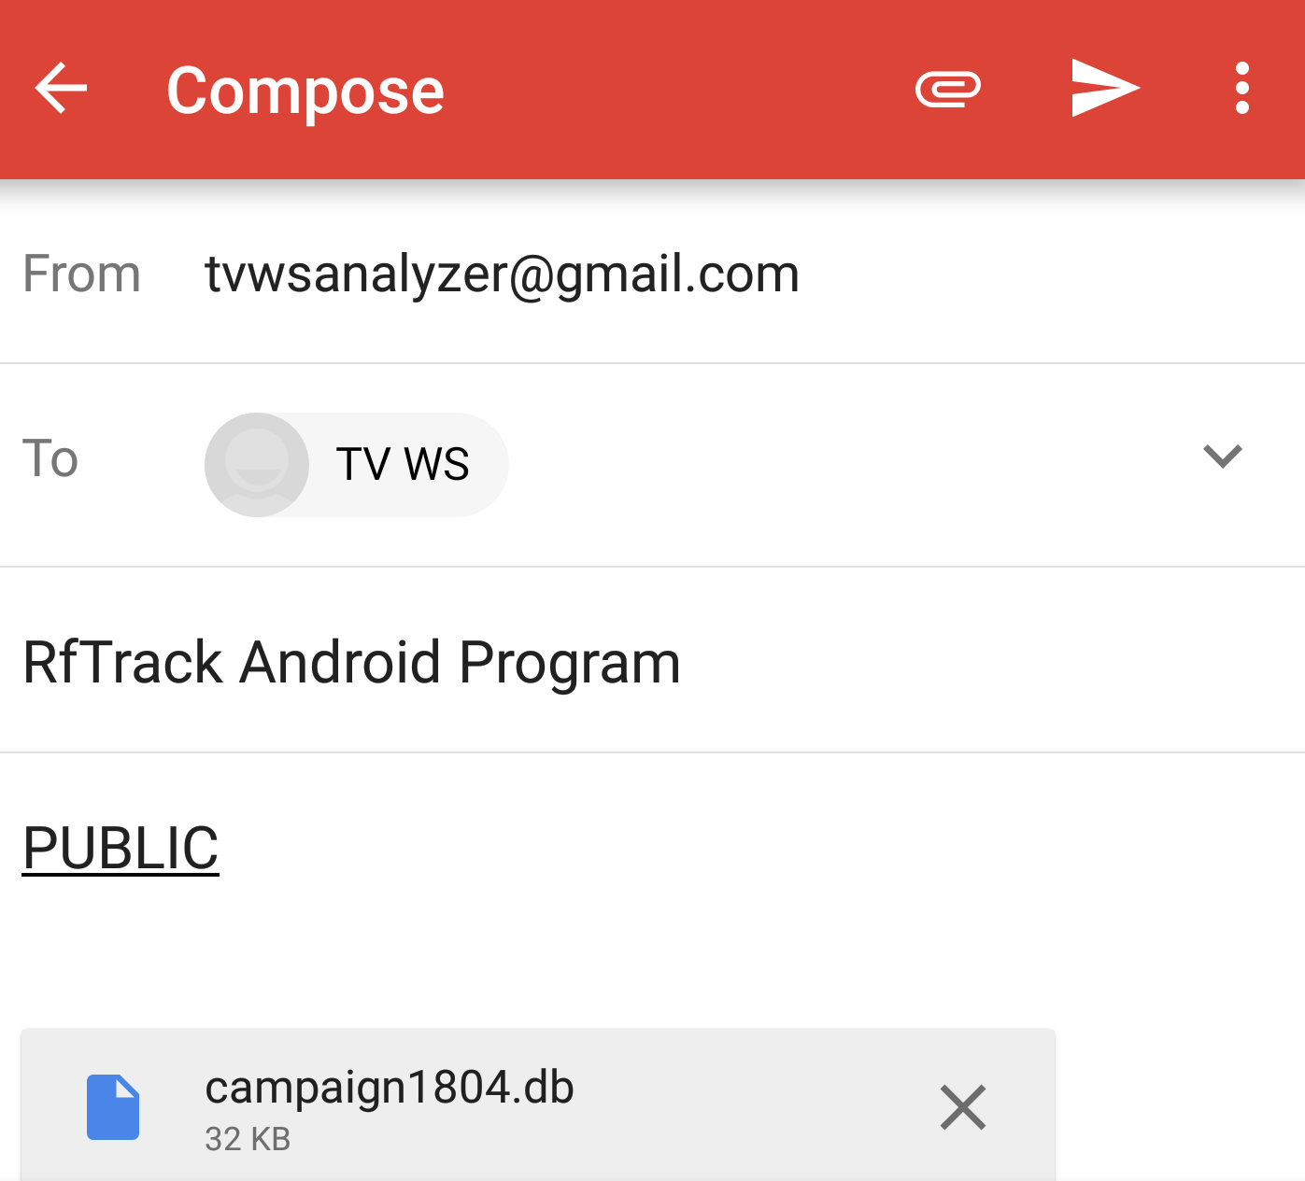
To send data, press the following icon (on top bar, upper right).
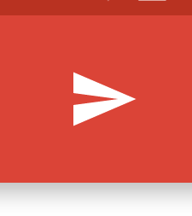

Check GPS
Pressing “Check GPS” on main menu, causes the program to check if the GPS is currently able to provide the correct position.
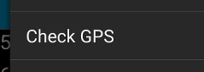

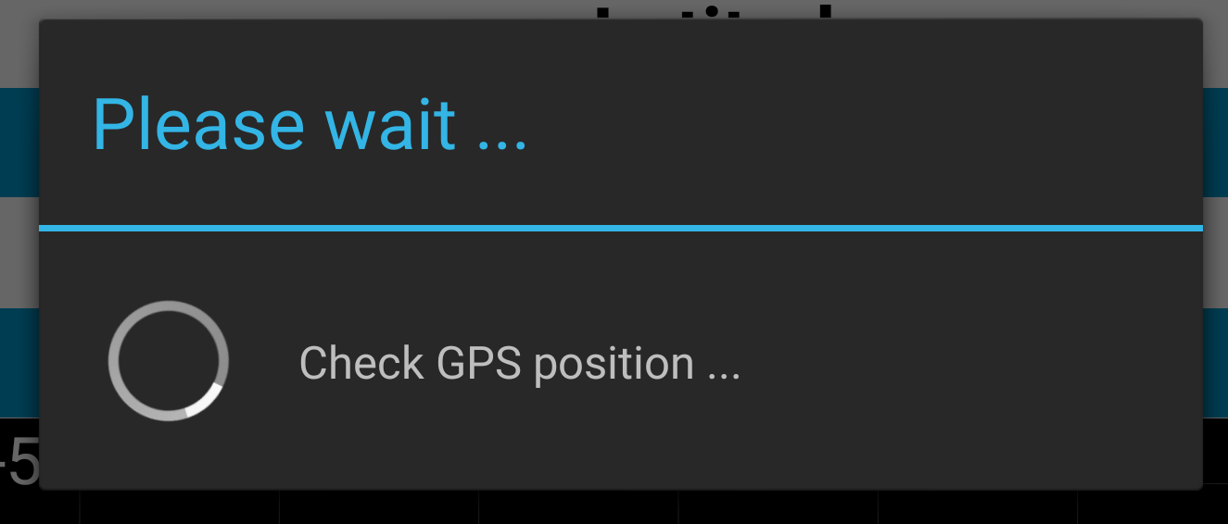

If the check fails (for example, the GPS is disabled), the program proposes the manual insertion of the position by the user.
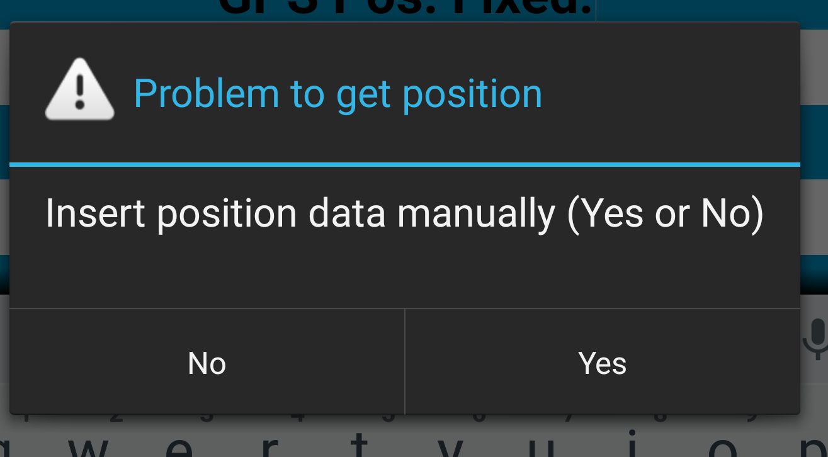

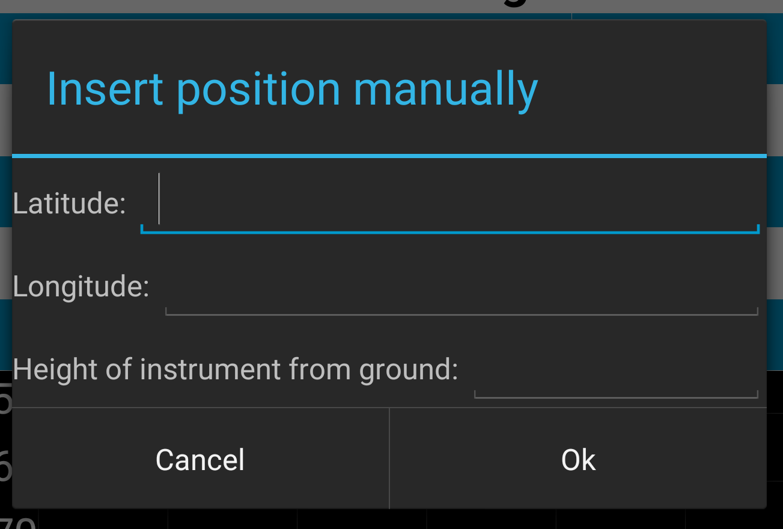

Android Device Info
The program checks the hardware and shows a report.
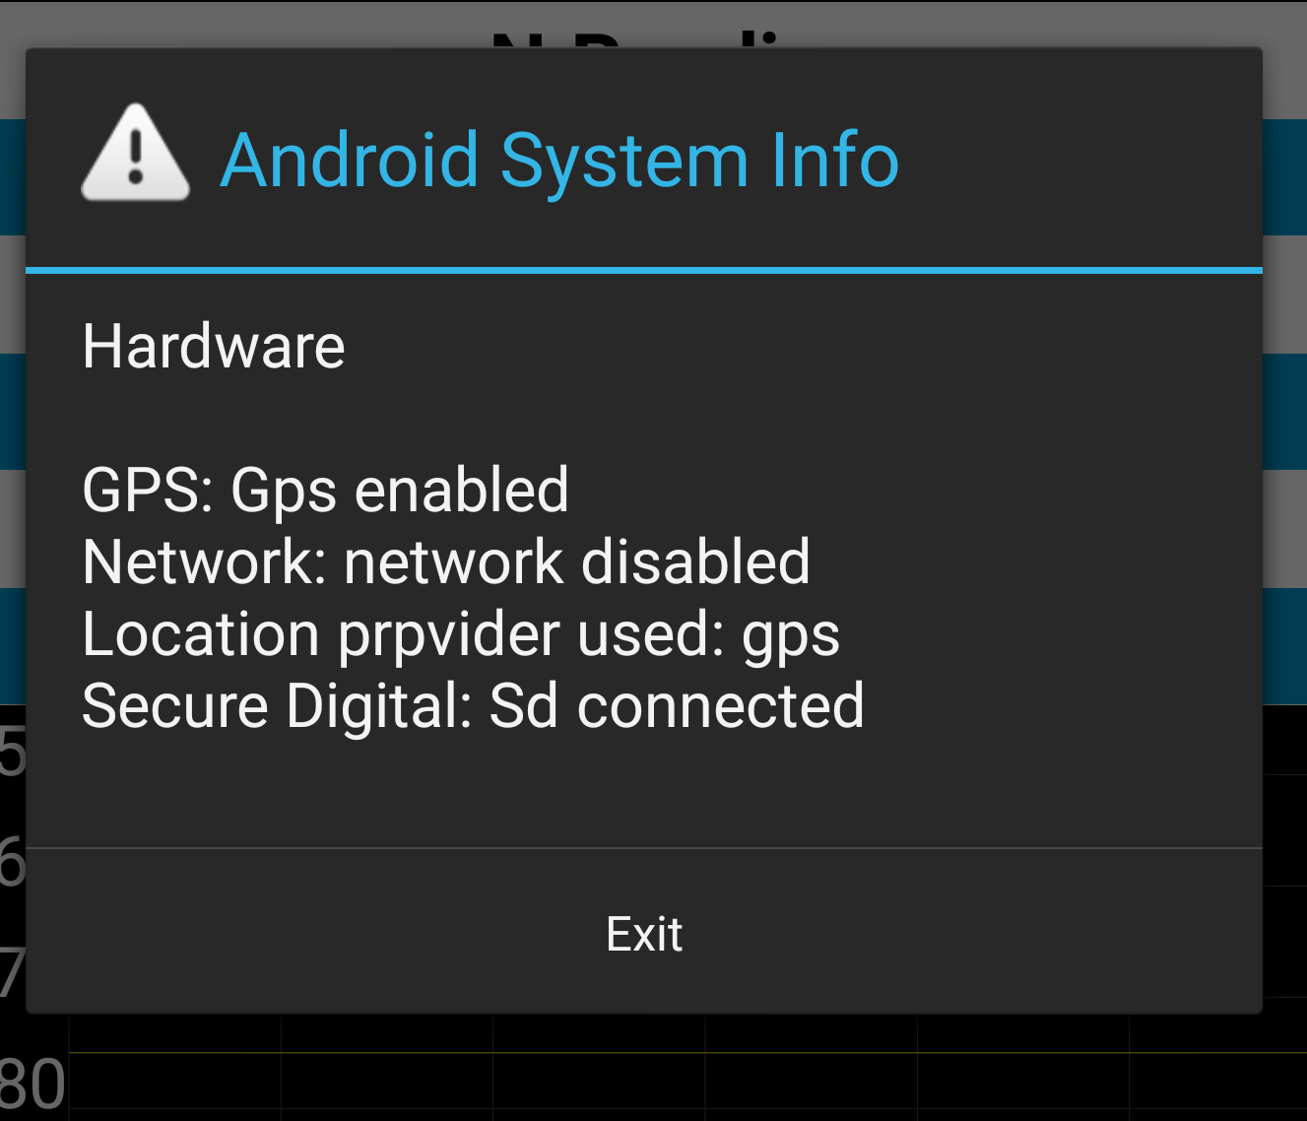

Program Info
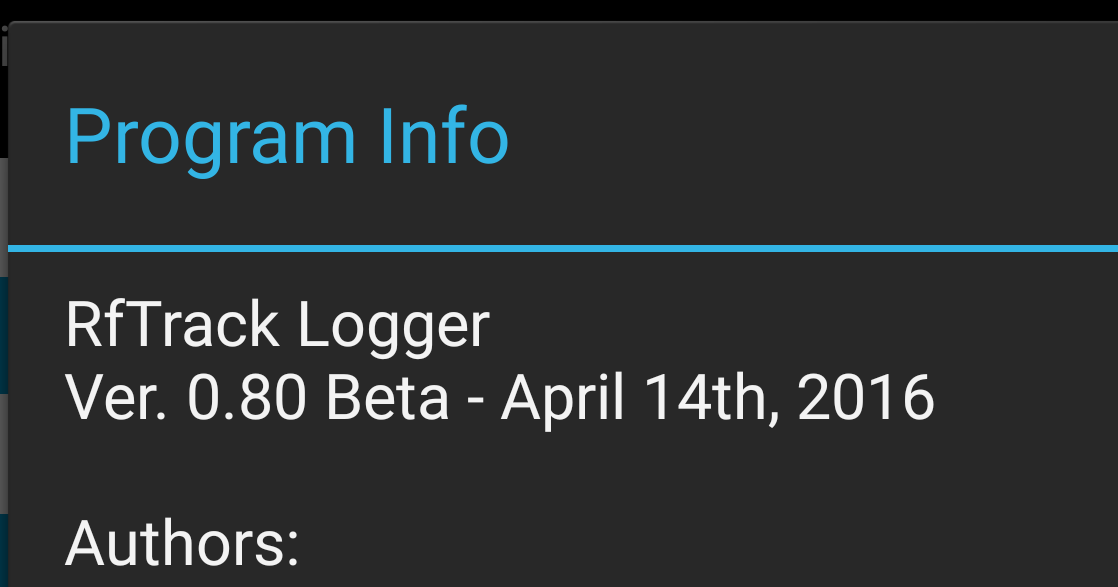

The Analysis Server
The remote server processes the info in the database and builds a report.
The reports is available at this web address:
http://wireless.ictp.it/tvws/
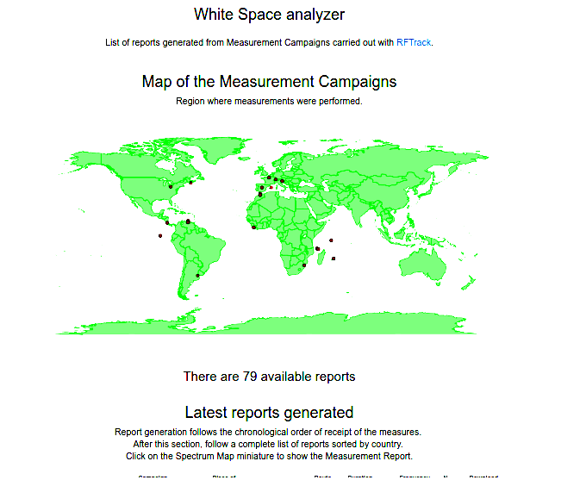

Scrolling the page shows a list of latest reports generated.
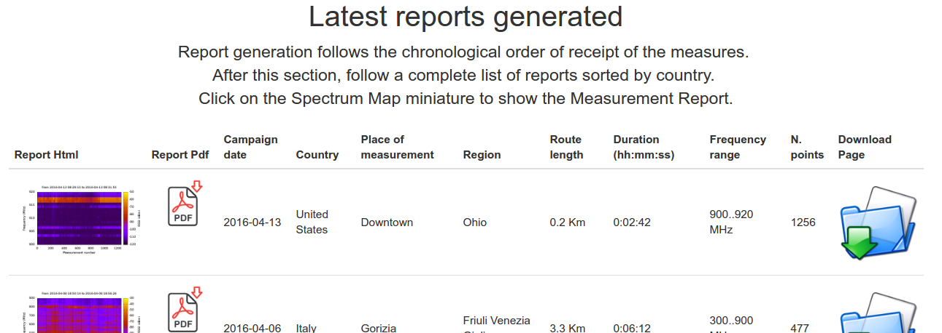

Then comes a section of reports sorted by countries in alphabetically order.
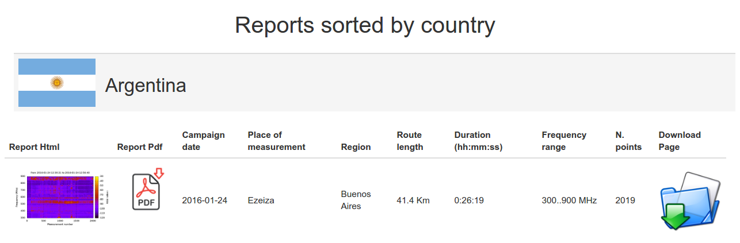

Each line of the page shows the identification information of the report.

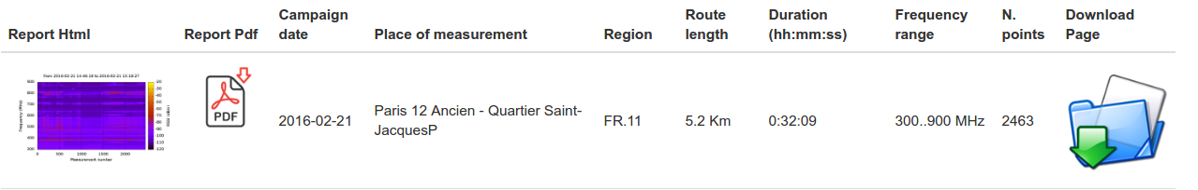
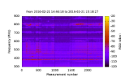 | Thumbnail for heatmap shown in the report.  Click to open the report html page.
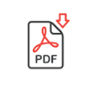 | Icon to open the report in PDF format
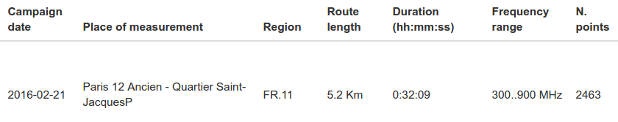 | Identifying information regarding the measurement campaign.
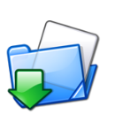 | Icon to open the page containing additional material of the respective measurement campaign.

The html report
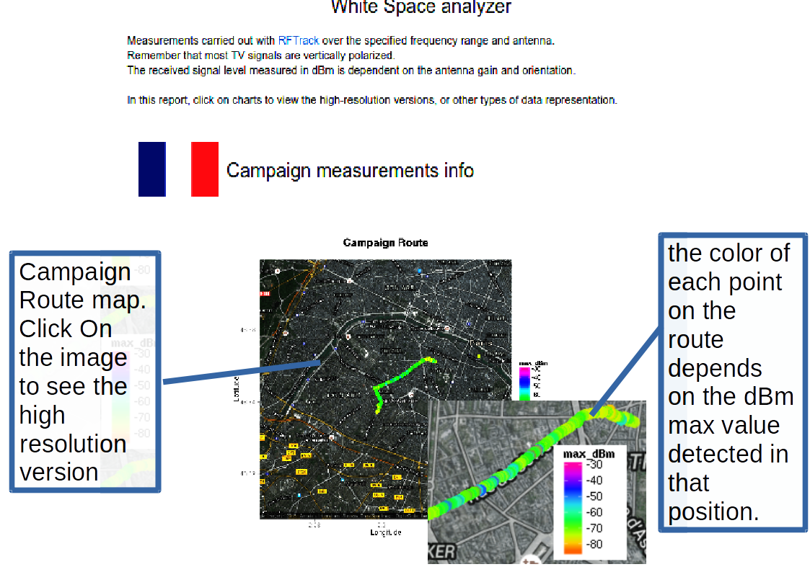

The following table contains info about the location where the measurements were taken
Info | Value
Campaign date: | 2016-02-21
Campaign duration: | 0:32:09 (hour:min:sec)
Route length: | 5.2 Km
N. points: | 2463
Country: | France
Country Code: | FR
Place of measurement: | Paris 12 Ancien - Quartier Saint-JacquesP
Region: | FR.11
Population: | no info
As in the Index page, this icon allows you to access to a page with additional material of the measurement campaign.

Other plots
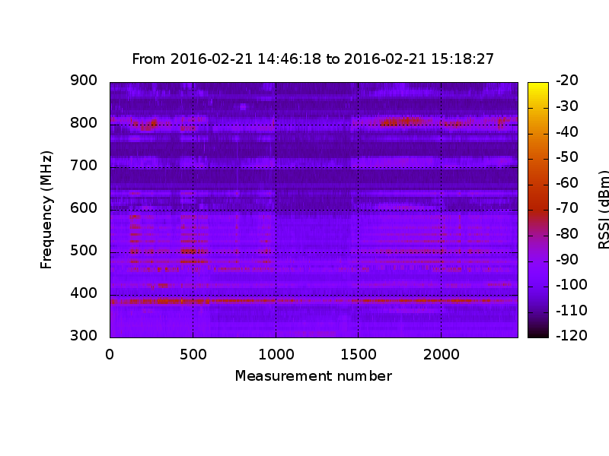 | Heatmap generated by all the measures of the campaign.  Clicking on the image, you can view a high resolution version of the graph.

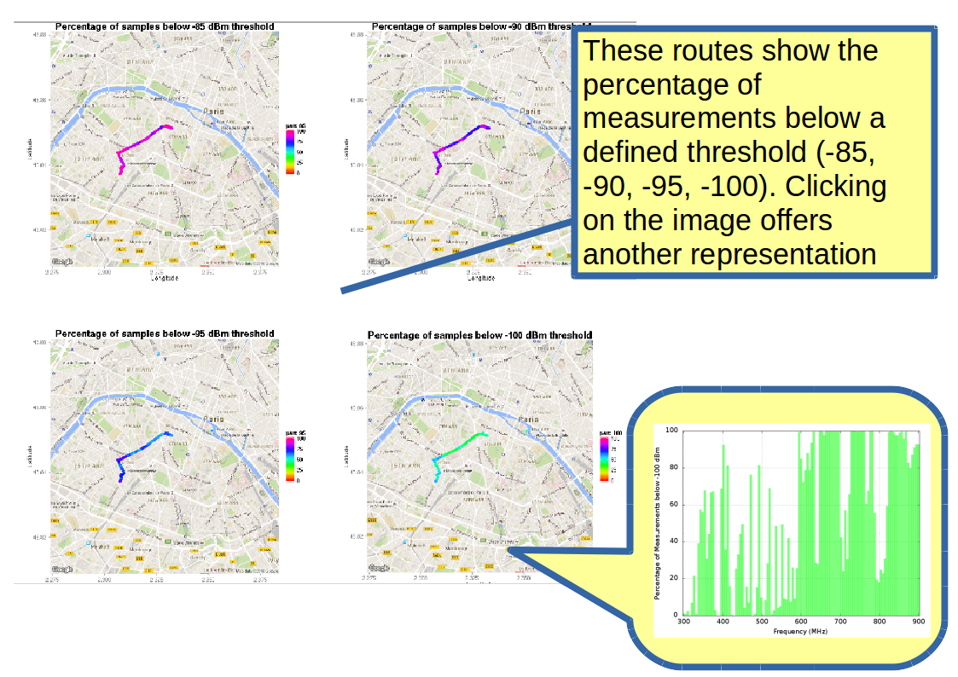

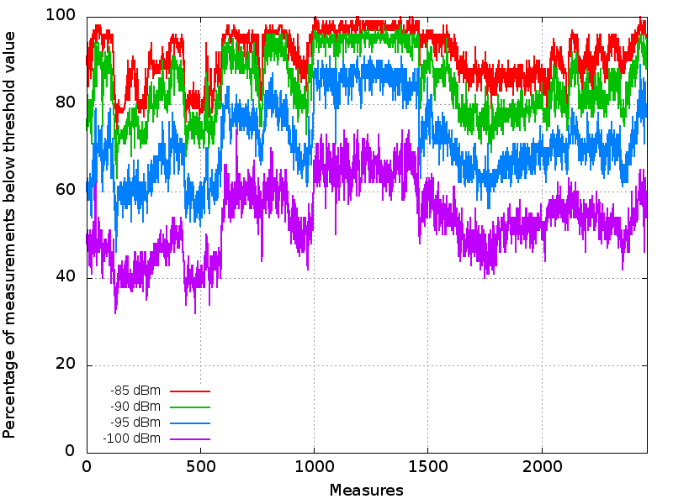 | Graph with the percentuage of dBm below a threshold value (-85,-90, -95, -100).  Clicking on the image, you can view a high resolution version of the same graph.
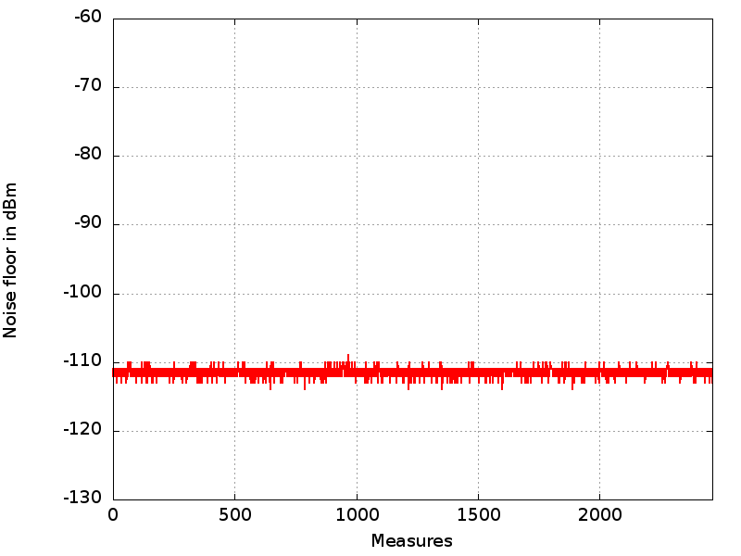 | Noise floor graph.  Clicking on the image, you can view a high resolution version of the same graph.

Additional material of the measurement campaign
After data analysis, an additional page containing other material regarding the measurement campaign is also generated.

Two videos
You may view two mp4 videos that display graphs of dBm versus frequency at the GPS position on the map.
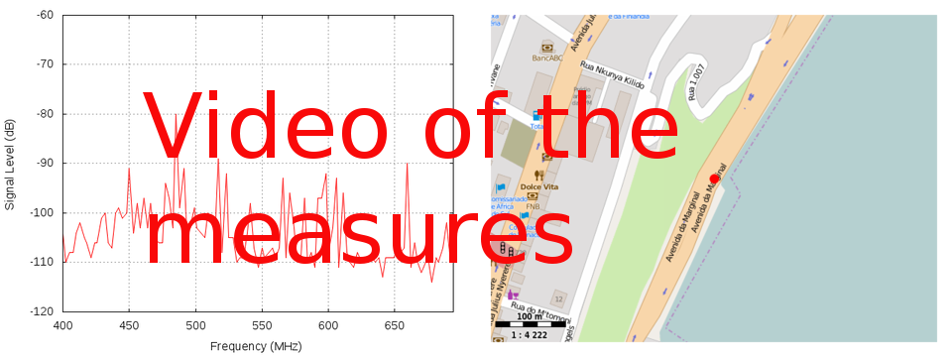 | Data analysis video, first version. | 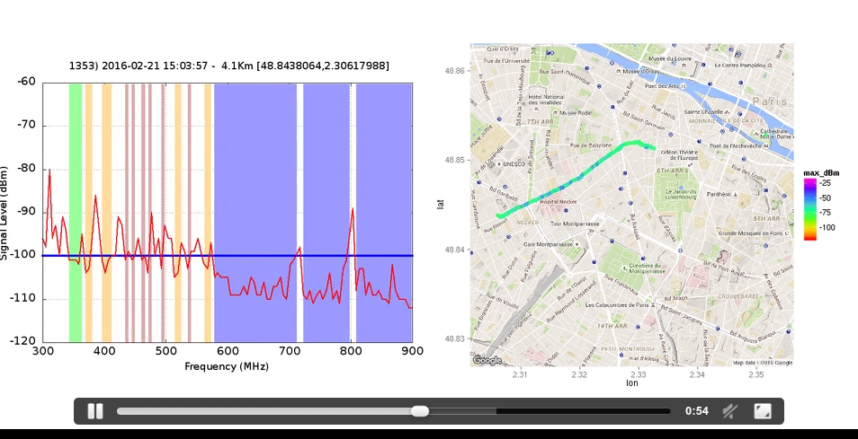
 | Data analysis video, second version. | 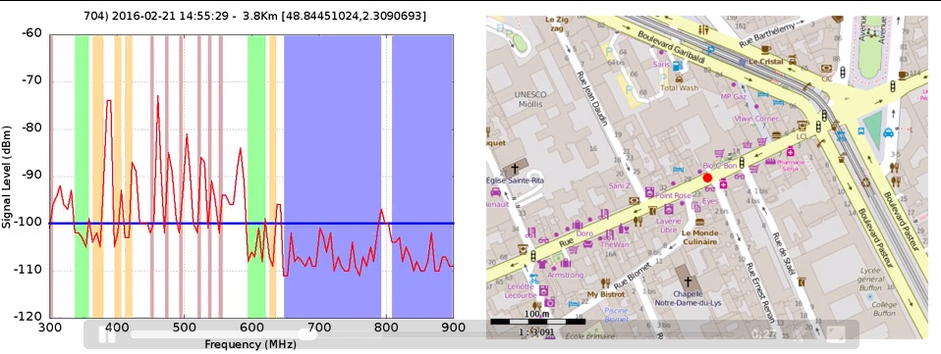

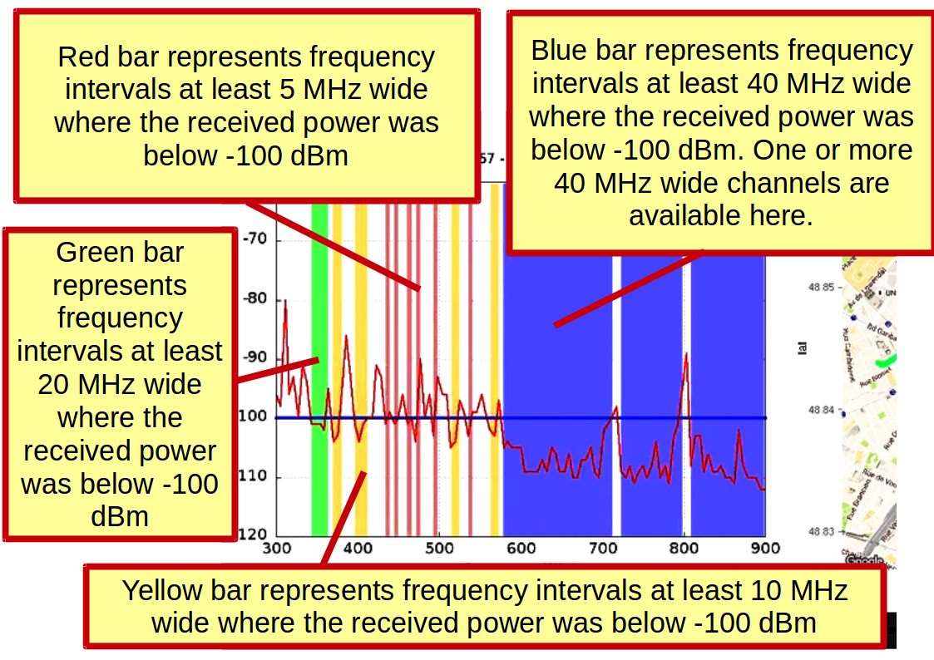

Other files that can be downloaded

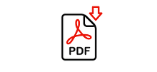 | Analysis Report in Pdf format.
 | Report images stored in Zip archive.
 | SQlite database, containing measurement data.

Technical information about the database used by RtfTrack

The RfTrack application saves all data in SQLite databases.
- SQLite is a lightweight relational database, used in Android for data storage purposes,
- This database requires no administration.
- Each complete database with multiple tables, indices, triggers, and views, is contained in a single disk file.
- SQLite is a compact library written in C: with all features enabled, the library size can be less than 500KB

For example, SQLite databases can be found in software running in Embedded devices and the internet of things
https://www.sqlite.org/whentouse.html
… “SQLite is a good fit for use in cellphones, televisions, game consoles, cameras, thermostats, automobiles, machine tools, airplanes, remote sensors, drones, medical devices, and robots: the "internet of things".

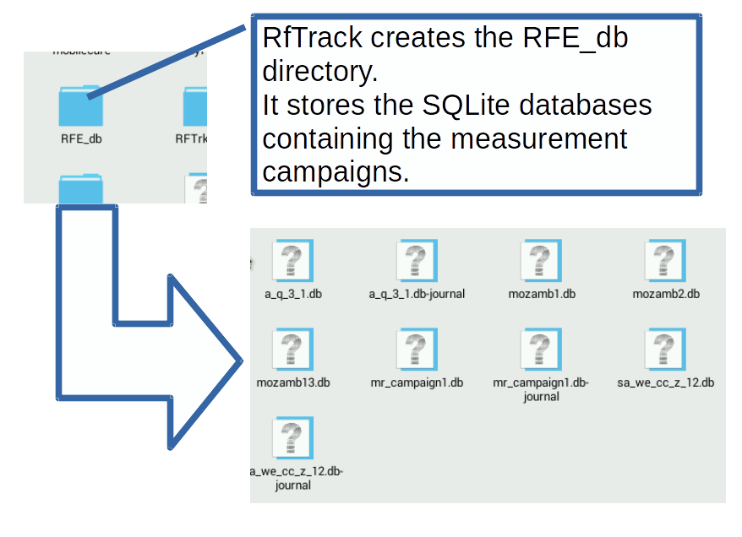

Some tools to manage SQlite databases
Below is the list of some freeware or open source tools that can be used to manage SQlite databases.
The list is provided for informational purposes only.
At any rate, the info provided may reflect preferences in the use of software.

Tool | Address | Info
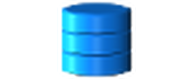 | https://addons.mozilla.org/en-US/firefox/addon/sqlite-manager/ | 'Sqlite Manager': Firefox browser extension.
 | https://github.com/lazierthanthou/sqlite-manager | 'Sqlite Manager', project page on GitHub.
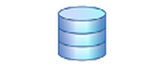 | https://chrome.google.com/webstore/detail/sqlite-database-browser-b/jlpbdkmaomigeneadlamehkfchdmojgg?hl=en | 'SQLite Database Browser': Chrome browser extension.
 | http://www.sqlitemanager.org/ | Sqlite Manager:  Web-based SQLite administration.
 | http://www.phpliteadmin.org/ | Phpliteadmin:  Web-based database management tool for SQLite.
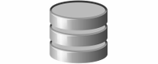 | http://sqlitebrowser.org/ | DB Browser for SQLite:  Open source tool to create, design, and edit SQLite databases.  For Mac OS X, Windows, Linux
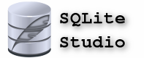 | http://sqlitestudio.pl/ | SqliteStudio: SQLite database manager.  For Mac OS X, Windows, Linux, BSD
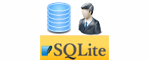 | https://play.google.com/store/apps/details?id=com.xuecs.sqlitemanager&hl=en | 'SQLite Manager', Android app.
 | https://itunes.apple.com/en/app/sqlite-manager/id800058050?mt=8 | 'SQLite Manager', IPhone application.
 | https://play.google.com/store/apps/details?id=com.kokufu.android.apps.sqliteviewer.free&hl=en | Android SQLite Viewer.

Project on github
The RTfTrack project has been released on GitHub and can be downloaded from this address:
https://github.com/tvwsanalyzer
Three repositories are available:
- rftrack-android-app: it contains the RfTrack Android app sources.
- rftrack-server-scripts: it stores the scripts of remote server, for data analysis and report generation of measuring campaigns
- rftrack-documentation: RfTrack project documentation



