1. General
I used Scrapy to implement this task. Run crawl.py will start the wiki crawling process, run analysis.py to generate statistic results from crawled data.

2. Process optimization
We assume that the content in wiki pages are all finalized and will not be changed, then the link paths and corresponding path lengths to philosophy page are all constant.

Under this assumption, we can use history results of link paths to help find out path lengths of new pages with fewer http requests.

For instance, if we know page A needs 5 steps to reach philosophy page, and page B will reach page A in 2 steps. Since the path to philosophy for page B is deterministic, then path length for page B is simply 2+5=7. Hence, we will save 5 http requests when crawling path length of page B.

The average path length is around 17, but if we have history data for around 1000 pages, then crawling length of a new page will only require 3 http requests in average.

On the other hand, our assumption may not hold true forever, which means the data collected with this method are not always accurate. One solution is to routinely update the history data we have.

3. Sample collection
The crawling process will start from a randow wiki page, it will stop when reaching the philosophy wiki page, or a page with no links or a page that does not exist, or when a loop occurs.
Multiple processes will be run until at least 500 wiki pages that can reach philosophy have been found.
The history data is in the csv file called ‘history_data.csv’. Each crawling process will read this file before crawling, and update this file once done.
In the csv, the first column is wiki page heading, the second column is the path length. If path length is -1, it means this page hasn’t reached philosophy with path length less than 1000; -2 means this page will get into a loop; -3 means this page will get into a dead end.

4. Results
4.1 Percentage
Based on the results I got, the stats show as follow:
90.06% of wiki pages will eventually reach philosophy;
9.60% of wiki pages will reach a page with no links or a page that does not exist;
0.34% of wiki pages will get into loops and never reach philosophy.

If we increase the sample size, the percentage of pages lead to philosophy should increase as well.

4.2 Distribution
The histogram of path lengths for 500 pages that reach philosophy is as follow:
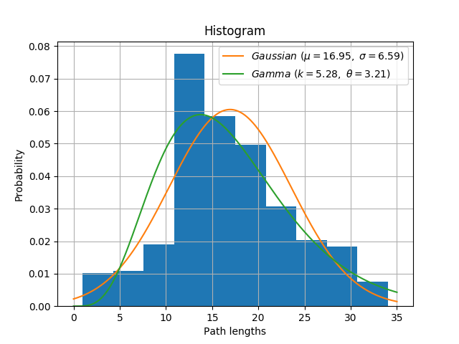

The shape of this sample distribution is not quite symmetric, and is skewed to the left side. We will test both Gaussian and Gamma distribution here.

Since sample data is discrete, I chose Chi-Square Goodness-of-Fit Test to test the hypothesis of normal distribution.

With null hypothesis that the data are Gaussian distributed, results show as follow:
statistic=59.367161172548158, p-value=1.7749729275719848e-09

With null hypothesis that the data are Gamma distributed, results show as follow:
statistic=76.321113899500503, p-value=8.6631664534275613e-13

With 5% significance level, the null hypothesis are both rejected. It does not follow Gaussian nor Gamma distribution.

The data of path lengths may not follow a typical distribution. Multi-modal or mixture of Gaussian are possible distributions worth testing next.

