Genetic Algorithms: Assignment 2022

Aid Convoy Trucks

20 Marks

You should demonstrate your answer in the tutorial on Friday week 13 (virtual Room) or the drop-in session in Week 14 date and times to be advised in announcements (some of these will be at 2:30 in virtual room), The final due date for the demonstration will be 3:30pm Friday 4th November.
NOTE: The written report and code submission are due on the 6th November just before midnight via Canvas.

I did a briefing on how this works at the lecture on Monday 17th so watch that echo recording for details.

Genetic Algorithms is one of a set of meta-heuristics that have been applied to optimization problems that do not have algorithmic solutions. These problems have to rely on heuristics that are tailored to the problem, or meta-heuristics – generalised heuristics that can be applied to a variety of problems.
Your assignment is to investigate how well GA performs on one particular problem, the packing of 3 aid trucks to cyclone ravaged Darwin.
In the classes supplied there is a list of items that will be loaded onto the 3 trucks.
You need to code the following (This is a minimum – feel free to rewrite my shell)
- Your gene structure/class
- Your genome structure/class
- Your mutation strategy/system/method(s)
- Finish the method showBest() to display the answers
- Anything else needed to make the program run as a GA; (eg initialise the population with random genes, mutate, selection and breed)
You can start with the Tkinter answer code I provide (which is my sample answer with the above routines deleted) or you can use the Knapsack Tutorial without a GUI interface (this would probably be easier for those who don’t know Tkinter, the main structure of the Knapsack program could be retained)
You need to demonstrate your program at one of the times listed above.
You will also need to submit a short report which should include the following:
- Your gene structure
- Your genome structure
- Your mutation strategy
- Other Code you changed (if relevant to the GA, don’t stress on reporting Tkinter widget changes)
- A paragraph or two on things that you found interesting or difficult during development of your GA
There is no fixed size for your report, but I would expect it to be between 1 – 3 pages.

You will also need to zip all the project code for your GA project and submit it to Canvas. So I will be able to run it – to confirm it works should I need to do so.

Your submission needs to use my code as a base (either the Knapsack Tutorial or the Tkinter code provided) and be written in a recent version of python.

Marking Criteria:
To get a Pass (10+ marks) | The Program must give a ‘reasonable’ solution relatively quickly without taking the item importance into account at all. (Trucks should fill to 18 or 19 on average)  The report will include the above items only
To get a Credit  (13+ marks) | The Program must give a ‘reasonable’ solution relatively quickly which should include some bias to getting higher priority items onto the trucks (note C=highest importance).  The loads must include the Hospital triage unit  NOTE: you are not permitted to Bias the mutation routine; to achieve this , you can only change the score routine.  The report will include the above items only
To get a DI  (15+marks) | The Program must give a ‘reasonable’ solution relatively quickly which should include some bias to getting higher priority items onto the trucks. Additionally this solution should treat the hospital as a two truck load (i.e either take both hospital parts or none)  And, the convoy needs at least two of the four petrol items to refuel for the journey back. (i.e. one of the four items from, Petrol44a, Petrol44b or Petrol20, Guzzoline e10)  The loads must include the Hospital triage unit  NOTE: you are not permitted to Bias the mutation routine , to achieve this , you can only change the score routine.  The report will include the above items only  Your solution must be able to deliver both hospital parts off the trucks and also in the trucks (obviously on different runs with different random seeds)
To get a HD  (17+marks) | This is the same as the DI option Plus the following experiment  The goal of this experiment is to see how much detecting duplicates (and removing them by mutations) affects the efficiency of a GA.  - Construct an experimental control (baseline) of your run that solves the DI level – make a note of how many generations are need to solve the problem. You need to do this 5 or 10 times and average the results (how many generations till you get a good solution) with different random seeds  - Modify the Code so it can detect duplicate genes in the gene pool, when it does so it should do a mutation on one of the duplicates. It should count how many times it does this and display that number. Then rerun 1) the same number of times and record the generations needed to get a good answer.  - Write a paragraph on that finding/result.

NOTE: in the Tkinter solution code you can modify the debug buttons any way you want, it’s just a placeholder.

Note : you must not overload the trucks if necessary you can underload by 1 or 2 , more then that is not a good solution

Do not have a base mutation percent above 5% (except for duplicate detection in the HD version which will raise it obviously)

I may ask to see your code during the demonstration, I may also do a plagiarism check on your code.
Screen shot from my Pass level example answer
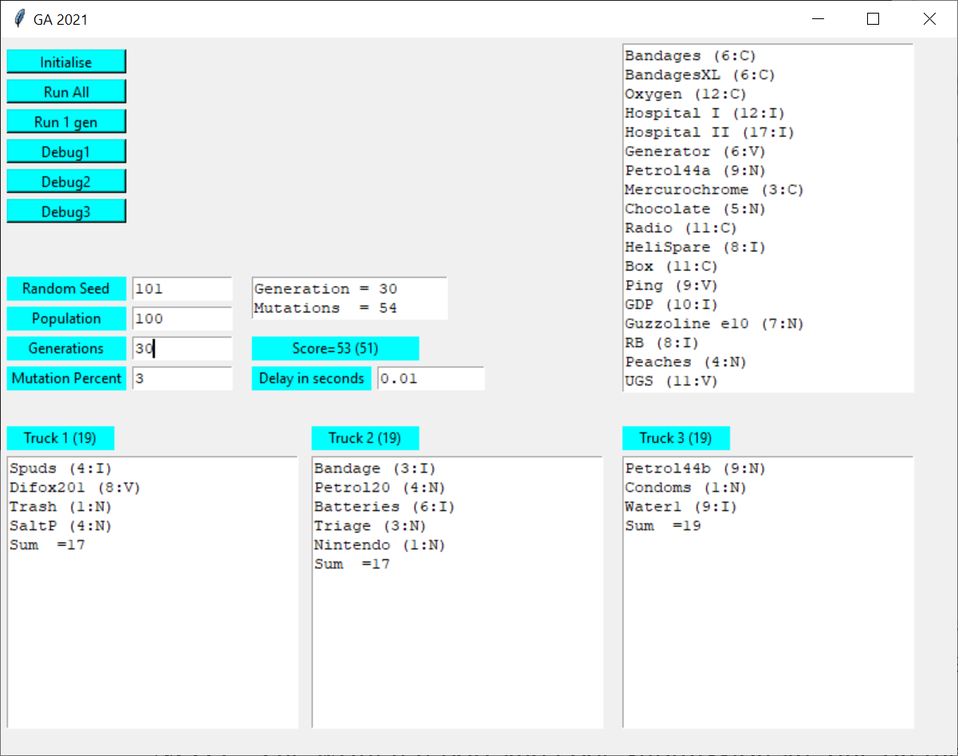
NOTE: correct usage is to press Initialise before Run 1 gen or Run All
The Items (name, long name, size, importance)
self.lst[0]=Item("Bandages","",6,"C"); # Importance C=Critical V=Very Important I=Important N=Not Important
self.lst[1]=Item("BandagesXL","",6,"C");
self.lst[2]=Item("Bandage","Full Body 'mummy' Cast",3,"I");
self.lst[3]=Item("Oxygen","Oxygen Cylinders",12,"C");
self.lst[4]=Item("Hospital I","Tent Hospital part 1",12,"I");
self.lst[5]=Item("Hospital II","Tent Hospital part 2",17,"I");
self.lst[6]=Item("Generator","Electricity Generator",6,"V");
self.lst[7]=Item("Petrol44a","44 Gal Drum of Petrol",9,"N");
self.lst[8]=Item("Petrol44b","44 Gal Drum of Petrol",9,"N");
self.lst[9]=Item("Petrol20","20L Gerrycans of fuel",4,"N");
self.lst[10]= Item("Condoms","",1,"N");
self.lst[11]= Item("Mercurochrome", "Disinfectant for wounds", 3, "C");
self.lst[12]= Item("Chocolate","Large box donated by Cadbury",5,"N");
self.lst[13]= Item("Radio","Large multifreq radio+gen",11,"C");
self.lst[14] = Item("HeliSpare","Helicopter Rotor", 8, "I");
self.lst[15] = Item("Box", "Grey box marked 'Top Secret'", 11, "C");
self.lst[16] = Item("Spuds", "Crate of Potates", 4, "I");
self.lst[17] = Item("Ping", "Machine That goes Ping", 9, "V");
self.lst[18] = Item("Difox201", "DF201 For mine rescue", 8, "V");
self.lst[19] = Item("Trash", "Trash Disposal system", 1, "N");
self.lst[20] = Item("Batteries", "Mobile Phone batteries", 6, "I"); # Importance C=Critical V=Very Important I=Important N=Not Important
self.lst[21] = Item("GDP", "Government policy manual", 10, "I");
self.lst[22] = Item("Guzzoline e10", "E10 good to reduce carbon", 7, "N");
self.lst[23] = Item("RB", "Rubber Bags and lime", 8, "I");
self.lst[24] = Item("SaltP", "Salt Pork", 4, "N");
self.lst[25] = Item("Water1", "Water 150L", 9, "I");
self.lst[26] = Item("Peaches", "Tins Of Peaches", 4, "N");
self.lst[27] = Item("UGS", "UGS - Type 20", 11, "V");
self.lst[28] = Item("MS", "Coffins", 9, "I");
self.lst[29] = Item("Doctor", "Doctors Kit", 13, "V");
self.lst[30] = Item("Albanese", "Anthony Albanese For a PR shoot", 8, "N");
self.lst[31] = Item("Triage", "Hospital triage unit", 3, "N");
self.lst[32] = Item("WPlant", "Water Purification Plant", 7, "V");
self.lst[33] = Item("Water2", "Water 300L", 12, "C");
self.lst[34] = Item("Nintendo", "Stop then getting bored", 1, "N");

Importance C = Critical (Really Very Very important)
Importance V = Very Important
Importance I = Important
Importance N = Not Important (least Important)

HINT: if you can maintain these globals it will help you to make less mods to the interface they are in g.py module import the module and access using a g prefix (eg g.POPULATION)

g.py is basically a file of globals

# globals called g

NUM_OF_TRUCKS = 3
NUM_OF_ITEMS = 35
TRUCK_CAPACITY = 19

POPULATION = 100;
MUTATIONPERCENT=3

generation=0; # Current generation
maxGeneration =20;
marker = -99999;
mutations = 0; # number of mutations
best = 0; # the nunber in the Population of the best individual
bestScore = -99991 # consider start value if your score gets bigger or lower for better

-------SOME HINTS FROM LAST YEAR ( Still applicable) -------------------------------------
Genome
There are at least 4 different genome structural possibilities select one you understand

Population
You probably don’t need more than 200; but up to 2000 is not considered excessive

Mutations
Most students last year had at least two kinds of mutations (one a large mutation , and a smaller one)
Don’t ‘bias’ your mutation routine to put in the hospitals or petrol I will check in code and deduct marks for that

Population culling
Culling the Bottom 50% of individuals (genomes) seems to work fine

Genome/startup
Needs to be Random – random, be sure to understand the effect of random seeds

