Design Journey Part 2

Group name: Give Us 100

Members’ names: Vini Tripathii, Ryan Feldman, Tyler Wang, Lu Yang

Members’ NetIDs:ut33 rpf53 tw325 ly298

Section: 213

**Part 1: Database Design**

**Conceptual ER Diagram (different arrows, see slide 13 of Lecture 17; relationship and ER, see lecture 16 and 18)**

In this part, please copy and paste your ER diagram for your database below (you can make your ER diagram using any tool of your choice). Make sure the relationships between each entity are clear and well thought-out. Don’t forget to indicate what kind of relationship each arrow represents. Your database description should go on the next page.

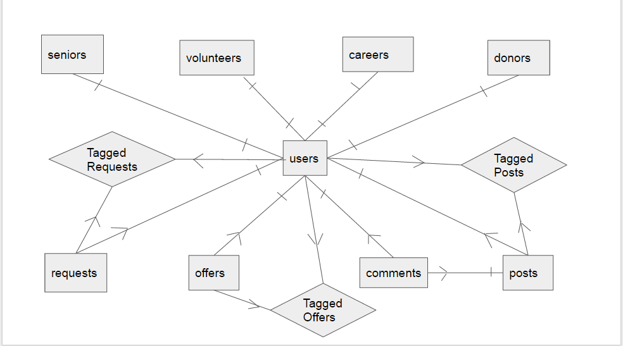

**Database Description**

Tell us what the database does. Make sure that you include enough detail so that we are able to understand what is going on in your ER diagram.

We currently have 13 tables, which can be divided into four groups:

Group 1: users, volunteers, seniors, careers, donors; this group record the user information

Group 2: requests, offers; this group records information from the post/request page

Group 3: posts, comments; this group records information from the forum page

Group 4: taggedPeople, taggedOffers, taggedRequests, taggedPosts; this group records the things tagged/starred by individual users

1. Users: record the personal information of users. One thing to notice: we allow one user to choose from one or more from the following categories: volunteers, seniors, donors, and careers, and these categories can be modified. Therefore, we use **four fields of boolean values to indicate what categories the user choose (seniorType, volunteerType, etc.)**

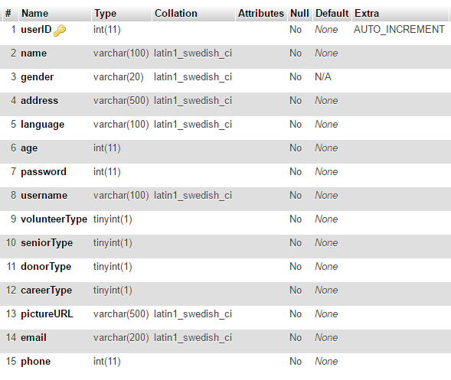

2. Volunteers: records the ids of users who check the volunteer type

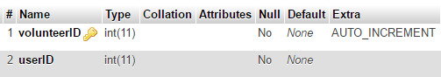

3. Seniors: records the ids of users who check the senior type

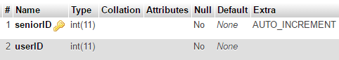

4. Donors: records the ids of users who check the donor type

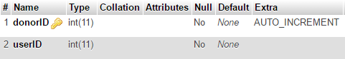

5. Careers:records the ids of users who check the career type

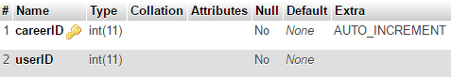

6. Request: records the details of requests made by users from the request/post page

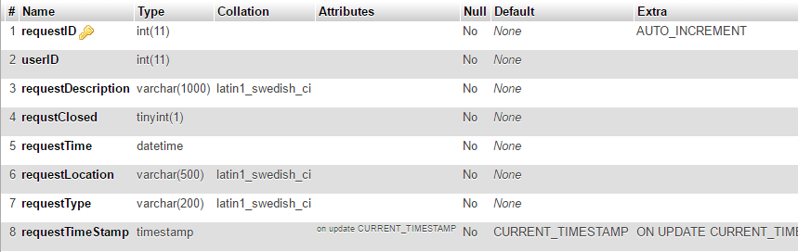

7. Offers: records the details of the offers made by users from the request/offer page.

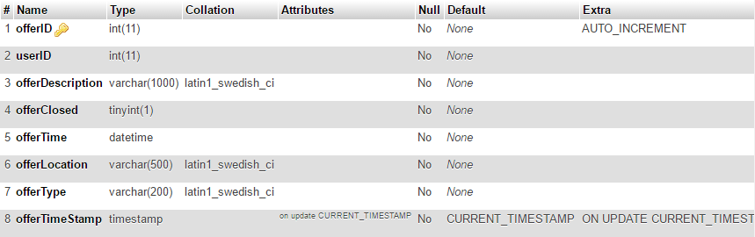

**8. Posts: records the details of the questions users post on the forum page.**

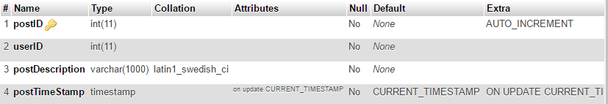

**9. Comments: records the users’ responses to specifc posts on the forum page.**

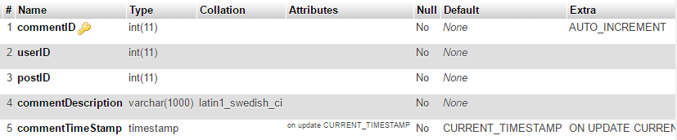

**10. TaggedPeople: record the people “tagged”/”starred” by individual users**

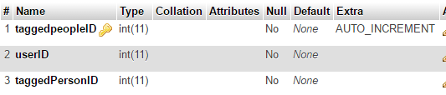

**11. TaggedPosts: record the posts “tagged”/”starred” by individual users**

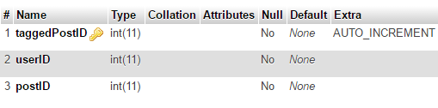

**12. TaggedOffers: record the offers “tagged”/”starred” by individual users**



**13. TaggedRequsts: record the requests“tagged”/”starred” by individual users**

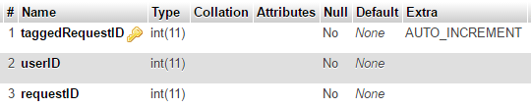

**Part 2: Website Layout**

**Content Organization**

This should be an improvement upon the table you used in **Design Journey Part 1**

|  |  |  |
| --- | --- | --- |
| **Main navigation**  (List your site’s navigation here) | **Sub category**  (List any sub categories of under the main navigation) | **Content**  (List all the content corresponding to main navigation and sub categories) |
| Home Page(logged in) | * Create Account/Log In * Volunteer * Donors * Career * Neighborhood(Forum) | Create Account: Redirects to Account Management page; accounts will vary depending on status of user (senior/retiree, donor, volunteer, service provider).  Log In: Redirects to login page for users who are already registered in the database.  Donors: Redirects to a list of relevant donors.  Career: Redirects to a list of people who are not just volunteers, but work with senior citizens  Neighborhood: A forum where anyone can ask questions and comment.  Until a user logs in, or makes an account, they will only be able to access the about page, the forum (though they can not ask questions or write answers). |
| Home Page (not logged in) | * Create Account/Log In * Home Page * Neighborhood(Forum) | See above |
| Login | * If the password and username are entered correctly, the user is redirected to the logged in homepage * A register button redirects to the make account page | Standard login form which requires username and password. Below form are two buttons, one that says ‘Login’ and the other that says ‘Make an account’ |
| Profile | * The only subcategory is “edit profile”, but the navigation bar common to all pages allows the user to go to a different page | Shows information about the user, the groups the user belongs to (Volunteer, Donor, ect), the user’s previous posts, request and offers, and any posts or people the user has tagged |
| Edit Profile | * Go back to profile * Save changes (submits edit profile) | Shows current information so user can edit easily without rewriting, and can add or drop groups. In essence it is a form. |
| Forum | * Health * Ask a question * Mortgage * Grandchildren * Estate * Category X   (Has subcategories, some of which remain undecided) | People can click on subcategories to read question and answer. They can also type their own answers in response. |
| Donate* | * Initiate Chat * Donate through paypal * Tag | Shows list of senior citizens and their need for which someone can donate. Donates can click on a person and initiate a chat, or donate right away via paypal Ex. Josh Stewart, 89, needs a hearing aid which costs $500. People can donate amounts through their paypal account. The button initiate and chat are below each description. |
| Volunteer* | * Initiate Chat * Tag | Shows list of volunteers |
| Career* | * Initiate Chat * Tag | Shows list of people whose career involves specialization in taking care of senior citizens (like live-in caretakers, ect) |
| Request* | * Initiate Chat * Tag | Shows list of senior citizens and their request |

*\*Since the search bar is part of the navigation page, users can also search through these pages.*

**Navigational Structure**

Explain how users will move between pages. What kind of navigational aids will you have? Will there be a menu bar? A drop-down menu? Tabs? Will you have this available across all your pages?

Tell us why you chose a particular navigation scheme over other possible choices, how the overall navigation of your site will work, how the various pages will be linked, and how the the navigation categories make sense from a user’s perspective. You may find it helpful to include a diagram of your site map here.

The navigation bar will consist of: Home, Profile, Forum, Requests, Offers and a search bar. The navigation bar is common to all pages. Additionally, pages that spawn forms will have an additional button that takes the user to the previous page. At no point will the user need to rely on back button.

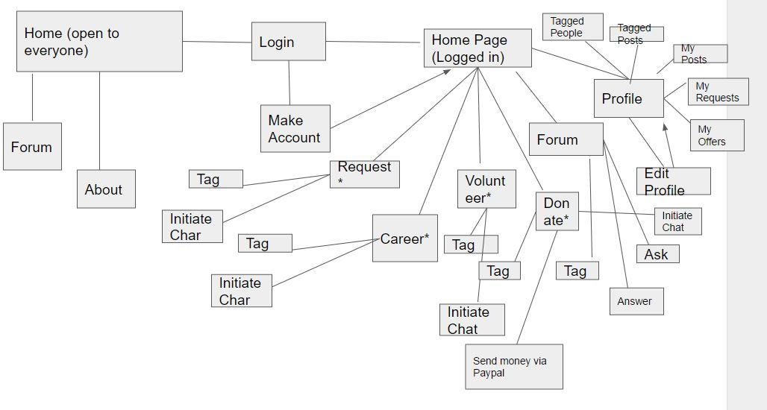

**Part 3: Interactive Functionality**

What interactive features will your site have? What PHP and Javascript elements will you include? Describe how the interactivity meets the needs of the clients/target audience.

1. Search: users can acquire the information (users, posts, etc.) they want via a general search field in the navigation bar (similar to that on Facebook), either by a key-word search or an advanced search

2. Register: users can register accounts

3. Edit: users are able to modify their profile information

4. Make posts/offers/requests/comments: users can post questions/responses on the forum page; they are able also to post requests/offers on the request/offer page;

5. Donate: users can donate money to other users

6. Chat: a user can initiate a private chat with another user

7.Tag/Star: a user can star/tag users/posts/requests etc. to a personal list and look at them later

8. Adjust: users can adjust the languages, the font size, and other settings

These functions satisfy the client’s need for users to 1. Connect and interact with other people 2. Get help from others 3. Offer help to others 4. provide functions that make the website convenient for use

**PHP Interactivity**

For each piece of PHP interactivity that you plan to implement, describe what the interaction is, how you will implement it, and which pieces of PHP code are required to complete it. You can describe these in terms of functions if you like, but only if you want to. If there is overlap between PHP and JavaScript interactivity, describe the interaction both here and in the JavaScript Interactivity section on the next page.

We will use php to implement several aspects of seniorcitizenconnect.com:

1. Header, navbar, and footer - elements which are common across all pages can be included using php, while variables are passed in to ensure that the user’s information is still passed between pages..
2. Collecting and acquiring database information - any forms for registration, login, or posts can be processed and recorded in the MYSQL database using PHP. In addition, PHP will be used for establishing a connection to the database, and making queries to the database.
3. PHP will be used to automate the generation of content, such as pictures and posts, on certain pages. This is usually done using loops.
4. PHP can be used to parse, sanitize, and hash any sensitive information from the user. PHP’s built-in sanitize filters makes it convenient to avoid injection from malicious users.
5. Chat room - PHP and JQuery can be used in conjunction in order to create a live chat room for users.

**JavaScript Interactivity**

For each piece of JavaScript interactivity that you plan to implement, describe what the interaction is, how you will implement it, and which pieces of PHP code are required to complete it. You can describe these in terms of functions if you like, but only if you want to. If there is overlap between PHP and JavaScript interactivity, describe the interaction both here and in the PHP Interactivity section on the previous page.

We will use ajax calls to acquire the information on the browser and use jQuery to help change it

Since we have many types of users, some pages will require javascript to show and hide content that is unique to each user type

Javascript can also be used to make dynamic changes to pages, such as deleting or editing content.

Javascript may be used in our implementation of search in a fashion similar to previous projects, where the search results are updated with each key.

PHP and JQuery will be used in conjunction in order to create a live chat room for users with phpchatfree

The main elements of the site will be done in PHP, not JavaScript.

Compared to the first milestone, did you make any changes to your plan to use the existing libraries (e.g. editor.js, jQuery Cookie, Image Sliders, jQuery) for the site? If so, write down the libraries, what you have to do to incorporate those libraries, and how much of your own code will satisfy the project requirements. If there is no change, write down N/A.

**We decide to use phpchatfree, an open source package, to implement our private chat rooms.**

**Part 4: Additional Comments**

If you feel like you haven’t fully explained your design choices, or you want to explain specific functions in detail, do so here. You can use this space to justify your design choices or ask other questions about the project and process.