Assignment #4. Experiment Execution, Results and Discussion
Kazakh–English Performance Gaps in Large Language Models: A Comparative Analysis of Translation and Question-Answering Accuracy and Linguistic Error Types
Students: Birkhanym Kazhymukhamet, Meruert Khaigeldinova, Dana Bekbosyn
Group: SE-2414
Repository: https://github.com/tw3tyy/kazllm (release tag: PENDING: create tag "assignment-4")
Status of this report. This version reports every response that the repository currently contains: 276 Gemini 3.5 Flash-Lite translation responses, which form 138 complete EN→KK / KK→EN pairs from FLORES-200. Runs that have not happened yet (QA, probes, KazParC, Qwen 2.5 1.5B, Gemma 3, NLLB-200, human annotation) are marked Pending in red. No number in this report is estimated or simulated; each one is produced by assignment4/analyze_partial.py from the saved logs. Fill the red items before submission.

1. Final Research Title
Kazakh–English Performance Gaps in Large Language Models: A Comparative Analysis of Translation and Question-Answering Accuracy and Linguistic Error Types (unchanged from Assignment 3).

2. Research Question, Aim, Objectives and Hypotheses
Primary research question. How does the accuracy of selected large language models on Kazakh-language translation and question-answering tasks compare with their accuracy on equivalent English-language tasks, and which types of linguistic error are associated with any differences observed?
Aim. To measure the Kazakh–English performance differential of LLMs on translation (MT) and reading-comprehension QA, and to categorise the linguistic errors behind it.
Objectives. O1 compile a parallel KK–EN suite (FLORES-200, KazParC, Belebele, 30 probes); O2 evaluate LLMs and an NLLB-200 baseline in both language conditions (chrF2, BLEU, QA accuracy); O3 blind manual error annotation with Cohen's κ; O4 relate error categories to metric degradation (Spearman ρ).
H1 (performance degradation in Kazakh). QA accuracy is lower in Kazakh than in English (McNemar exact test, Holm-corrected), and the MT direction gap ΔchrF2 = chrF2(EN→KK) − chrF2(KK→EN) is negative with a 95% bootstrap CI below zero and below the NLLB-200 directional gap (ΔLLM − ΔNLLB < 0).
H2 (morphological error predominance). Morphological errors are the most frequent category in Kazakh outputs: the bootstrap 95% CI of δmorph = P(morph) − max other P(c) is strictly positive.

3. Deviations from the Frozen Protocol
All deviations below are also recorded in DEVIATIONS.md in the repository.
Table 1. Deviations from the frozen protocol
# | Frozen protocol (A3 / Appendix A) | What changed | Reason | Effect on conclusions
1 | GPT-4o, Llama-3.1-70B, Gemini-1.5-Pro | Gemini 3.5 Flash-Lite (API), Qwen 2.5 1.5B and Gemma 3 (local, Ollama) | No paid API budget; 8 GB RAM laptop | Findings apply only to these smaller models; not comparable to GPT-4o-class systems
2 | Gemini 2.5 Flash-Lite | Gemini 3.5 Flash-Lite | 2.5 returned HTTP 404 on generation (verification/ folder) | None on data; changed before any benchmark response
3 | Greedy decoding, identical length limits | temperature 0, seed 42; Gemini thinkingLevel=MINIMAL; token budgets differ by backend | API and Ollama expose different settings | Small; recorded per request
4 | Full benchmark, 830 prompts per model | 276 of 830 Gemini prompts collected; QA, probes, KazParC, Qwen, Gemma pending | Free-tier quota (HTTP 429 stops the runner) | Results are interim and MT-only; H1-QA and H2 cannot yet be tested
5 | Pilot items separate from test set | All 70 pilot items are in the test set | Inherited dataset | Sensitivity analysis without them (Section 6.4); 14 of the 138 scored items overlap
6 | Simple baseline | Dictionary word-substitution MT baseline and always-A QA baseline (kazllm/baselines.py) | Needs no model or label information | None

4. Final Experimental Setup
Data. The frozen benchmark (data/benchmark.jsonl, 430 items, SHA-256 9ca2a593…6c4d910) contains 200 MT pairs (140 FLORES-200 devtest, 60 KazParC), 200 Belebele QA items and 30 morphological probes, sampled with seed 42. At the time of writing, responses exist for 138 FLORES-200 items in both directions; these 138 items are the analysed test set in this report. The test set was not used for any prompt or setting decision: prompts were fixed in Assignment 3 and are identical for all models and both directions.
Conditions. (a) Simple baseline: dictionary word-substitution (MT) and always-A (QA). (b) Strong literature baseline: NLLB-200 distilled 600M (Pending). (c) Evaluated LLMs: Gemini 3.5 Flash-Lite (run), Qwen 2.5 1.5B and Gemma 3 (Pending). Fairness: every condition receives the same items, the same zero-shot English instruction, no tuning, and the same scoring code.
Variability. All conditions are deterministic (temperature 0, one run per prompt), so uncertainty is reported as 95% bootstrap confidence intervals (1000 resamples, seed 42), as the brief requires for single deterministic runs.
Table 2. Final setup
Item | Setting
Model / version | gemini-3.5-flash-lite, API version 3.5-flash-lite-07-2026 (results/gemini_model.json)
Decoding | temperature 0, seed 42, thinkingLevel MINIMAL, max 2,048 output tokens (MT)
Prompt (MT) | "Translate the following {src} sentence into {tgt}. Output only the translation."
Collection window | 9 Nov 2026 (timestamps in outputs/gemini-3.5-flash-lite.jsonl)
Metrics | sacreBLEU 2.6.0: chrF2 (primary, char order 6, β = 2) and BLEU (13a)
Statistics | Paired bootstrap CI; Wilcoxon signed-rank on sentence chrF2 with Holm correction; rank-biserial r
Software | Python 3, numpy, scipy, sacrebleu, matplotlib (requirements.txt)
Analysed items | 138 FLORES-200 items × 2 directions = 276 responses

5. Main Results
Table 3 reports corpus-level scores for every condition that has been run. Gemini scores chrF2 56.4 (95% CI [54.1, 58.7]) when translating into Kazakh and 65.3 ([63.1, 67.6]) when translating into English. The dictionary baseline scores 2.5 and 1.7 in the same directions, so Gemini is far above the simple baseline in both directions. The direction gap ΔchrF2 is -8.9 points (paired bootstrap 95% CI [-12.2, -5.6]).
Table 3. Main results, FLORES-200 subset (n = 138 items per direction). Values: corpus score [95% bootstrap CI]. Primary metric: chrF2.
Condition | chrF2 EN→KK | chrF2 KK→EN | BLEU EN→KK | BLEU KK→EN | QA acc. KK | QA acc. EN
Dictionary baseline (simple) | 2.5 [2.0, 3.0] | 1.7 [1.4, 2.2] | 0.9 [0.2, 1.7] | 0.8 [0.2, 1.5] | n/a | n/a
Always-A (simple, QA) | n/a | n/a | n/a | n/a | Pending | Pending
Gemini 3.5 Flash-Lite | 56.4 [54.1, 58.7] | 65.3 [63.1, 67.6] | 20.9 [18.4, 23.4] | 38.7 [35.4, 42.0] | Pending | Pending
NLLB-200 600M (strong baseline) | Pending | Pending | Pending | Pending | n/a | n/a
Qwen 2.5 1.5B | Pending | Pending | Pending | Pending | Pending | Pending
Gemma 3 | Pending | Pending | Pending | Pending | Pending | Pending

Statistical comparison. Sentence-level chrF2 scores are paired by item, so we use the Wilcoxon signed-rank test (Table 2 of the brief: paired continuous measure) and correct the three comparisons with Holm's method. Effect size is the matched-pairs rank-biserial correlation r (−1 to 1).
Table 4. Paired tests on sentence-level chrF2 (Wilcoxon signed-rank, Holm-corrected)
Comparison | n | Median Δ chrF2 | W | p (raw) | p (Holm) | r (rank-biserial)
Gemini: EN→KK vs KK→EN | 138 | -6.9 | 2564 | < 0.001 | < 0.001 | -0.47
Gemini vs dictionary baseline, EN→KK | 138 | 54.6 | 3 | < 0.001 | < 0.001 | 1.00
Gemini vs dictionary baseline, KK→EN | 138 | 64.4 | 0 | < 0.001 | < 0.001 | 1.00

Practical significance. The Kazakh-direction deficit is 8.9 corpus chrF2 points; the median per-sentence difference is -6.9 points with r = -0.47, which is a moderate effect. Because chrF2 is computed on different target languages, this raw gap is not by itself proof that the model is worse at Kazakh; the frozen protocol interprets it relative to the NLLB-200 gap, which is still pending.
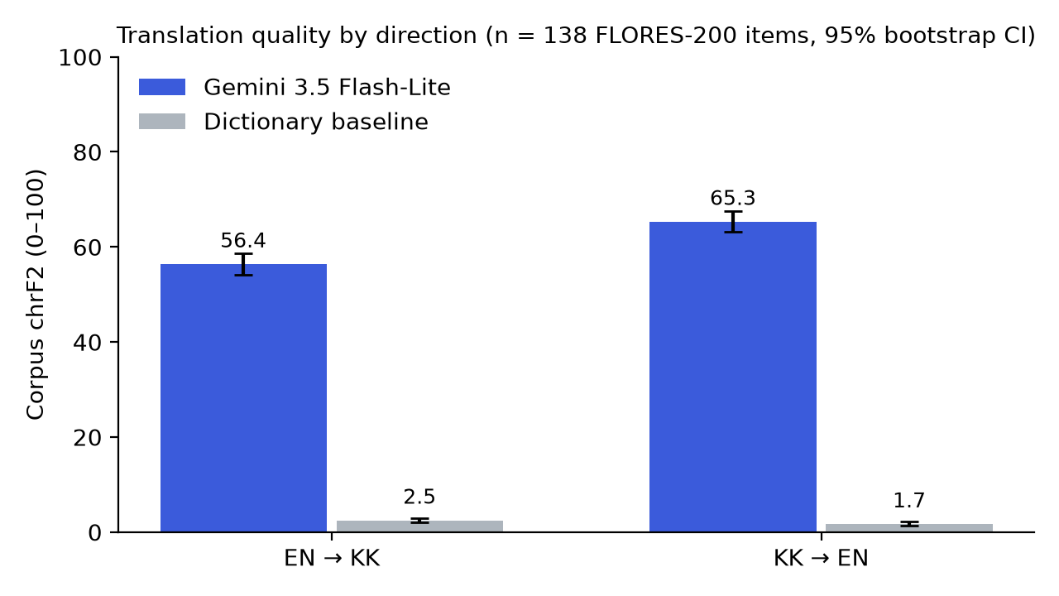
Figure 1. Corpus chrF2 by translation direction for Gemini 3.5 Flash-Lite and the dictionary baseline (n = 138 FLORES-200 items; error bars are 95% bootstrap CIs, 1000 resamples).
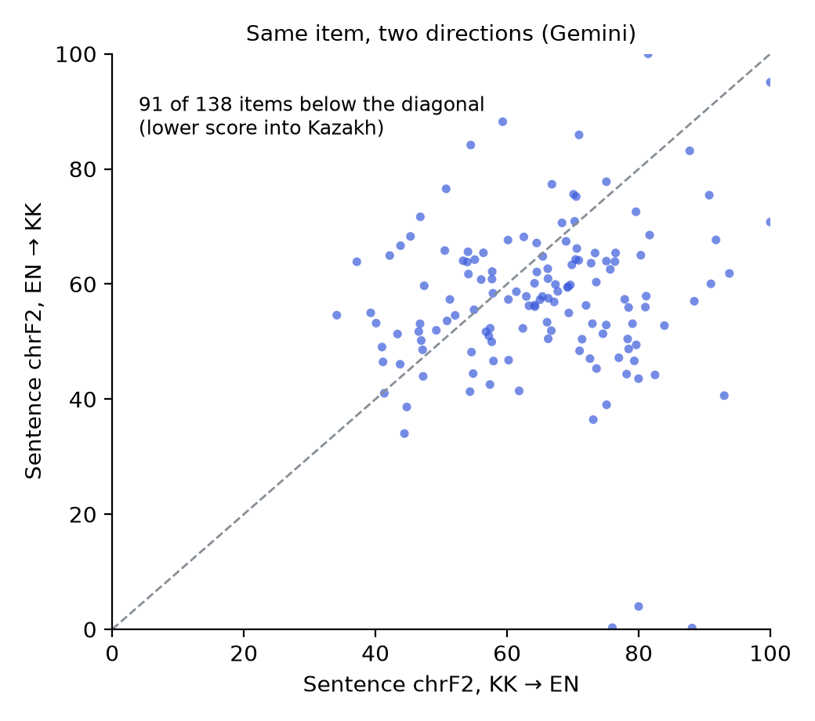
Figure 2. Per-item sentence chrF2 in both directions. Points under the dashed diagonal score lower when the model translates into Kazakh.

6. Additional Analysis: Why Does It Work (or Not)?

6.1 Error analysis (required)
We took the 30 EN→KK outputs with the lowest sentence chrF2 and assigned each to one primary error type using the Assignment 3 decision tree (Semantic → Lexical → Morphological → Syntactic), plus 'Reference mismatch' for acceptable translations that score low only because they word the sentence differently from the reference. We added a 'Script' type for Kazakh written in Latin letters, which the Assignment 3 taxonomy did not foresee. Counts are in Table 5 and examples in Appendix B. Across all 138 EN→KK outputs, 3 are mostly Latin-script (results/script_check.json); they are exactly the three lowest scores.
Table 5. Primary error type of the 30 lowest-scoring EN→KK outputs (provisional, see note)
Error type | Count | % of 30
Reference mismatch | 13 | 43%
Lexical | 9 | 30%
Semantic | 4 | 13%
Script | 3 | 10%
Morphological | 1 | 3%

Note: these labels are a provisional first pass. Before submission, two team members must re-label the 30 cases blind (annotation/HOW_TO_ANNOTATE.md) and report Cohen's κ; replace this table with their consensus labels.

6.2 Subgroup analysis: source domain
Table 6. Gemini chrF2 by FLORES-200 domain
Domain | n | chrF2 EN→KK | chrF2 KK→EN | Δ [95% CI]
wikibooks | 49 | 58.7 | 65.2 | -6.5 [-10.2, -2.5]
wikinews | 46 | 55.0 | 67.4 | -12.4 [-18.4, -6.4]
wikivoyage | 43 | 55.3 | 63.1 | -7.8 [-14.8, -1.7]

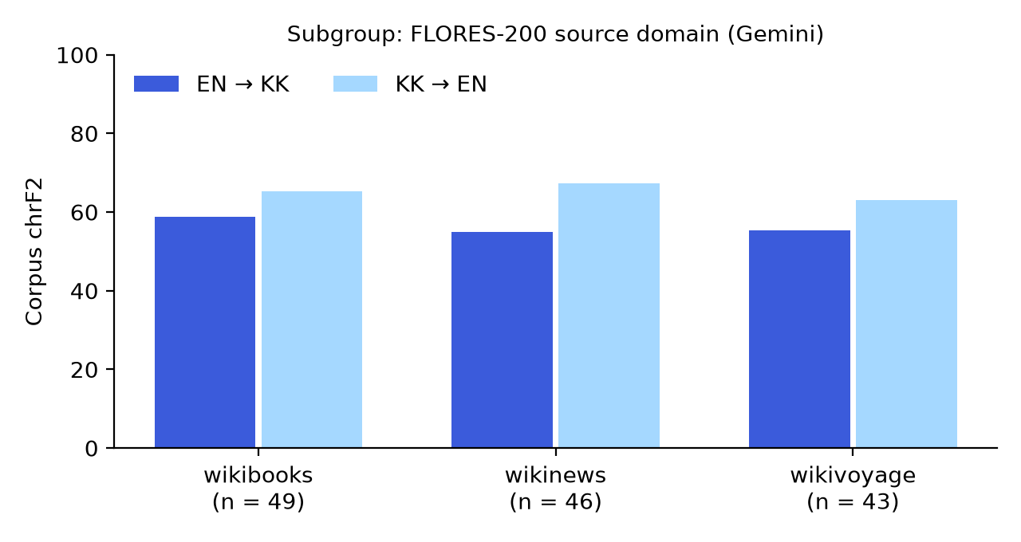
Figure 3. Gemini corpus chrF2 by FLORES-200 domain and direction.
The gap appears in every domain. It is widest for wikinews (Δ -12.4) and narrowest for wikibooks (Δ -6.5). Subgroups are small, so their CIs overlap and these differences are exploratory.

6.3 Sensitivity analysis: sentence length
Table 7. Gemini chrF2 by source-length tertile
English source length | n | chrF2 EN→KK | chrF2 KK→EN | Δ
short (≤19 words) | 48 | 60.5 | 64.9 | -4.4
medium (19–23 words) | 46 | 54.8 | 68.7 | -13.9
long (>23 words) | 44 | 55.1 | 62.9 | -7.8

Spearman correlation between English source length and sentence chrF2: EN→KK ρ = -0.15 (p = 0.087); KK→EN ρ = -0.09 (p = 0.316).

6.4 Robustness: excluding pilot-overlap items
Removing the 14 items that also appeared in the pilot leaves 124 items. chrF2 becomes 56.4 (EN→KK) and 65.3 (KK→EN); Δ = -8.9 [-12.5, -5.5], compared with -8.9 on all items. The direction of the result does not depend on the overlapping items.

6.5 Efficiency
Table 8. Gemini API cost and latency per translation request
Direction | Latency median [IQR] (s) | Latency p95 (s) | Output tokens, median | Characters per output token
EN→KK | 1.04 [0.96–1.19] | 1.48 | 56 | 2.43
KK→EN | 0.91 [0.83–1.04] | 1.31 | 26 | 4.92

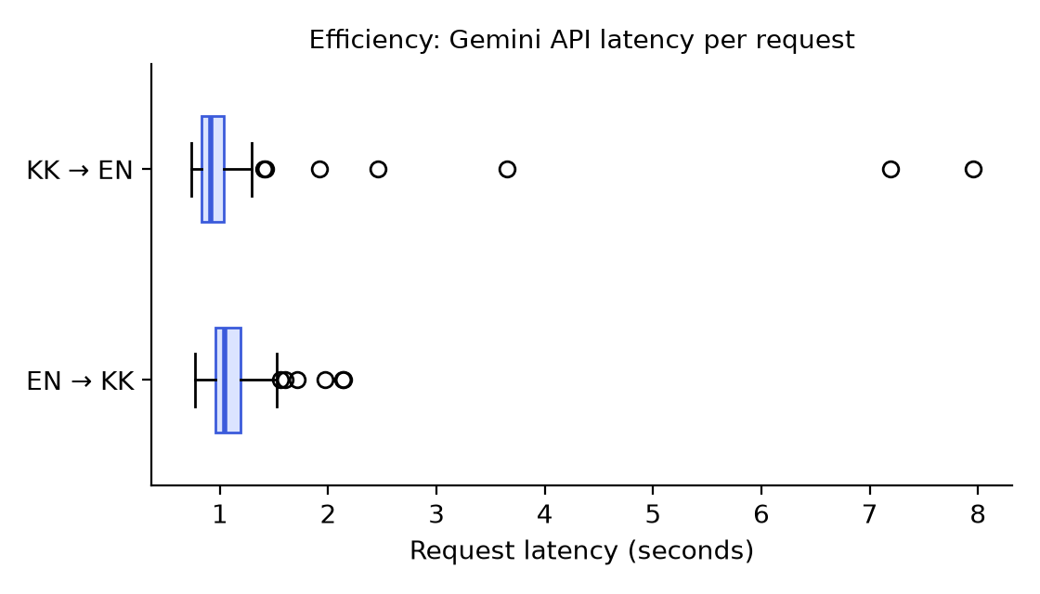
Figure 4. Distribution of Gemini request latency by direction (seconds).
Kazakh output packs fewer characters into each token (2.43 vs 4.92), so the same content costs more tokens in Kazakh. Latency differs between directions (Wilcoxon p = < 0.001), but it is measured over the public API and reflects server load as well as the model.

7. Answering the Research Question and Hypotheses
Table 9. Hypotheses and objectives
Hypothesis / objective | Evidence | Result in numbers | Verdict
H1-MT: chrF2 lower into Kazakh | Table 3, 4; Fig. 1, 2 | Δ = -8.9 [-12.2, -5.6]; Wilcoxon p(Holm) < 0.001, r = -0.47 | Partly supported: gap is significant; the NLLB comparison required by the frozen rule is pending
H1-QA: accuracy lower in Kazakh | Table 3 | Pending | Not yet tested
H2: morphological errors predominate | Table 5, App. B | Provisional: 1 of 30 worst outputs morphological; lexical most frequent. δmorph CI pending blind annotation | Not yet tested; provisional evidence leans towards not supported
O1 benchmark compiled | data/benchmark.jsonl, hash | 430 items, 830 prompts/model | Achieved
O2 performance measured | Table 3 | 276/830 prompts, 1 of 3 LLMs | Partly achieved
O3 annotation, κ | Appendix B | Pending | Pending
O4 error–gap association | Section 6 | Pending (needs O3) | Pending

Answer to the research question (current evidence). On the 138 FLORES-200 items collected so far, Gemini 3.5 Flash-Lite translates into Kazakh with a chrF2 of 56.4, against 65.3 when translating into English, a gap of 8.9 points whose 95% CI excludes zero and which holds across domains, sentence lengths and after removing pilot-overlap items. Gemini is far ahead of the simple dictionary baseline in both directions. We cannot yet say whether this gap is larger than the gap expected from the target language alone, because the NLLB-200 reference run is pending, and we cannot yet answer the QA half of the question or say which error type dominates. These conclusions apply to one model, one dataset source and one prompt.

8. Discussion

8.1 Interpretation
The Kazakh-direction gap is consistent across domains and length groups (Sections 6.2–6.4), and length explains little of it (ρ = -0.15). The provisional error analysis points to three sources. First, the worst outputs (3 of 138) are written in Latin-script Kazakh, which scores near zero against a Cyrillic reference: Kazakh is moving to a Latin alphabet, and the model sometimes picks that script. Second, lexical failures (non-words, Russian spellings, untranslated names, hallucinated glosses) are the most common real error. Third, almost half of the 30 lowest-scoring outputs are acceptable translations worded differently from the single reference, so part of the gap is a property of chrF2 on an agglutinative target, not a model deficit. Only one case was a pure morphological (suffix) error, which, if the blind annotation confirms it, would not support H2. This is why the frozen protocol compares the LLM gap with the NLLB gap rather than reading the raw Δ alone.

8.2 Comparison with previous studies
- NLLB Team (2022) [6]. NLLB-200 reports systematically higher scores for translation into English than out of English for low-resource languages. Our Gemini result has the same direction, which agrees with their finding that generating a low-resource target is the harder side. Whether Gemini's gap is larger or smaller than NLLB's own will be settled by the pending baseline run.
- Bandarkar et al. (2024), Belebele [1]. Belebele shows that LLM reading-comprehension accuracy falls for lower-resource languages relative to English. Our MT finding is consistent with that pattern; our QA run will test it directly on the same Belebele kaz_Cyrl items.
- Yeshpanov et al. (2024), KazParC [10]. KazParC reports that Kazakh-specific training data improves MT quality over general systems. Our general-purpose LLM shows a clear Kazakh-direction deficit, in line with their argument for Kazakh-specific resources; the KazParC portion of our benchmark (pending) will show whether the gap differs on originally-Kazakh text, where translationese is lower.
- Freitag et al. (2021) [3]. Their MQM study shows that automatic metrics miss many meaning-level errors and over-penalise valid paraphrase. Our 'reference mismatch' cases are an instance of the second effect, which supports adding human error annotation to chrF2.
Check: make sure these four studies are the ones in your Assignment 1 literature review, and cite exactly the findings stated there.

8.3 Unexpected or negative results
The run did not reach the planned 830 prompts per model because the free-tier quota stopped it, and no QA, probe or KazParC item has been answered yet. This is reported rather than hidden: the hypotheses that depend on those runs are marked as not yet tested.

8.4 Practical implications
For Kazakh users and developers, the results suggest using small LLMs such as Gemini Flash-Lite with care when generating Kazakh text, especially long or technical sentences, and reviewing case endings and named entities. Translating Kazakh into English is noticeably more reliable. Evaluators should not compare chrF2 across target languages without a reference system.

8.5 Threats to validity
- Internal: incomplete run (one model, MT only); provider-side model updates; the Gemini 2.5 → 3.5 switch.
- External: FLORES-200 is translated from English Wikipedia-style text, so results may not hold for native Kazakh text, other domains or larger models.
- Construct: chrF2 across different target languages is not commensurate; references are single translations; the error labels are provisional.
- Statistical conclusion / reproducibility: one deterministic run per prompt; possible pretraining contamination of FLORES-200; API latency depends on server load. Mitigations: bootstrap CIs, paired tests with Holm correction, pilot-overlap sensitivity check, logged request hashes and timestamps.

8.6 Limitations and future work
- Complete the 830-prompt runs for Gemini, Qwen 2.5 1.5B and Gemma 3, and the NLLB-200 baseline, then re-run the analysis.
- Blind double annotation of 100 Kazakh outputs per model with Cohen's κ ≥ 0.60, and the δmorph bootstrap test for H2.
- Add a second reference or a learned metric (e.g. COMET) to separate paraphrase from real errors.
- Report the probe set separately as the contamination-free check.

9. Reproducibility Statement and Repository Link
Repository: https://github.com/tw3tyy/kazllm. Commands that regenerate every table and figure in this report:
git clone https://github.com/tw3tyy/kazllm.git && cd kazllm
python3 -m venv .venv && source .venv/bin/activate
pip install -r requirements.txt
python assignment4/analyze_partial.py . assignment4/results
python assignment4/build_report.py assignment4
Table 10. Reproducibility checklist
Requirement (Part 7) | Status
README with purpose, structure, install, commands | Present
Environment file (requirements.txt) | Present
Scripts that regenerate tables and figures | assignment4/analyze_partial.py, build_report.py (add to repo)
Configuration and seeds | config.json (temperature 0, seed 42, 1,000 bootstrap resamples)
Raw result logs | outputs/gemini-3.5-flash-lite.jsonl; per-item scores in results/per_item_scores.csv
LICENSE file | Missing: add LICENSE
Tagged release "assignment-4" | Missing: git tag assignment-4 && git push --tags
Reproduction test record | Pending: Appendix C

10. References
[1] L. Bandarkar et al., "The Belebele benchmark: A parallel reading comprehension dataset in 122 language variants," ACL 2024, pp. 749–775. https://doi.org/10.18653/v1/2024.acl-long.44
[2] J. Cohen, "A coefficient of agreement for nominal scales," Educ. Psychol. Meas., 20(1), 37–46, 1960.
[3] M. Freitag et al., "Experts, errors, and context: A large-scale study of human evaluation for machine translation," TACL 9, 1460–1474, 2021.
[4] P. Koehn, "Statistical significance tests for machine translation evaluation," EMNLP 2004, pp. 388–395.
[5] Q. McNemar, "Note on the sampling error of the difference between correlated proportions or percentages," Psychometrika 12(2), 153–157, 1947.
[6] NLLB Team et al., "No language left behind: Scaling human-centered machine translation," arXiv:2207.04672, 2022.
[7] K. Papineni et al., "BLEU: A method for automatic evaluation of machine translation," ACL 2002, pp. 311–318.
[8] M. Popović, "chrF: character n-gram F-score for automatic MT evaluation," WMT 2015, pp. 392–395.
[9] M. Post, "A call for clarity in reporting BLEU scores," WMT 2018, pp. 186–191.
[10] R. Yeshpanov, A. Polonskaya, H. A. Varol, "KazParC: Kazakh parallel corpus for machine translation," LREC-COLING 2024, pp. 9633–9644.
[11] S. Holm, "A simple sequentially rejective multiple test procedure," Scand. J. Statist. 6(2), 65–70, 1979.
[12] F. Wilcoxon, "Individual comparisons by ranking methods," Biometrics Bulletin 1(6), 80–83, 1945.

Appendix A. Experiment Protocol Freeze Form
Date and time of upload to Moodle: fill in the real upload timestamp
Appendix A. Protocol freeze
Item | Our decision
Primary research question | As in Section 2
Hypotheses | H1 (Kazakh degradation in MT and QA), H2 (morphological error predominance)
Primary metric and justification | chrF2: character n-grams credit partially correct agglutinative word forms that BLEU scores as zero; recommended for morphologically rich targets [8]
Secondary metrics | BLEU; QA accuracy (Clopper-Pearson CI); error-category proportions; latency
Baseline 1 (simple) | Dictionary word substitution (MT); always-A (QA)
Baseline 2 (strong) | NLLB-200 distilled 600M
Proposed / evaluated conditions | Gemini 3.5 Flash-Lite, Qwen 2.5 1.5B, Gemma 3 (zero-shot, temperature 0)
Dataset and test-set identifier | data/benchmark.jsonl, 430 items / 830 prompts, SHA-256 9ca2a593b80e8c270a73745bd3963147dda619e073841a78d170608be6c4d910
Runs / seeds | 1 deterministic run per prompt, seed 42; 1,000 bootstrap resamples (seed 42)
Statistical tests | McNemar exact (QA), paired bootstrap CI and Wilcoxon (MT), Holm correction; Cohen's κ; Spearman ρ
Result that SUPPORTS | H1: QA p(Holm) < 0.05 with lower KK accuracy; MT Δ CI < 0 and ΔLLM − ΔNLLB < 0. H2: δmorph CI > 0
Result that does NOT support | H1: CI includes 0 or KK ≥ EN. H2: δmorph CI includes or is below 0
Planned additional analyses | Error analysis; subgroup by source/domain; pilot-overlap sensitivity; length sensitivity; latency

Appendix B. Error Analysis Table
Appendix B. 30 lowest-scoring EN→KK outputs, provisional labels
Item | chrF2 | Error type | Example / note
mt_flores200_00874 | 0.2 | Script | Whole output in Latin-script Kazakh (Qatti aua raiı…); reference is Cyrillic
mt_flores200_00088 | 0.3 | Script | Latin-script output; also invented name Saǵıshegish for Sagittarius
mt_flores200_00303 | 4.0 | Script | Mixed Latin/Cyrillic; 'Economy, Trade and Industry' left in English
mt_flores200_00446 | 34.0 | Reference mismatch | Correct meaning; nouns (пацифизм мен оқшаулану) instead of reference adjectives
mt_flores200_00860 | 36.4 | Lexical | Latin word 'Sol' for 'Осы'; non-existent word қағазбастылық
mt_flores200_00886 | 38.6 | Reference mismatch | Correct paraphrase (қатаңдай түсті)
mt_flores200_00346 | 39.0 | Morphological | Possessive suffix error: әрпи instead of әрпі
mt_flores200_00201 | 40.6 | Lexical | Super-G rendered as супер-гигант; name forms differ (Аустралиялық, Гурли)
mt_flores200_00480 | 41.0 | Reference mismatch | Output is faithful; reference itself is loose
mt_flores200_00865 | 41.3 | Semantic | Negation scope: 'not all Sámi' became 'all Sámi did not'
mt_flores200_00502 | 41.4 | Semantic | Added gloss not in source: (арнайы сөздік қорын)
mt_flores200_00839 | 42.5 | Reference mismatch | Acceptable restructuring of the sentence
mt_flores200_00666 | 43.6 | Lexical | Citation names left in Latin script; команда vs топ
mt_flores200_00725 | 44.0 | Reference mismatch | Correct paraphrase
mt_flores200_00202 | 44.2 | Lexical | Non-existent numeral беінші (should be бесінші)
mt_flores200_00210 | 44.3 | Reference mismatch | Correct, clause order changed
mt_flores200_00868 | 44.4 | Semantic | 'Subject to a travel advisory' rendered as 'travel is recommended'
mt_flores200_00900 | 45.3 | Reference mismatch | Correct paraphrase
mt_flores200_00952 | 46.1 | Semantic | 'Worked to death' rendered as 'tortured to death'
mt_flores200_00060 | 46.5 | Lexical | St. Peter's as Әуес Петр (wrong word for 'saint', should be Әулие)
mt_flores200_00972 | 46.6 | Reference mismatch | Correct paraphrase
mt_flores200_00776 | 46.6 | Lexical | Tamaki Drive left in Latin; misspelt Мишшн
mt_flores200_00867 | 46.8 | Lexical | Russian spelling Цыган instead of Kazakh Сыған
mt_flores200_00765 | 47.0 | Lexical | Hallucinated gloss (лосось/моос): лосось is Russian for 'salmon'
mt_flores200_00436 | 47.2 | Reference mismatch | Correct; reference splits into two sentences
mt_flores200_00856 | 48.2 | Reference mismatch | Correct overall; арқалық for 'backpack' is unusual
mt_flores200_00150 | 48.4 | Reference mismatch | Correct; translates the MSF name, reference keeps French
mt_flores200_00288 | 48.6 | Reference mismatch | Correct paraphrase
mt_flores200_00384 | 48.7 | Lexical | Garbled non-word сондай-жекөлікке ('also the water')
mt_flores200_00808 | 49.0 | Reference mismatch | Correct paraphrase

Full source, reference and output text for each row: assignment4/error_annotation.csv.

Appendix C. Reproduction Test Record
Appendix C. Reproduction test
Item | Record
Person who reproduced the results | Team member name
Date, machine, OS | fill in
Commit / release tag | assignment-4
Commands executed | Section 9 commands
Main table reproduced? | Yes / Partly / No
Differences and explanation | fill in
README problems fixed | fill in

