**微算機系統**

**小組專案報告**

實驗一

組別： 30

班級、姓名與學號：

資工二 林品緯111590012

資工二 陳偉瑜111590020

1. 實驗內容：

控制配線，指撥開關控制，七段顯示器控制

1. 實驗過程及結果：

預期實驗結果的真值表

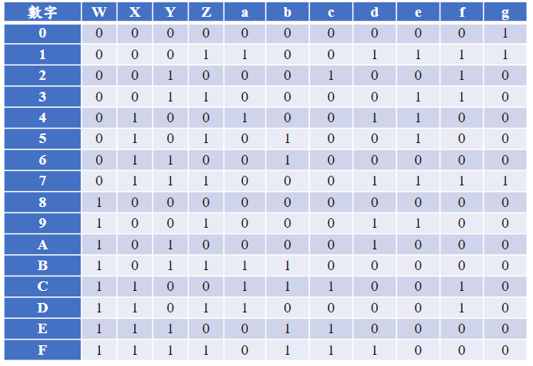

根據上方真值表使用卡諾圖來化簡並設計出電路

化簡a~g輸出布林代數如下:

電路設計:

下圖為以Quartus之RTL所viewer產生的電路圖

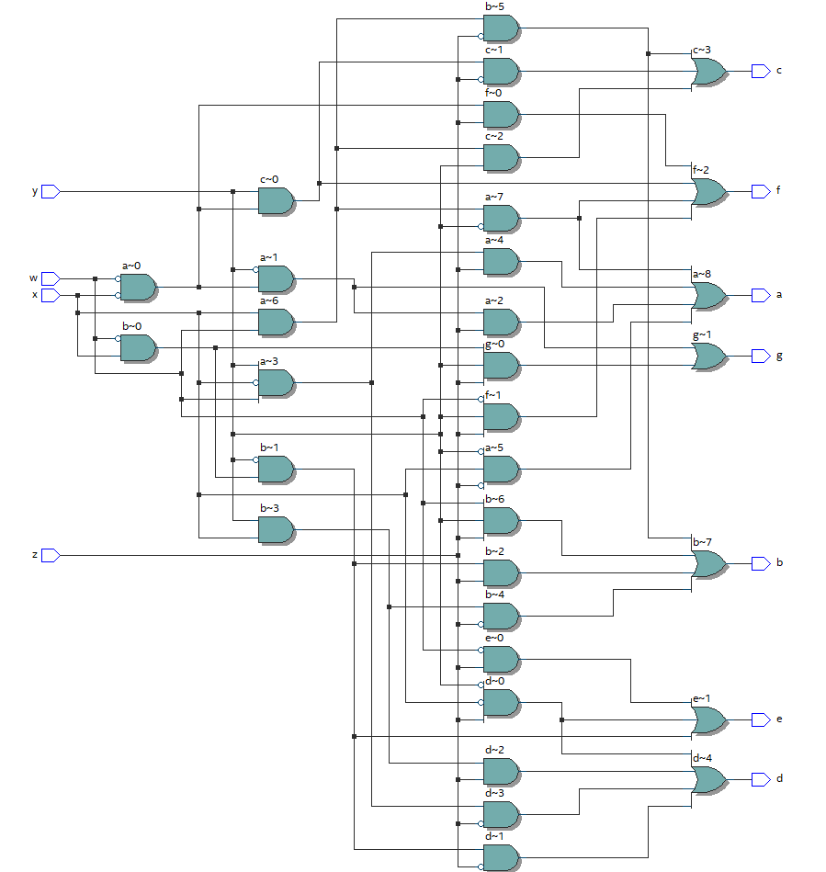

實驗的結果:

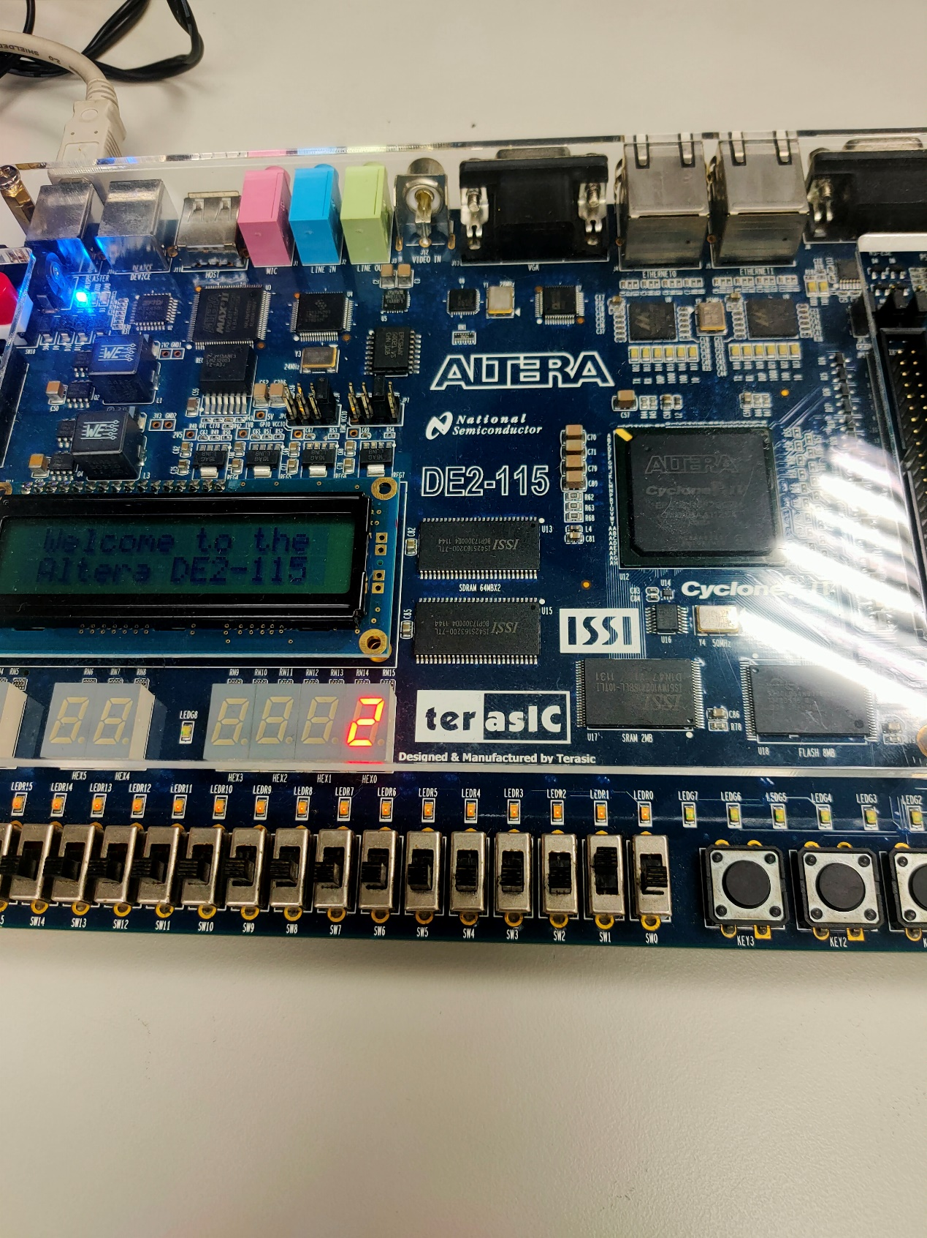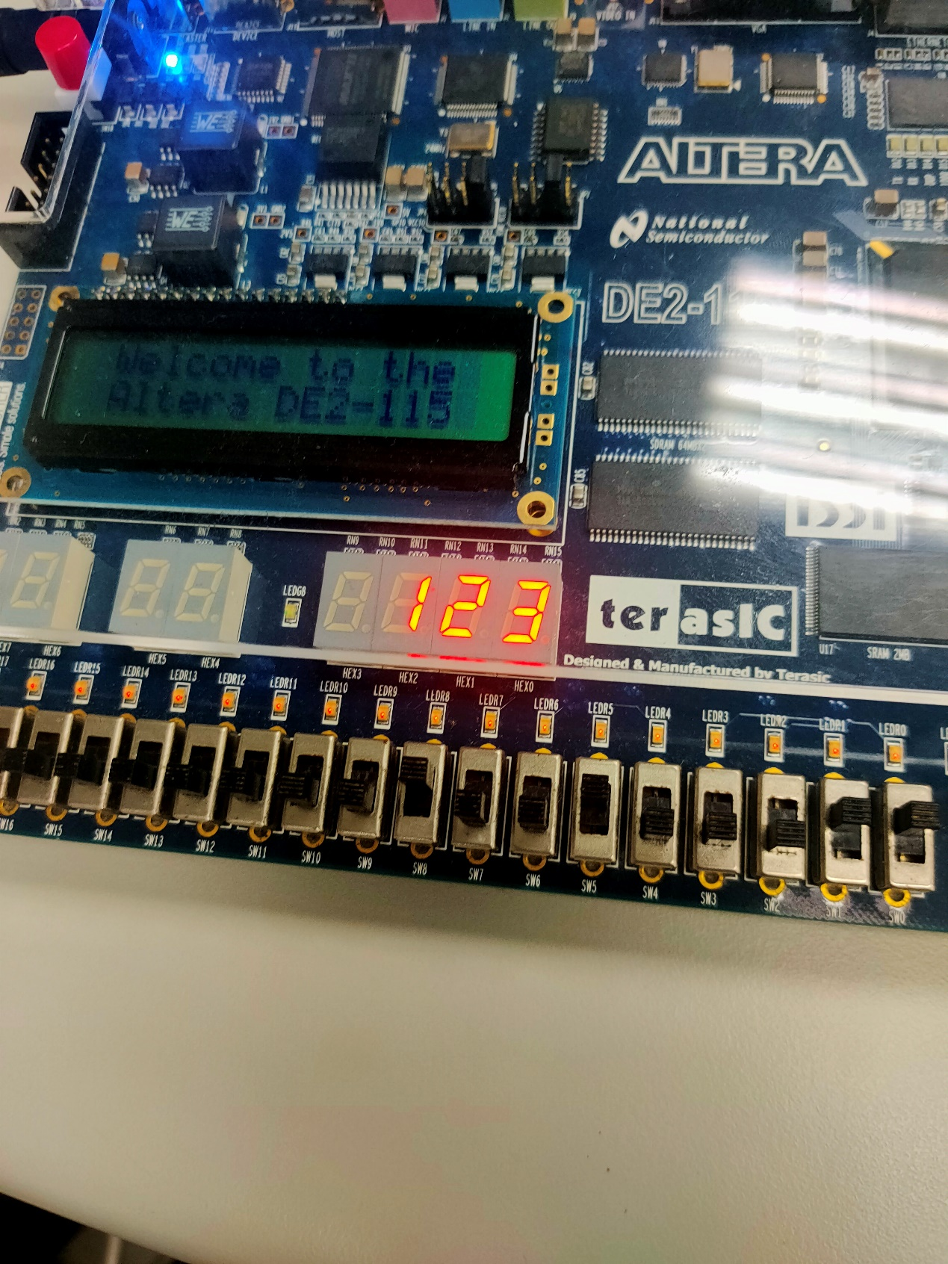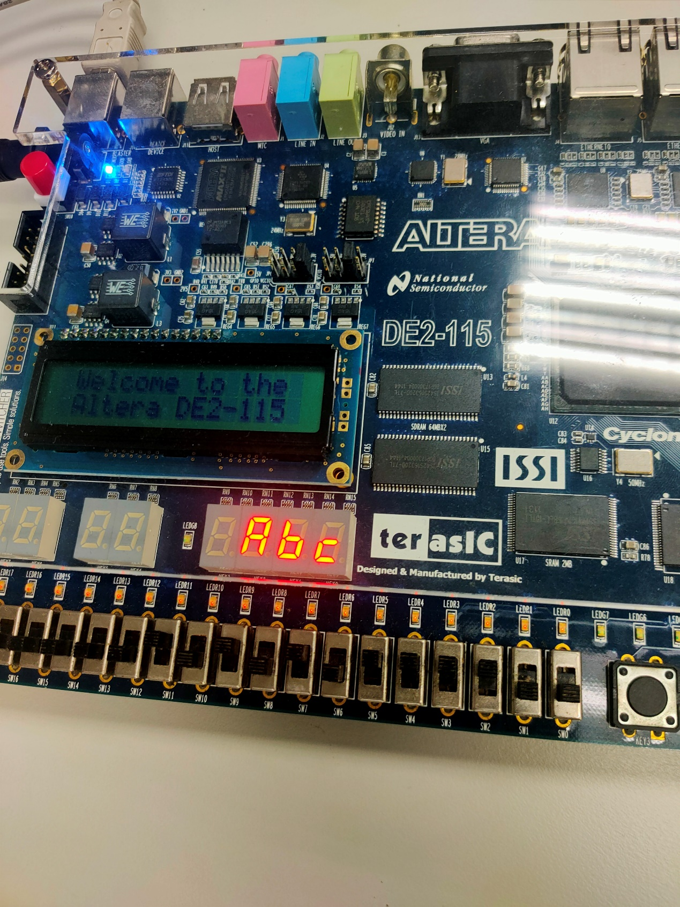

1. 程式碼

|  |
| --- |
| 基本題 |
| library IEEE;  use IEEE.std_logic_1164.all;  entity seven_light is  port(w,x,y,z : in bit;  a,b,c,d,e,f,g:out bit);  end seven_light;  architecture logic_fun of seven_light is  begin  a<=(not w and not x and not y and z) or (w and not x and y and z) or (x and not y and not z) or (w and x and not y);  b<=(not w and x and not y and z) or (x and y and not z) or (w and x and not z) or (w and y and z);  c<=(not w and not x and y and not z) or (w and x and not z)or (w and x and y);  d<=(not x and not y and z) or (not w and x and not y and not z)or (x and y and z)or (w and not x and y and not z);  e<=(not w and z) or(not w and x and not y)or(not x and not y and z);  f<=(not w and not x and z)or(not w and not x and y) or (not w and y and z)or(w and x and not y);  g<=(not w and not x and not y)or (not w and x and y and z);  end logic_fun; |

|  |
| --- |
| 加分題 |
| library IEEE;  use IEEE.std_logic_1164.all;  entity seven_light is  port(w,x,y,z : in std_logic_vector(0 to 2);  a,b,c,d,e,f,g:out std_logic_vector(0 to 2));  end seven_light;  architecture logic_fun of seven_light is  begin  a(0)<=(not w(0) and not x(0) and not y(0) and z(0)) or (w(0) and not x(0) and y(0) and z(0)) or (x(0) and not y(0) and not z(0)) or (w(0) and x(0) and not y(0));  b(0)<=(not w(0) and x(0) and not y(0) and z(0)) or (x(0) and y(0) and not z(0)) or (w(0) and x(0) and not z(0)) or (w(0) and y(0) and z(0));  c(0)<=(not w(0) and not x(0) and y(0) and not z(0)) or (w(0) and x(0) and not z(0))or (w(0) and x(0) and y(0));  d(0)<=(not x(0) and not y(0) and z(0)) or (not w(0) and x(0) and not y(0) and not z(0))or (x(0) and y(0) and z(0))or (w(0) and not x(0) and y(0) and not z(0));  e(0)<=(not w(0) and z(0)) or(not w(0) and x(0) and not y(0))or(not x(0) and not y(0) and z(0));  f(0)<=(not w(0) and not x(0) and z(0))or(not w(0) and not x(0) and y(0)) or (not w(0) and y(0) and z(0))or(w(0) and x(0) and not y(0));  g(0)<=(not w(0) and not x(0) and not y(0))or (not w(0) and x(0) and y(0) and z(0));  a(1)<=(not w(1) and not x(1) and not y(1) and z(1)) or (w(1) and not x(1) and y(1) and z(1)) or (x(1) and not y(1) and not z(1)) or (w(1) and x(1) and not y(1));  b(1)<=(not w(1) and x(1) and not y(1) and z(1)) or (x(1) and y(1) and not z(1)) or (w(1) and x(1) and not z(1)) or (w(1) and y(1) and z(1));  c(1)<=(not w(1) and not x(1) and y(1) and not z(1)) or (w(1) and x(1) and not z(1))or (w(1) and x(1) and y(1));  d(1)<=(not x(1) and not y(1) and z(1)) or (not w(1) and x(1) and not y(1) and not z(1))or (x(1) and y(1) and z(1))or (w(1) and not x(1) and y(1) and not z(1));  e(1)<=(not w(1) and z(1)) or(not w(1) and x(1) and not y(1))or(not x(1) and not y(1) and z(1));  f(1)<=(not w(1) and not x(1) and z(1))or(not w(1) and not x(1) and y(1)) or (not w(1) and y(1) and z(1))or(w(1) and x(1) and not y(1));  g(1)<=(not w(1) and not x(1) and not y(1))or (not w(1) and x(1) and y(1) and z(1));  a(2)<=(not w(2) and not x(2) and not y(2) and z(2)) or (w(2) and not x(2) and y(2) and z(2)) or (x(2) and not y(2) and not z(2)) or (w(2) and x(2) and not y(2));  b(2)<=(not w(2) and x(2) and not y(2) and z(2)) or (x(2) and y(2) and not z(2)) or (w(2) and x(2) and not z(2)) or (w(2) and y(2) and z(2));  c(2)<=(not w(2) and not x(2) and y(2) and not z(2)) or (w(2) and x(2) and not z(2))or (w(2) and x(2) and y(2));  d(2)<=(not x(2) and not y(2) and z(2)) or (not w(2) and x(2) and not y(2) and not z(2))or (x(2) and y(2) and z(2))or (w(2) and not x(2) and y(2) and not z(2));  e(2)<=(not w(2) and z(2)) or(not w(2) and x(2) and not y(2))or(not x(2) and not y(2) and z(2));  f(2)<=(not w(2) and not x(2) and z(2))or(not w(2) and not x(2) and y(2)) or (not w(2) and y(2) and z(2))or(w(2) and x(2) and not y(2));  g(2)<=(not w(2) and not x(2) and not y(2))or (not w(2) and x(2) and y(2) and z(2));  end logic_fun; |