The Orange Pi 3 LTS is based on the Allwinner H6 SoC (system on a chip), it is equipped with 2GB of LPDDR3 Random Access Memory and 8GB of EMMC storage. Cost is around £30 and has performance similar, if not better, to the Raspberry Pi 3.

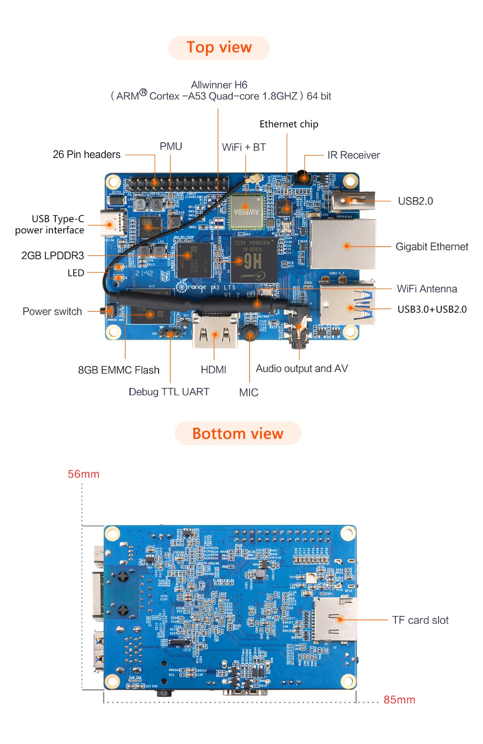

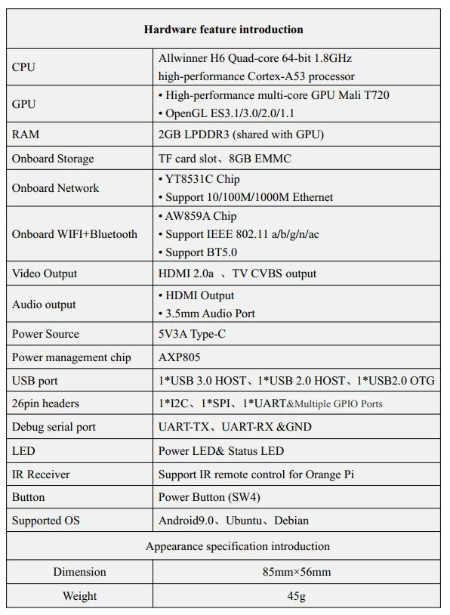**Hardware Specification**

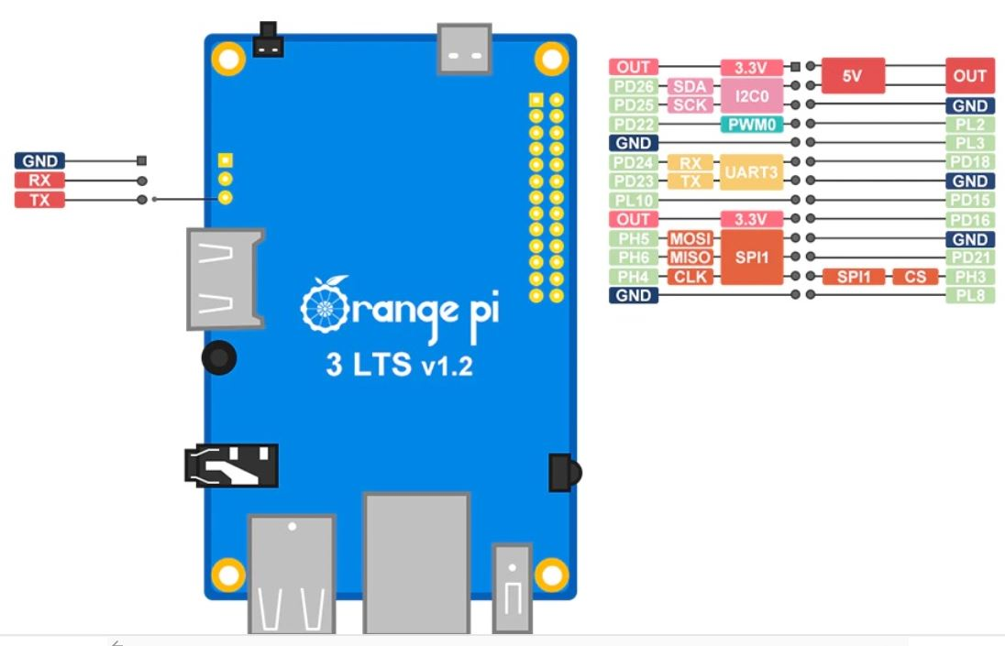**Pinout**

MaxAir can be installed on the Armbian Orange Pi 3 release.

The main difference between this board (and a number of other Orange Pi boards) is that the main Input/Output interface is presented on a 26pin header, which is rotated 180°as far as pin numbering is concerned when compared to the Raspberry Pi’s 40pin I/O connector. Pins 1-26 of the Orange Pi board I/O connector correspond to pins 1-26 of the Raspberry Pi boards 40pin I/O connector. Hence this board has less available GPIO pins, when compared to the Raspberry Pi. Not taking in to account the UART3, I2C3 and SPI1 interface pins, the available GPIO pins are 7, 11, 12, 13, 15, 16, 18, 22 and 26 ie a total of nine. The board is supported by Adafruit-Blinka and Adafruit-PlatformDetect and hence is compatible with MaxAir’s use of GPIO pins.

UART operation is supported on the same physical pins as the Raspberry Pi, the UART used is identified as ‘ttyS3’, when used for MaxAir’s Serial Gateway.

## Enabling Hardware Interfaces

The ‘armbian-config’ utility is used to enable interfaces such as UARTs or SPI or w1-gpio. To execute type armbian-config from a command line prompt:

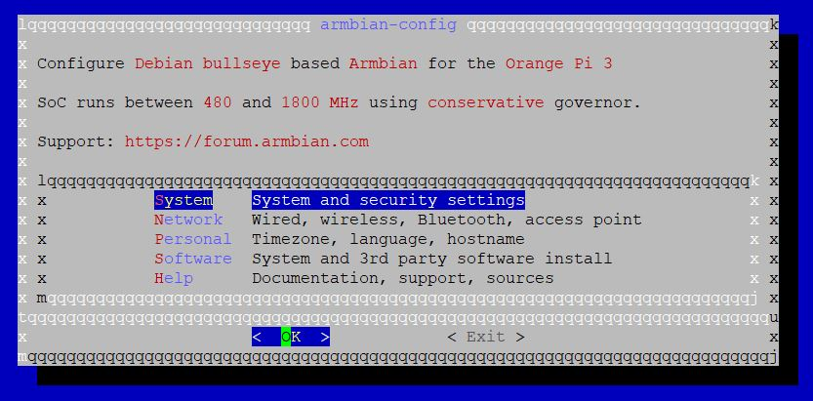

Select ‘System’ and then press the ‘Return’ key to action.

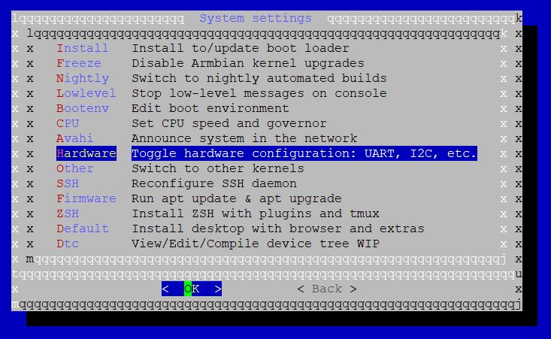

Select ‘Hardware’ and then press the ‘Return’ key to action.

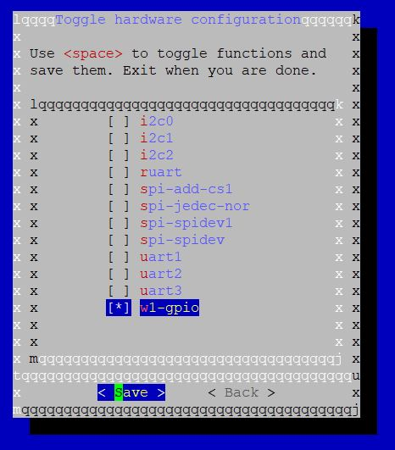

To enable any interface, move to the relevant line and press the ‘Space Bar’ to enable the option, when finished press the ‘Return’ key. To action the hardware configuration changes, reboot the Orange Pi.

### Additional Step to Select the Pin used for w1-gpio

By default, GPIO Pin PC9 is defined for use by the w1-gpio interface but in the case of this board, this GPIO pin is not available. If for example we wished to use the same physical used by Raspberry Pi boards (GPIO4, physical pin 7), we will need to use pin PD22 which is found at physical pin 7. In order to do this, edit the file /boot/ armbianEnv.txt and add the following line ‘**param_w1_pin=PD22**’ eg.

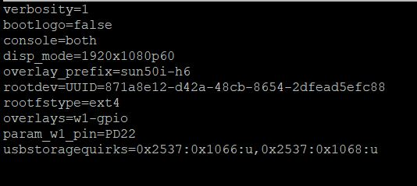

## GPIO Pin Usage with Adafruit Blinka

MaxAir uses Adafruit Blinka and Adafruit PlatformDetect Python libraries to both identify the SBC in use and manipulate the GPIO pin states. For Orange Pi boards running the Armbian OS, the board is identified using the file ‘/etc/armbian-release’. As there is currently no Armbian release specifically for the Orange Pi 3 LTS, Orange Pi’s own Linux Debian OS is used. This OS is almost identical to Armbian and in fact uses a tailored of the Ambian tool to compile the release.

One difference is that the file ‘armbian-release’ is replaced by ‘orangepi-release’, hence Adafruit PlatformDetect will not be able to identify the board. A work-around is to create the file ‘/etc/armbian-release’, containing the correct information.

As the Orange Pi 3 LTS and the Orange Pi 3 share the same processor and have identical GPIO pin mappings, a version of ‘/etc/armbian-release’ can be created which will identify the board as an Orange Pi 3.

Use nano to create the file ‘/etc/armbian-release’ and add the following text :-

**# PLEASE DO NOT EDIT THIS FILE**

**BOARD=orangepi3**

**BOARD_NAME="Orange Pi 3"**

**BOARDFAMILY=sun50iw6**

**BUILD_REPOSITORY_URL=https://github.com/orangepi-xunlong/orangepi-build**

**BUILD_REPOSITORY_COMMIT=990c7da-dirty**

**DISTRIBUTION_CODENAME=buster**

**VERSION=2.1.6**

**LINUXFAMILY=sunxi64**

**BRANCH=current**

**ARCH=arm64**

**IMAGE_TYPE=user-built**

**BOARD_TYPE=conf**

**INITRD_ARCH=arm64**

**KERNEL_IMAGE_TYPE=Image**

Finally save the file.