MaxAir relies on a number of services in order function and is built on a LAMP (**L**inux, **A**pache, **M**ySQL, **P**HP) platform. The setup process is performed by executing **php /var/www/setup.php**, which will check that the platform requirements are met before installing the software and configuring the initial database.

## Services

### pihome_jobs_schedule

This service manages the running of a periodic tasks, to check it is functioning from the command prompt execute:

**systemctl status pihome_jobs_schedule.service**

The expected response should be similar to the following:

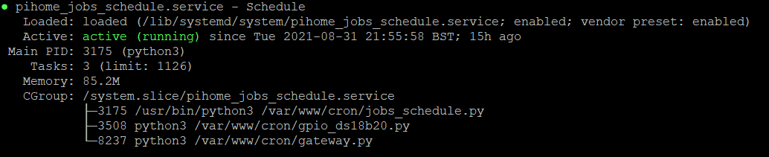

The screen above shows that the service is running and controlling the scheduling of the ‘jobs’ job_schedule.py, gpio_ds18b20.py and gateway.py.

If the service is not running, the MaxAir setup process has failed in some way. A complete re-install is recommended.

## Jobs

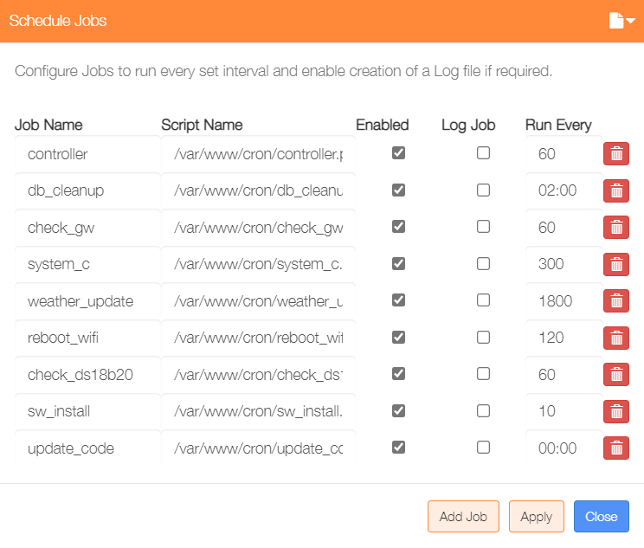The scheduler service executes a number of jobs on a periodic basis, these jobs will be installed as part of the setup process.

The installed jobs can be views from the ‘Jobs’ menu item in the ‘Settings/System Configuration menu.

### jobs_schedule

This job manages the running of the other periodic tasks, to check it is functioning from the command prompt execute:

**ps -ax | grep jobs_schedule.py | grep -v grep**

The expected response should be similar to the following:

**3175 ? Ss 0:47 /usr/bin/python3 /var/www/cron/jobs_schedule.py**

If nothing is returned, then this indicates that the scheduler function is not operating

### gateway

This job manages collection of sensor data and the setting of relay states, to check it is functioning from the command prompt execute:

**ps -ax | grep gateway.py | grep -v grep**

The expected response should be similar to the following:

**8237 ? S 0:09 python3 /var/www/cron/gateway.py**

If nothing is returned indicating that the gateway is not operational, try starting it manually using the following command, which may give some clues as to why it has not started:

**python3 /var/www/cron/gateway.py**

### ds18b20

This job manages collection of 1-wire sensor data, to check it is functioning from the command prompt execute:

**ps -ax | grep gpio_ds18b20.py | grep -v grep**

The expected response should be similar to the following:

**3508 ? S 0:00 python3 /var/www/cron/gpio_ds18b20.py**

If nothing is returned indicating that the 1-wire sensors are not operational, try starting it manually using the following command, which may give some clues as to why it has not started:

**python3 /var/www/cron/ gpio_ds18b20.py**

### controller

This job is the main engine for MaxAir, it controls the zones by reading and writing to message queues shared with the gateway job and by reacting to ‘state’ information provided by operating mode and schedule settings.

The jobs scheduler is configured to execute controller once every 60 seconds, it can be executed manually using the following command:

**php /var/www/cron/ controller.php**

The response shown below is for a two zone system, operating in ‘Boiler Mode’, with an active schedule.

Additional debugging information is available by executing with an additional argument eg:

**php /var/www/cron/ controller.php 1**

The actual argument is unimportant, any single character will work.

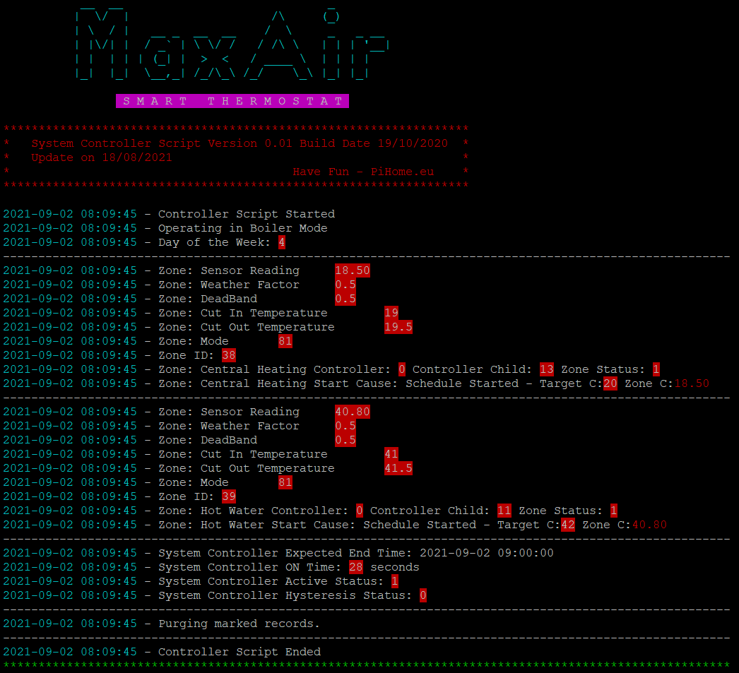

The Controller output display shows:

* The Mode of Operation – Boiler or HVAC
* A block of information for each enabled zone
* A block of information for the System Controller
* If any database records have been marked for deletion and deleted this will be indicated. This usually happens because ‘old’ zone/system controller log records have been deleted.

From the example above the current status of the Central Heating Zone can be determined:

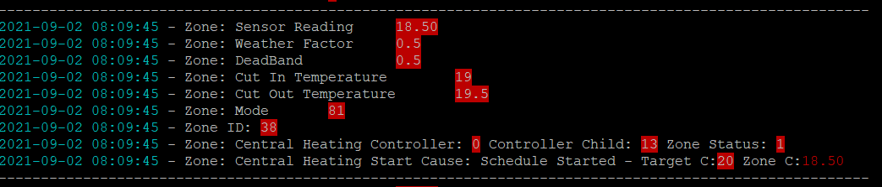

1. The temperature sensor reading for the zone is 18.5°C
2. The weather factor is 0.5°C
3. The zone deadband is 0.5°C
4. The zone will cut in at 19.0°C
5. The zone will cut out at 19.5°C
6. The current zone state is 81, from the table below this indicates that the zone is being controller by a schedule and is currently running
7. The Zone ID is 38
8. The controller relay for this zone has a node_id of 0 (the GPIO interface) and a node_child_id of 13 (pin 13 of the GPIO interface), it current state is 1 (activated).
9. The zone start cause is it that it has an active scheduled, which has been started, the target temperature is 20.0°C and the current temperature is 18.5°C

After the information for each zone, the System Control status is show:

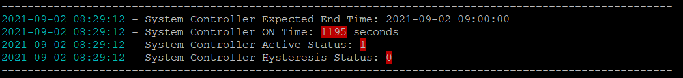

1. The end time is set by the current schedule.
2. The time that the System Controller’s relay has been activated is shown.
3. The current System Controller state is shown (1 = ON).
4. The Hysteresis state is shown (1 = System Controller is waiting for hysteresis timer to expire).

## Zone Mode

|  |  |
| --- | --- |
| **Zone Main Mode** | |
| 0 | Idle |
| 10 | Fault |
| 20 | Frost |
| 30 | Over temperature |
| 40 | Holiday |
| 50 | Night Climate |
| 60 | Boost |
| 70 | Override |
| 80 | Scheduled |
| 90 | Away |
| 100 | Hysteresis |
| 110 | Add-On |
| 120 | HVAC |
| 130 | Under Temperature |
| 140 | Manual |
|  | |
| **Zone Sub Mode** | |
| 0 | Stopped (within deadband) |
| 1 | Heat Running |
| 2 | Frost |
| 3 | Stopped (coop start waiting for the System Controller) |
| 4 | Manual Operation - ON |
| 5 | Manual Operation – OFF |
| 6 | HVAC – Cooling Running |
| 7 | HVAC Fan Only |

## Checking GPIO Relay Operation

Relays are controlled by the gateway job, which reserves any configured relays and hence they are not available for any other use.

A test program is available, which temporarily stops the gateway job to enable setting relays either ON or OFF. For example if a relay is connected to pin 13 of the GPIO header and is switched ON by applying a HIGH level trigger, then to switch the relay ON, from the command line execute:

**python3 /var/www/cron/ gpio_relay_test.py 13 1**

to switch the relay OFF, from the command line execute:

**python3 /var/www/cron/ gpio_relay_test.py 13 0**

If the relay is switched ON by applying a LOW level trigger, then to switch the relay ON, from the command line execute:

**python3 /var/www/cron/ gpio_relay_test.py 13 0**

to switch the relay OFF, from the command line execute:

**python3 /var/www/cron/ gpio_relay_test.py 13 1**