# MaxAir Technical – Deleting Zones, Relays, Sensors and Nodes

The MaxAir system has been built using a relation database to maintain both the system configuration and status. Therefor the relationships between elements must be taken in to account when attempting deletion.

Some of the important relationships are shown in the diagram below:

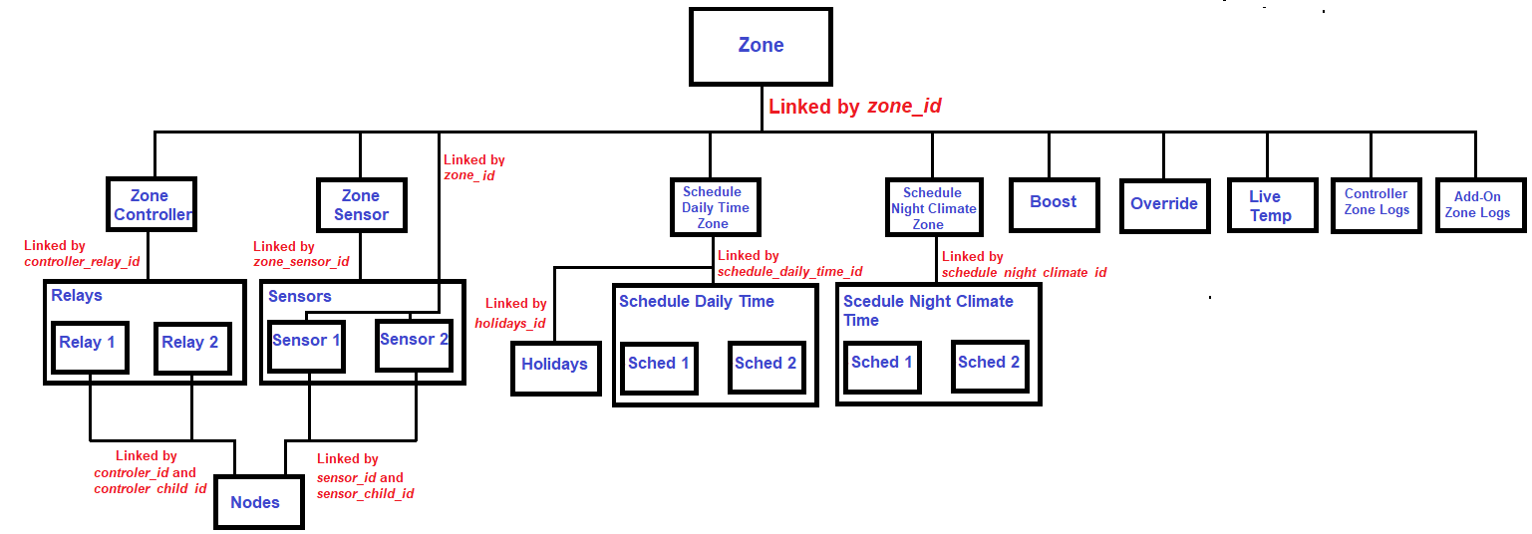

## Deleting Zones

When a Zone is selected for deletion, the linked entries in a number of other database tables will need to be deleted before the zone can be removed, those tables are:

1. Zone Controller
2. Zone Sensor
3. Schedule Daily Time Zone
4. Schedule Night Climate Zone
5. Boost
6. Override
7. Live Temperature
8. Controller Zone Logs
9. Add-On Zone Logs

Before a Zone can be removed from the system, the linked entries in the nine tables listed above must be deleted. The delete zone process manages this process, it deletes the related entries in the nine tables listed before deleting the entry in the Zone table itself.

The data in Relays, Scheduled Daily Time, Scheduled Night Climate Time and Holidays tables will not be modified. The reason for this is that these items i.e., the relays, sensors and schedules will remain available to be used again if required.

The Sensors table is a special case, this is because MaxAir is capable of displaying Sensor data without have to be attached to a Zone. Sensors can be either to linked to a valid zone_id or to zone_id 0. When a Zone is deleted, any sensor associated with the Zone will have their zone_id set to 0, which will unlink the sensor from the Zone to be deleted.

## Deleting Relays

Relays can only be deleted if they have not been allocated to a Zone and thus have an entry in the Zone Controllers table. In order to be selectable for deletion they must be unlinked from the Zone to which they have been allocated, either by deleting the Zone or by changing the relay allocation for the associated Zone to a different relay.

## Deleting Sensors

Sensors can only be deleted if they have not been allocated to a Zone and thus have an entry in the Zone Sensors table. In order to be selectable for deletion they must be unlinked from the Zone to which they have been allocated, either by deleting the Zone or by changing the sensor allocation for the associated Zone to a different sensor.

## Deleting Nodes

Nodes can only be deleted if they have not been allocated to either a relay or sensor and thus have an entry in either the relays or sensors tables. In order to be selectable for deletion they must be unlinked from the relay or sensor to which they have been allocated, either by deleting the Zone to which they are allocated or by changing the relay or sensor allocation for the associated Zone to a different relay or sensor.