# MaxAir – Displaying Temperature Sensors Graphs

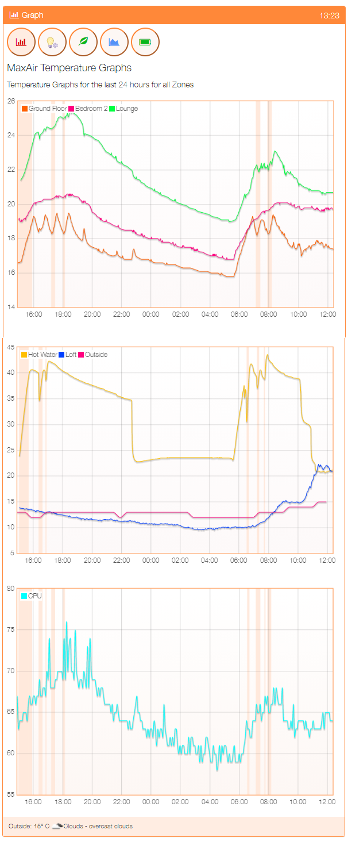

MaxAir is capable of displaying temperature values in one of three graph panes. For example, pane-1 is displaying the central heating zone temperature (Ground Floor) and two room temperatures. Pane-2 is displaying the Hot Water zone temperature, plus the loft room temperature and the outside temperature as measured by the systems ‘weather’ function. Pane-3 is displaying the systems CPU temperature, this will, by default, always be displayed in pane-3 and cannot be disabled.

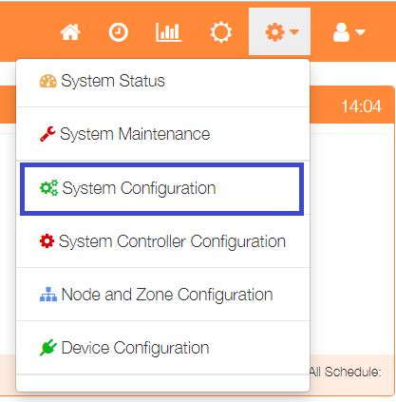In order to determine which temperature sensors will be graphed and on which graph the data will be displayed, select ‘System Configuration’ from the settings dropdown list and click the ‘Select Graph’ Button.

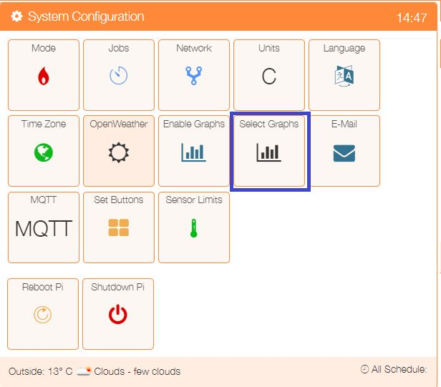

Set the ‘Graph Number’ to display in either pane-1 or pane-2 or pane-3, setting to 0 will mean that a sensor will not be displayed and any graph.

