# MaxAir – Raspberry Pi Connecting a DS18B20 Temperature Sensors

The One Wire temperature sensor DS18B20 is very popular, easily available, relatively cheap and provides satisfactory precision of temperature readings. The DS18B20 has operating temperature range from -55°C to +125°, an accuracy to ±0.5°C. DS18B20 and can easily interface with Raspberry Pi.

This sensor has three pins: VDD, GND and DATA. The voltage range is between 3.0 to 5.5, this can be easily interfaced with Raspberry Pi, communication is achieved using the ‘1-wire’ protocol. Each DS18B20 sensor has a unique serial code, therefore multiple devices can be interfaced on same line.

## Connecting to the Raspberry Pi

The DS18B20 is available in two forms, either as bare device or in a weatherproof encapsulation, both have three connections:

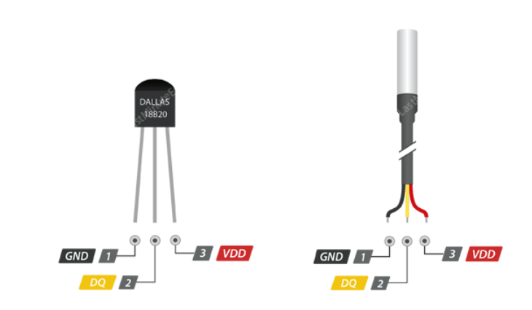

GND - Ground Pin

DQ - 1-Wire Data Bus should be connected to a digital pin on microcontroller

VDD - pin supplies power for the sensor which can be between 3.3 to 5V

The 1-wire interface has been implemented in the Raspberry Pi’s Raspbian operating system using the GPIO4 pin, although by default it is disabled. To enable, connect to the Raspberry Pi and from a command line prompt and execute ‘sudo raspi-config’

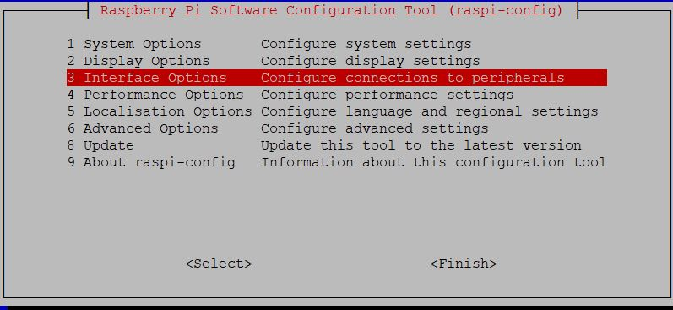

Select option 3

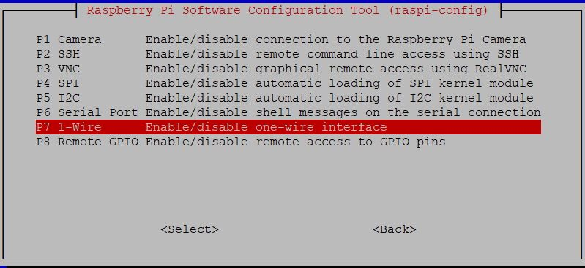

Select P7

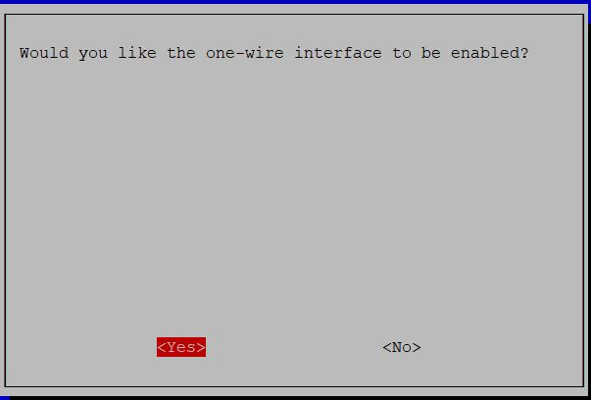

Confirm Yes

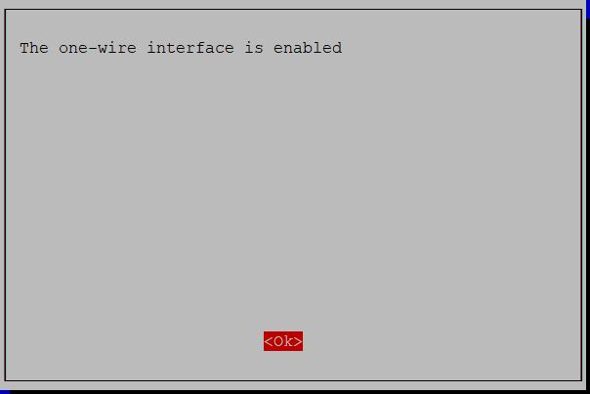

OK to exit

Exit raspi-config and reboot the Raspberry Pi as requested.

Connect the DS18B20 to the Raspberry Pi as follows:

|  |  |
| --- | --- |
| GND | To pin 9 |
| DQ | To Pin 7 |
| VDD | To Pin 1 |

Additionally, connect a 4K7 resistor between pins 1 and 7.

To check that the Raspberry Pi is able to read the sensor, form the Raspberry Pi command line enter ‘sudo cat /sys/bus/w1/devices/w1_bus_master1/w1_master_slaves’, any connected devices should be shown:



In the case of this example, the DS18B20’s id is 28-f3a49d1964ff

To check that it is possible to read the temperature from the device, at the command line enter ‘/sys/bus/w1/devices/28-f3a49d1964ff/w1_slave’, the response should be:



The first line shows if the reading was successful (“YES”) and in the second line after “t=” is the temperature reading in milli degrees Celsius (24125).

## Connecting the Sensor to MaxAir

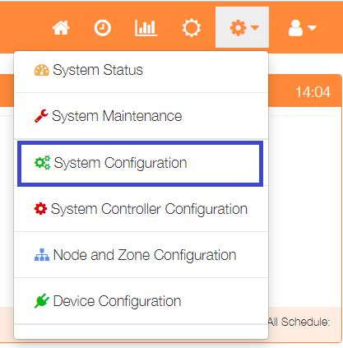

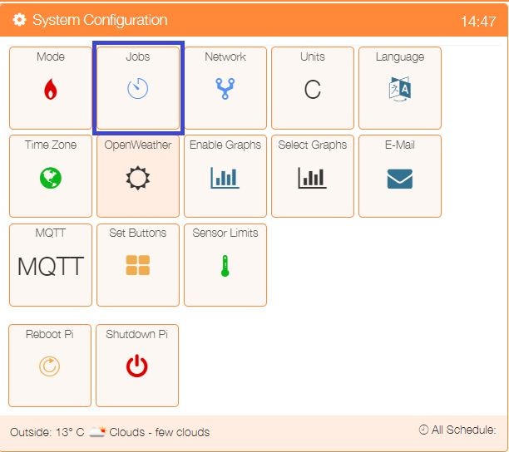By default MaxAir does not check for 1-wire sensors, to enable select ‘System Configuration’ from the Settings dropdown list and click the ‘Jobs’ button.

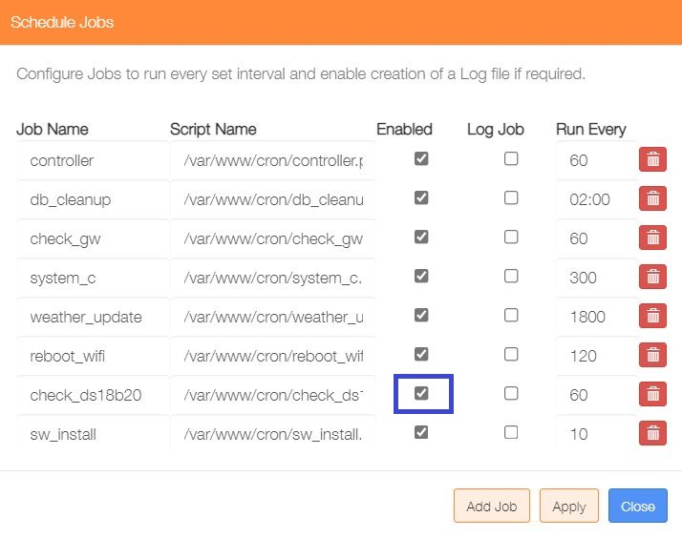

Click in the ‘Enabled’ tickbox for the ‘check_ds18b20’ job and then click on the Apply button.

This will cause the MaxAir system to create new nodes for each DS18B20 device connected and capture temperature readings once every 60 seconds.

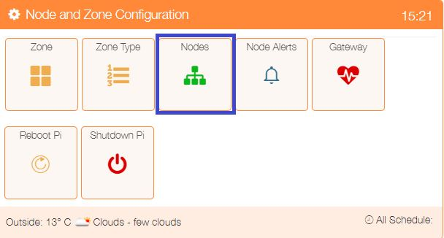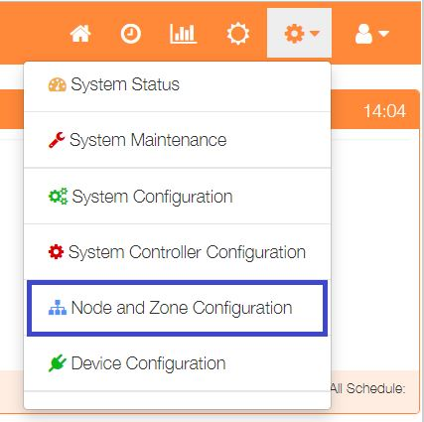To check that the new nodes have been detected, select ‘Node and Zone Configuration’ from the Settings dropdown list and click the ‘Nodes’ button.

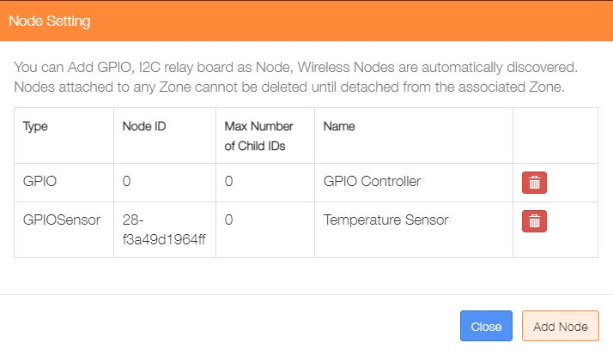

The new sensor is shown with its system generated Node ID based on the sensor’s ID code.

## Capturing the Sensor Temperature Readings

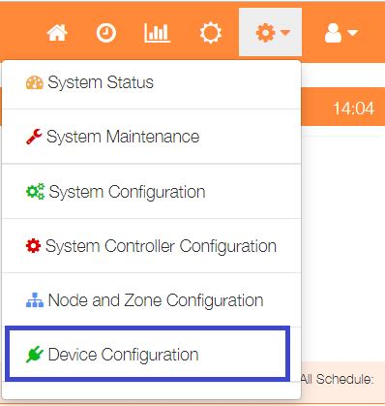

Select ‘Device Configuration’ from the Settings dropdown list and click the ‘Sensors’ button.

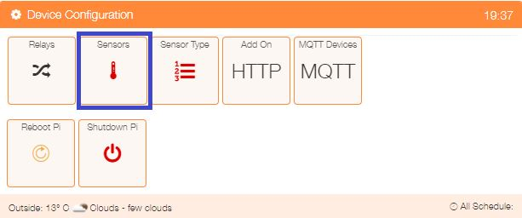

Click on the ‘Add Sensor’ button to configure the first sensor

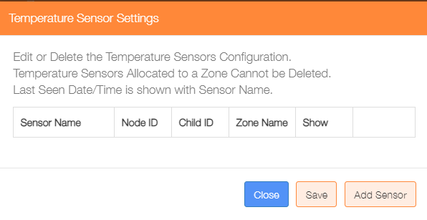

An alternative method to go directly to the Add Sensor dialogue, is from the Home screen click on the ‘One Touch’ button then select the ‘Add Sensor’ menu item.

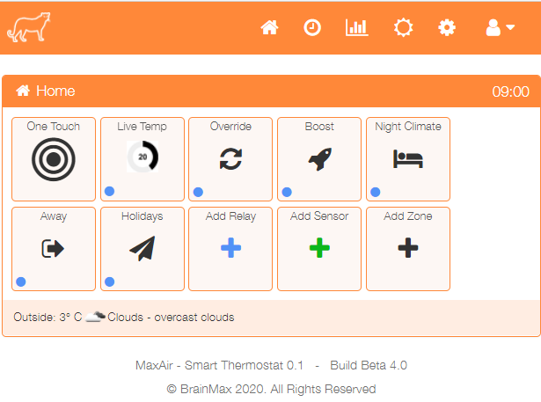

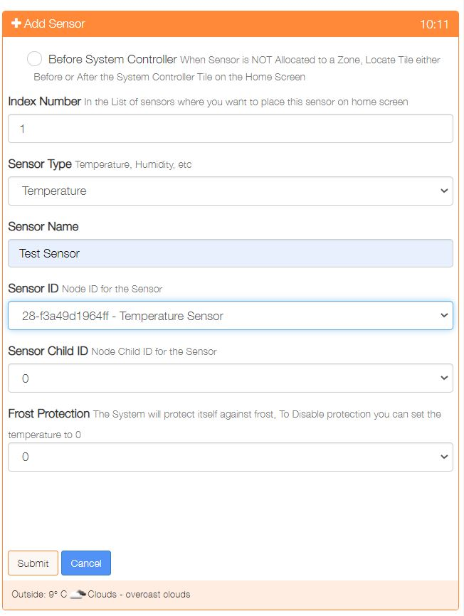

Show either before or after the system controller on the Home sscreen

Used to order where on the Home screen the sensor is displayed

Provide a name for this sensor device

Select the Sensor ID from the dropdown list of available Nodes

Choose the Child ID from the dropdown list, for nodes with only 1 sensor, this will be 0

Select the frost protection temperature or 0 to disable this feature

If frost protection is enabled, then select the zone to be activated on protection

Click on ‘Submit’ to add the device.

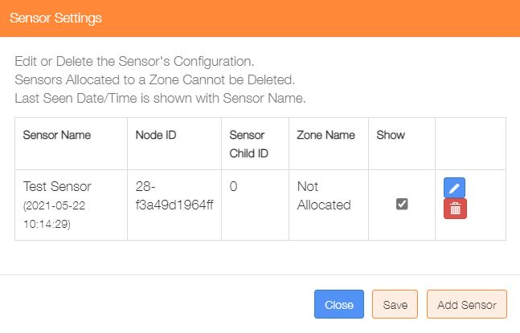Re-selecting the Sensors menu item from the Settings/Node and Zone Configuration menu will display the updated list of currently configured temperature sensors.

This dialogue can be used to Add/Delete/Edit the sensor configurations.

The ‘Show’ tickbox can be used suppress displaying a sensor on the Home screen.

All the sensors are shown as ‘Not Allocated’ until the later zone configuration step has been completed.