# MaxAir – Humidity Sensors

MaxAir is capable of displaying humidity sensor values on the home screen, like the temperature sensors, it is possible arrange the order in which they are displayed.

A MySensors ‘sketch’ is available for the Si7021 temperature/humidity sensor device. It will be automatically detected in the same manner as other MySensor nodes, node ID 0 will be allocated to for temperature and Node ID 1 for humidity.

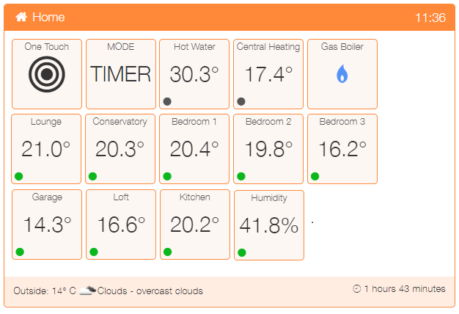

This example shows a total of ten temperature sensors. The Hot Water and Central Heating sensors are attached to their respective zones. The other eight temperature sensors and a single humidity sensor are not attached to any zones and are simply displaying the temperature or humidity where they are located.

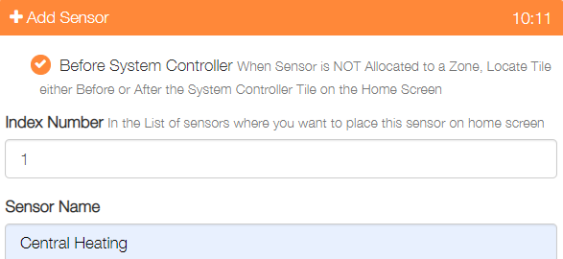

The positioning is set when the sensor device is added by using the ‘Index Number’ value. The ‘Before System Controller’ tickbox determines if the sensor is displayed to the left or right of the ‘System Controller’ tile.

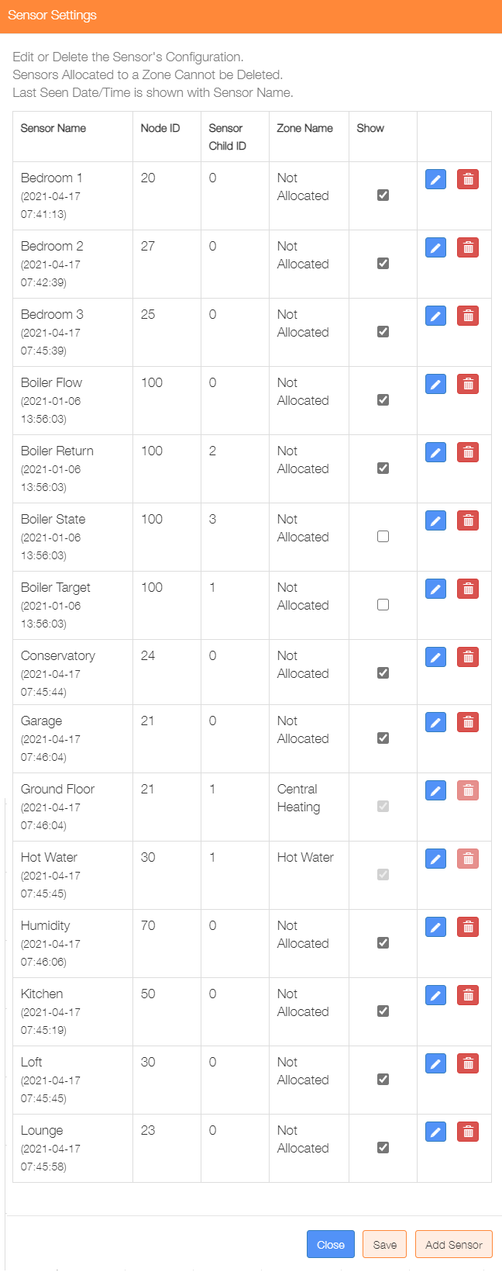

The position can be changed using the Sensors menu item in the Settings/Node and Zone Configuration menu. This display show whether or not sensors are allocated to zones, there is also a tickbox which can be used to disable the display of the sensor on the home screen.

A graph option is available for displaying all humidity sensors over a 24-hour period.

