# MaxAir – Live Temperature Control

MaxAir typically uses values stored in the ‘Schedules’ to control temperatures. In order to mimic the functionality of a room thermostat device, MaxAir uses a ‘Live Temperature’ feature to control the Central Heating or HVAC zone temperature.

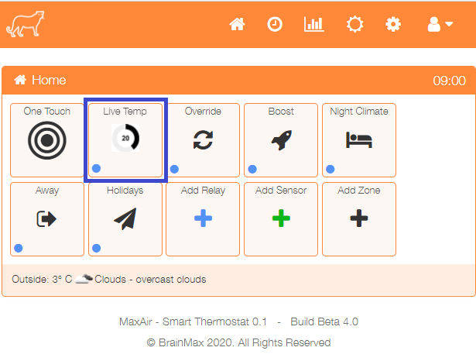

To access ‘Live temperature’ click on the ‘One Touch’ button to open the one touch menu.

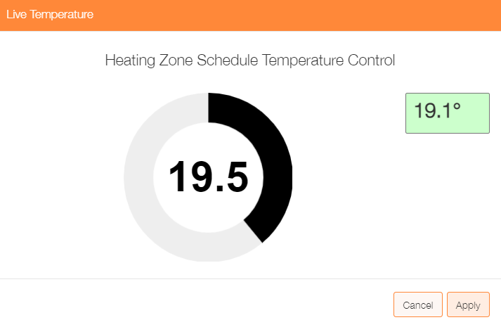The ‘Live Temperature’ control displays a temperature knob which can be dragged to alter the system’s control temperature.

A display window shows the temperature being measured by the zone temperature sensor.

Once the required temperature has been set, click on the ‘Apply’ button.

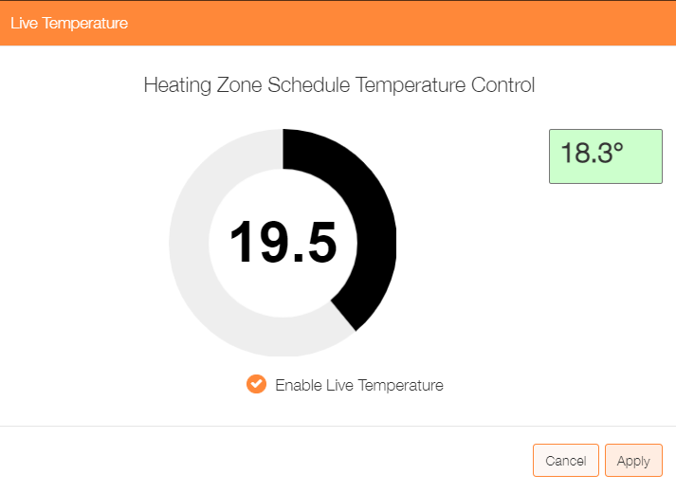

Once applied the override temperature can be cancelled by re‑opening the control, clicking to clear the ‘Enabled Live Temperature’ checkbox and then clicking on the ‘Apply’ button.

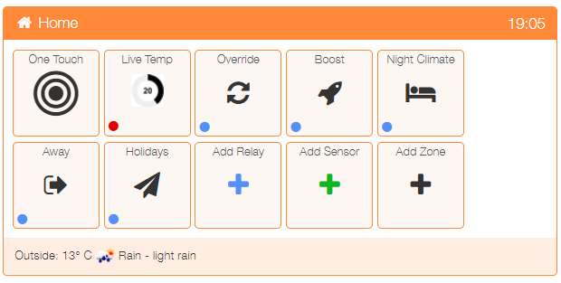The status of the ‘Live Temp’ control can be determined by the status indicator located in the lower left-hand corner of the control

Blue – disabled

Red - enabled

The control works differently dependant on the system operation mode.

#### BOILER and HVAC Systems - Working in ‘Timer’ Mode

1. The control will display the Central Heating or HVAC zone target temperature being used by the current schedule.
2. Applied changes will remain active until the schedule terminates or until disable.

#### BOILER and HVAC Systems - Working in ‘Boost’ or ‘Override’ Mode

1. The control will display the Central Heating or HVAC zone boost or override temperature.
2. Applied changes will remain active until the boost or override terminates or until disabled.

#### BOILER Systems - Working in ‘CE’ or ‘BOTH’ Modes or HVAC Systems – Working in ‘AUTO’, ‘HEAT’, ‘COOL’ or ‘FAN’ Modes

1. The control will display the Central Heating or HVAC zone default temperature.
2. Applied changes will remain active until the mode is changed or until disabled.