# MaxAir System/Operating Modes

The MaxAir system has two ***system modes***:

1. HVAC – MaxAir is configured to control heating, ventilation and air conditioning installations, where three switching relays are required.
2. Boiler - MaxAir is configured to control heating systems where a boiler and zone relays are used, typically switching relays will be required for the boiler and each zone.

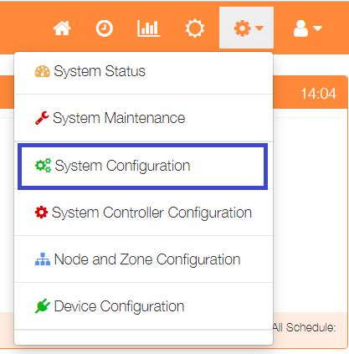

To set the system mode, select ‘System Configuration’ from the Settings dropdown list, then click the ‘Mode’ button.

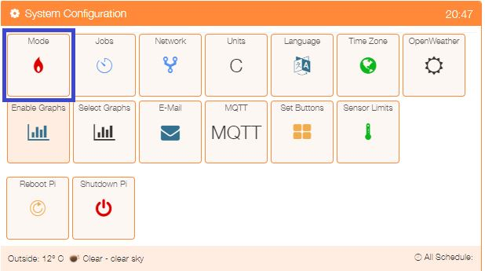

The Mode button on the Home page can operate either as a cyclic button, scrolling through each mode of operation or can be used to open a pop-up menu, which allows selection of the desired operating mode.

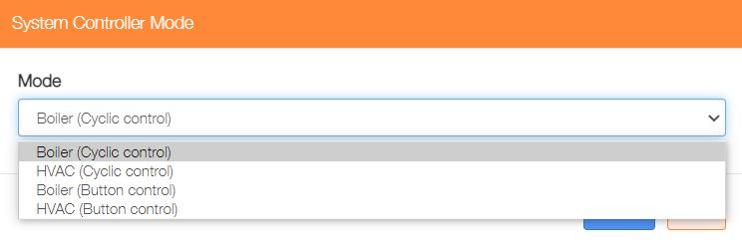Click on the ‘Mode’ button then select the system mode from the dropdown list and click on the ‘Save’ button to update the system.

## Operating Modes – Boiler Configuration, Cyclic Operation

When configured to operate in ‘Boiler Mode’, the MaxAir system has five operating modes:

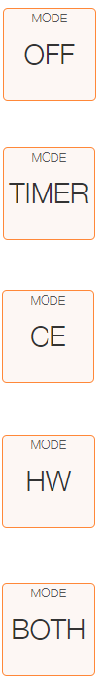

The system is disable.

The system is operating in Timer Mode, with on/off timings and temperatures controlled by schedules.

The Central Heating zone operates continually with the temperature controlled by the Zone Default Temperature.

The Hot Water zone operates continually with the temperature controlled by the Zone Default Temperature.

Both the Central Heating and Hot Water zones operates continually with their temperatures controlled by the particular Zone Default Temperature.

## Operating Modes – HVAC Configuration, Cyclic Operation

When configured to operate in ‘HVAC Mode’, the MaxAir system has eight operating modes:

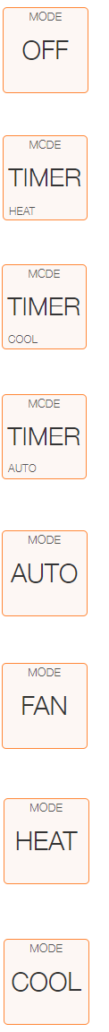

The system is disable.

The system is operating in Heating Timer Mode, with on/off timings and temperatures controlled by schedules, but with no cooling capability.

The system is operating in Cooling Timer Mode, with on/off timings and temperatures controlled by schedules, but with no heating capability.

The system is operating in Auto Timer Mode, with on/off timings controlled by schedules and with the temperature controlled by the Zone Default Temperature, switching between heating and cooling as required.

The HVAC zone operates continually with the temperature controlled by the Zone Default Temperature, switching between heating and cooling as required.

The fan operates continually.

The HVAC zone operates continually with the temperature controlled by the Zone Default Temperature but with no cooling capability.

The HVAC zone operates continually with the temperature controlled by the Zone Default Temperature but with no heating capability.

## Operating Modes – Button Operation

The operating modes are the same as above. The Home screen button is of a slightly different format:

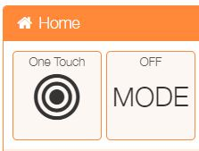The Mode button shows the currently selected operating mode in the legend at the top of the button, clicking on the button will open a popup menu showing the available options.

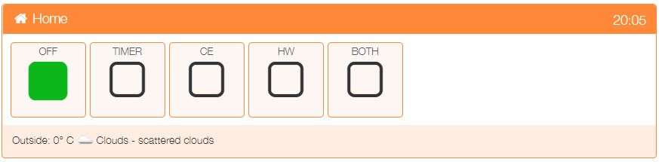Shown is the system operating in ‘boiler’ mode and switched ‘OFF’. To change click on the desired mode, the system will return to the Home page with the new setting shown on the Mode button legend.

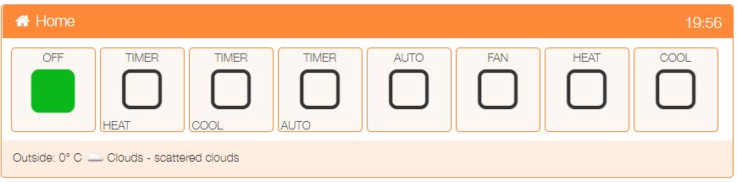When the system is configured to work in HVAC mode, the selection screen reflects the available HVAC operating modes.