MaxAir supports nodes based on their type, these types define the basic capability of the sensor:

* A node which is associated with a temperature sensor
* A node which is associated with a humidity sensor
* A node which is associated with a binary switch

A number of Sensor Types are pre-defined:

* Temperature – a sensor returning an analogue temperature value
* Humidity – a sensor returning an analogue temperature value
* Switch – a sensor returning a binary ON/OFF value

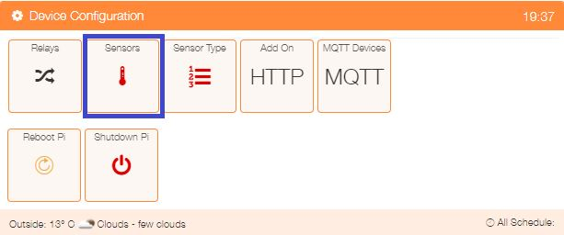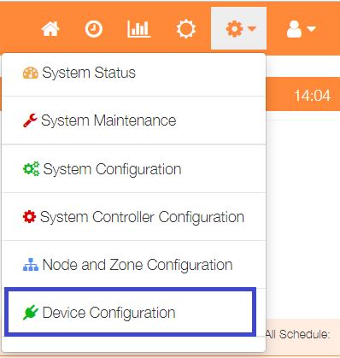The currently defined Sensor Types can be viewed by selecting ‘Device Configuration’ from the Settings dropdown list, then click the ‘Sensors’ button.

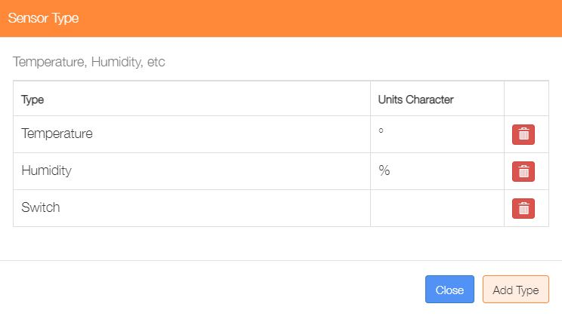

Sensor Types can be deleted by clicking on the ‘trash’ icon or addition ones added by clicking on the ‘Add Type’ button.

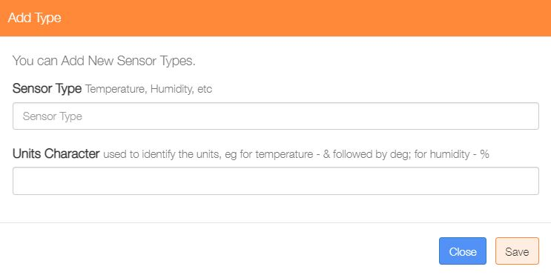Enter a name for the new Sensor the and if required enter the unit’s character, that may be a ‘simple’ character such as % for Humidity or a ‘special’ string of character such as &deg; which HTM interprets as the temperature ° symbol. Finally click on the ‘Save’ button.