MaxAir can be configured to send email notifications once an Email account has been configured to send outgoing mail.

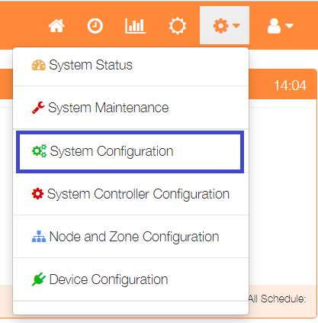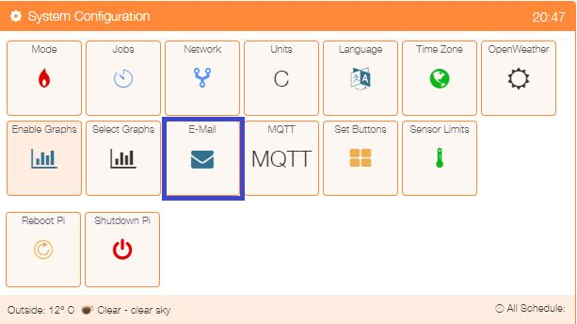In order to configure an email account, select ‘System Configuration’ from the Settings dropdown list, then click the ‘E-Mail’ button.

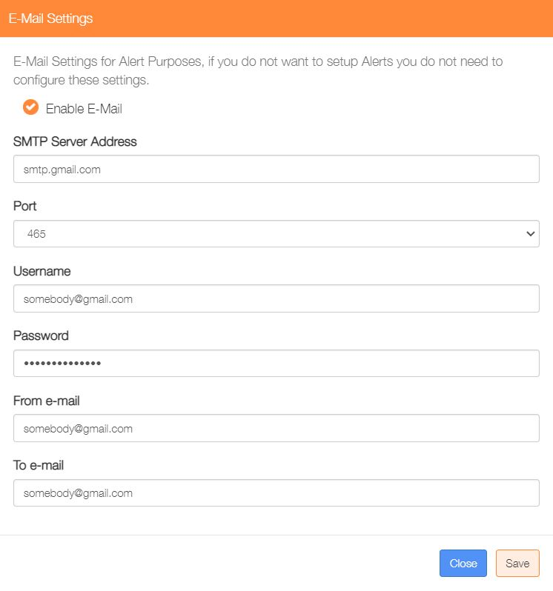

Enable the Email service

Enter your outgoing SMTP server

Select port 25 for unencrypted email or 465 for encrypted.

Enter the username for your SMTP server.

Enter the password for your SMTP server.

Enter the FROM, Email address (usually your own email address).

Enter the TO, Email address (usually your own email address).

Click on ‘Save’