MaxAir communicates with its input sensors and output controllers through the use of two message queues. The sensor and controller devices can be connected to the system either directly using physical input/output ports on the device hosting MaxAir (eg a Raspberry Pi SBC), or remotely using some method to transfer the message queue information between the device hosting MaxAir and the remote input/output device.

The transfer of message queue information is through the use of a Python script file (gateway.py), which runs continually on the device hosting MaxAir.

## Using a ‘MySensors’ Gateway

Probably the most common configuration for MaxAir is to interface the temperature sensor inputs and relay outputs using the MySensors framework.

**MySensors Temperature Sensors**

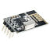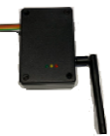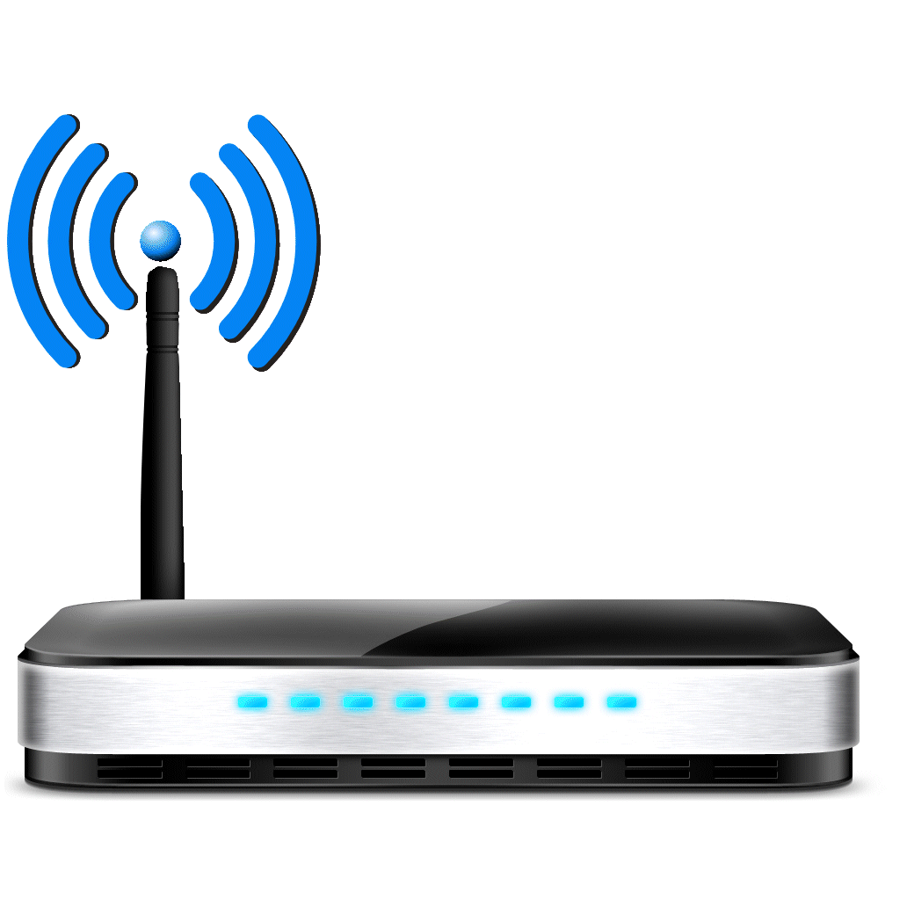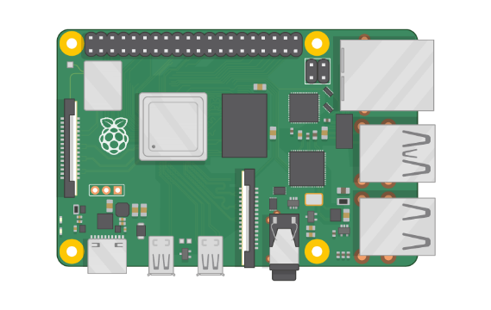

**OR**

**WiFi/Ethernet Gateway**

**GPIO Gateway**

**OR**

**Serial Gateway**

**MySensors WiFi Network**



**Local Network**

**MySensors Relays**

## Using Virtual Gateway

MaxAir can be configures to operate without the use of a MySensors Gateway.

#### Using Sensors and Relays connected using the GPIO Bus

With this configuration no gateway hardware is interfaced to the device hosting MaxAir.



**Local Network**

**1-wire Bus**

**GPIO Bus**

**1-wire Temperature Sensors**

**GPIO Relays**

#### Using Sensors and Relays connected using MQTT

With this configuration no gateway hardware is interfaced to the device hosting MaxAir.



**MQTT Broker**

**MQTT Relays**





**MQTT Relays**

**Local Network**



## Mixed Mode Operation

MaxAir supports Mixed Mode Operation where a combination of MySensor devices and directly connected GPIO devices and/or MQTT and/or I2c devices are used together.

Possible configurations are:

1. MySensors Temperature Sensors, with MySensors Controllers. (MySensors Gateway)
2. MySensors Temperature Sensors, with GPIO Controllers. (MySensors Gateway)
3. MySensors Temperature Sensors, with MQTT Controllers. (MySensors Gateway)
4. MySensors Temperature Sensors, with I2c Controllers. (MySensors Gateway)
5. 1-wire GPIO Temperature Sensors, with MySensors Controllers. (MySensors Gateway)
6. 1-wire GPIO Temperature Sensors, with GPIO Controllers. (Virtual Gateway)
7. 1-wire GPIO Temperature Sensors, with MQTT Controllers. (Virtual Gateway)
8. 1-wire GPIO Temperature Sensors, with I2c Controllers. (Virtual Gateway)
9. MQTT Temperature Sensors, with MySensors Controllers. (MySensors Gateway)
10. MQTT Temperature Sensors, with MQTT Controllers. (Virtual Gateway)
11. MQTT Temperature Sensors, with GPIO Controllers. (Virtual Gateway)
12. MQTT Temperature Sensors, with I2c Controllers. (Virtual Gateway)

## The MaxAir Gateway Script

The way that the Pyton script ‘gatway.py’ operated dependant on which of the above scenarios is being used.

#### When Using a MySensors Gateway

If a MySensors gateway is being used, then both the outgoing and incoming message queues are process by the script. If any directly connected 1-wire sensors are being used, then their incoming message queue is managed by a separate Python script ‘gpio_ds18b20.py’.

#### When Using a Virtual Gateway

If a Virtual gateway is being used then the gateway script will be used to control GPIO, I2c or MQTT devices. If any directly connected 1-wire sensors are being used, then as before their incoming message queue is managed by a separate Python script ‘gpio_ds18b20.py’.

## Configuring the Gateway

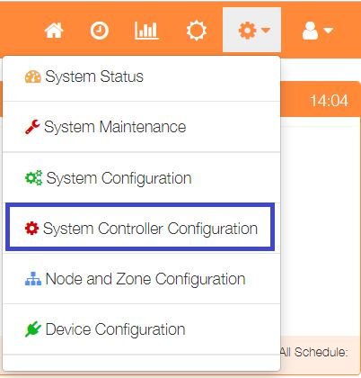

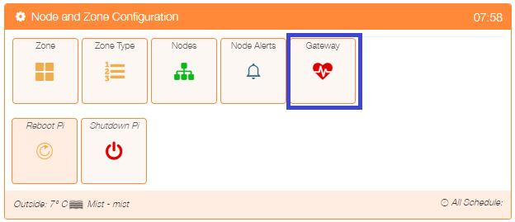The gateway is configured by selecting ‘Node and Zone Configuration’ from the Settings dropdown list, then clicking the ‘Gateway’ button.

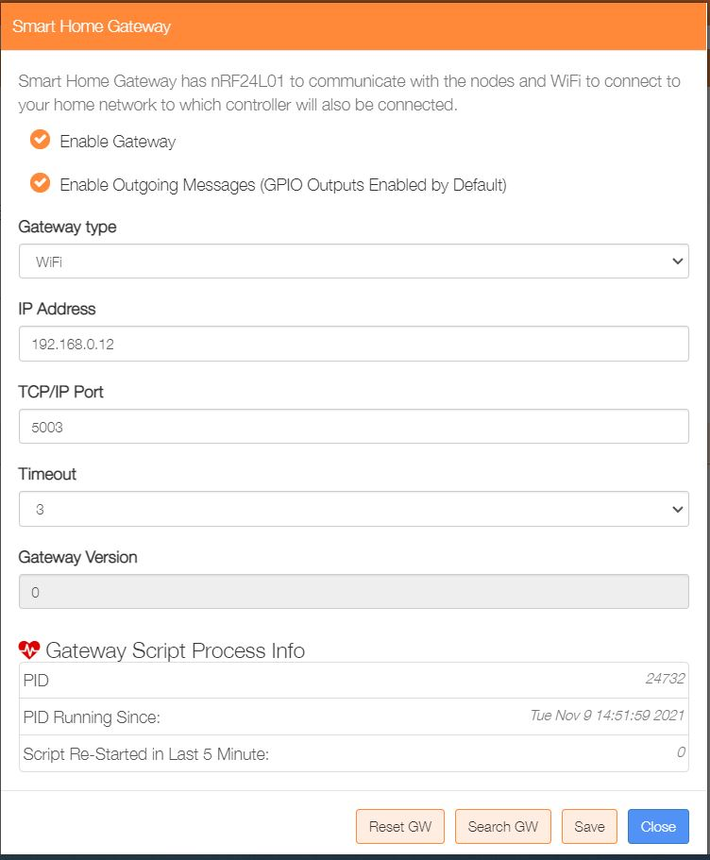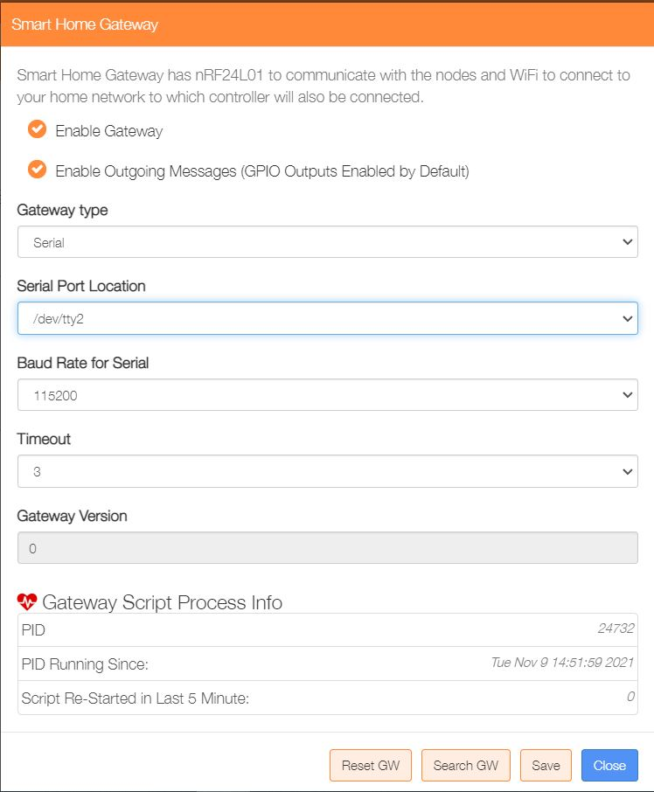If a MySensor gateway is present the configure for either Serial or WiFi.

If no MySensors gateway is required, then configure as a Virtual gateway.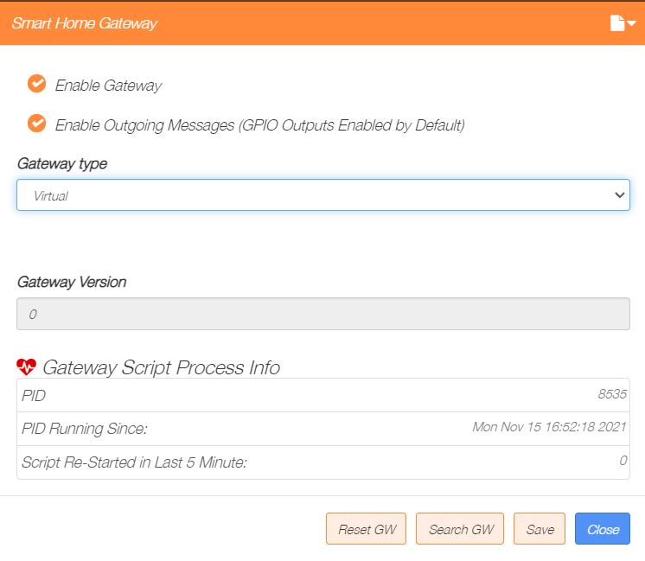

## The Gateway Script File

The Gateway Script file ‘/var/www/cron/gateway,py’ is configured to run automatically and it has an associated ‘watchdog’ process, which will attempt to restart it should it terminate for any reason. The Gateway option described above displays information about the current running gateway script.

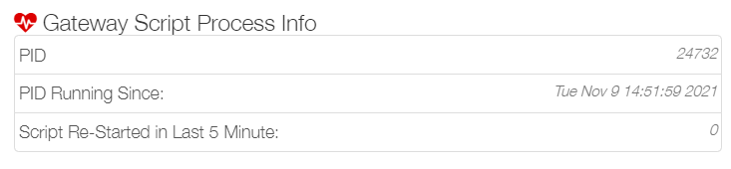

The status of the gateway script can also be checked from the command line using –

‘**ps -aux | grep gateway.py | grep -v grep**’

Information with regards to connecting 1-wire sensors and their operation can be found at MaxAir Documentation in ***Setup 1-Wire Sensors***.