# Setup Guide - Schedules

The example configuration has both a Central Heating and Hot Water zone, in the case of HVAC systems, there will only be a single HVAC zone.

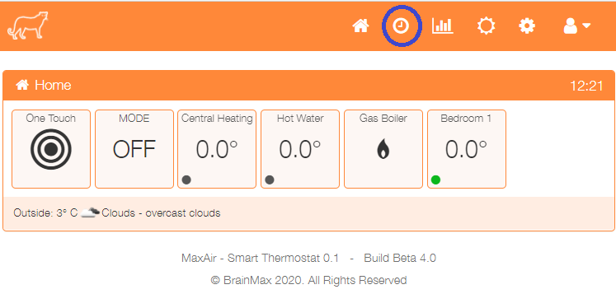Click on the toolbar clock icon to configure schedules.

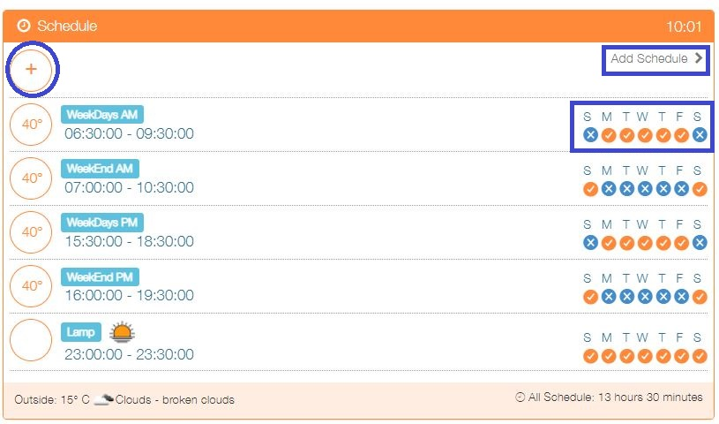

Click on + or ‘Add Schedule’

Or

Click on an existing schedule to edit.

The Add or Edit schedule screen will be presented, the example below shows:

* An enabled schedule
* Operated Monday to Friday
* Titled Weekdays AM
* Operated between 0630 hours and 0930 hours
* Controls both the Central Heating and Hot Water Zones
* Uses 40°C as the Hot Water Zone cut-off temperature
* Uses 19.5°C as the Central Heating Zone cut-off temperature

## Sunrise/Sunset Feature

If the MaxAir Weather feature is enabled, then both the Start Time and End Time for the schedule can either use the times entered or be linked to the Weather generated sunrise and sunset times. For example, the Start Time could be set to sunset and the End Time to for example 23:00hours. An Offset value can be entered as a positive or negative value applied to the sunrise or sunset time.

## Coop Start Feature

Coop Start schedule won't start Zone heating if Boiler is not already running. If Boiler is running and temperature is below setpoint minus deadband, schedule will start the Zone heating. After starting it operates as any other schedule, and will stop the Zone heating when setpoint temperature is reached.

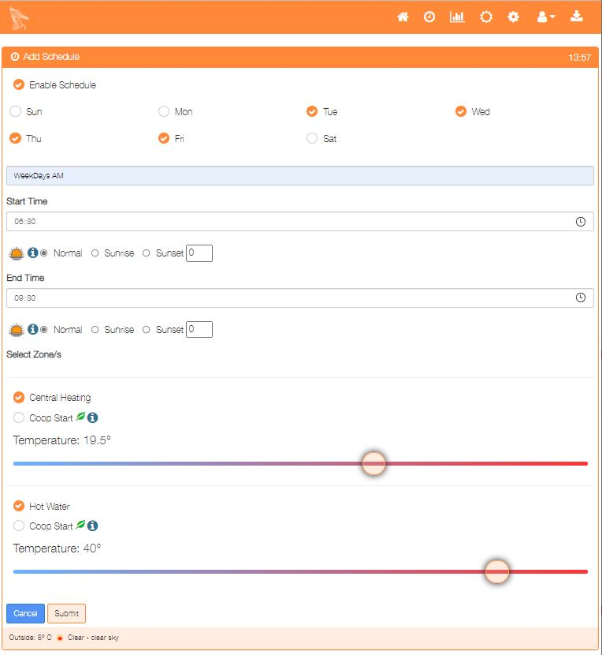

Once configured, click on the ‘Submit’ button to save the schedule.

## Switch Schedule

In the case of ‘Switch’ schedules, no temperature slider will be presented, as before the Start Time and End Time can be linked to sunrise/sunset if required. For the example below the Start Time will be the sunset time minus thirty minutes and the End Time will be 23:00hours.

