# MaxAir System Controller Setup

## Boiler Mode

A relay is used as a trigger for activating the boiler, this relay needs to be added as a relay device before it can be associated with the ‘System Controller’.

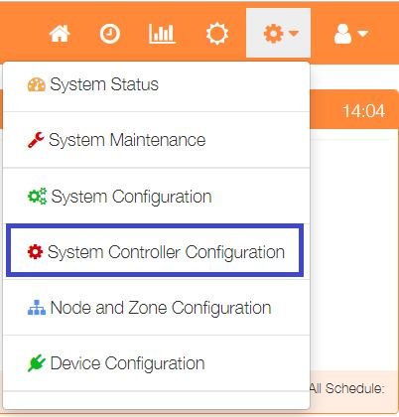

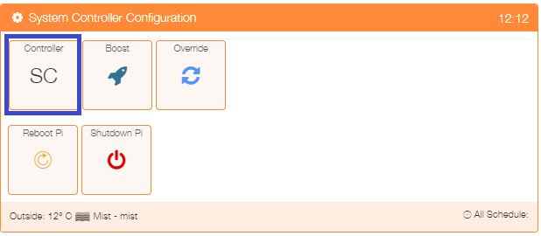Select ‘System Controller Configuration’ from the Settings dropdown list, then click the ‘SC’ button.

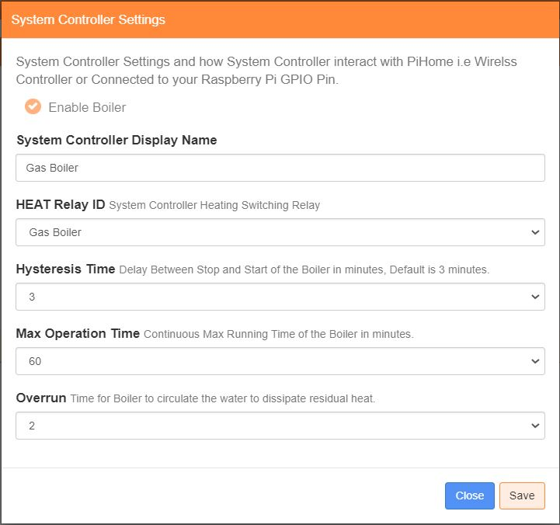

Enter a name for this controller

Select the relay from the dropdown list

Enter a hysteresis value in minutes

Enter a maximum running time in minutes

Enter overrun time in minutes

Click on ‘Save’ to update

## HVAC Mode

Three relays are used to activating the heating, cooling and fan functions of the HVAC system, these relays need to be added as a relay device before they can be associated with the ‘System Controller’.



Select ‘System Controller Configuration’ from the Settings dropdown list, then click the ‘SC’ button.

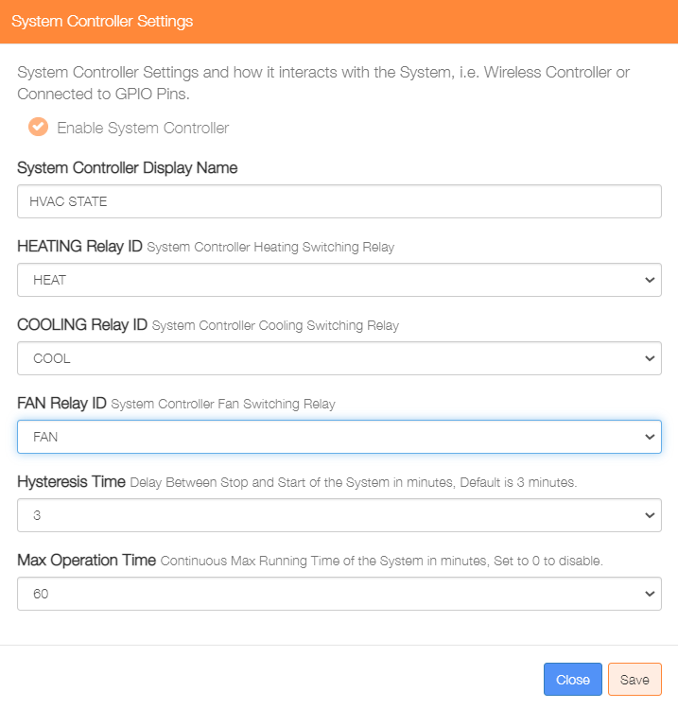

Enter a name for this controller

Select the HEATING relay from the dropdown list

Select the COOLING relay from the dropdown list

Select the FAN relay from the dropdown list

Enter a hysteresis value in minutes

Enter a maximum running time in minutes

Click on ‘Save’ to update