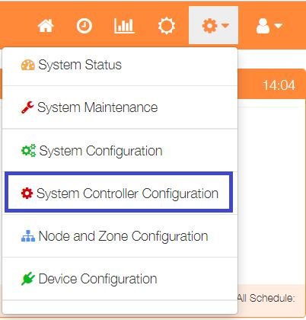The Override function uses the ‘Maximum Temperature’ value set within the Zone configuration.

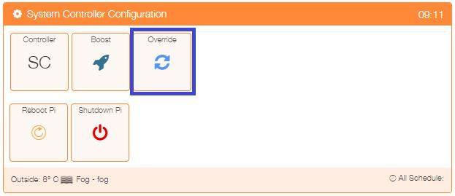The setting for each zone can be viewed by selecting ‘System Controller Configuration’ from the Settings dropdown list, then click the ‘Override’ button.

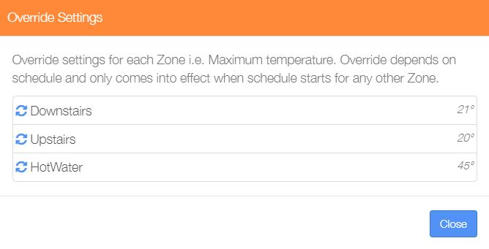

This example shows the Maximum Temperatures set for 3 active zones.

**For example, if we activate Override for the HotWater zone, then when any other zone schedule is active, the HotWater zone will also become active, using the Maximum Temperature value as the control temperature.**

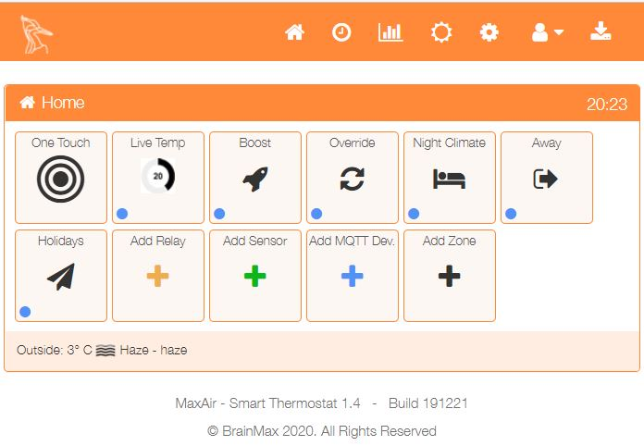To activate Override, use the ‘Override’ option from the One Touch menu.

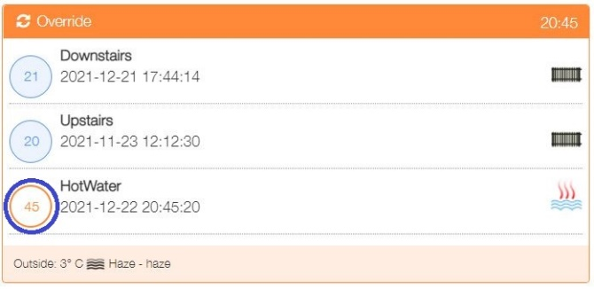

Click on the temperature status icon to activate Override for the HotWater zone.