### Introduction

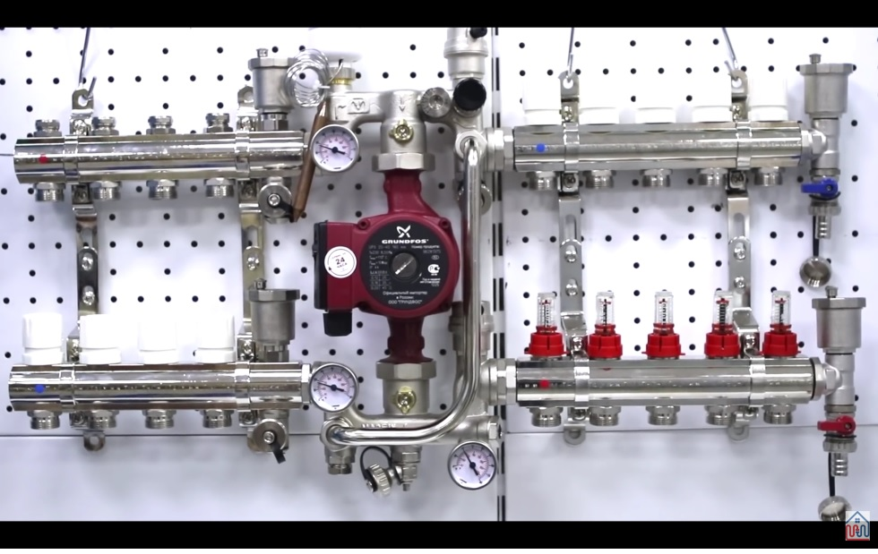Pump type relays are used where zones require the use of an external pump, for example where a pump is attached to a manifold:

The difference between a pump relay and a zone relay is that; the pump relay can be attached to multiple zones as a second controller and will switch ON if any of the zones, to which it is associated, are themselves in the ON state and will only switch OFF when all the associated zones are in the OFF state.

### Adding a Pump Relay

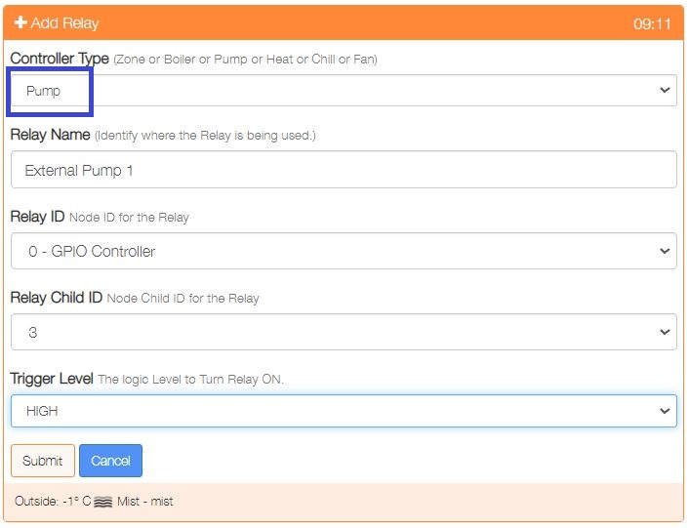

Pump relays are created either from One Touch/Add Relays or from Settings/Node and Zone Configuration/Relays Add Relays. When creating select ‘Pump’ as the Controller Type.

### Associating the Pump Relay with a Zone

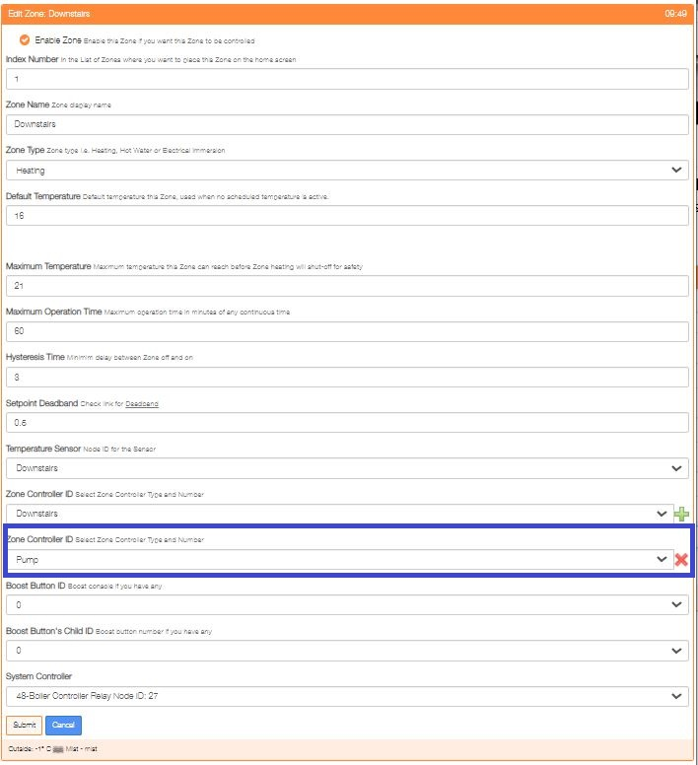To associate a Pump Relay with a Zone, simply add it as a second Zone Controller.

### Multiple Pump Relays

The system supports the use of multiple Pump Relays, for example Pump Relay 1 could be created and associated with Zone 1 and Zone 2 and Pump Relay 2 could be created and associated with Zone 3 and Zone 4.

### Overrun

The Pump relay is associated to the Zone relay and hence is a Zone relay is in the overrun condition then the associated Pump relay will also be in the overrun state.