MaxAir can be configured to send email notifications if a sensor value is either below a pre-set minimum value or above a pre-set maximum value.

In order to use this feature ‘Email Notifications’ must be configured, please see relevant documentation.

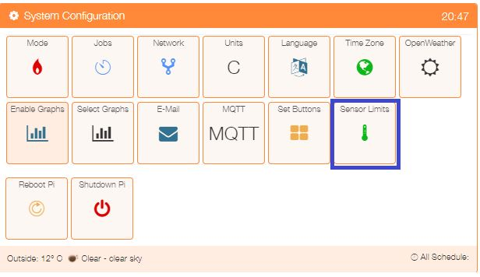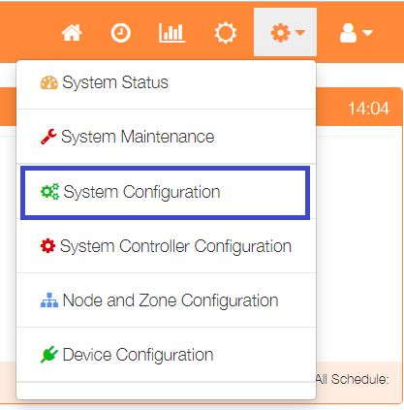Select ‘System Configuration’ from the Settings dropdown list, then click the ‘Sensor Limits’ button.

.

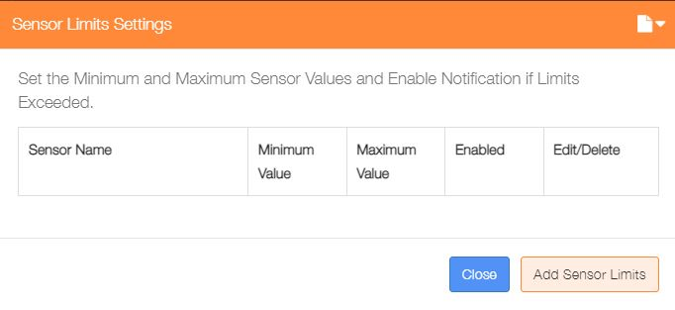

If no Sensor limits have been defined, then click on the ‘Add Sensor Limits’ button.

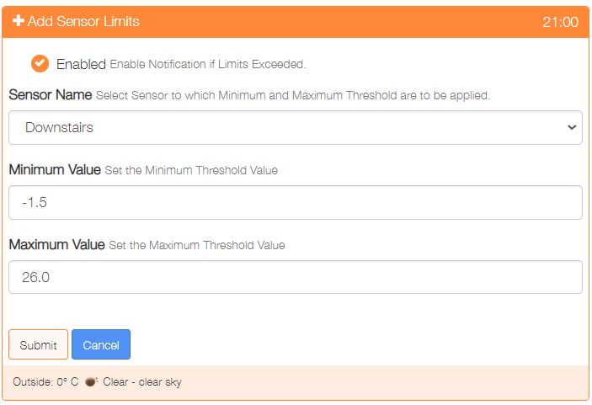

Click to enable these limits.

Select the sensor.

Set the minimum value.

Set the maximum value.

Click ‘Submit’ to save the limits for the selected sensor.

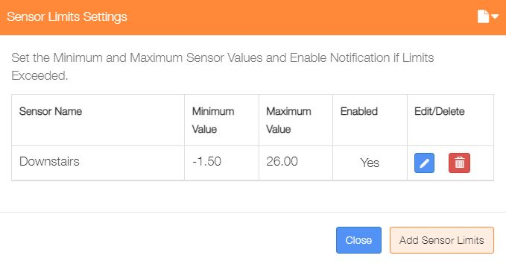

Any defined sensor limits can be shown from Settings/System Configuration and click on the Sensor Limits menu option.

Limits for a particular sensor can be either edited or delete ftom this screen.

**Note: Email Notifications needs to be active.**