The Schedule Start Time Offset function is used to advance a schedule start time based on a sensor temperature measurement, using a linear scale between two set temperature values.

For example :-

Low Temperature = -5

High Temperature = 10

Maximum Offset (in minutes) = 30

If the temperature sensor is reading -5, then the schedule start time will be advanced by 30 minutes

If the temperature sensor is reading 10, then the schedule start time will be advanced by 0 minutes

For each 1 degree between the Low and the High temperature, the offset value will be decreased by 30/(10 - -5) ie 2 minutes for every 1 degree change.

## Setup

From the ‘One Touch’ menu, select ‘Offset’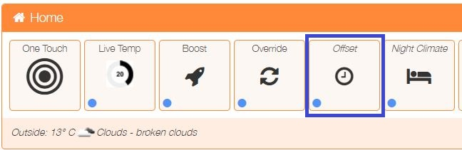

Any existing Schedule Offsets will be displayed, they can be deleted or edited from this screen. To add a new Schedule Offset, click on the ‘Add Schedule Offset’ button.

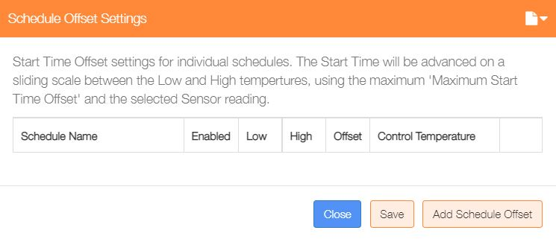

Enable the offset, then select an existing schedule from the drop-down list. Set Low Temp, High Temp and Maximum Start Time values and finally set which sensor will be used for the comparison temperature. If the MaxAir ‘OpenWeather’ feature is enabled, then you will be able to use this as the reference temperature sensor.

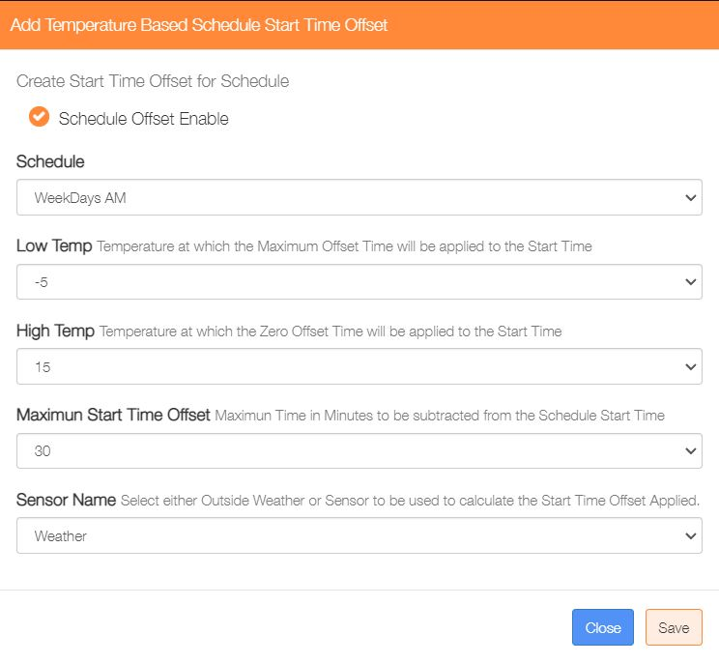

Once a Schedule Offset has been added, it can be deleted or edited from the One Touch/Offset menu.

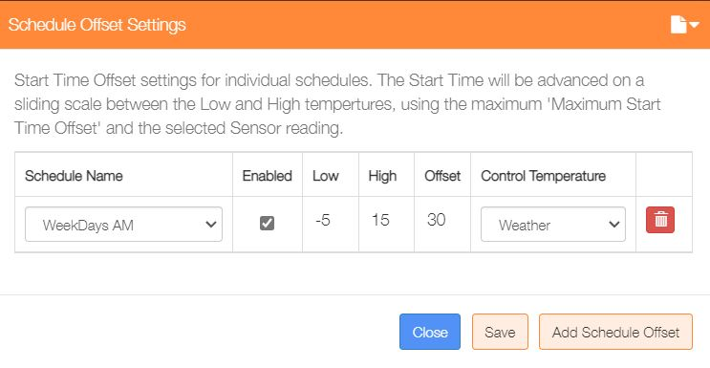

If a running schedule has an active Offset applied then this will be identified by the status indicator on the One Touch/Offset button turning from blue to red, with the current offset in minutes displayed.

