MaxAir Switch type zones can be controlled in a number of ways:

1. By the use of a schedule to set ON and OFF timings.
2. By the use of the Home Screen Switch zone button to toggle the ON/OFF state.
3. By the use of voice control (if enabled) toggle the ON/OFF state.
4. When a schedule associated with the Switch zone is running, the Home Screen Switch zone button can be used to toggle the ON/OFF state, overriding the running schedule.
5. When a schedule associated with the Switch zone is running, voice control (if enabled) can be used to toggle the ON/OFF state, overriding the running schedule.

**Note 1**: With options 4 and 5 above, the Switch Zone will be placed into the ‘Override’ state and the Override button status will be red. The Switch button style will depend on the state after toggling i.e., either ON or OFF. The zone will remain in the override state until the current running schedule terminates.

The Switch zone and Override button displays will show the zone state as below:

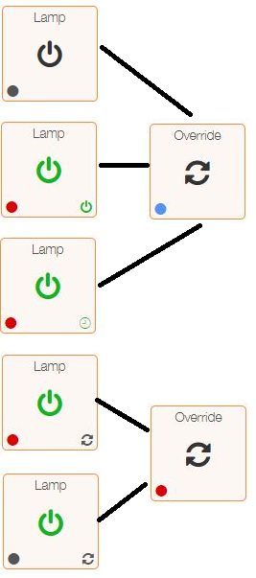

Switch Zone in OFF state.

Switch Zone in ON state.

Switch Zone is running a schedule and switched ON.

Switch Zone is running a schedule and switched ON by override condition.

Switch Zone is running a schedule and switched OFF by override condition.

**Note 2**: When the Switch zone in in the manual ON state the start any subsequent schedule will place the zone into the scheduled ON state and it will remain in this state until the schedule terminates in the normal manner.