Although MaxAir was developed primarily to control heating systems, it does have home automation capability, through the use of ‘Switching Zones’.

Multiple zone types are supported, currently there are eight types of zone, Heating, Water, HVAC, Humidity, Immersion, Switch, Binary and HVAC-M (multi-zone HVAC). The first four and last control both zone and system controller relays, while the remainder control only zone relays and are classified as ‘Switching Zones’.

The difference between the three switching zones is as follows:

|  |  |
| --- | --- |
| **IMMERSION** | Controls zone relay/s based on readings from a temperature sensor. |
| **SWITCH** | Controls zone relay/s based on a schedule (no sensor) |
| **BINARY** | Controls zone relay/s based on readings from a binary sensor. |

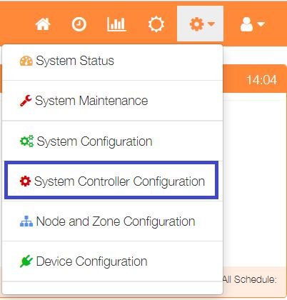Zones are creaded by using the Add Zone dialogue.

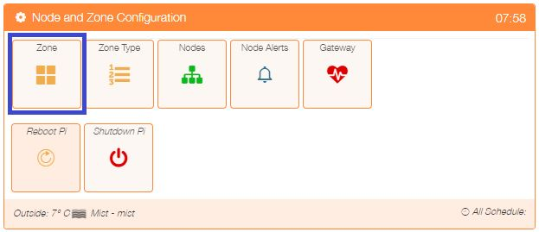Select ‘Node and Zone Configuration’ from the Settings dropdown list, then click the ‘Zone’ button, to display a list of any currently configured zones.

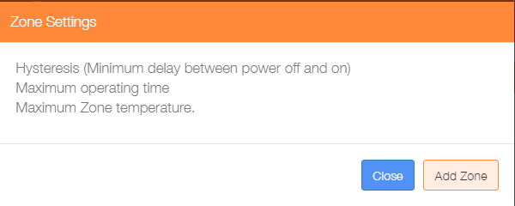

Click on the ‘Add Zone’ button to configure the first zone.

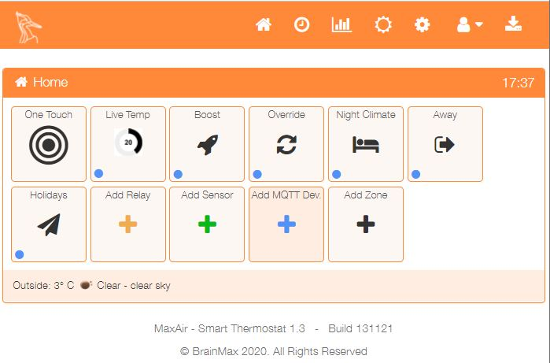

An alternative method to go directly to the Add Zone dialogue, is from the Home screen click on the ‘One Touch’ button then select the ‘Add Zone’ menu item.

The add zone dialogue will depend on the Zone Type selected, the example below shows a ‘Binary’ zone, for an ‘Immersion’ zone the ‘Switch Sensor’ field would be replaced by ‘Temperature Sensor’ and for a ‘Switch’ zone the field would be removed.

The ‘Sensor’ field will only present relevant ‘Sensor Types’, ie. For a ‘Binary’ zone, binary sensors will be available and for an ‘Immersion’ zone temperature sensors.

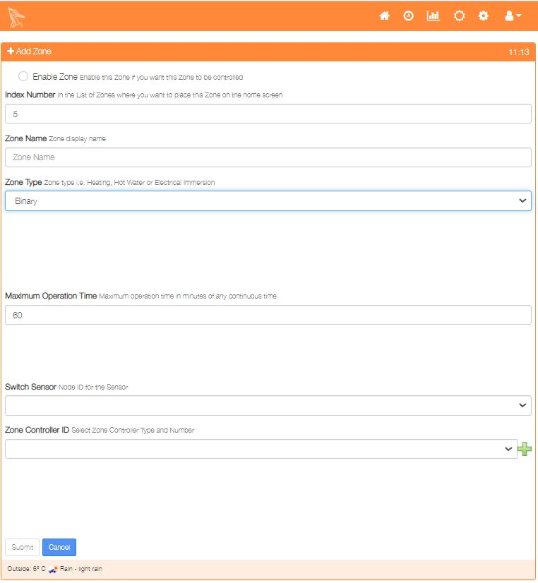

# Usage Examples

## Immersion Zone

* A MySensors type temperature sensor is created.
* The sensor is attached to the hot water tank.
* A MySensors type relay is created.
* The relay is connected to control the mains power supply to the immersion element.
* An ‘Immersion’ zone is created using the sensor and relay created above.
* A schedule is created defining the time window and cut-off temperature.

## Switch Zone

* A relay is created, this could be a MySensors relay, a GPIO relay or a Tasmota relay.
* The relay is connected to control the mains power supply to the lamp.
* An ‘Switch’ zone is created using the relay created above.
* A schedule is created defining the time window for the relay to switch ON.

## Binary Zone

* A Binary Sensor is created, this could be a MySensors device or a GPIO pin.
* The sensor is attached to switch, which is operated by the object being controlled, for example to control fluid level in a tank, we could use a float switch.
* A relay is created, this could be a MySensors device or a GPIO relay or a Tasmota relay.
* The relay is connected to control the mains power supply to the object being controlled, for example a flow control valve.
* A schedule is created defining the time window within which the state of the binary switch will be used to control the state of the associated relay.