# MaxAir Technical – Task Scheduling

MaxAir requires a number of background tasks to be actioned periodically, a task scheduler, running as a system service, is provided to achieve this functionality. The task scheduler executes once every second, this determines the maximum repetition rate. The list of tasks to be executed is dynamic, so that tasks can be added or deleted from the schedule as required. The tasks will typically be script files and can be, for example, coded as ‘Shell’, or ‘Python’ or ‘PHP’ scripts.

MaxAir has eight pre-installed tasks:

1. The ‘controller’ Task – main engine for the system, controlling the target heating system, it executes once every 60 seconds.
2. The ‘db_cleanup’ Task – deletes aged database records, it executes daily at 2AM.
3. The ‘check_gw’ Task – manages the System Gateway hardware to send and receive messages, it executes once every 60 seconds.
4. The ‘system_c’ Task – reads the CPU temperature from the systems control board, it executes once every 300 seconds.
5. The ‘weather_update’ Task – collects weather data from the ‘openwather’ API, it executes once every 1800 seconds.
6. The ‘reboot_wifi’ Task – checks the status of the wifi connection and attempts to restart if required, it executes once every 120 seconds.
7. The ‘sw_install’ Task – checks for software install requests, it executes every 10 seconds.
8. The ‘gpio_ds18b20’ Task – optional to read GPIO connected temperature sensors.

### Checking TheTask Scheduler is Running

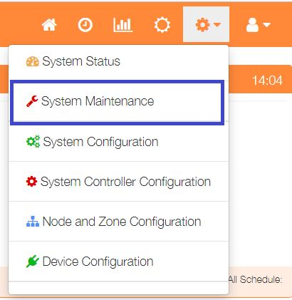

To display a list of the currently installed Services and their status, select ‘System Maintenance’ from the Settings dropdown list, then click the ‘Services’ button.

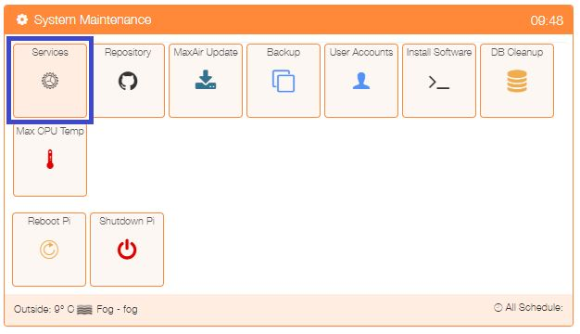

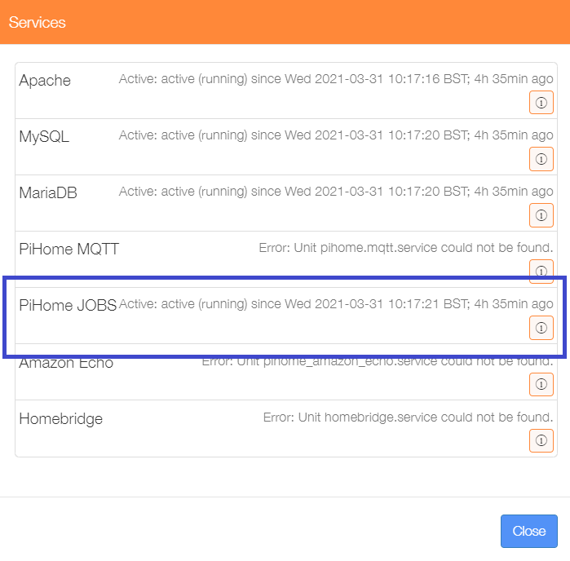The PiHome JOBS service is shown to be Active. Close the menu.

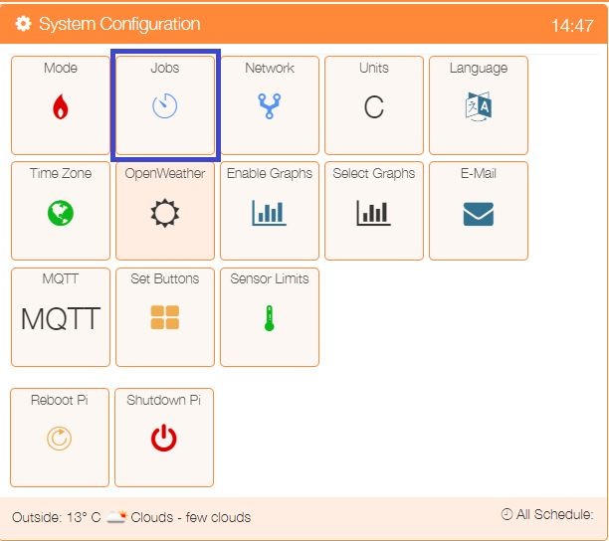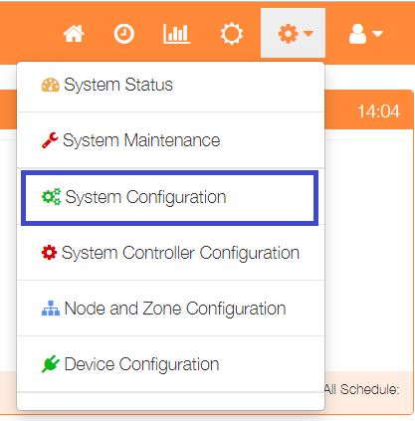 To show the list of active tasks, select ‘System Configuration’ from the Settings dropdown list, then click the ‘Jobs’ button.

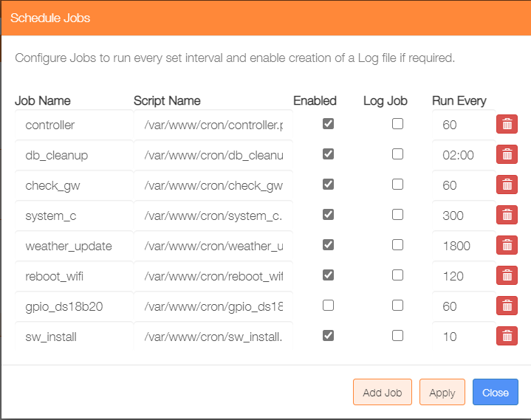

The 8 pre-installed tasks are shown, with the exception of the ‘gpio_ds18b20’ task, they will be enabled by default and will not be writing their output to a log file. The log to file option for any job can be activated by checking the tickbox. The execution frequency can be edited and tasks delete if chosen. If changes have been made, they will not be actioned until the ‘Apply’ button is clicked.

New tasks can be added to the scheduler by clicking on the ‘Add Job’ button

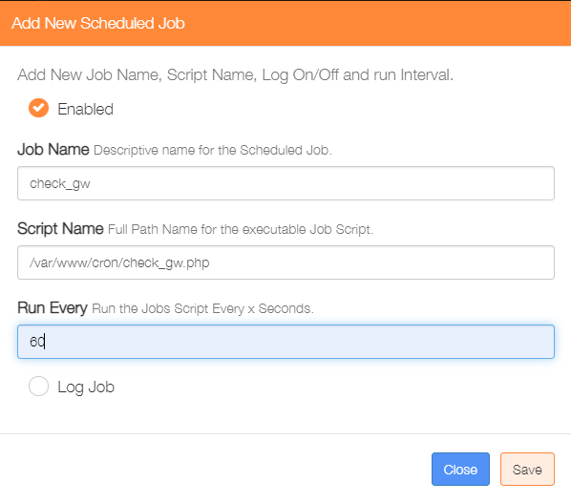

Check to enable the task.

Enter a name for the task.

Enter the full path name of the task script file.

Enter how often to run, see note below

Check if a log file is to be written.

Click on ‘Save’ to update the task scheduler.

Note: log files will be written to directory /var/www/cron/logs/

Note: If a numeric value ‘*x*’ is entered, then the task will execute every *x* seconds. If a time value is entered eg *’02:00*’, then the task will execute once a day at the set time, in the case of this example at 2AM.

### View Last Job Output

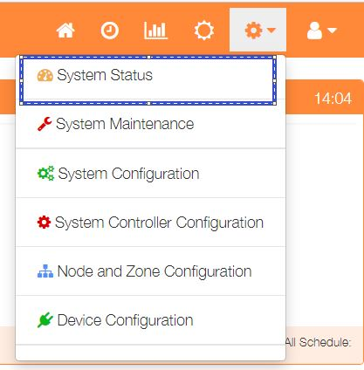

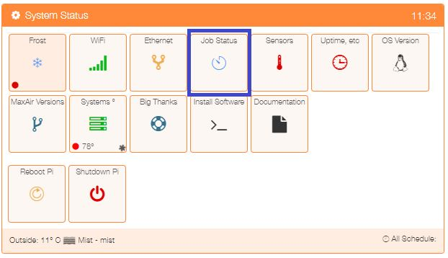 select ‘System Status’ from the Settings dropdown list, then click the ‘Job Status’ button.

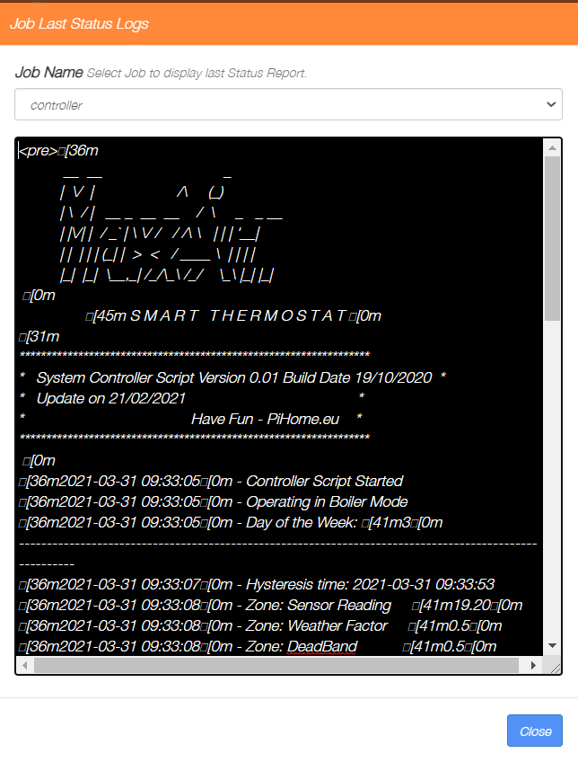

Select the task of interest from the dropdown list of installed tasks to display the results of the last execution in the display window. Click on the ‘Close’ button when finished.