MaxAir supports zones based on their type, these types define the basic capability of the zone:

* Associated with a sensor, zone controller relays and system controller relays
* Associated with a sensor and zone controller relays
* Associated with only zone controller relays
* Associated with a sensor and system controller relays

A number of Zone Types are pre-defined:

* Heating – has a temperature sensor, zone controller relays and a system controller relay
* Water – has a temperature sensor, zone controller relays and a system controller relay
* Immersion – has a temperature sensor and zone controller relays
* Switch – has system controller relays
* HVAC – has a temperature sensor and system controller relays
* Humidity - has a humidity sensor and zone controller relays
* Binary – has a ON/OFF sensor and zone controller relays
* HVAC-M – has a temperature sensor, zone controller relays and system controller relays

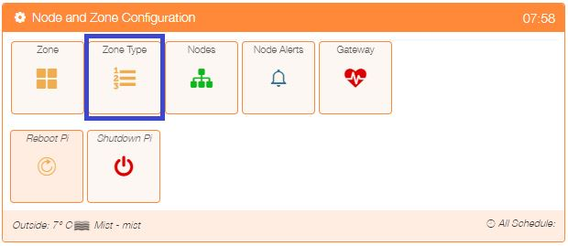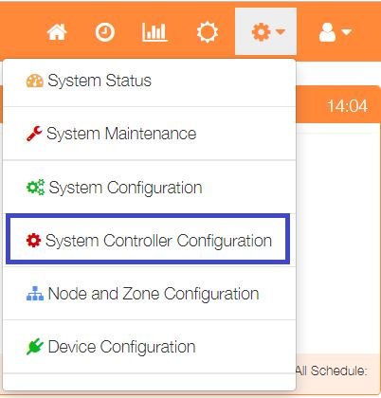The currently defined Zone Types can be viewed by selecting ‘Node and Zone Configuration’ from the Settings dropdown list, then clicking the ‘Zone Type’ button.

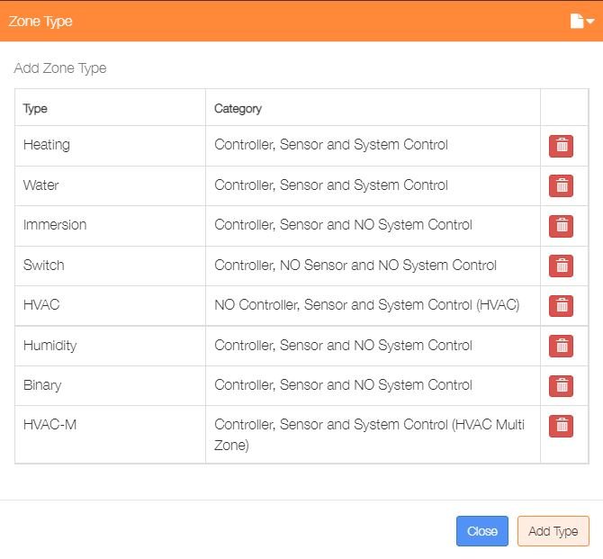Zone Types can be deleted by clicking on the ‘trash’ icon or addition ones added by clicking on the ‘Add Type’ button.

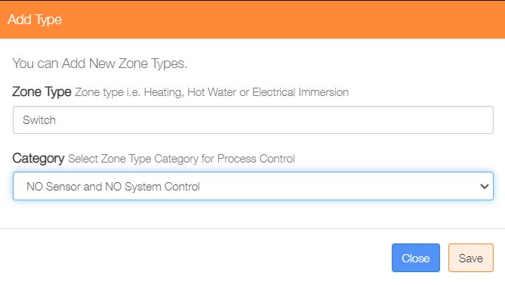Enter a name for the new Zone the and select the appropriate ‘Category’ from the dropdown list, finally click on the ‘Save’ button.