## Introduction

The MaxAir Gateway/Relay Controller is based around the ‘WT32-ETH01’ module and combines a MySensors gateway, a WiFi network interface, a Ethernet network interface with a 16 port relay controller. The unit can be configured to operate in either WiFi only mode, Ethernet only mode or in dual mode with both WiFi and Ethernet connections.

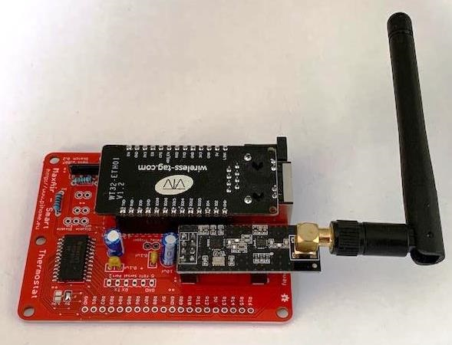

Both network interface are configured to operate in DHCP mode by default, but the ‘WT32-ETH01’ firmware can be reprogrammed so that either interface can be configured with a static IP address.

An FDTI port is provided to allow reprogramming and the following jumpers are available to configure the device:

|  |  |
| --- | --- |
| 2pin Trigger | No Jumper - relays are triggered with a LOW logic level.  Jumper - relays are triggered with a HIGH logic level. |
| 3pin Network Interface | Either the WiFi or Ethernet network interface can be disable. |
| 2pin Clear WiFi | Powerup with jumper in place will clear the stored WiFi settings. |
| 2 pin Prof | Powerup with jumper in place will place the ‘WT32-ETH0in programming mode. |

The status of the module can be checked by browsing to its IP address:

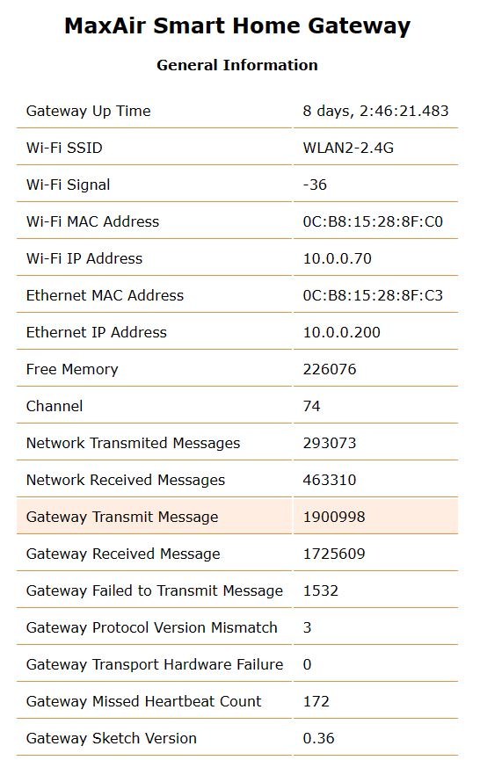

## Relay Adapter Board

Relays can be connected directly to the 20pin header, using jumper cables or by using the Relay Adapter interface board, which is designed to fit the common 8 or 4 relays boards available from either eBay or Amazon.

### 8 Relay Module

Mount the module using nylon standoffs, the two 15mm standoffs will support the adapter board.

Attach a 10way stackable header to the relay board interface connector.

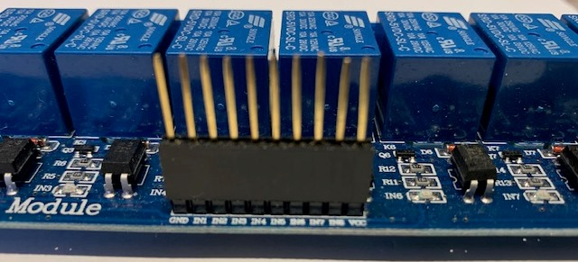

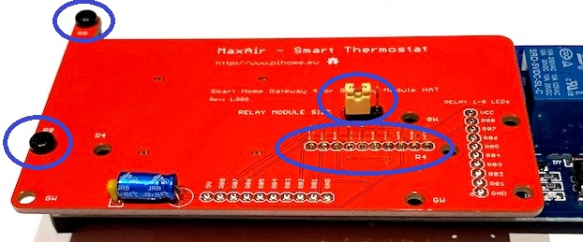

Place the adapter board over the relay board, threading the stackable header pins through the associated holes in the board, secure the adapter board to the relay board using two screws. Finally trim the stackable header pins, solder to the board and install the jumper to configure for a 8 relay module.

### 4 Relay Module

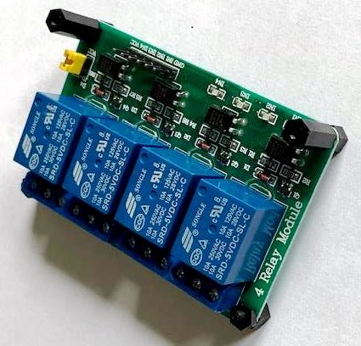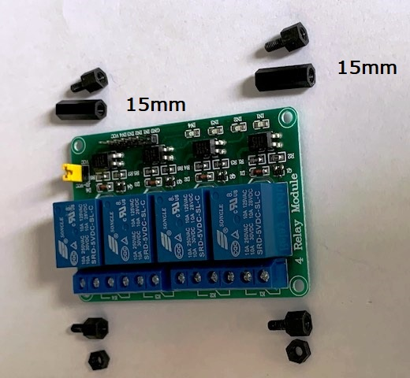Mount the module using nylon standoffs, the two 15mm standoffs will support the adapter board.

Attach a 10way stackable header to the relay board interface connector (a 6way stackable header could be used, but by using a 10way, then the adapter board can be used for either 4 or 8 relay modules).

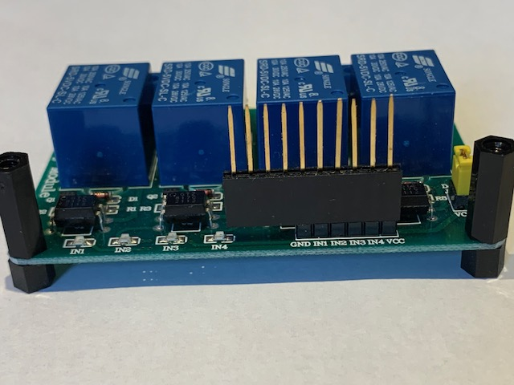

Place the adapter board over the relay board, threading the stackable header pins through the associated holes in the board, secure the adapter board to the relay board using two screws. Finally trim the stackable header pins, solder to the board and install the jumper to configure for a 4 relay module.

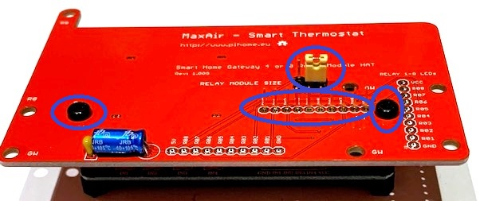

### Attaching the Gateway/Controller Board

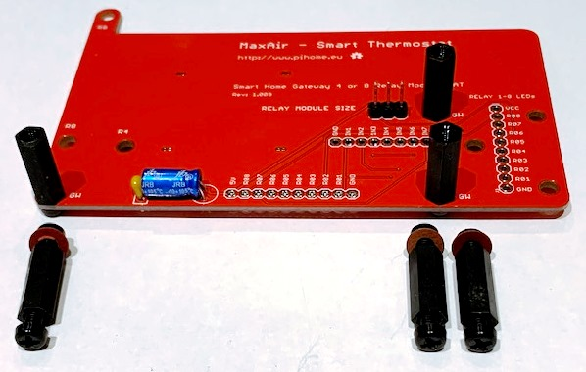Attach three 15mm standoffs to support the gateway/controller board, placing a fibre washer between each standoff and the board

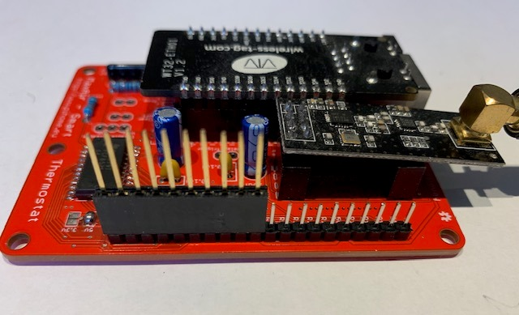

Attach a 10way stackable header to the gateway/controller board interface connector.

Place the gateway/controller board over the relay adapter, threading the stackable header pins through the associated holes in the relay adapter board, secure the gateway/controller board to the relay adapter board using three screws. Finally trim the stackable header pins and solder on the reverse side of the relay adapter board.

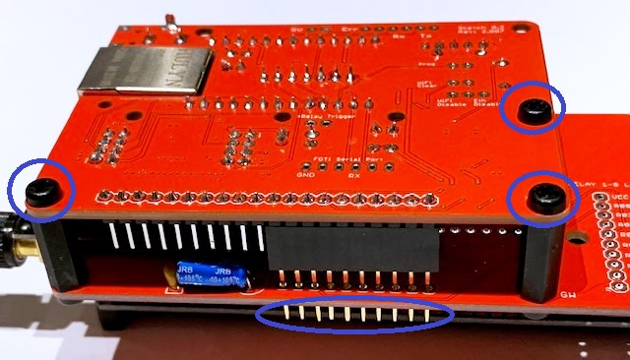

### Optional LED Display Board

An optional board is available to connect up to eight LEDs. The board needs to be configured depending on the trigger logic state required to activate the relays, the orientation of the LEDs is also dependant on the trigger logic state.

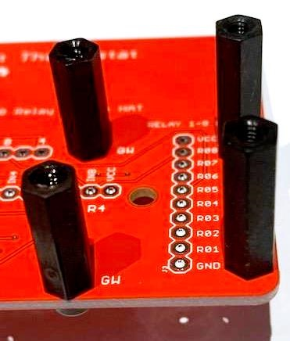

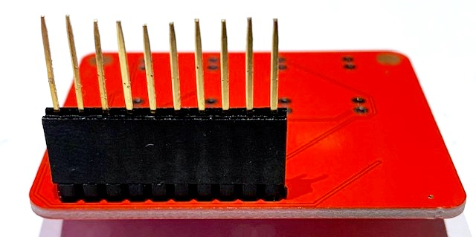Install two standoffs to support the LED board, these can be up to 20mm in length.

Attach a 10way stackable header to the LED board connector.

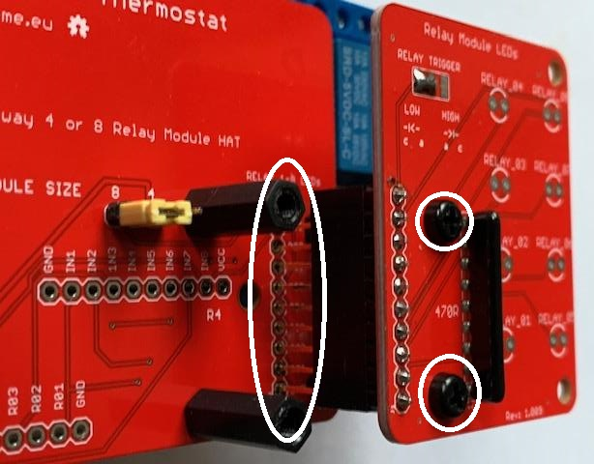

Place the LED board over the Relay Adapter, threading the stackable header pins through the associated holes in the Relay Adapter board, secure the LED board to the Relay Adapter board using two screws. Finally trim the stackable header pins and solder on the reverse side of the Relay Adapter board.

The LED has a solder jumper which is set depending on whether the relays are LOW or HIGH triggered.

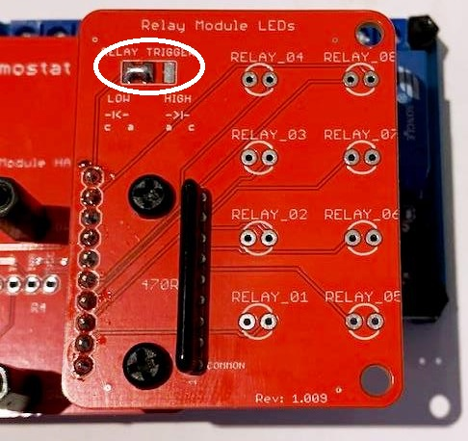

The example above shows the LED board configured for a LOW triggered relay module. The LED orientation for each trigger level is shown by the legend printed on the board just below the solder jumper.

### Accessing The Relay Module Connectors

It is possible to access the relay module connectors with the Gateway/Controller board in place as it is slightly offset, although it is simpler to remove the three securing screws to allow the Gateway/Controller board to be removed.

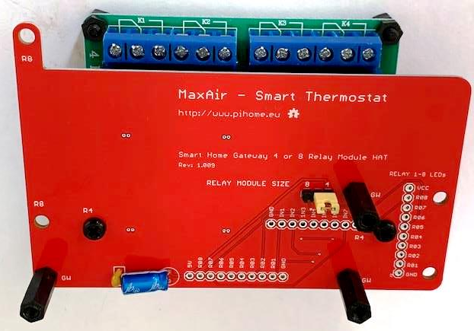

### Case Mounting

The assembled Gateway/Controller, Relay Adapter and Relay Module can be mounted in a suitable case. As can be seen the jumpers and FDTI programming port have been installed on the reverse side of the Gateway/Controller board to make for easy access.

