Introduction
A number of database tables can quickly grow in size and impact on system performance. In order to manage these tables, it is possible to schedule deletion of any records older than a configurable time period.
The tables impacted are:
- gateway_logs
- nodes_battery
- messages_in
- relay_logs
- sensor_graphs – not configurable, fixed to delete any records older than 24 hours.
- bus_controller_log (ONLY IF EBUS OR EMS CONTROLLER SCRIPTS ARE IN USE)

Enabling the Feature
The feature can be setup and enabled from Settings/System Maintenance/DB Cleanup.
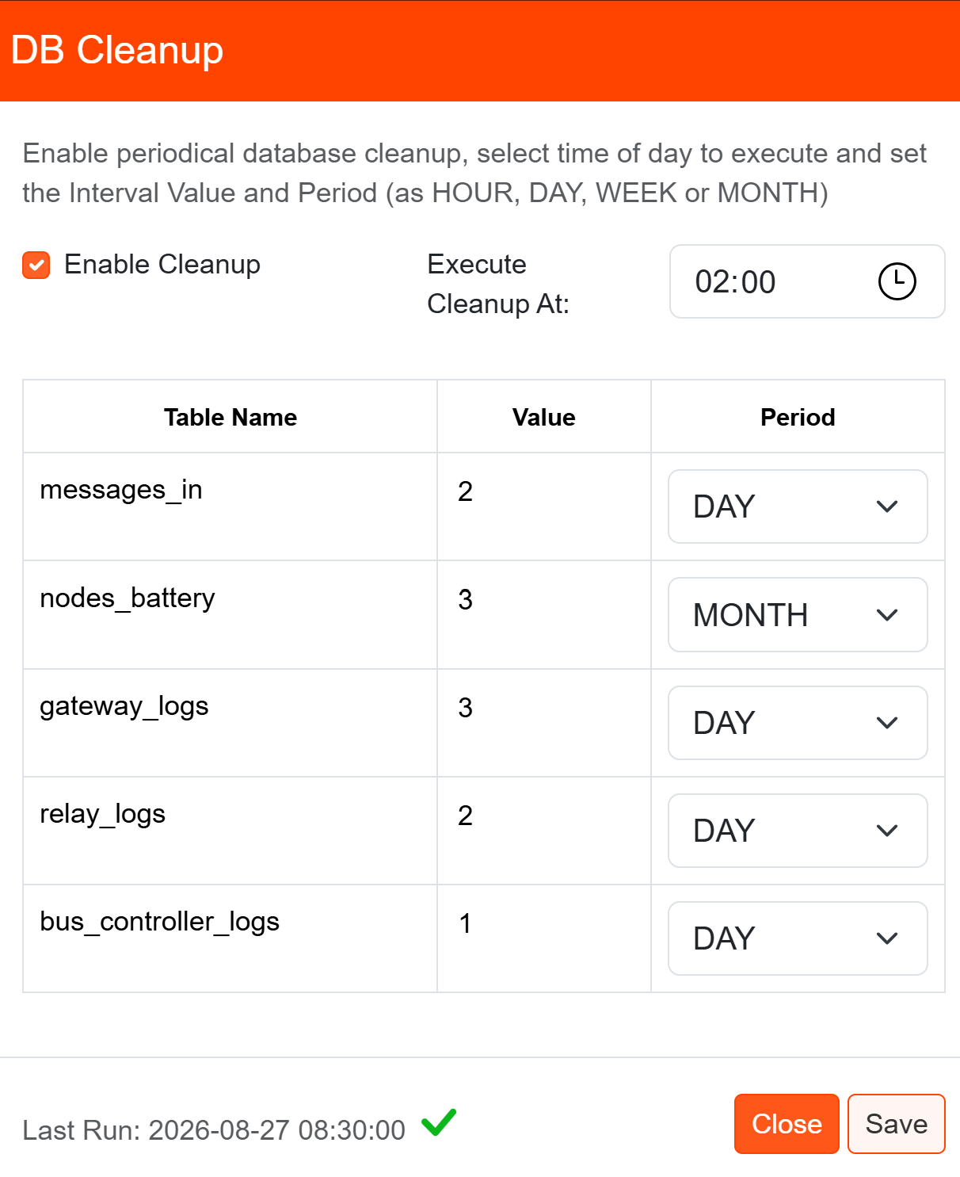

Enable or disable the feture and select the time at which the clean-up will occur.

Select the time interval for each table. after which the records will be purged from the database.

Indication of the time at which the last clean-up was performed and wether successful or not.

