Introduction
This feature allows the target temperature for the Hot Water zone to be adjusted depending on the outside temperature, this target temperature will be used in place of the scheduled value.
The algorithm used is as follows:
- Calculate the average control temperature over the preceding 24 hours
  - If the calculated average is below a pre-set threshold then
    - Calculate a water delta as the pre-set threshold value minus the calculated average
    - Multiply the water delta by a pre-set coefficient
    - Calculate a target temperature for the zone as the zone default temperature plus the water delta value
    - If the calculated target temperature is above 60C, then set as 60C

Experimentation has shown the following parameter to offer a saving in energy usage balanced with a usable hot water temperature:

Hot Water Zone Default Temperature | 40C
Threshold Temperature | 21C
Coefficient | 0.6

Enabling Hot Water Zone Weather Compensation
The feature can be setup and enabled from the Settings/System Configuration/ Hot Water Comp menu
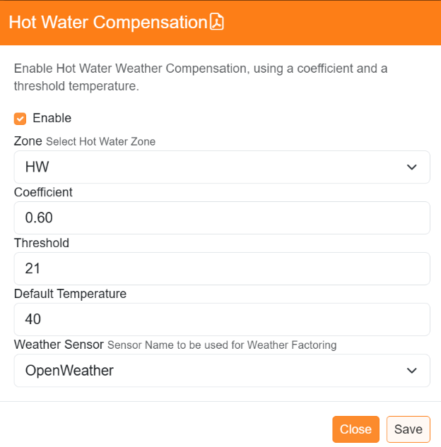

Enable/Disable the feature.

Note only ‘Water’ type zones are selectable.

The coefficient value.

The threshold value.

The Zone Default Temperature

The sensor to be used as the control

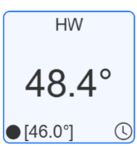
Note. The default temperature used is that set in the Zone configuration menu, ‘Default Temperature’ parameter and can be changed directly from this menu.
When a Hot Water zone is operating in Weather Compensation mode, the target temperature will be displayed within square brackets.

