It is possible to arrange the tile positioning on the Home screen, around a fixed reference set by the ‘System Controller’ tile.
Tiles on the home screen are categorized as:
- Heating/Water Zone tiles, placed BEFORE the System Controller tile.
- Add-On Zone tiles (eg Immersion zones, Switch zones …) placed AFTER the System Controller tile.
- Standalone Sensors and Relays (ie. Devices not attached to a zone, placed either BEFORE or AFTER the System Controller tile.

Positioning Zone Type Tiles
Form the Settings/Node and Zone Configuration menu, select ‘Zone Indexing’
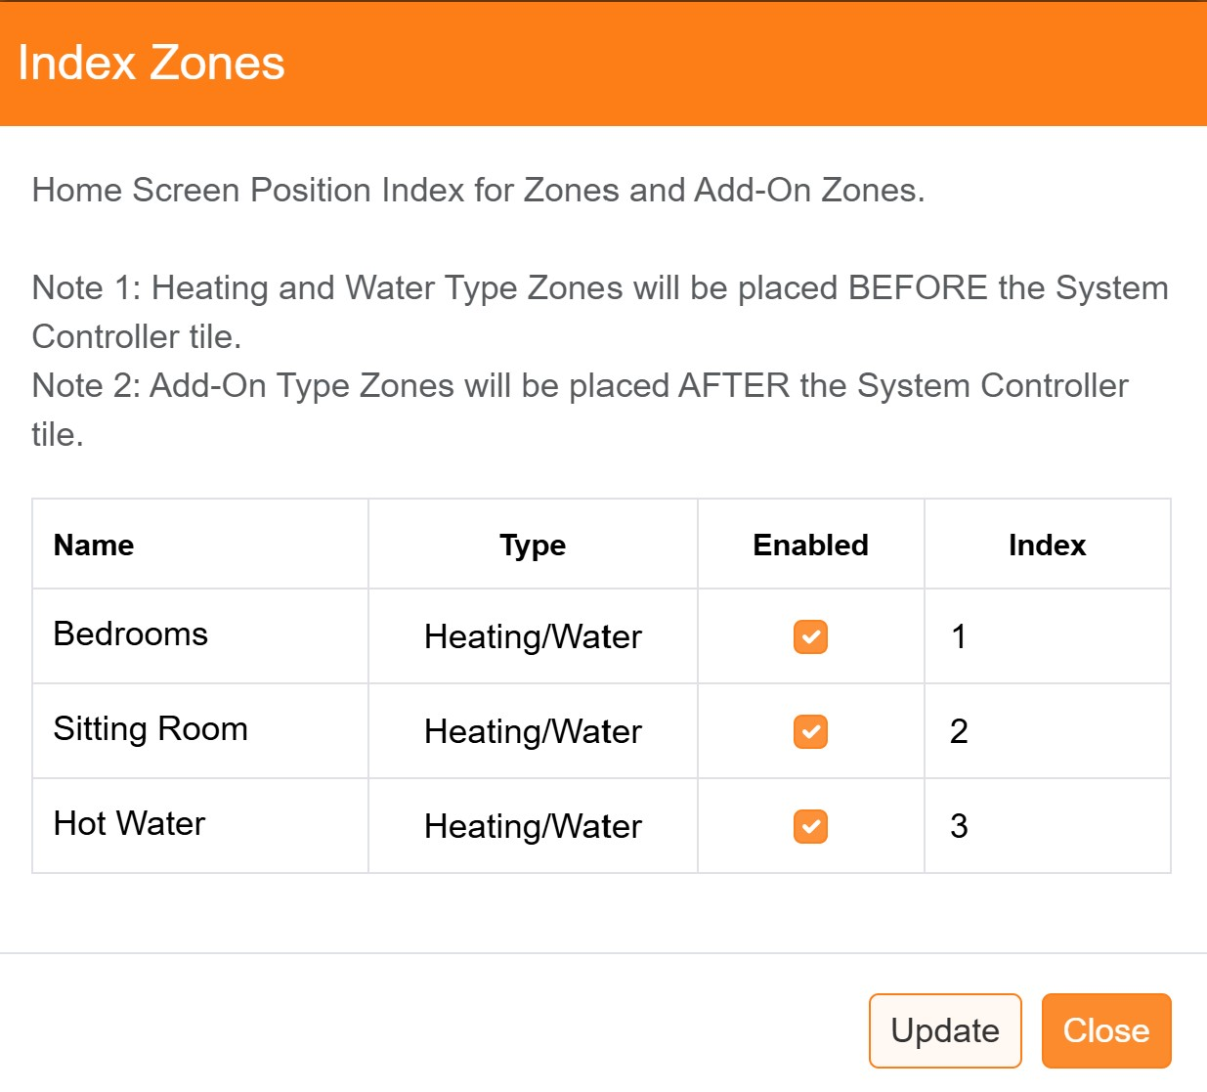

Zones can be disabled so that they are not displayed (and are non-operational) and/or the order in which they are displayed on the Home Screen can be altered.
Once the required changes have been made, click the ‘Update’ button to save the new configuration to the database and then exit with the ‘Close’ button.
Note: the ‘Index’ values for Heating/Water and Add-On type zones are independent (ie. They can both start from 1).

Positioning Standalone Device Tiles
Form the Settings/Device Configuration menu, select ‘Device Indexing’
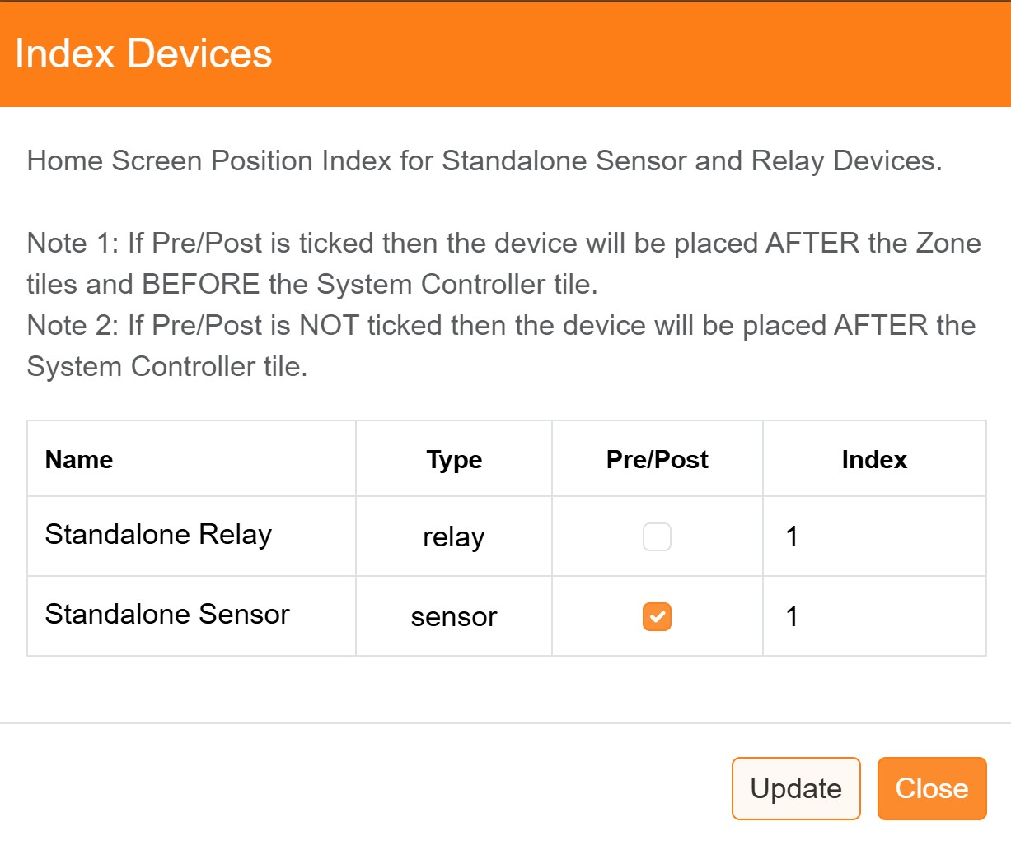

Devices can be position so that they are displayed either BEFORE or AFTER the ‘System Controller’ tile by ticking the ‘Pre/Post’ selection. The order in which they are displayed on the Home Screen can be altered as required.
Once the required changes have been made, click the ‘Update’ button to save the new configuration to the database and then exit with the ‘Close’ button.
Note: the ‘Index’ values for Pre and Post are independent (ie. They can both start from 1).

