Introduction
Stand-Alone relays are devices which are NOT attached to a Zone. Their state can be toggled from a Home screen tile, they can be attached to a schedule and they can be formed in to Groups, so that the actions applied to ant relay in the group, will also be applied to any other relays in that group.

Adding a Stand-Alone Relay
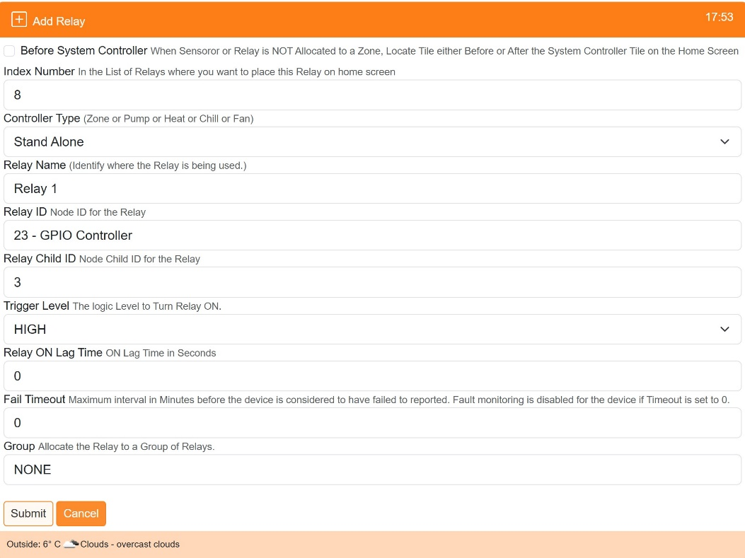
Stand-Alone relays are created either from One Touch/Add Relays or from Settings/Node and Zone Configuration/Relays Add Relays. When creating select ‘Stand Alone’ as the Controller Type.
This category of relay has the option to add to a pre-existing ‘Group’.

Relay Groups
Groups can be created to allow individual Stand-Alone relays to be associated with each other, so that the actions applied to any relay in the group, will be replicated to all other relays in the group. For example a schedule applied to one relay in the group, will be applied to all other associated relays.
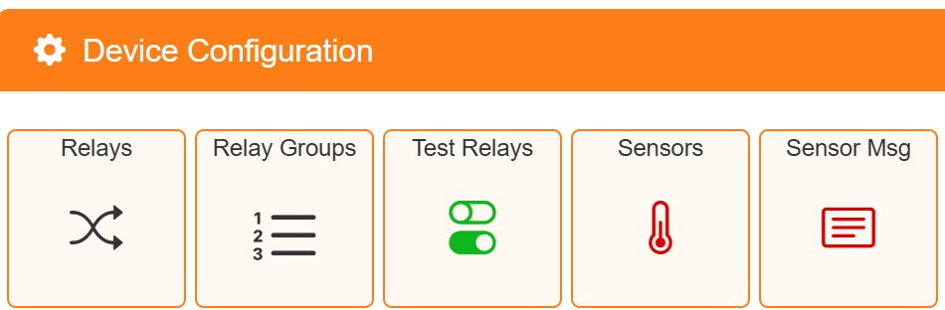
Groups are created from the ‘Settings/Device Configuration/Relay Groups’ menu’

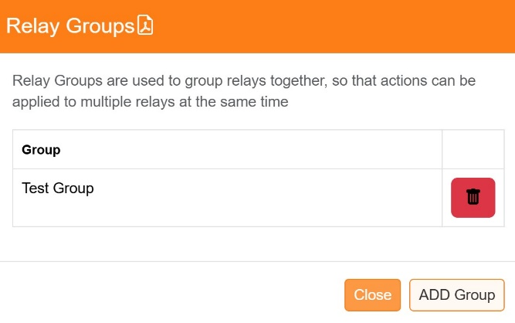
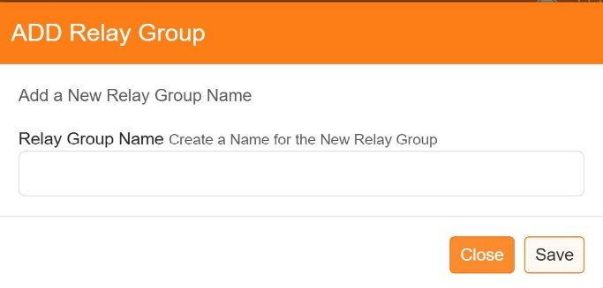
Relay groups can be added or deleted from this menu

Relay Scheduling
Stand-Alone Relays can be scheduled in the same way as Zones are scheduled. See the setup instructions for Scheduling, the only difference is that from the Scheduling screen select to add a ‘Relays’ schedule, rather than a ‘Zones’ schedule.
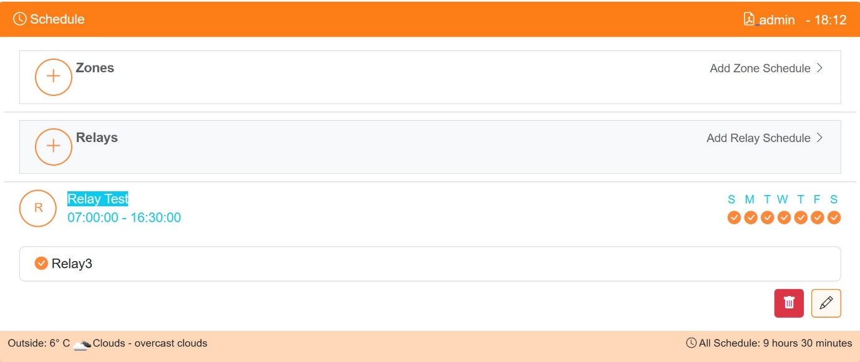

Home Screen Tiles
Stand-Alone relays can optionally be displayed on the Home screen. Their ‘on-click’ action will depend on whether or not the relay has a currently active schedule.
If no schedule is running then clicking on the tile will toggle the state of the relay, the change of state will be reflected in any Group associated relays.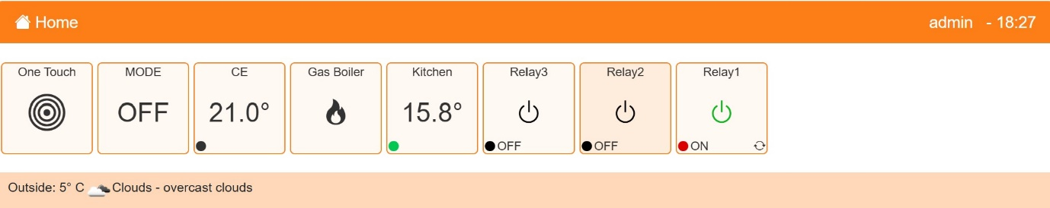

If a schedule is currently active for the relay then
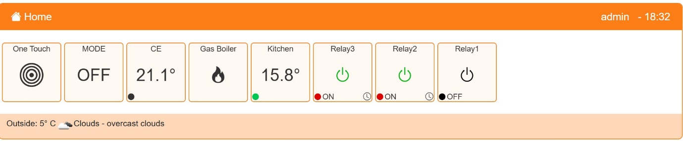
Clicking on the tile will display the schedule status.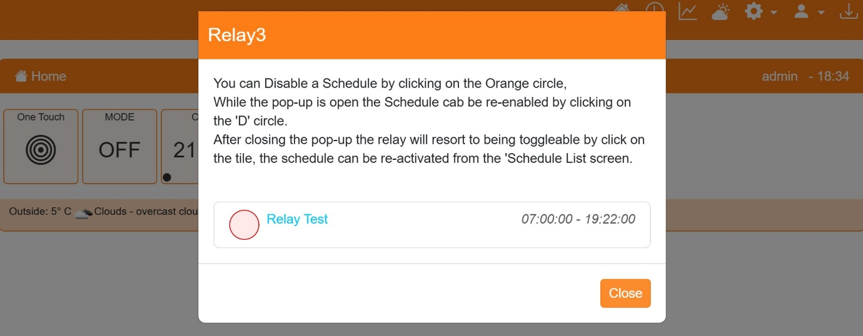
If Grouping is in use then it is possible to only display one of the grouped tiles on the home screen, use the menu option Settings/Device Configuration/Relays to display the list of relays and then un-check any relays that need not be displayed, click on ‘Save’ to set the new configuration.
