Introduction
This feature allows the disabling of any schedule between two dates defined as the ‘Summer’ period. The purpose is for example to disable the central heating schedule during the warm summer months. Functionality is provided to both define the start and end dates for the period and to suspend the disable function using a single button press.

Enabling the feature on a Schedule by Schedule basis
The feature can be setup and enabled from the configure schedule setup screen, a checkbox “Disable Schedule in Summer’, by default the feature is disabled.
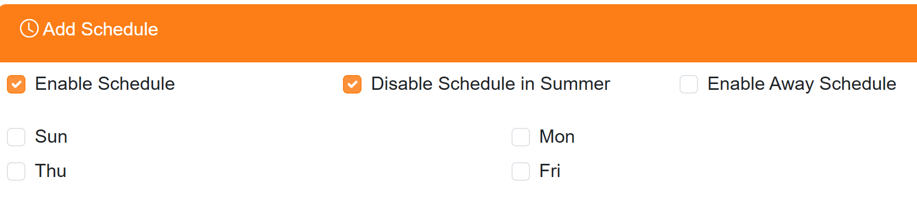

Defining the ‘Summer’ period Start and End Dates
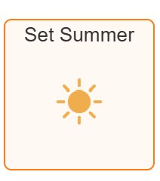
A menu selection Settings/System Configuration/Set Summer is provided to open a popup where the start and end dates can be set.

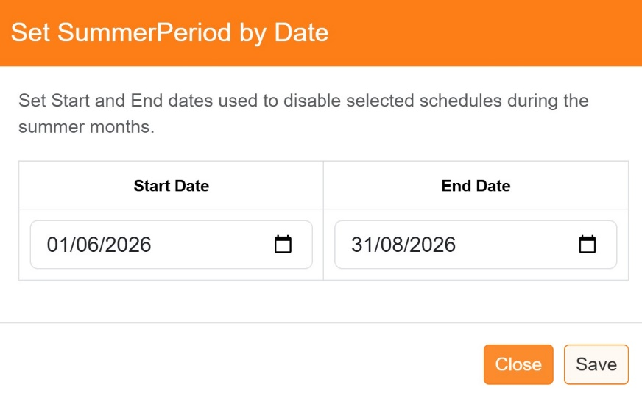
The start and end dates can be entered manually or by invoking the calendar control.
The defaults used are meteorological dates for summer start and end in the northern hemisphere ie. starting on the 1st June and ending on the 31st August.

Note: the year will automatically update on New Years Day of each year.

OneTouch Control
The OneTouch button can be used to re-enable all schedules which have been suspended during the ‘Summer’ period.
During the Winter period clicking on the ‘Summer Mode’ tile will toggle the ON/OFF button text but will not affect the status of the schedule. The lower left hand corner icon will remain as a black circle, the lower right indicator will display ‘Winter’.
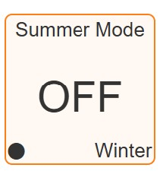
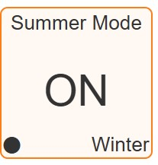

During the Summer period clicking on the ‘Summer Mode’ tile will toggle the ON/OFF button text, in the ON state any schedule where ‘Disable Schedule in Summer’ is checked, will be disabled. The lower left hand corner icon will be shown as a red circle and the lower right indicator will display ‘Summer’. Any effected Zone will show in the lower right hand corner, the disabled schedule icon and a sun icon. In the OFF state any schedule where ‘Disable Schedule in Summer’ is checked, will be disabled, the lower left-hand corner icon will be shown as a blue circle and the lower right indicator will display ‘Summer’, the ‘Disable Schedule in Summer’ function will be suspended.
