‘Message Relays’ provide the ability to display external text information on a Home Screen relay tile in the lower right text area.
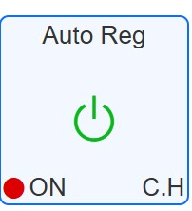
For example, it is possible to display external status information captured from an interface to the boiler. Due to the format of the ‘relays’ table, this information is passed as a numeric code, which must be converted to the message to be displayed on the tile’
The same technique could be used for displaying data from any other external sources.

Implementation

MaxAir
- A ‘Dummy’ node will be created.
- A ‘Message Relay’ device will be created and allocated to the ‘Dummy’ node.
- Mapping information will be created to place the required information on the relay tile.

External System
- The external system will be able to access the MaxAir database from its Python script.
- The required data in the form of a message code will be captured and used to add an entry to the MaxAir ‘relays’ table ‘current_val_2’ column, using the Relay ID created above.

MaxAir Configuration
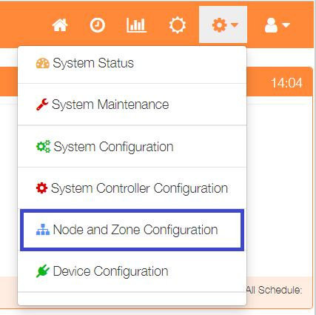
Select ‘Node and Zone Configuration’ from the Settings dropdown list, then click the ‘Nodes’ button.
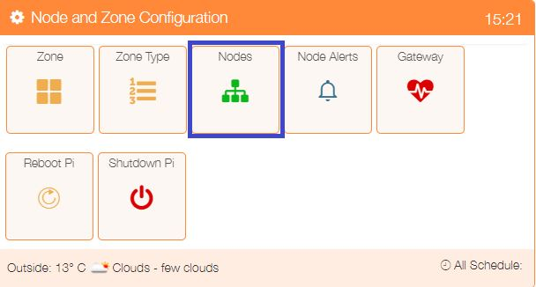

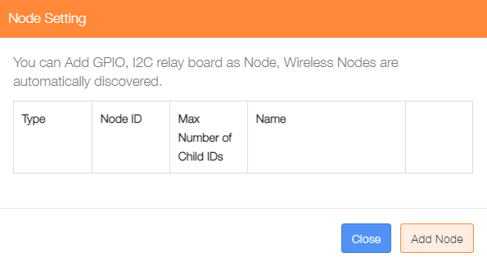

Click on ‘Add Node’.

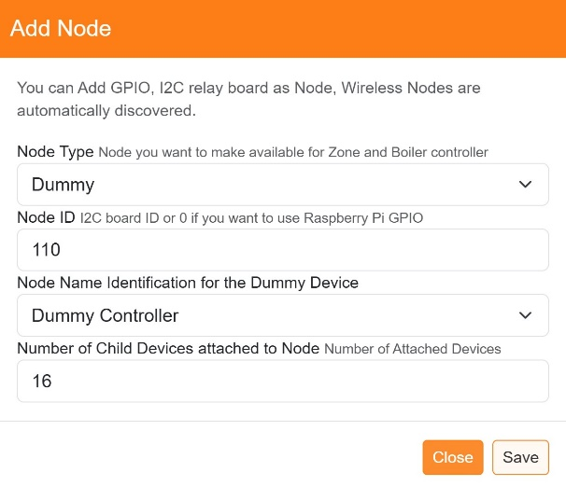
Add a ‘Dummy’ node type, the ‘Node ID’ can be any value not currently in use, and for this example the ‘Number of Child Devices attached to Node’ will be 16.

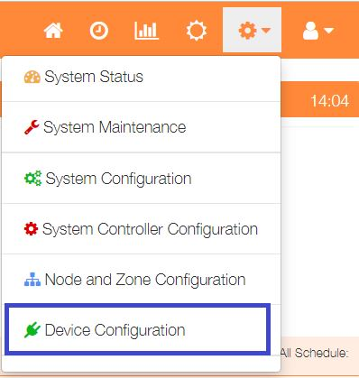

Select ‘Device Configuration’ from the Settings dropdown list, then click the ‘Sensors’ button.

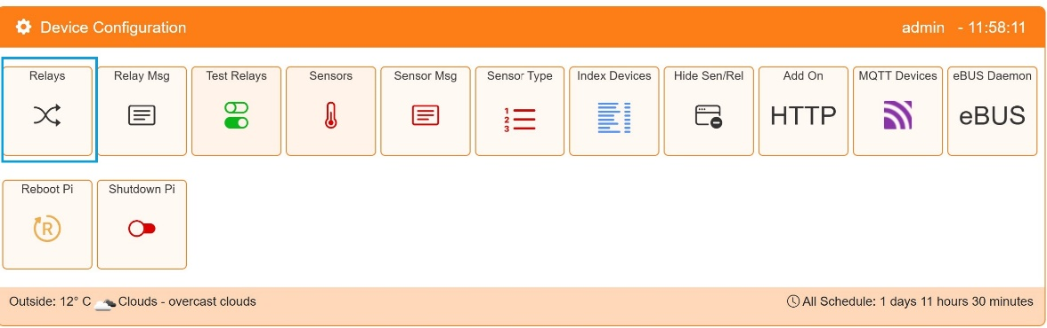
Click on the ‘Add Relay’ button to configure the first sensor

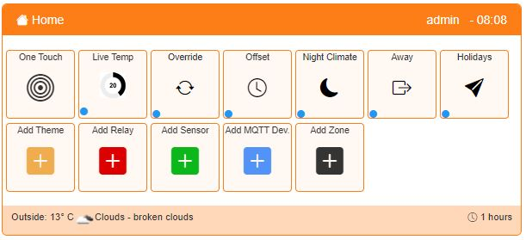
An alternative method to go directly to the Add Relay dialogue, is from the Home screen click on the ‘One Touch’ button then select the ‘Add Relayr’ menu item.

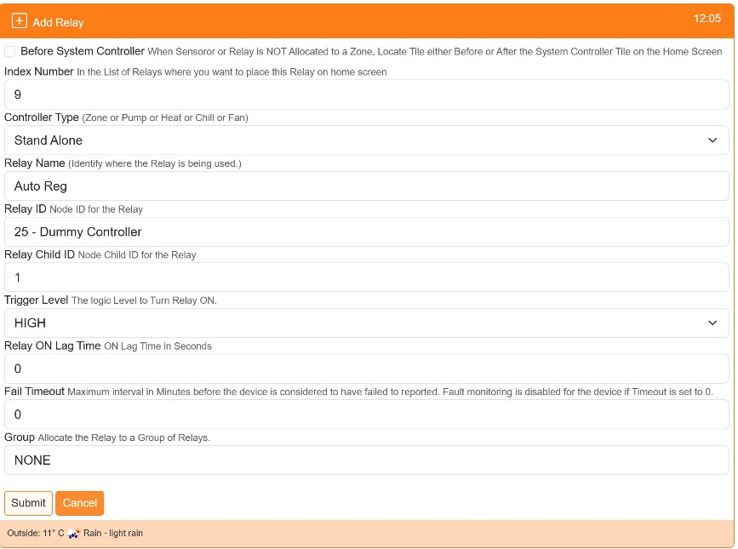
Show before or after the system controller on the Home screen

Used to order where on the Home screen the sensor is displayed

Select ‘Stand Alone’ as type

Provide a name for this relay device

Select the Relay ID from the dropdown list of available Nodes

Choose the Child ID from the dropdown list, for nodes with only 1 relay, this will be 0

Click on ‘Submit’ to add the device.

Select ‘Device Configuration’ from the Settings dropdown list, then click the ‘Relay Msg’ button.

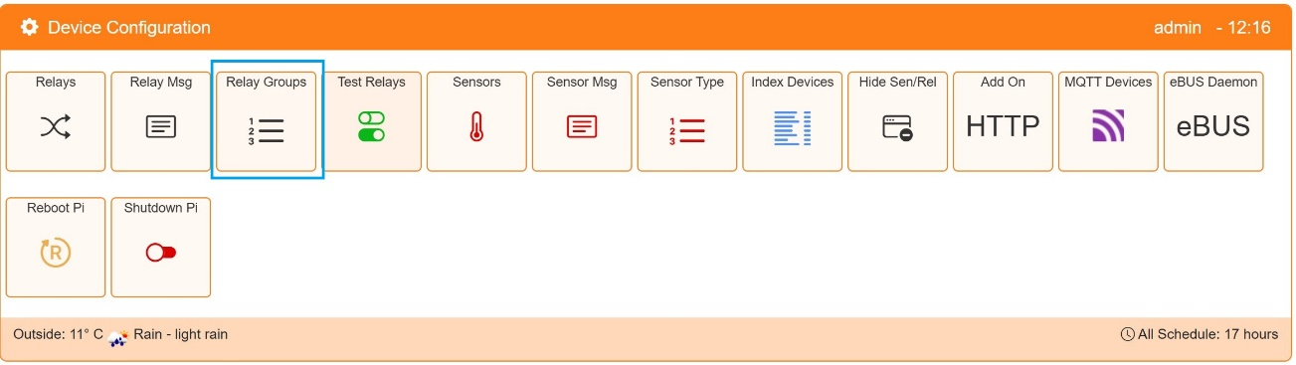
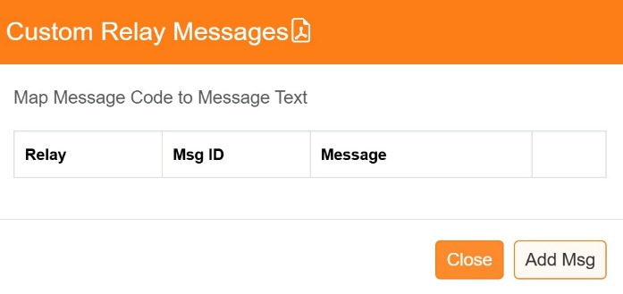
To start building the message mapping, click on the ‘Add Msg’ button.

For a lower right message:

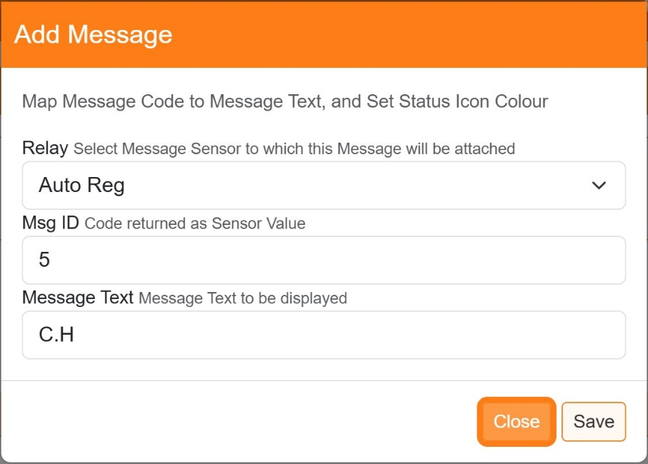

Select the Message Relay

Add the Message numeric code

Enter the text to be displayed

Click ‘Save’ when completed.

Example Python Script to Update the MaxAir Database

#!/usr/bin/env python
import time, datetime, MySQLdb
from configparser import ConfigParser

#### Initialise the database access varables ####
config = ConfigParser()
config.read('/var/www/st_inc/db_config.ini')
servername = config.get('db', 'hostname')
username = config.get('db', 'dbusername')
password = config.get('db', 'dbpassword')
dbname = config.get('db', 'dbname')
nodeID = config.get('db', 'kitchen_node_id')

#### Initialise the database connection ####
con = mdb.connect(dbhost, dbuser, dbpass, dbname)
cur = con.cursor()

# Update MaxAir Database Relays
def update_maxair_relays (conn, relay_id, val_2) :
cnx = conn.cursor()
# get 'current_val_2
cnx.execute("SELECT * FROM `relays` WHERE `id` = (%s) LIMIT 1;",
(relay_id,))
result = cnx.fetchone()
relay_to_index = dict(
(d[0], i) for i, d in enumerate(cnx.description)
)
relay_name = result[relay_to_index["name"]]
relay_child_id = int(result[relay_to_index["relay_child_id"]])
current_val_2 = float(result[relay_to_index["current_val_2"]])
if val_2 != current_val_2 :
# update 'current_val_2'
try :
query = ("UPDATE `relays` SET `current_val_2` = " + str(val_2) + " WHERE `id` = " + str(relay_id) + ";")
cnx.execute(query)
conn.commit()
except mdb.Error as e:
print("DB Error %d: %s" % (e.args[0], e.args[1]))
print(traceback.format_exc())
logging.error(e)
logging.info(traceback.format_exc())
conn.close()
print(infomsg)
sys.exit(1)

cnx.close()
return True

# Find the node and child ids for the dummy relays used to pass data back to the MaxAir database
# ***********************************************************************************************
# check if a 'Auto Regulation' relay exists in the database
regulation_relay = False
cur.execute("SELECT * FROM relays WHERE name = 'Auto Reg' LIMIT 1;")
result = cur.fetchone()
if cur.rowcount > 0 :
relay_to_index = dict(
(d[0], i) for i, d in enumerate(cur.description)
)
auto_reg_id = int(result[relay_to_index["id"]])
regulation_relay_id = int(result[relay_to_index["relay_id"]])
if int(result[relay_to_index["message_in"]]) == 1 :
regulation_msg_in = True
else :
regulation_msg_in = False
cur.execute('SELECT node_id FROM nodes WHERE id = (%s)', (regulation_relay_id, ))
result = cur.fetchone()
if cur.rowcount > 0 :
node_to_index = dict(
(d[0], i) for i, d in enumerate(cur.description)
)
regulation_node_id = int(result[node_to_index["node_id"]])
regulation_relay = True

Loop reading status from boiler and send to MaxAir
while True:
## Derive the value to pass to the indicate which message to use for the lower right indicator, eg. we will use 'heat_curve' as the value ##
heat_curve = 6
# set lower right message if dummy relay exits
if regulation_relay:
# update 'current_val_2'
update_maxair_relays(con, auto_reg_id, heat_curve) # Add Error and Current Status to the messages_in table

time.sleep(1)

