MaxAir implements status indicators, which reflect the current operational state of the system. These indicators vary depending on the function of the on-screen tile.

Zone Tiles
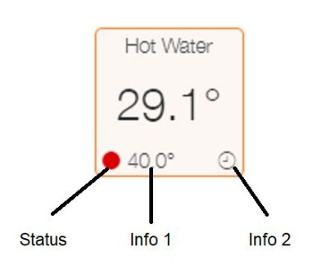

Status | Meaning
 | Fault or Idle
 | Deadband or Coop
 | Away, Holidays or Hysteresis
 | Running
 | All other states

Info 1 | Meaning
Numeric Value | Target Temperature for the Zone

Info 2 | Meaning
 | Controller or Sensor Fault
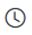 | Schedule Running
 | Zones in Hysteresis in Operation
 | Manual Mode
 | Zone Overrun or Override in Operation
 | Maximum Zone Temperature Exceeded
 | Night Climate in Operation
 | Away in Operation
 | Holiday Schedule in Operation
 | Boost in Operation
 | Running Schedule has been disabled.
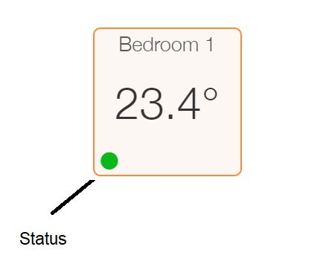

Sensor Tiles

Status | Meaning
 | Normal Operation
 | Sensor has Not Reported within timeout

System Controller Tile
The System Controller Tile uses colour coding of the flame to indicate the current state.
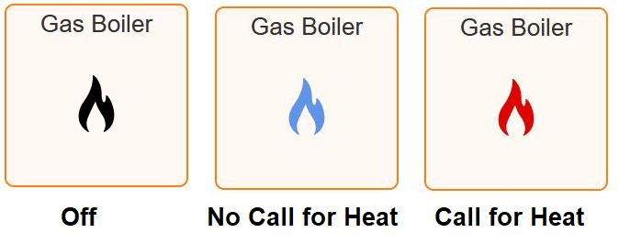

Addition information is shown by the right corner status indicator.
