# MaxAir – Frost Protection

MaxAir includes functionality to protect the Heating/HVAC system from extreme low temperature environmental conditions.

The system works by setting a low temperature trigger for one or more temperature sensors and then associating a controller relay or relays to be activated if the trigger temperature is reached.

Frost Protection can be activated when a temperature sensor is Added or Edited

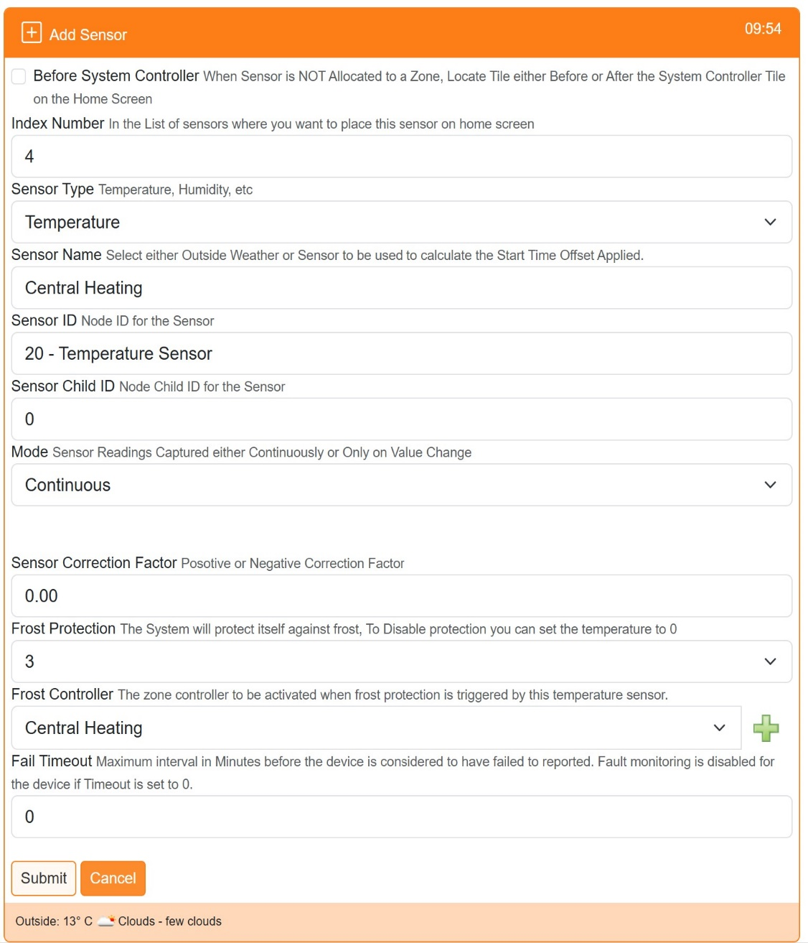

Set the trigger temperature or 0 to disable

Select controller relay/s to be activated by the trigger

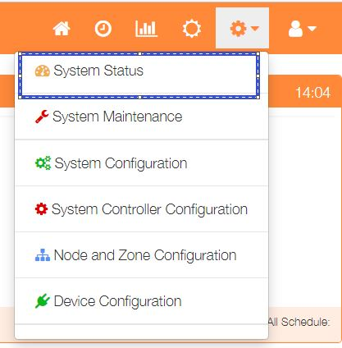

The Frost Protection configuration can be view by selecting ‘System Status’ from the Settings dropdown list, then click the ‘Frost’ button.

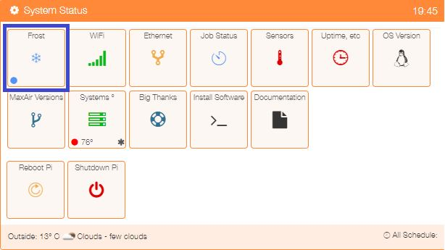The status indicator in the lower left‑hand corner of the ‘Frost’ tile will show the current state of Frost Protection:

* Blue – No Frost Protection
* Red – One or more zones in Frost Protection mode

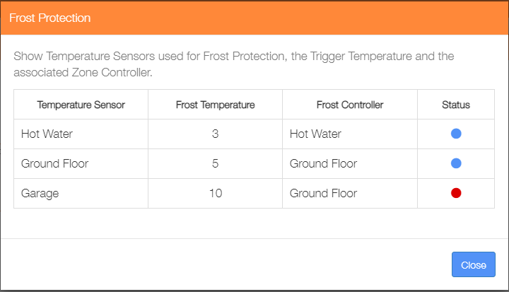

This example shows the Hot Water Sensor triggering the Hot Water Zone at 3°

The Ground Floor Sensor triggering the Ground Zone at 5°. The Ground Floor Zone is also triggered by the Garage Sensor at 10°

The Status indicators show that Frost Protection is currently active, triggered by the Garage Sensor.