I built this app using the EF Core 2 tutorial found at:

<https://docs.microsoft.com/en-us/ef/core/get-started/aspnetcore/new-db?tabs=visual-studio>

<https://www.entityframeworktutorial.net/efcore/entity-framework-core.aspx>

I created a basic (barebones) ASP.NET Core app, then added the following NuGet packages:

* Microsoft.EntityFrameworkCore.SqlServer
* Microsoft.EntityFrameworkCore.Tools
* AutoMapper
* AutoMapper.Extensions.Microsoft.DependencyInjection

Screenshot:

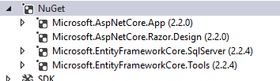

To configure AutoMapper, I used this:

<https://stackoverflow.com/questions/40275195/how-to-setup-automapper-in-asp-net-core>