**Instructions for updating the DLPDLCR471TPEVM Firmware Bootloader to v3.2.2.**

**NOTES:**

1. **The new Firmware Bootloader v3.2.2 should be installed before the new Main App v3.2.5 (or later) is installed.**
2. **Please refer to the** [**DLPDLCR471TPEVM User’s Guide**](https://www.ti.com/lit/pdf/dlpu105) **for EVM description and operating instructions. Compatible AC-DC power adapter requirements are included in the User’s Guide (UG).**
3. **Updating Bootloader**
4. Before executing the bootloader_update_x54x-1.1.0-Setup.exe file provided with this README file, do the following steps:
   1. Close the EVM GUI program if it is open.
   2. Connect a compatible power supply per UG requirements and instructions.
   3. Turn AC power on.
   4. Turn SW1 (PROJ_ON) switch on to turn on projector.
   5. Wait for splash image to appear.
5. Connect your computer to the EVM with a USB A-Micro B cable.
6. Navigate to and double click on the bootloader_update_x54x-1.1.0-Setup.exe file.
7. The following Welcome Window will pop-up. Click Next> button to continue.

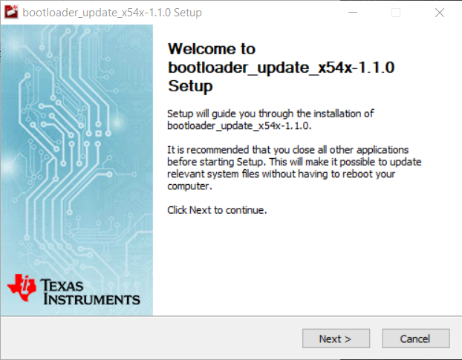

1. The License Agreement will pop-up. Click I Agree button to accept and continue.

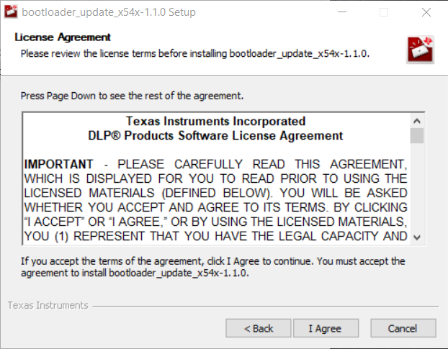

1. The Choose Install Location Window will pop-up. Follow instructions to accept default destination folder or select another folder to install the Bootloader Update program on your computer. Click Install to continue.

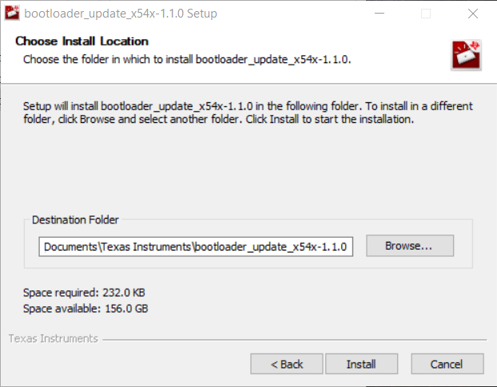

1. The Completing Setup Window will pop-up. Leave both check boxes selected and click the Finish button to continue.

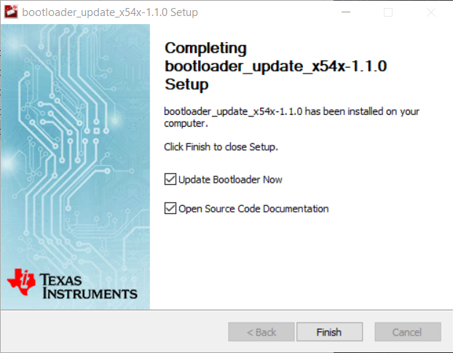

1. The Installation Complete Window will pop-up indicating the program has been successfully installed on the computer. Click the Next> button to continue.

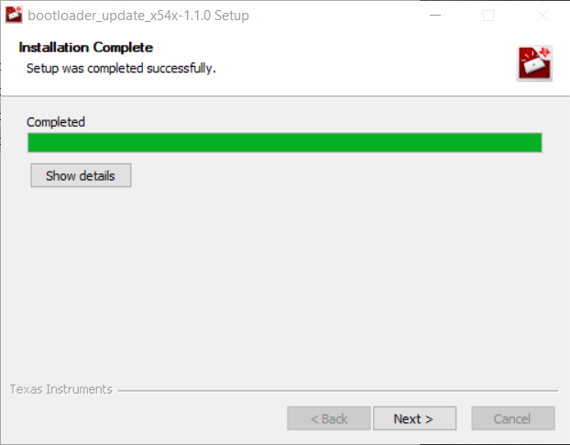

1. The new bootloader firmware will be flashed into the EVM flash memory as shown in the following command window with successful completion. 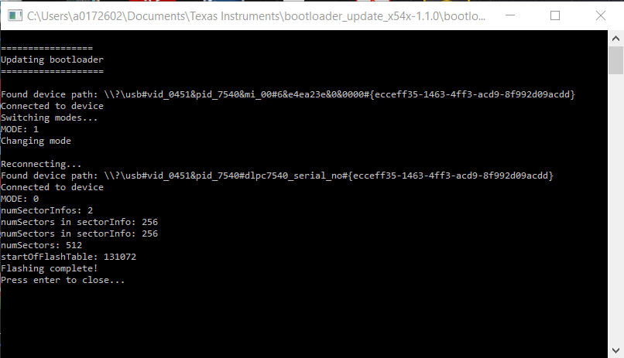
2. Press <Enter> key to close the command window, which completes the bootloader update.
3. Switch SW1 OFF and then back ON to reset the EVM and display splash image again.
4. The user must install and use the [DLP417TP EVM Graphical User Interface (GUI)](https://www.ti.com/tool/DLPDLC-GUI) program so that the latest Main App Firmware can be installed next. Follow the instructions provided with the new Main App firmware release, or the programming procedures in the [EVM GUI User’s Guide](http://www.ti.com/lit/pdf/dlpu074).

If update fails, contact engineering support through the [DLP Products and MEMS TI E2E™](https://e2e.ti.com/support/dlp__mems_micro-electro-mechanical_systems/f/993) community support forums.