Page 1 of 8

Medical Entity vocabulary extension proposal of schema.org

1. The goal:

To extend the medicalEntity vocabulary of schema.org.

2. Rationale:

MedicalEntity and subtypes vocabulary provided in schema.org are largely used by content publishers that wish to mark up health and medical content on the web. Like all schema.org schemas, the health and medical schema is intended to make it easier for people to find the right web pages by exposing structured information contained in web pages to search engines, and may also enable other applications that make use of the structure.

However, given the complexity of health and medical content, some classes and predicates were missing, or incompletely defined to achieve this indexing use. Today, most of health and medical web content are structured documents, based on clinical information models or HL7 standards (HL7 V3 RIM, CDA, C-CDA, FHIR etc.) and are integrating existing vocabularies and terminology (SNOMED, ICD, LOINC, ATC, RxNorm etc.).

Moreover, some case use scenarios go beyond this simple indexing: schema.org has been used in recent health APIs, as a pillar source of medical ontology/vocabulary for formalization of healthcare information, through RDF graphs which is a high contribution to the semantic web interoperability. To meet those challenges it was necessary to extend the MedicalEntity vocabulary and take this opportunity to refine some of existing concept (classes and predicates).

The intention here is neither to have a comprehensive medical ontology nor provide a clinical information model nor define or codify a new controlled medical vocabulary, but to provide a scalable, use-driven vocabulary schema, in-line with the schema.org philosophy.

3. Approach used:

In this design, none of existing concepts (classes and predicates) are renamed or deleted. There are only additions of new classes/predicates and extensions (definitions or domain and range) on the existing concepts. For granular classes the priority is given to use the schema.org vocabulary in clinical information models which use classes from existing vocabularies and terminology (SNOMED, ICD, LOINC, ATC, RxNorm etc.) so the new concepts are minimized. This is a scalable approach as schema.org can’t include all those granular concepts.

Additional, staying in schema.org best practice and philosophy we avoided some discussions interfering with high-level schema.org design. Finally to refine existing concepts or for a better
Page 2 of 8

integration of new concepts, there was hierarchy rebuild, like declaring existing schema classes/properties as subClass of or subPropertyOf.

4. High level overview of the principle changes

The proposal contains 3 types of changes:

- Changes: only hierarchies (purpose: corrections of existing hierarchy or for integrating new proposed classes/predicates)

  - Class : 18

  - Predicates : 9

- Deletions: 0

- Additions/extension

Class : 172 (Overview here)

Predicates : 173 (Overview here)

A table showing all changes details is provided below, but in nutshell changes are:

Classes:

-Added AnatomicalOrgan and AnatomicalRegion classes under hierarchy of AnatomicalEntity class and related properties

-Extended subclass of AnatomicalSystem class and related properties -Extended subclass of MedicalSignOrSymptom class and related properties

-Big extension in MedicalProcedure with a one change (actually additional declaration) of making the MedicalTherapy a subclass of TherapeuticProcedure class, itself a subclass of MedicalProcedure class. The PreventiveProcedure become a subclass of MedicalProcedure class as well.

-extending Person class with Patient class as subclass.

-making the Drug also a subclass in low level hierarchy of Substance (the new class).

- Extended subclass MedicalEnumeration (some of subclasses are the existing ones: see below table).

-New classes added.

Properties:

-adverseOutcome, location, provider, medicalSpeciality and procedure were extended with granular

subproperties

-status was extended with 2 granular subproperties
Page 3 of 8

-introduction of Snomed concepts use as domain/range objects (not always but where there was no clear similar schema.org existing class)

-new properties added.

Comparing the existing schema.rdfa file and the proposed schema.rdfa patch, there are in total 2578 insertions (+), 59 deletions (-), 25 fixes (changes in subPropertyOf/subClassOf/rdfs:comment in existing properties/classes) , 0 class/predicate rename and 0 class/predicate deletions.

We are aware that some improvement may be required even beyond official publication, but those will be minimal.

Table1. The suggested change details:

Current version | Proposal version | Rationale
:AnatomicalStructure  subClassOf  :MedicalEntity | :AnatomicalStructure  subClassOf  : AnatomicalEntity | AnatomicalEntity was  suggested as parent of all  anatomical related concepts  what is more scalable if one  day we need to extend  anatomy vocabulary
: AnatomicalSystem  subClassOf  :MedicalEntity | : AnatomicalSystem  subClassOf  : AnatomicalEntity | cfr supra
: MedicalProcedure  rdfs:comment | rdfs:comment Definition extended | The definition change to  cover all medical related  procedure
: MedicalTherapy  subClassOf  : MedicalEntity | : MedicalTherapy  subClassOf  : TherapeuticProcedure | TherapeuticProcedure was  suggested as parent of all  therapeutic concepts in scope  of rebuilding  MedicalProcedure entity  (mainly to comply with  medical terminologies:  Snomed and HL7 standards)
: Drug  subClassOf  :MedicalEntity | rdfs:comment Definition extended  : Drug  subClassOf  : PharmaceuticalSubstance | PharmaceuticalSubstance  was suggested as parent of  all Pharmacological  substance which extends the  vocabulary

Page 4 of 8

: DrugClass  subClassOf  : MedicalTherapy | : DrugClass  subClassOf  : MedicalEnumeration | Since the MedicalTherapy is  defined as a medical  procedure it cannot have a  DrugClass (defined here as  list item/concept)as children.
: MedicalEnumeration  rdfs:comment | rdfs:comment Definition extended | This concept class seems to  be the same as the medical  observation defined with  Snomed. The definition was  updated to reflect its  hierarchy content.
: MedicalCondition  subClassOf  :MedicalEntity | : MedicalCondition  subClassOf  : ClinicalFinding | ClinicalFinding was  suggested as parent of all  medical condoition  (disorders) concepts what is  in line with Snomed  terminology.
:AnatomicalStructure  subClassOf  :MedicalEntity | :AnatomicalStructure  subClassOf  : AnatomicalEntity | AnatomicalEntity was  suggested as parent of all  anatomical related concepts  what is more scalable if one  day we need to extend  anatomy vocabulary
: Patient  subClassOf  : MedicalAudience | : Patient  subClassOf  : MedicalAudience  : Patient  subClassOf  : Person
: MedicalClinic  subClassOf  : MedicalOrganization | : MedicalClinic  subClassOf  : MedicalOrganization  : MedicalClinic  subClassOf  : HealthFacility | HealthFacility was suggested  as parent of all health related  premises what is more  covering other places like  medical room, wards, etc.
: Ultrasound  subClassOf  : MedicalImagingTechnique  : MedicalImagingTechnique  subClassOf  : MedicalEnumeration | : Ultrasound  subClassOf  : MedicalImaging | MedicalImaging is the most  correct parent as it’s defined  here as a medical procedure.
: SurgicalProcedure  rdfs:comment | rdfs:comment Definition updated
: MedicalSignOrSymptom  subClassOf  :MedicalEntity | : MedicalSignOrSymptom  subClassOf  : MedicalCondition | Following the Snomed  hierarchy.

Page 5 of 8

: MedicalSignOrSymptom  rdfs:comment  : MedicalSymptom  rdfs:comment | rdfs:comment  Definition updated  rdfs:comment  Definition updated | Disambiguation (vs  MedicalSign)
: PhysicalExam  subClassOf  : MedicalEnumeration | : PhysicalExam  subClassOf  : MedicalProcedure  rdfs:comment  Definition updated | PhysicalExam is here defined  as a procedure. So is fitting  well in medical procedure  hierarchy and not in  enumeration.
: VitalSign  subClassOf  : PhysicalExam | : VitalSign  subClassOf  : MedicalSign | VitalSign is here defined as a  sign. So is fitting well in  medical sign hierarchy and  not in physical exam (which  is a medical procedure).
: PsychologicalTreatment  subClassOf  : MedicalTherapy | : PsychologicalTreatment  subClassOf  : TherapeuticProcedure | PsychologicalTreatment is is  fitting well in  TherapeuticProcedure  hierarchy and not in  MedicalTherapy.
: cause  rdfs:comment | rdfs:comment  Definition updated
: comprisedOf  rdfs:comment | rdfs:comment  Definition updated
: diagnosis  :domainIncludes | domainIncludes  Domain/range extended  rdfs:comment  Definition updated
adverseOutcome, location,  provider, medicalSpeciality,  procedure, |  | extended with granular  subproperties

- How will look like after implimenting the proposal

Class hierarchy overview (Can be seen in full here)
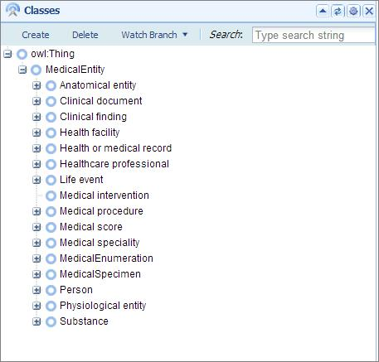
Page 6 of 8

5.2. Class hierarchy details (the displayed text reflects labels not item name)
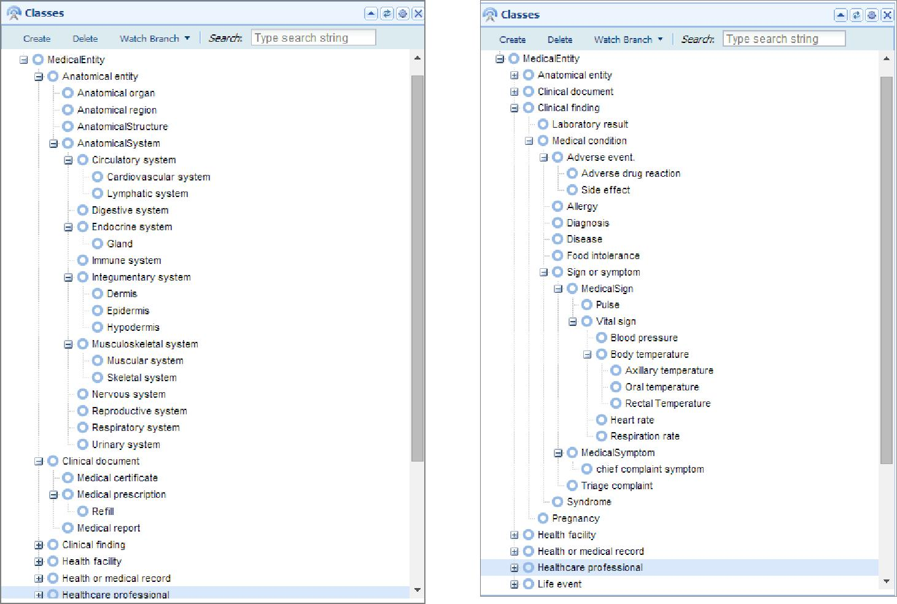
Page 7 of 8
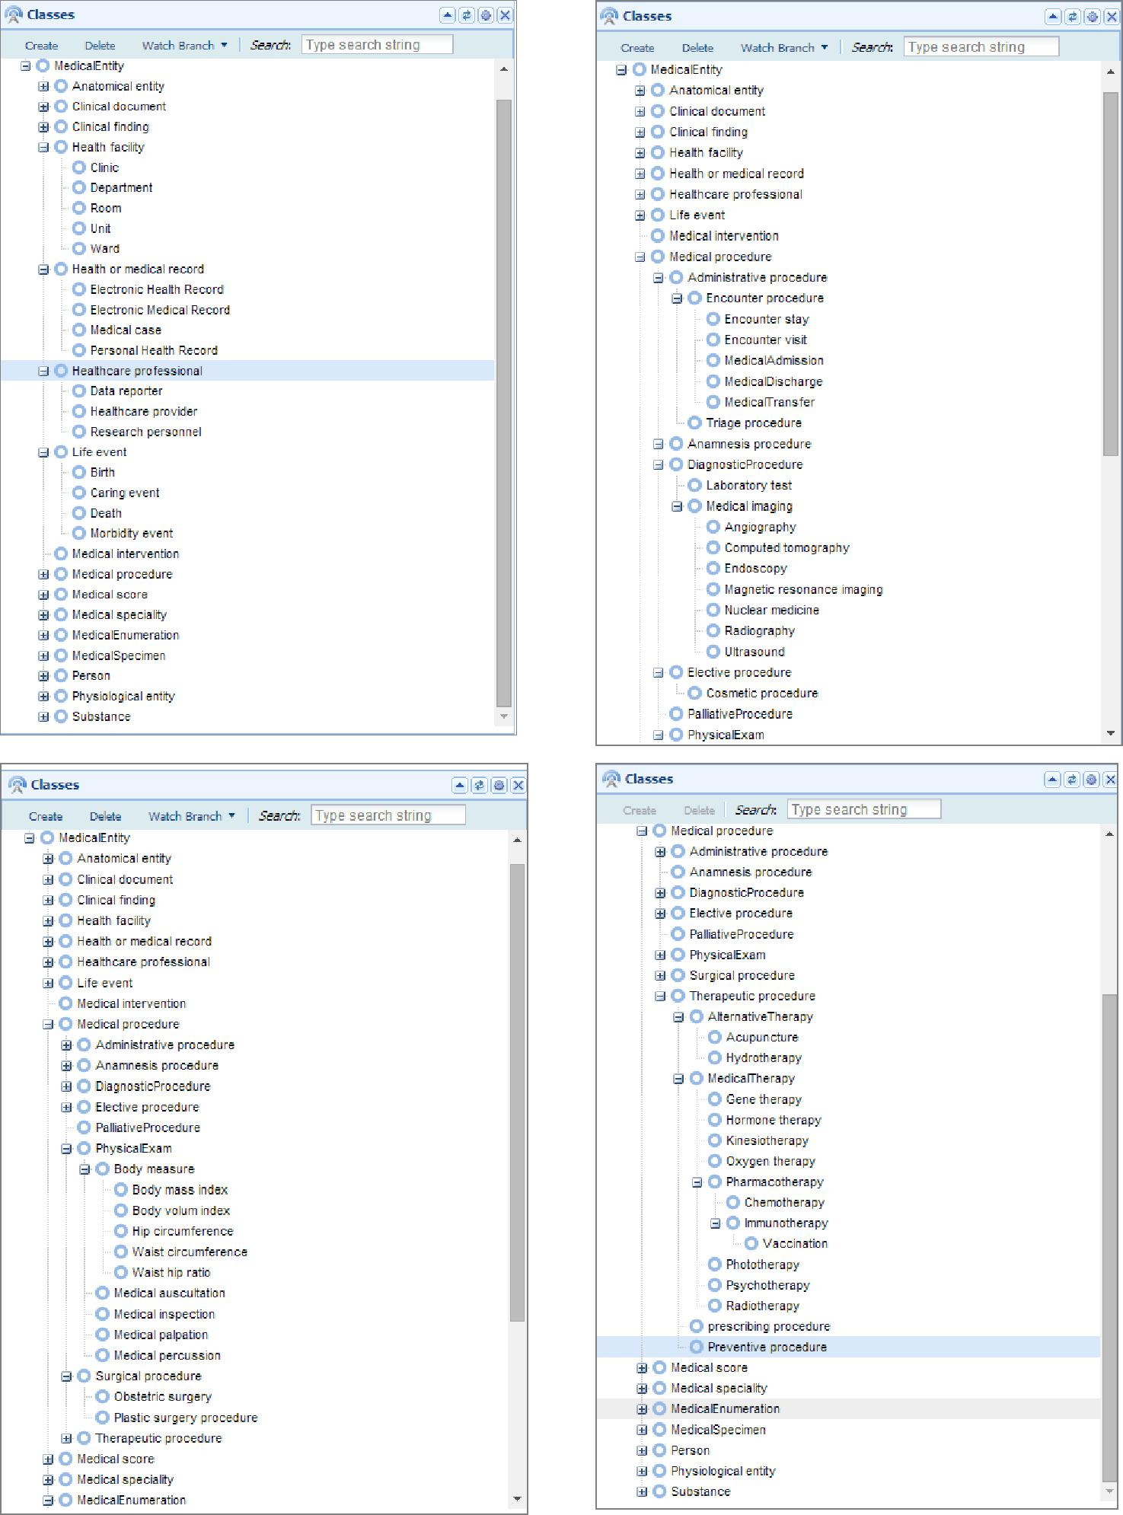
Page 8 of 8
