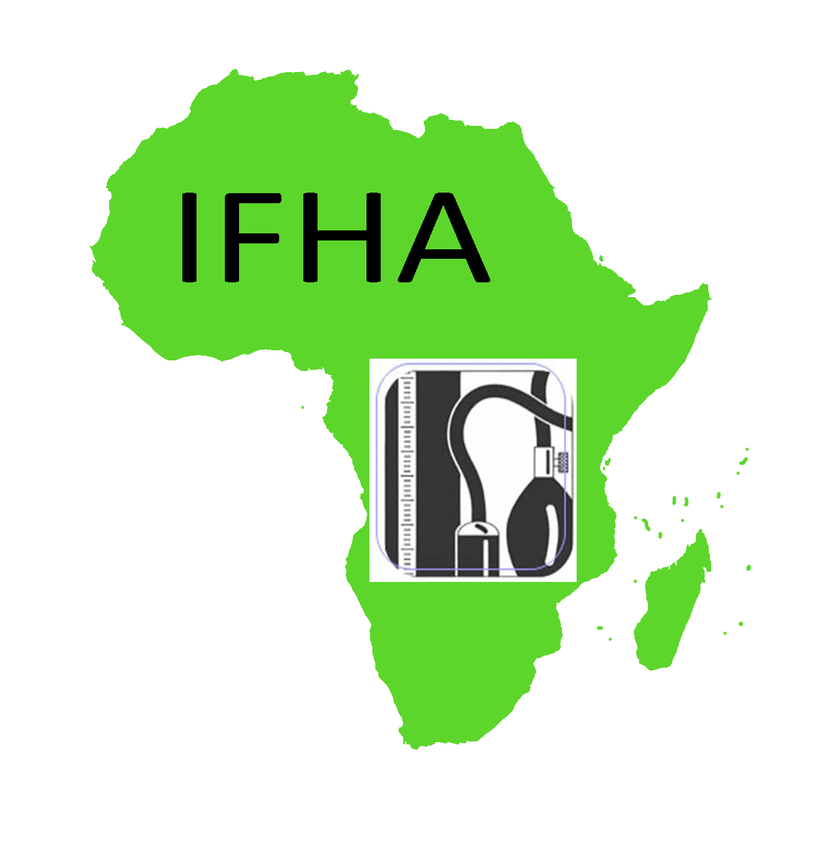
REGISTRATION FORM Page 2
IFHA – 4th African Scientific Meeting on Hypertension

Kinshasa, Democratic Republic of Congo (DRC),
07-08 May 2010

Please complete clearly and in BLOCK CAPITALS

Last Name: …………………………………………………………………First Names:…………………………………………………………………………………. Prof/Dr/Mrs/Miss/Ms etc: ……………………………….□ Male □ Female Speciality: …………………………………………………………………………………..Grade: ……………………………………………………………………….
Work address:………………………………………………………………………………………………..................................................…
………………………………………………………………………………………………………………………………………………………………………………………………………………………………………….. City:…………………………………………………………………………………………………………………………………………………………………………………… Post/Zip Code:……………………………………………………………………Country: ………………………………………………………………………………. *Email:…………………………………………………………..………………………………………………….……………………………………………………………... Business Tel. No: …………………………………………………………Fax No:…………………………………………………………………………………………

*NB: It is important that you provide an e-mail address so that notification can be sent to you when the final details of the conference are available on the conference website

Registration Fee | Please tick () relevant box |  | Payment $
❑ 50.00$ US (Members)   75.00$ US (Non-members)   25.00$ US (Trainee/Student*) | The $50 registration does not cover accommodation. It covers 2 lunches (Friday and Saturday - 07&08 May). Individuals may book accommodation directly from the website or Go to this website to book directly from the hotel  HOW TO REGISTER  Delegates can register ON-LINE for the conference, AND PAY using a secure credit card payment site. Note that On-site registration is only cash payment, either in Euros ,$ US, or Congolese franc (CDF)  * Students should attach a letter from their Head of Department/Supervisor confirming their status to the registration form
Attendance and Social Events  Please tick () relevant boxes | ISH Teaching seminar, 05-06/05/2010 | Friday, 07/05/2010 | Saturday, 08/05/2010
I will be attending the Hypertension Teaching Seminar | □ Yes  □ No  | □ Yes      □ No  | □ Yes      □ No 
I will be attending the IFHA – 4th African Scientific Meeting on Hypertension. | □ Yes  □ No  | □ Yes      □ No  | □ Yes      □ No 
I will attend the Welcome Reception on Friday, 07/05/2010 | □ Yes  □ No  | □ Yes      □ No  | □ Yes      □ No 
I will attend the Conference closing Dinner on Saturday, 087/05/2010 | □ Yes  □ No  | □ Yes      □ No  | □ Yes      □ No 
I will require single (or double) accommodation on: | □ Yes     □ No  | □ Yes      □ No  | □ Yes      □ No 
Please indicate any special requirements:
□ Vegetarian □ Other (Please state foods that you are unable to eat)………………………………..……………………
…………………………………………………………………………………………………………………………………………
□ Access Needs: (Please specify, e.g. wheelchair user, mobility difficulties, hearing impaired etc)……………………………………
…………………………..………………………………………………………………………………………………………………………………

REGISTRATION FORM Page 2
IFHA – 4th African Scientific Meeting on Hypertension

Kinshasa, Democratic Republic of Congo (DRC),

07-08 May 2010

Name of delegate: ________________________________________

(Please enter your name again here, to avoid confusion in the event of pages 1 and 2 becoming separated in a faxed transmission – thank you)

Payment Details | Please tick () relevant box below All payments to be in Euros Registrations will not be accepted without payment Please fully complete – all sections are essential in order to process payment
□ By Cheque/ Bank transfer | Payable to :  ADF-IFHA (Clermont -00744, France)  IBAN: FR76 3000 3007 4400 0508 0412 192  BIC/SWIFT: SOGEFRPP
□ Please deduct the total sum due from: | Credit Card: ◻ MasterCard ◻ Visa Card  No: ___________________________________  Card Security Code (last 3 digits of code on the back of the card): ______________  Expiry Date: ____________  Cardholder’s Signature:_______________________________  Please note credit card payments are subject to an additional charge (MasterCard & Visa: 2.95%) Name and address (including postcode) of the cardholder: ________________________________________________________________________________________________________________________________________________________________________________________________________________________________________________________________________________________________________________________________________________________________________
By returning the completed registration form you are confirming agreement for your name and town being listed on the participants list, to your e-mail address being used by the Secretariat and to the terms and conditions of the meeting including cancellation policies on the preceding pages

Please return to:
IFHA, International Secretariat,
ULB – ERASME HOSPITAL,
808 Lennik road, 1070 Brussels.
Contact: Dr Daniel Lemogoum
For early processing send a scanned copy to Professor JR M’Buyamba-Kabangu (jerembu@yahoo.fr) Copy to General Secretary Office (dsg@ifha-online.org; sg@ifha-online.org ); but you must send hard copy to above indicated address, mandatory.

