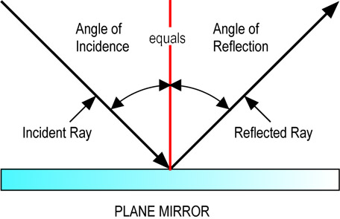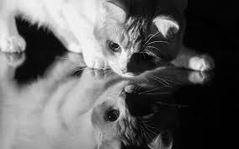

Physics Lab: Waves Unit

Reflection and Refraction

Name: ___________________________________________ Date: _________________

**Materials:**

Station # 1: Light box, pencil/pen, paper, and protractor

Station # 2: Water box, pencil/pen, paper and protractor

**Station #1 Procedure: Reflection**

1) Place the light box onto your paper in the middle

2) Trace the light box and mirror onto your paper

3) Turn the light box on and trace the light beam as it A) comes into the mirror and B) leaves the mirror

4) Turn the mirror to a different angle and repeat steps 1-3

5) Turn the mirror to 90 degrees to the beam of light and repeat steps 1-3

6) Make sure light box is OFF and proceed to the Station # 2

**Data:**

Make accurate diagram of each step of this station’s procedure. Each diagram will include; a) the incoming ray b) the reflected ray c) the surface of the mirror d) the normal line e) the incident angle f) the reflected angle e) the light box.

Mirror at an angle to the light box

Mirror at a different angle to the light box

Mirror straight across from the light box (10 pts.)

Table 1: Reflection: Using your diagrams, measure the incident and reflected angles of the light.

|  |  |  |
| --- | --- | --- |
| Position of light box | Incident Angle | Reflected Angle |
| At an angle to the mirror |  |  |
| At a different angle to the mirror |  |  |
| Straight across from the mirror | O |  |

**Station #2 Procedure: Refraction**

1) Place water box on your paper

2) Trace the outline of your box onto your paper

3) Place the pencil in front of your water box and locate the pencil’s image from behind the box. Mark the location of the pencil’s image with an R (for refracted).

4) Mark the actual position of the pencil with an I (for incident).

5) Move the Pencil to another position and repeat steps 1-4.

6) Move the Pencil so that it is directly across from your eye and repeat 1-4 again.

**Data:**

Make accurate diagram of each step of this station’s procedure. Each diagram will include; a) the incoming ray b) the refracted ray c) the surface of the water box d) the normal line e) the incident angle f) the refracted angle g) the water box.

Pencil at an angle to the water box (10 pts. )

Pencil at a different angle to the water box (10 pts.)

Pencil straight across from the water box (10 pts.)

Table 2: Refraction: Use your diagrams to measure the incident and refracted angles.

|  |  |  |
| --- | --- | --- |
| Position of Pencil | Incident Angle | Refracted Angle |
| At an angle to the water box |  |  |
| At a different angle to the water box |  |  |
| Straight across from the water box | O |  |

**Lab Questions**: Answer the following questions in complete sentences and use the correct terms from this unit. All students must write their own answers here, in their own words.

1. Explain the Law of Reflection using data from your lab results to support your answer. Be sure to state the Law of Reflection in your answer.
2. Explain Refraction and use data from your lab to support your answer. Be sure to define refraction in your answer.