Name: _______________________________________________________________________
Review for Waves Exam
List all important equations from this unit (there are ~3):

Vocabulary

- mechanical waves
- longitudinal waves
- transverse waves
- frequency
- wavelength
- velocity of waves
- medium
- volume
- pitch
- refraction
- reflection
- Doppler Effect
- Electromagnetic waves
- Electromagnetic spectrum
- Amplitude
- Period
- Constructive interfernce
- Destructive interference

  - If you are 3,000 m away from a lightning strike, how long will it take for the sound to reach you?

  - Draw a picture to show how light behaves when shined on a surface. Show how would it be reflected, and below explain how you know. In your explanation include an explanation of incidence rays, reflected rays, as well as the angle of incidence and angle of reflection. Include those in your picture and label them.

  - What happens to the speed of a wave if you change its frequency? Wavelength? Amplitude? What is the only way to change speed?

  - How does changing the frequency of a sound wave affect what you hear? How does changing the amplitude affect what you hear?

  - As the frequency of a wave increases, what happens to its wavelength?

  - What is the difference between reflection and refraction?

  - What is the frequency of a sound wave with a wavelength of 50 m and a speed of 340 m/s? Show GEMA

  - What is the frequency of a wave with a period of 10 s?

  - What is the wavelength of a sound wave with a period of 4 seconds?

  - What is the frequency of a wave with a wavelength of 10 m and a speed of 1500 m/s?

  - On the wave below, write the letter on the line that correctly labels the following terms:
- Amplitude
- Wavelength
- Crest
- Trough

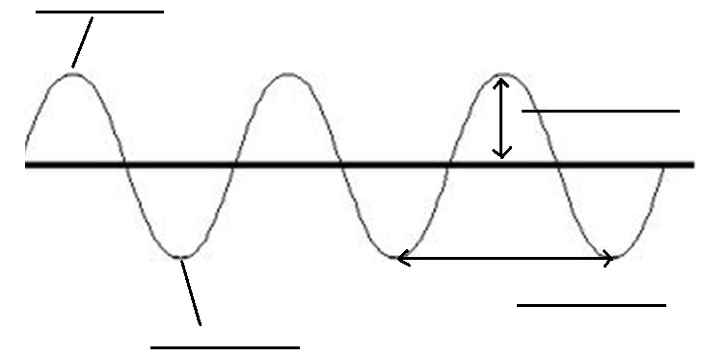

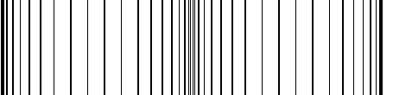
  - Circle the correct word(s) below that describe this wave:

This wave is longitudinal / transverse. The energy moves left and right / up and down and the medium moves left and right / up and down. The energy and medium move parallel / perpendicular to each other.

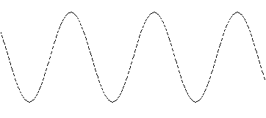
  - Circle the correct word(s) below that describe this wave: .

This wave is longitudinal / transverse. The energy moves left and right / up and down and the medium moves left and right / up and down. The energy and medium move parallel / perpendicular to each other.

14. Determine if each of the following is an example of simple harmonic motion (yes or no).
- A pendulum. ________
- A child swinging on a swing set. ________
- A car driving down the street. ________
- A hammock swaying back and forth in the wind. ________
- A firefighter climbing a ladder. ________
- A subway train accelerating from a stop. ________
- A mass hanging from a spring, bouncing up and down. ________

15. Use wave (a) and wave (b) below to circle the correct answers in #11 through #15.
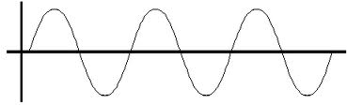
- (b)

- Wave (a) has a higher / a lower / the same frequency compared to wave (b)
- Wave (a) has a longer / a shorter / the same wavelength compared to wave (b)
- Wave (a) has a larger / a smaller / the same amplitude compared to wave (b)
- Wave (a) has a higher / a lower / the same pitch compared to wave (b)
- Wave (a) is louder / quieter / the same volume compared to wave (b)

16. If you increase the frequency of a wave, its wavelength will _________________
a. increase
b. decrease
c. stay the same

17. If you increase the frequency of a wave, its amplitude will _________________
a. increase
b. decrease
c. stay the same

18. Use the wave drawn below to answer the questions: 19. Use the wave drawn below to answer the questions:

: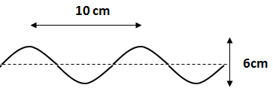 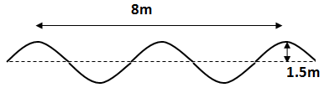
- What is the wavelength? What is the wavelength?

- What is the amplitude? What is the amplitude?

- If a water wave oscillates up and down three times each second and the distance between wave crests is four meters…

  - What is its frequency?

  - What is its wavelength?

  - What is its wave speed?

- A wave has a period of 0.75 seconds. What is its frequency?

- A wave has 20 cycles in 40 seconds. What is the period of the wave?

- When a vibration matches the natural frequency of an object, causing the waves to get bigger and bigger, this is called ___________________________.

  - Give one example: _________________________________________________________________________________
_________________________________________________________________________________

- Draw a transverse wave with a high frequency and large amplitude:

- Draw a transverse wave with a low frequency and small amplitude:

- Draw a transverse wave with a long wavelength and large amplitude:

- Draw a transverse wave with a short wavelength and large amplitude:

- A ray of light in air (n=1.00) strikes a block of quartz at an angle of incidence of 30º. The angle of refraction of refraction is 20º. What is the index of refraction of the quartz?

- One ray of light in air (n=1.00) strikes a diamond (n=2.42) and another strikes a piece of fused quartz (n=1.46), in each case at an angle of incidence of 40º. What is the difference between the angles of refraction?

- The following two waves overlap as shown below. Will they interfere constructively or destructively? What will the resulting wave look like?

