USING A STAIRCASE PROCEDURE TO DETERMINE THE ABSOLUTE THRESHOLD CONTRAST OF VISUAL GRATINGS

Twarita Shah

Ahmedabad University

Professor Nithin George

PSY310

EXPERIMENT I

The staircase method or the ‘up/down method’ is a technique used mainly in experimental psychophysics to measure the absolute threshold at which a particular stimulus can be detected by participants. It can be best explained by an example. Let’s assume, that the task is to determine the absolute intensity at which a particular participant responds to a sound. The first intensity at which the experimenter delivers the sound is arbitrary. Then the participant responds to whether they detected it or not. If they say ‘yes’, the intensity of the sound is reduced by a specific intensity. However, if they say ‘no’, then the intensity of the sound is increased by a particular value. This process is termed as reversal. Hence, after a series of trials, the absolute threshold is determined by the average of the intensities at which a reversal has taken place.

There are several other techniques that can also be used to measure thresholds such as the method of limits. This method keeps on increasing the intensity of the stimulus till the participant can detect it or decreasing the intensity of the stimulus till the participant can no longer detect it. After a series of several such trials, the mean of all the measured thresholds is considered to be the absolute threshold.

Compared to other methods, the staircase method requires lesser number of stimuli to be presented for getting reliable results. Moreover, it also doesn’t present stimulus at an intensity that is exceedingly above or below the threshold value. Hence, the staircase method has been used extensively in the last few decades as it is often more efficient and reliable than the other classical measures used in psychophysics.

**METHOD**

The aim of this experiment is to find the absolute threshold and accuracy of the participant’s ability to detect the contrast change in visual gratings, through a staircase procedure.

**Participant/s**

The test was performed by the experimenter herself as a part of the Lab in Psychology course at Ahmedabad University.

**Materials and Procedure**

The experimenter received the video explaining the study 24 hrs before it was created and performed. The material used during the creation of the experiment was the experimenter’s personal laptop equipped with the latest version of PsychoPy.

The experimenter followed along the instructions of the professor to formulate the task on PsychoPy. Using the ‘components’ provided in PsychoPy, a custom inter-stimulus interval of 1.0 second was defined. Then, a polygon indicator in the shape of the cross was added for the duration of 1.0 second, while a grating stimulus was added for the duration of 0.3 seconds with its location being variable. Hence, the grating could appear on either left or right side randomly. After this step, the response keys were defined, in this case, the left and right arrows of the keyboard.

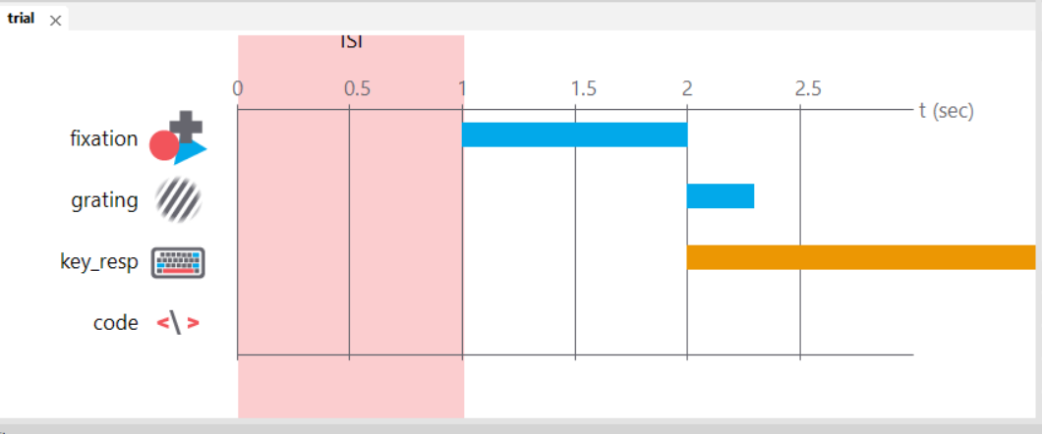

Image 1

Moreover, a python code was added to the program to define a routine in which the stimuli would occur.

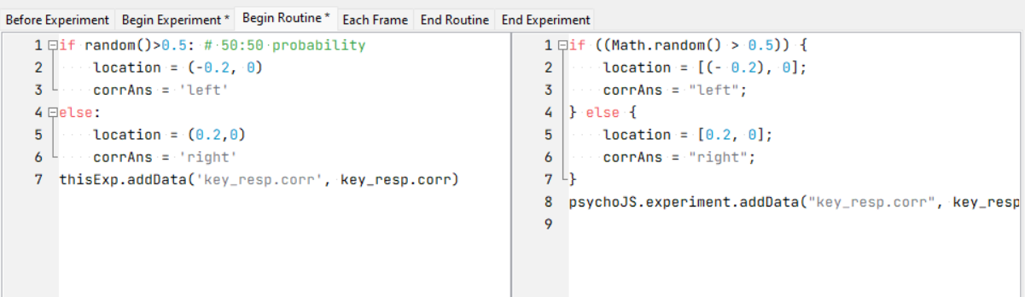

Image 2

The number of trials for the experiment were defined as n=100, and the loop was supposed to use interleaved staircases procedure to measure the threshold intensity with the starting contrast value of 0.05. Subsequently, to store the data for the experiments an Excel file was created to measure and define the 5 variables shown in the image.

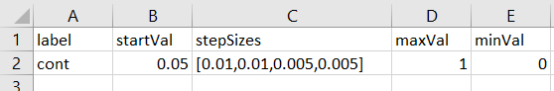

Image 3

Lastly, the experiment was given a test run to see whether it worked reliably before the actual trials started.

**Testing Conditions**

The participant (in this case the experimenter, herself) was told to perform 100 trials in one session. Hence, she was told to ensure that she was not distracted or disturbed by her surroundings and could perform the task continuously without breaks. These conditions were met sufficiently.

**Data Collection**

PsychoPy directly stores the data it gathers during the experiment in a new Excel file within a predefined folder. Hence, the data was stored reliably and then, cleaned to retain values related to the trial intensity and the accuracy of the participant.

**RESULTS**

The average absolute threshold intensity obtained after running 100 trials of the experiment is 0.05119.

**Number of Trials Vs Contrast Value**

By comparing the *trials.intensity* column which represents the change in the contrast value over the course of the trials and the number of trials, we find the following scatter.

The contrast value has increased gradually as the number of trials increased. The intensity of the contrast started from 0.05 and reached 0.051224. Hence, we can conclude that as the number of trials increased, there was a greater change in the contrast values or intensity as compared to Trial 1.

**Accuracy Vs. Number of Trials**

By comparing the *key_resp.corr* column which represents the accuracy of the responses of the participant and the number of trials, we find the following scatter plot. The value 0 is the incorrect response while the value 1 is the correct response.

We can see that there are frequent reversals in the accuracy of the responses, over the course of the trials. Hence, there is no specific relationship between the accuracy and the number of trials. The reason for this occurrence could be attributed to the increase in the difficulty of the task after a correct response is given, as per the principles of the staircase procedure.

**DISCUSSION** While in the recent decades, the staircase procedure is considered to be the most efficient method of calculating the threshold of a stimuli, it does have its shortcomings. The participant can easily become aware of the manner in which the stimuli are being presented, for example, a lower intensity of the stimuli is shown when the participant’s answer is correct. This consciousness will not pose an issue if the task is easy, however, the participant’s attitude can be drastically affected if the task is difficult and the participant is aware of the pattern in which the stimuli is being presented. Often, to get over such a bias, the randomized ‘double staircase procedure’ is used which is more variable and also provides reliable results, however, it also has some caveats.

Future research related to determining thresholds can focus on developing more suitable, accurate and efficient procedures that can be used in such experiments.

**REFERENCES**

Experimental Psychology, 10th Edition, Kantowitz, Elmes, Roediger, Cengage

India, ISBN: 9353502837, Year: 2019, Chapter 5.

Cornsweet, T. N. (1962). The staircase-method in Psychophysics. *The American Journal of Psychology*, *75*(3), 485. https://doi.org/10.2307/1419876