ORIENTATION DISCRIMINATION TASK WITH VISUAL GRATINGS

Twarita Shah

AU2020056

Ahmedabad University

Professor Nithin George

PSY310 Lab in Psychology

ORIENTATION DISCRIMINATION TASK WITH VISUAL GRATINGS

Signal Detection Theory or SDT, first described by Green and Swets (1966), can be applied to any area of psychology where two kinds of stimuli are to be differentiated. In studies related to perception, the SDT is used to discriminate between signals (presence of stimuli) and noise (absence of stimuli). SDT includes yes/no tasks, divided into signal trials where the stimulus is present and noise trials where the stimulus is absent. The participants indicate on the basis of their judgement, through ‘yes’ or ‘no’, whether the stimulus is present or not.

The responses of the participants are judged on the basis of a criterion, which is defined by the value of a decision variable. If the subject responds ‘yes’, then the decision variable is high, or else, the subject responds ‘no’.

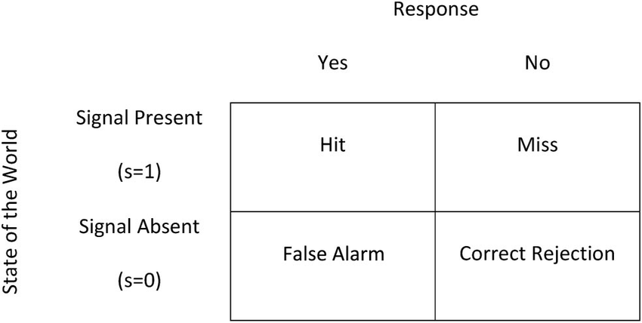

Image 1.

These responses are further characterized into 4 different categories: hits (signal trials where the response is ‘yes’), misses (signal trials where the response is ‘no’), false alarms (noise trials where the response is ‘yes’) and correct rejection (noise trials where the response is ‘no’). Furthermore, the hit rate (probability of saying ‘yes’ on trials) and false alarm rate (probability of saying ‘no’ on trials) are calculated to describe the performance of the participant.

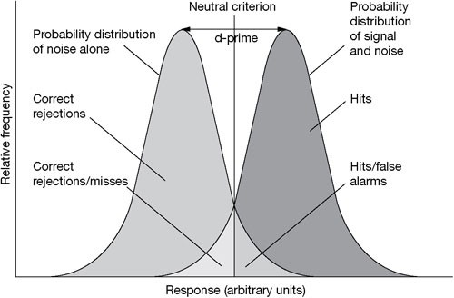

Image 2.

The distribution of these values across signal and noise trials, is called the signal and noise distribution, respectively, as shown in the image 2. It also shows through the value of the criterion whether the participant has the tendency to say ‘yes’ (liberal) or say ‘no’ (conservative). Hence, SDT separates the response bias and the sensitivity of the participant through these variables and helps us evaluate their performance.

# Method

The aim of this experiment is to find the response bias (c) and sensitivity of the participant (d-prime) on an orientation discrimination task with visual gratings, through signal detection theory.

**Participant/s**

The test was performed by the experimenter herself as a part of the Lab in Psychology course at Ahmedabad University.

**Materials and Procedure**

The experimenter received the video explaining the study 24 hrs before it was created and performed. The material used during the creation of the experiment was the experimenter’s personal laptop equipped with the latest version of PsychoPy.

The experimenter followed along the instructions of the professor to formulate the task on PsychoPy. Using the ‘stimuli’ option a polygon indicator was added for the duration of 1 second. Then a Gaussian, sinusoidal visual grating was added for a duration of 0.3 seconds, to be shown after the polygon had appeared. The orientation property of the grating was randomized by using ‘$tilt’ as a variable.

Furthermore, a keyboard response was set with the ‘up’ key indicating the presence of the stimuli and the ‘down’ key indicating the absence i.e., the experiment used the yes/no task. The, a Python code was added at the beginning of the experiment and at the end of the routine.

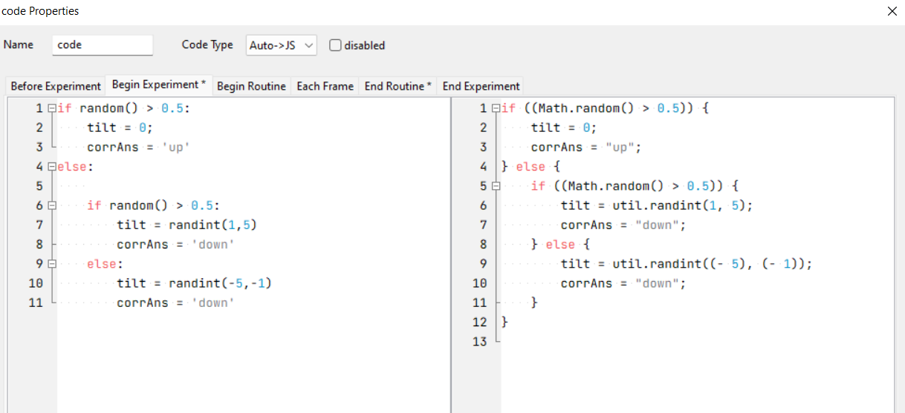

Image 3.

The loop properties were kept as random with the number of trials as 100. The experiment. This experiment didn’t require an Excel file as the variables were defined within the code itself.

Lastly, the experiment was given a test run to see whether it worked reliably before the actual trials started.

**Testing Conditions**

The participant (in this case the experimenter, herself) was told to perform 100 trials in one session. Hence, she was told to ensure that she was not distracted or disturbed by her surroundings and could perform the task continuously without breaks. These conditions were met sufficiently.

**Data Collection**

PsychoPy directly stores the data it gathers during the experiment in a new Excel file within a predefined folder. Hence, the data was stored reliably and then, cleaned to retain values related to the yes/no task. The data was categorized by the experimenter into hits, misses, false alarms and correct rejections.

|  |
| --- |
| Hit Rate= Hit/Hit+Miss |
| False Alarm (FA rate) = FA/FA+Correct Rejection |
| d-prime = z(Prop Hit) -z(Prop FA) |
| c= -(z(Prop Hit) + z(Prop FA)/2)) |

Table 1.

These values were then used to calculate the hit and false alarm rate which were then used for evaluating the sensitivity and the bias of the participant.

### Result

The number hits, misses, false alarms and correct rejections found from the data of the participant are as follows.

|  |  |  |
| --- | --- | --- |
|  | Respond YES | Respond NO |
| Signal Present | Hit | Miss |
| Signal Absent | False Alarm | Correct Rejection |
|  |  |  |
|  | Respond YES | Respond NO |
| Signal Present | 24 | 30 |
| Signal Absent | 11 | 35 |

Table 2.

The criterion, denoted by ‘c’ of the participant is 0.494262, while the d-prime or the d’ is 0.569392.

**Discussion**

The values of criterion and d-prime represent the response bias and the sensitivity of the participant, as mentioned in the introduction. Response bias shows the tendency of the participant to lean towards ‘yes’ or ‘no’. While the sensitivity shows whether the participant is able to distinguish between the noise and the signal. Both of these values came out as negative.

Hence, since criterion is 0.494262, it means that participant has the tendency to say ‘no’ more often, denoting a conservative bias. While the d-prime value of 0.569392 shows that the participant has a higher hit rate than the false alarm rate. It shows that the participant responded ‘no’ in many trials, even if the signal was present. Therefore, we can conclude that the participant can adequately differentiate between the noise and the stimulus, despite having a bias.