VISUAL SEARCH EXPERIMENT TO DETERMINE   
THE ACCURACY AND THE REACTION TIME OF THE TASK

Twarita Shah

Ahmedabad University

Professor Nithin George

PSY310

Lab in Psychology

REPORT

VISUAL SEARCH EXPERIMENT TO DETERMINE   
THE ACCURACY AND THE REACTION TIME OF THE TASK

Visual search is a versatile paradigm that significantly contributes to the study of attention, a vital topic in psychology. The demands on attention can be varied through modulating the search task, which in turn manipulates the visual search by limiting and selecting the amount of information available at different levels of processing. This intersection of visual search and attention provides a glimpse into the vast world of attentional phenomena. The effects of divided attention are illustrated by the effects of set size (the number of stimuli in a display) while the effects of selective attention are illustrated by cueing subsets of stimuli within the display.

The speed and the accuracy of the response through the visual system has been evaluated primarily by measuring performance through a several different visual search tasks. In these, the observer is tasked with searching for a predefined target that is present among a group of distractor items. In such studies, the primary manipulation is between the aspects of targets and distractors, and the number of distractors in the display. For example, certain associations (such as, finding only 'T' among a variety of 'L'-shaped distractors) result in faster RTs that do not show a huge change since very few additional distractors are added to the display. There is a general consensus that the results from such experiments can help us assess the efficiency of visual search. Thus, holding a crucial role in the field of attention.

# Method

The aim of this experiment is to determine the reaction time and accuracy of the participant through a visual search task. The task includes searching for ‘T’ among hosts of L-shaped distractors.

**Participant/s**

The test was performed by the experimenter and four of her classmates as a part of the Lab in Psychology course at Ahmedabad University.

**Materials and Procedure**

The experimenter received the video explaining the study 24 hrs before it was created and performed. The material used during the creation of the experiment was the experimenter’s personal laptop equipped with the latest version of PsychoPy.

The experimenter followed along the instructions of the professor to formulate the task on PsychoPy. Using the ‘stimuli’ option a cross-shaped polygon indicator was added for the duration of 1 second. Then, a text component ‘T’ was added for infinite duration, to be shown at a random place on the screen, after the polygon appeared. Similarly, the L-shaped distractor was also added through a text component. Furthermore, a mouse response was added, where the correct click was characterized by the location of target. Then, a Python code was added at the beginning and the end of the routine.

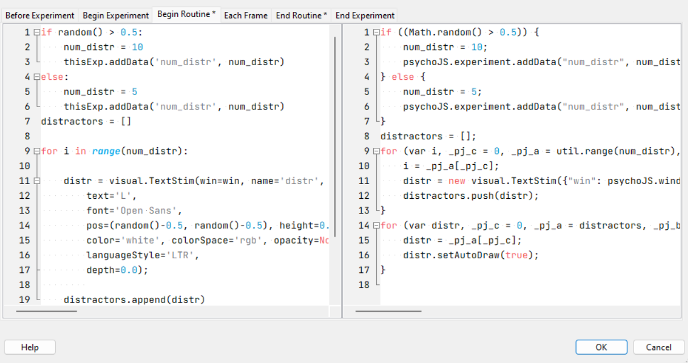

Image 1.

The loop properties were kept as random with the number of trials as 200. This experiment didn’t require an Excel file as the variables were defined within the code itself.

Lastly, the experiment was given a test run to see whether it worked reliably before the actual trials started.

**Testing Conditions**

The participants were told to perform 200 trials in one session. Hence, they were told to ensure that they were not distracted or disturbed by their surroundings and could perform the task continuously without breaks. These conditions were met sufficiently.

**Data Collection**

PsychoPy directly stores the data it gathers during the experiment in a new Excel file within a predefined folder. Hence, the data was stored reliably and then, cleaned to retain values related to the visual search task. The data was categorized by the experimenter into reaction times, accuracy and set-sizes. All 200 trials of the 5 participants were considered as they had answered every trial correctly.

These values were then used to calculate the slope of the set-size vs. RT curve (y2-y1)/x2-x1, where, x is the set size and y is the RT) as well as the mean RT taken by the participant. These values were then compared to the reaction times of other participants.

**Results**

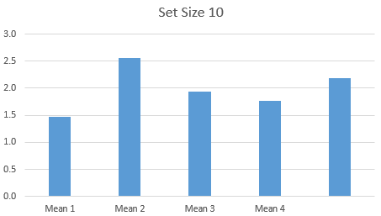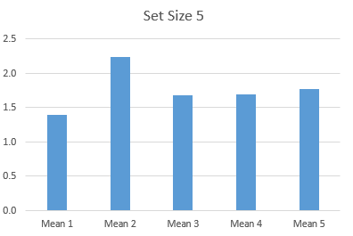The mean reaction time for the 200 trials of the 4 participants are 1.428454516, 2.401438784, 1.790043986, 1.72871032 and 1.966535968, respectively. Moreover, the mean reaction times of different set-sizes are compared in the graphs and the tables below.

Graph 1 and 2.

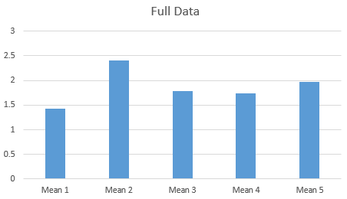

Graph 3, 4 and 5.

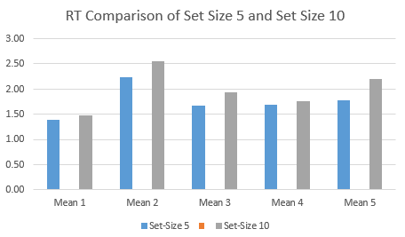

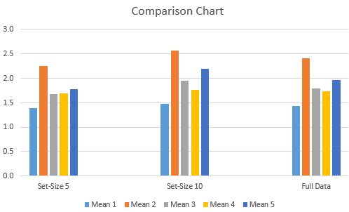

|  |  |  |  |
| --- | --- | --- | --- |
|  | Set-Size 5 |  | Set-Size 10 |
| Mean 1 | 1.39003260095515 | Mean 1 | 1.47092084210782 |
| Mean 2 | 2.24136891818577 | Mean 2 | 2.55833894950291 |
| Mean 3 | 1.67957778016942 | Mean 3 | 1.94259255595084 |
| Mean 4 | 1.692214698 | Mean 4 | 1.762398587 |
| Mean 5 | 1.773290042 | Mean 5 | 2.19338988 |

Table 1.

Meanwhile, the slope size for set-size vs. reaction time for each participant is 0.016177648, 0.063394, 0.052603, 0.014037 and 0.08402, respectively.

**Discussion**

The slope of the reaction time x set-size function is a standard measure of search efficiency, since it gives an estimate of search output in terms of items per unit time. The visual searches with slopes that are close to zero are the most efficient. Therefore, if we compare the slopes of all the 5 participants, then we find that participant 4 (slope=0.014037) is the most efficient out of all five participants while participant 5 (slope=0.08402) is the least efficient. However, there is no drastic difference in the slope and therefore, the efficiencies of the 5 participants.

Moreover, after analysing the graph comparing the mean RTs of set-size 10 and set-size 5, we find that the reaction time is higher for set-size 10, which is consistent with the assumption that set-size can affect the efficiency of visual attention. In this case, it seems that a greater set-size leads to a higher reaction time.

REFERENCES

Greenberg, A. S., Rosen, M., Cutrone, E., & Behrmann, M. (2015). The effects of visual search efficiency on object-based attention. *Attention, perception & psychophysics*, *77*(5), 1544–1557. <https://doi.org/10.3758/s13414-015-0892-7>

Davis, E. T., & Palmer, J. (2004). Visual search and attention: an overview. *Spatial vision*, *17*(4-5), 249–255. <https://doi.org/10.1163/1568568041920168>

Wolfe, J. M., Palmer, E. M., & Horowitz, T. S. (2010). Reaction time distributions constrain models of visual search. *Vision research*, *50*(14), 1304. <https://doi.org/10.1016/j.visres.2009.11.002>

Wolfe, J., & Horowitz, T. S. (2008, July 31). Visual search - Scholarpedia. Retrieved September 29, 2022, from http://www.scholarpedia.org/article/Visual_search