MOTOR SEQUENCE LEARNING TASK TO MEASURE THE REACTION TIME OF SEQUENTIAL VS. RANDOMIZED TRIALS

Twarita Shah

Ahmedabad University

Professor Nithin George

PSY310

Lab in Psychology

REPORT

Github Link: https://github.com/twaritashah/PSY310_TwaritaShah

MOTOR SEQUENCE LEARNING TASK TO MEASURE THE REACTION TIME OF SEQUENTIAL VS. RANDOMIZED TRIALS

People frequently acquire knowledge depending on which outcome is most likely to occur from a given stimulus. In other words, individuals form associations between a certain actions and consequences. Hence, organisms observe the statistical recurrence of various contingencies in their surroundings and learn from them. In the past, there has been debate on the role of contingency in learning as compared to the classical or operant conditioning techniques. However, Robert Rescorla established that learning is not always induced by pairing a conditioned stimulus (CS) with an unconditioned stimulus (UCS), and he asserted that the CS must denote a contingency. Therefore, contingency or the extent to which knowledge of one event reduces uncertainty about another influences human learning. For example, in this experiment, the sequential contingency of the stimuli on the lines leads to faster and more accurate detection of its location by participants.

# Method

The aim of this motor sequence task experiment is to determine the differences in the reaction time of the participant by comparing their performance on the sequential and randomized trial conditions.

**Participant/s**

The test was performed by the experimenter as a part of the Lab in Psychology course at Ahmedabad University.

**Materials and Procedure**

The experimenter received the video explaining the study 24 hrs before it was created and performed. The material used during the creation of the experiment was the experimenter’s personal laptop equipped with the latest version of PsychoPy.

The experimenter followed along the instructions of the professor to formulate the task on PsychoPy. Using the ‘stimuli’ option a cross-shaped polygon indicator was added for the duration of 1 second. Then, a rectangular polygon was added which would appear at 1 second and stay for infinite duration, its size, position and orientation were adjusted according to the requirements of the task. This component was then copied to create a total of 4 polygons, which differed in the positions at which they would appear. These positions ranged from -150 pixels from center to +150 pixels (-150, -50, 50, 150). One more polygon was added, which was triangular in shape and was set to appear randomly on the top of any of the rectangular polygons at the time of 2 seconds and stay for infinite duration.

Furthermore, a keyboard response of (z, x, c, v) was added where each of the keys represented a rectangular polygon. Then, an excel sheet defining the functions as follows, was added to the trial.

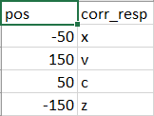

Image 1.

For the first trial, the loop properties were set to sequential and the number of repeats were 24 which would lead to 96 trials. Then, another trial was created with the exact same conditions, where the only difference was in the type of loop. In this case, it was set to FullRandom (randomized) trials. Hence, experiment was divided into two conditions each with 96 trials for each of them.

Lastly, the experiment was given a test run to see whether it worked reliably before the actual trials started.

**Testing Conditions**

The participant was told to perform 96 trials for each condition in one session. Hence, she was told to ensure that she was not distracted or disturbed by her surroundings and could perform the task continuously without breaks. These conditions were met sufficiently.

**Data Collection**

PsychoPy directly stores the data it gathers during the experiment in a new Excel file within a predefined folder. Hence, the data was stored reliably and then, cleaned to retain values related to the motor sequence task. The data was categorized by the experimenter into reaction times and conditions. These values were then used to calculate the mean RT of the participant for each condition as well as the difference between them.

**Results**

The mean reaction time for the 96 trials of the sequential condition of the experiment was **0.394185 seconds**, while the mean reaction time for the 96 trials of the randomized condition was **0.520633 seconds.** The mean RTs of the two different conditions are compared in the graph below.

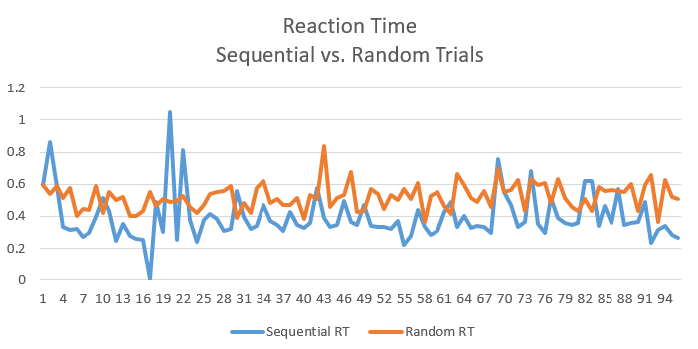

Graph 1.

Meanwhile, it can be consistently observed that the reaction time for randomized trials is higher than that for sequential trials. Hence, when we calculate the difference between their reaction times, we find that it is **0.126448 seconds.** Please note that all 96 trials for each condition have been used as all responses were correct.

**Discussion**

The consistent difference in the reaction times of the two conditions results from the high contingency of the stimuli to appear in a particular order on the lines in the sequential condition, allowing the participant to easily predict and prepare to respond by pressing the concerned key. This perception of the statistical regularity of the stimuli leads to a faster reaction time.

In study designs where the same participants are repeatedly exposed to the same conditions, treatments, or stimuli, counterbalancing is a technique that enables a researcher to control the effects of extraneous factors like practice and familiarity with a task that can create order and sequence effects. The systematic alteration of the conditions' order within a study is referred to as counterbalancing, and it improves the internal validity of the study. Hence, by counterbalancing the orders of the conditions the experimenter can get rid of the general carryover effects that happen due to recurring exposure to the experimental task.

REFERENCES

Schmidt, J.R. (2012). Human Contingency Learning. In: Seel, N.M. (eds) Encyclopedia of the Sciences of Learning. Springer, Boston, MA. https://doi.org/10.1007/978-1-4419-1428-6_646

Gallistel, C.R. (2012). Contingency in Learning. In: Seel, N.M. (eds) Encyclopedia of the Sciences of Learning. Springer, Boston, MA. https://doi.org/10.1007/978-1-4419-1428-6_135

Rescorla, R. A. (1988). Pavlovian conditioning: It's not what you think it is. American Psychologist, 43(3), 151–160. https://doi.org/10.1037/0003-066X.43.3.151

Corriero, E. (2017). Counterbalancing. In M. Allen (Ed.), The sage encyclopedia of communication research methods (pp. 278-281). SAGE Publications, Inc, https://dx.doi.org/10.4135/9781483381411.n103