These bugs are rather difficult to replicate.

Therefore this troubleshooting guide is mostly incomplete

Arduino fail to Connect

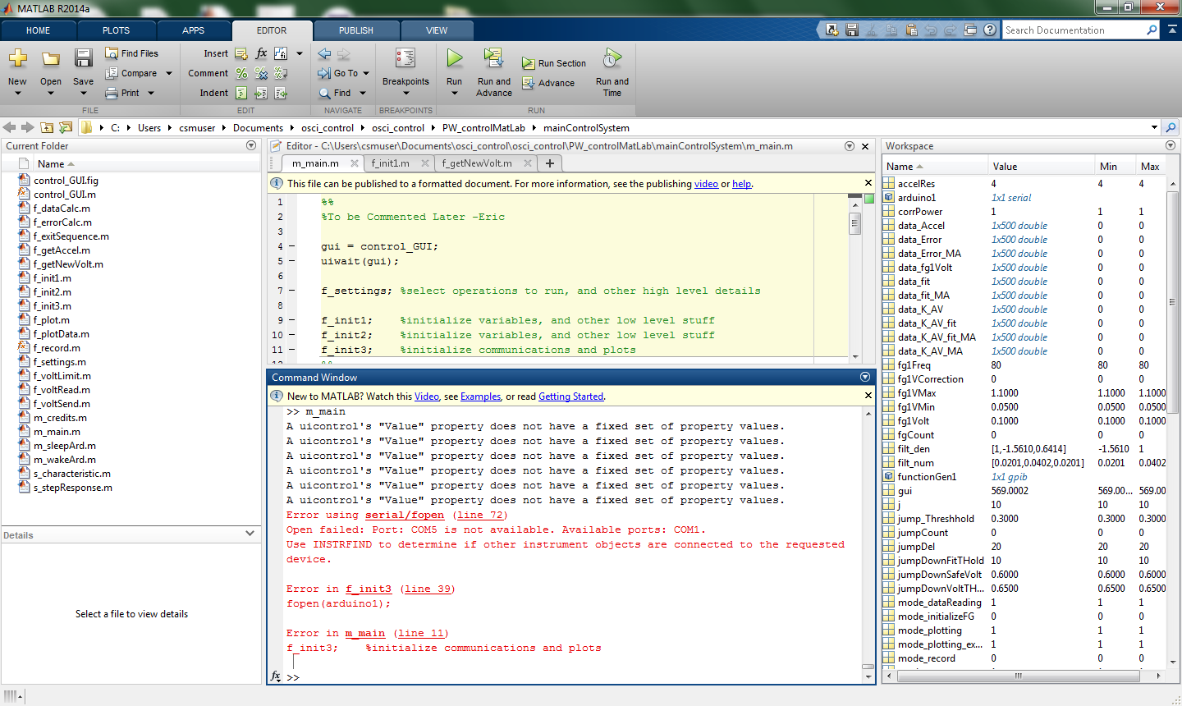

Make sure USB cable are plugged in correct order

(Arduino on Right, Function Generator on Left)

Function Generator Fail to Connect

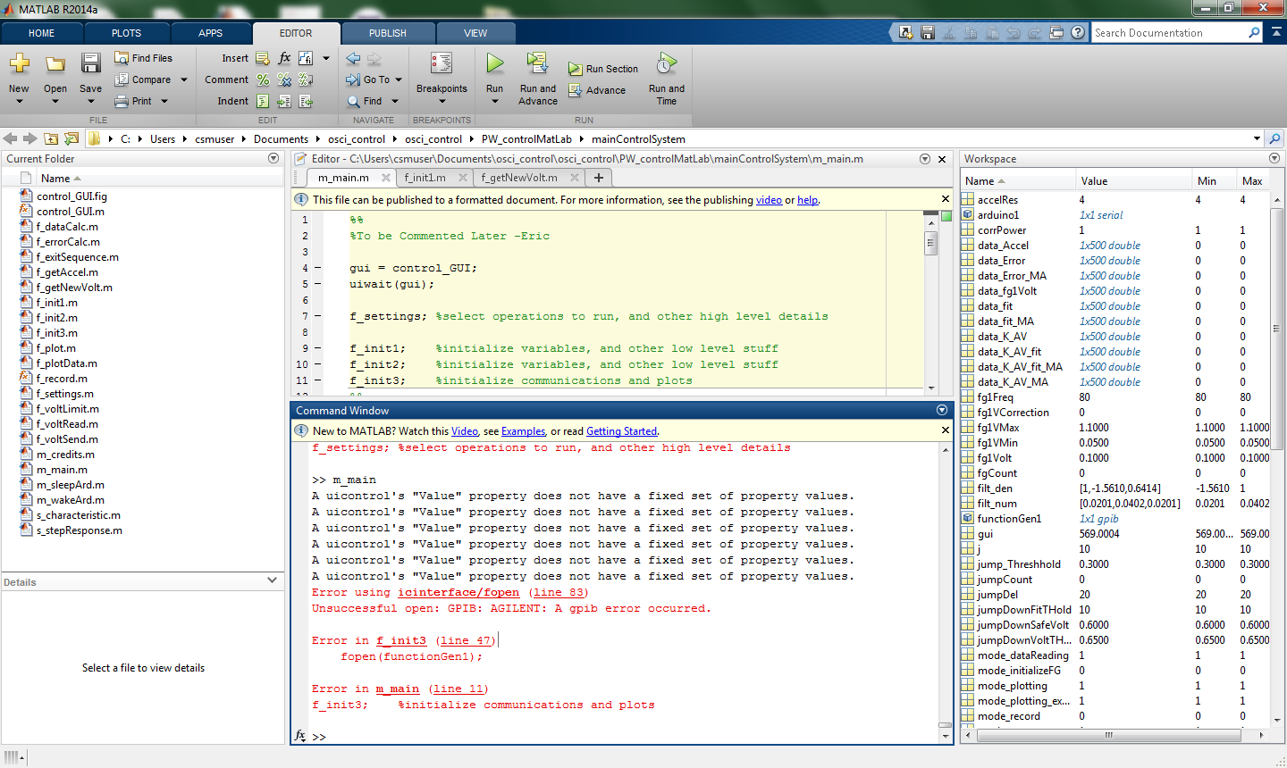

1) Make sure White cable is plugged in, on left side

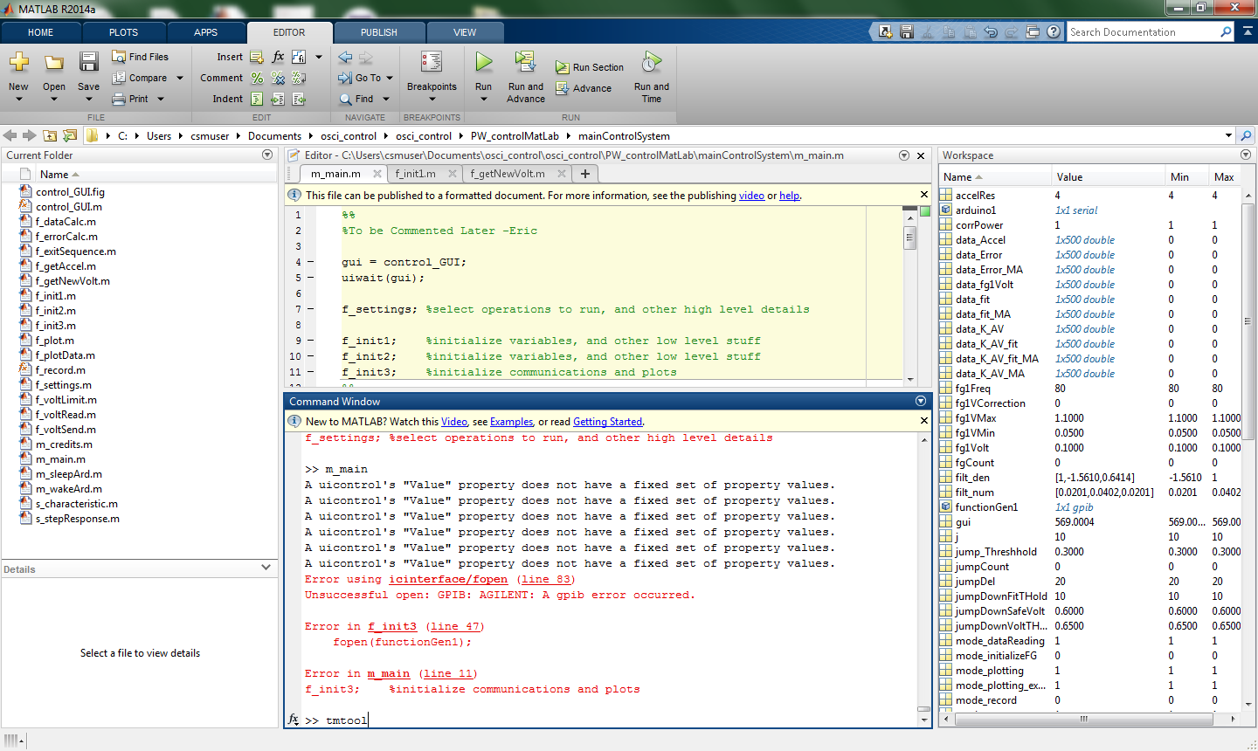

2) Open tmtool

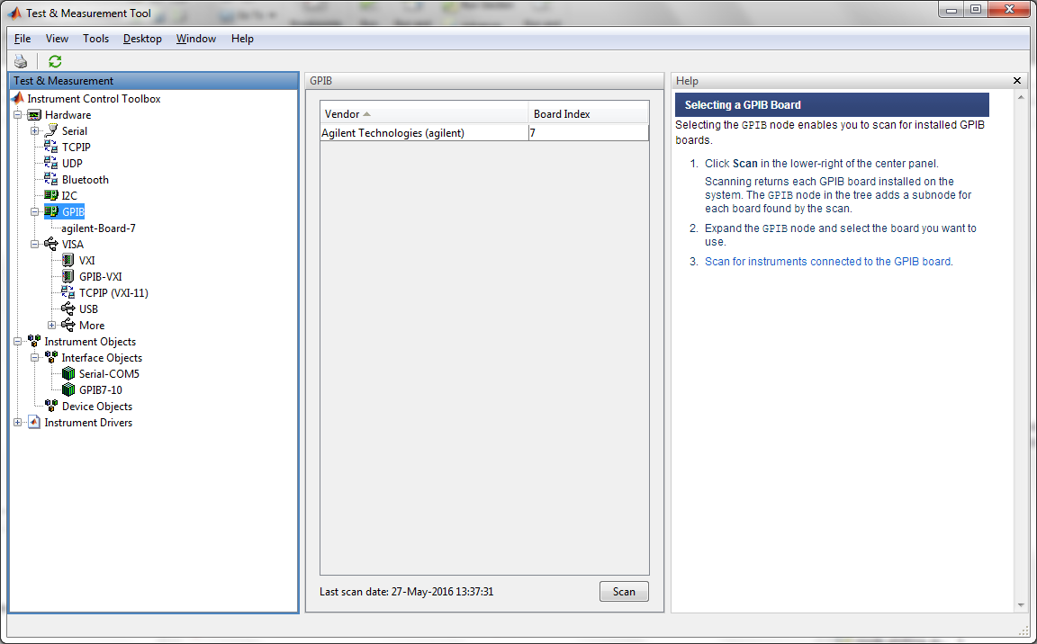

3) Select GPIB

Click Scan

If a board appears, the problem might be fixed. Try running program again

4)