June 03, 2016

**Starting the program**

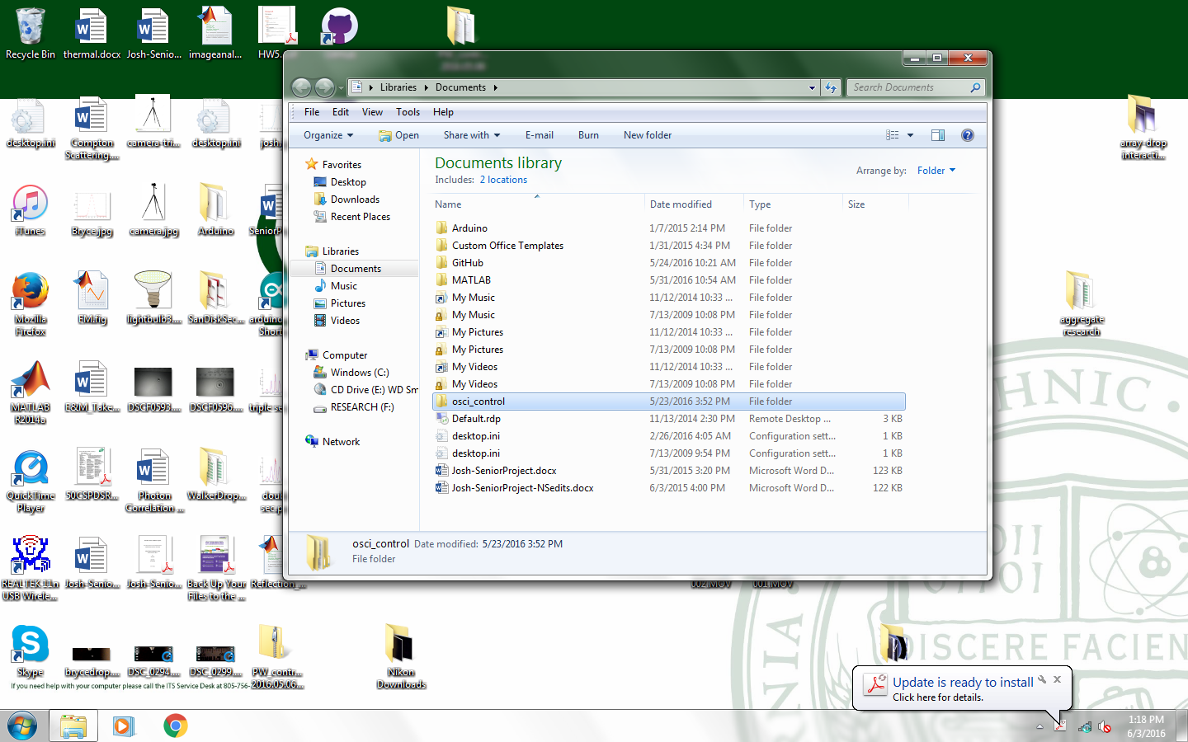

1. Go to Documents, find “osci_control” folder

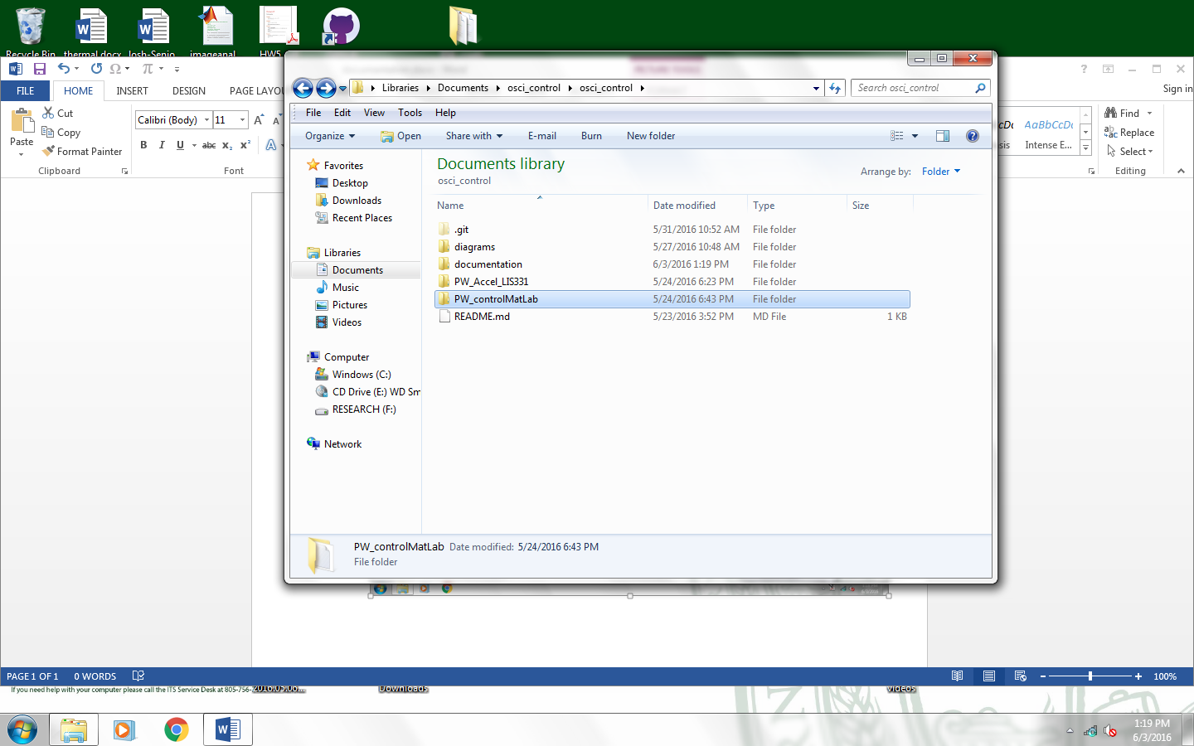

1. Go to “PW_controlMatLab” Folder

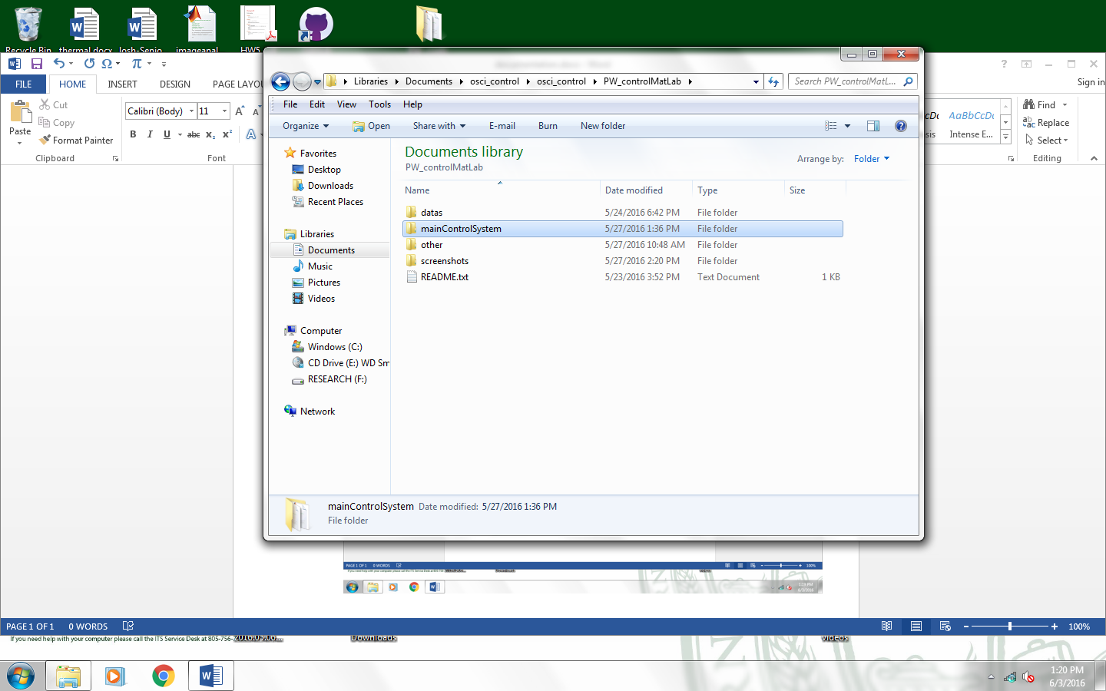

1. Go to “mainControlSystem” folder

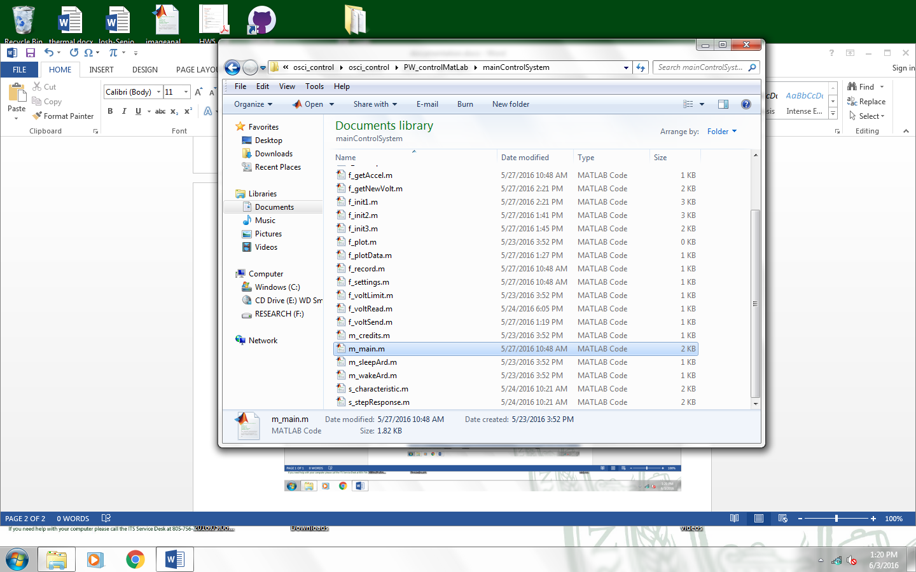

1. Open “m_main.m”

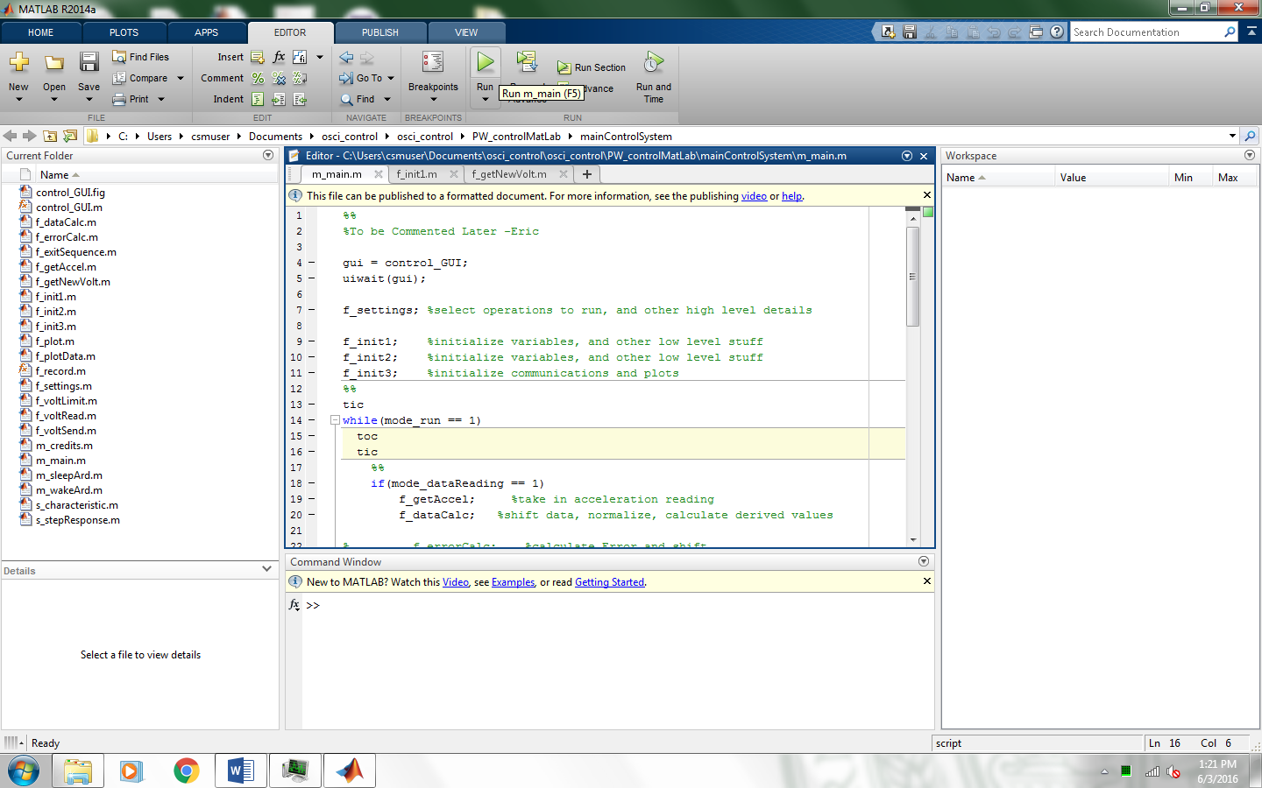

1. Click “run” button

Turn on the function generator and power amplifier.

Set function generator to 80Hz for safety reasons

Set power Amplifier to maximum gain (Lower right dial)

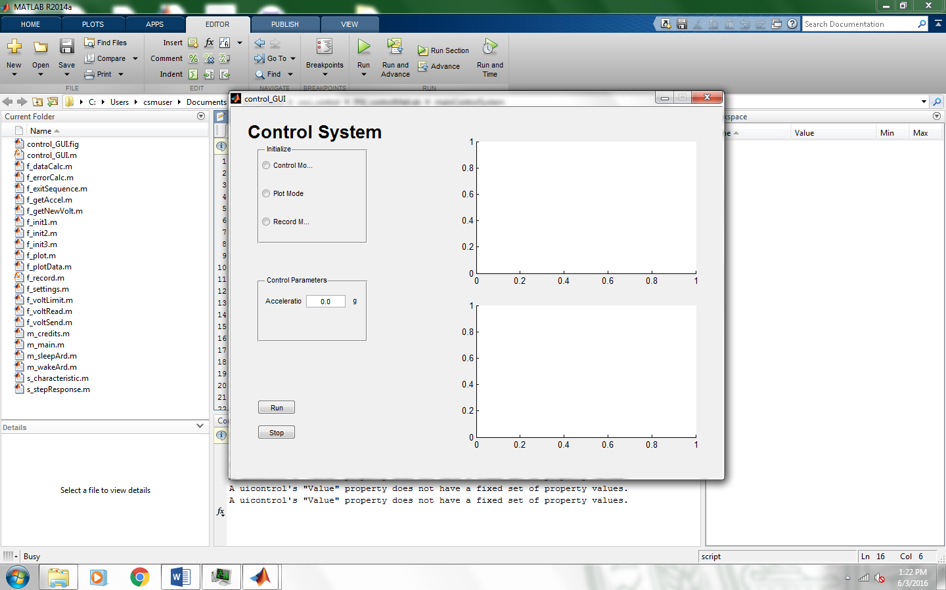

1. Select Modes and acceleration

Control Mode will adjust voltage until Acceleration is at the Target Acceleration

Plot Mode will plot the acceleration and other data in real time

Control Mode and Plot Mode can run Simultaneously

Record Mode is currently untested. It allows recording of acceleration over 10 seconds

**Ctrl+C to end program**

**Close the GUI before clicking “run” again**