NSL23 PROJECT COMPANION
Understanding the NSL23
Low-Resource Alphabet Study
A plain-language, detailed guide to the data, models, mathematics, results, limitations, and the Version 2 publication path
The result to remember The strongest Version 1 model scored 59.4% ± 3.3% accuracy on a 49-way unseen-signer development exam. That is real evidence from these clips, but it is exploratory—not a final estimate for all future signers.

49 classes | 375 primary clips | 2 complete test signers
36 consonants + 13 vowels | Audited original isolated videos | S1 and S2, each in turn

CURRENT PROJECT STATUS
Version 1 has audited results and remains an exploratory study.
Version 2 is protocol-ready but must not be trained until independent human review is complete.
This guide is for the project owner’s understanding. The manuscript remains the formal scientific record.

1. Start here: the paper in five minutes
The study asks a simple but demanding question: if the model learns from some people, can it recognize all 49 Nepali Sign Language alphabet classes when a different person signs them?
Imagine studying with six classmates and then taking an exam written by a seventh person. A random clip split would let that seventh person appear in both study material and the exam; this paper instead removes the exam signer from training. That makes changes in hand shape, speed, camera angle, clothing, and background much harder to exploit accidentally.
Plainest possible conclusion Full-frame ImageNet features generalized poorly. A compact description of the hand—21 landmarks, wrist normalization, and 20 joint angles—worked much better, especially when the network learned a distance-based prototype for each class.

The five facts that organize everything
- The release contains 630 videos, but not 630 equivalent independent training examples. Some are aggregate tapes and some are cropped copies.
- The defensible Version 1 sample is 375 original, individually labelled, isolated clips covering all 49 classes.
- S1 and S2 are the only people with a complete 49-class isolated set. Each contributes 98 test clips: 49 classes × two lighting conditions.
- The strongest exploratory model is a prototypical BiLSTM using wrist-relative coordinates plus 20 joint angles: 59.4% ± 3.3% accuracy.
- A prospective Version 2 result needs untouched test signers recovered from aggregate tapes, so human temporal annotation—not more model design—is now the gate.

Version 1 and Version 2 are different scientific jobs
Question | Version 1 | Version 2
Purpose | Explore what works on the audited isolated sample | Prospectively test a locked method on sealed signers
Status | Complete; reproducible; exploratory | Protocol-ready; zero verified segments; do not train
Evaluation people | S1 and S2, reused during study-level development | All complete signers among sealed S5/S14/S4/S6; at least two required
Legitimate headline | 59.4% cross-signer development accuracy | Only the frozen Stage 4 endpoint, if coverage gate passes
Immediate next work | Journal formatting and transparent positioning | Two independent annotation passes, agreement, adjudication, freeze

How to read this guide
- Sections 2–4 explain what data enters the experiment and why the split is credible.
- Sections 5–7 explain the features, neural networks, training objectives, and evaluation mathematics.
- Sections 8–10 interpret the results without turning a development result into a deployment claim.
- Sections 11–12 explain exactly why manual review is required and how Version 2 becomes publishable.
- Sections 13–15 give reproducibility, storage, submission, and glossary checklists.

2. What the dataset actually contains
The first scientific contribution is not a neural network. It is an audit that separates original isolated clips from aggregate recordings and derived copies.
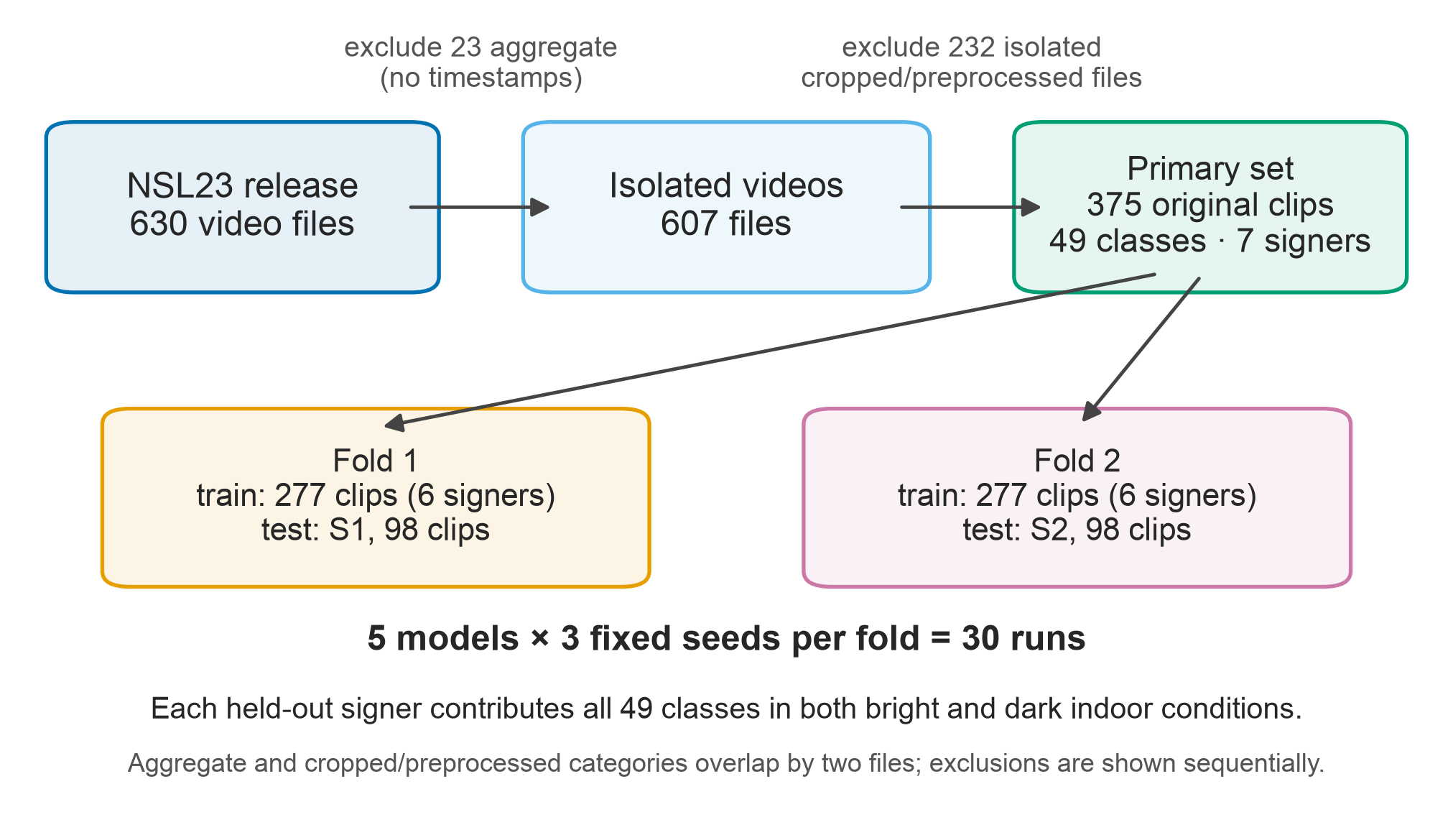
Figure 1. Dataset audit and Version 1 study flow. The primary set is the intersection of original and individually labelled files.

Why 630 files and 1,205 reported gestures are not 1,205 independent clips
A dataset can count several different things. A file is a container on disk. A gesture instance is a movement reported inside a file. A model sample is the exact bounded segment sent to the network. Those counts are equal only when every file contains exactly one gesture and no derived copy is treated as new evidence. NSL23 does not have that simple structure.
Release category | Count | What it means for Version 1
Decodable video files | 630 | Inventory count; not automatically independent samples
Individually labelled files | 607 | Includes originals and derived cropped/preprocessed copies
Aggregate tapes | 23 | Long recordings containing multiple gestures without verified temporal boundaries
Cropped/preprocessed files | 234 | Derived views that can duplicate an original performance
Primary original isolated clips | 375 | The defensible Version 1 sample

Leakage example Suppose an original clip is in training and a cropped copy of that same performance is in test. The model appears to generalize, but it has already seen the underlying motion. Removing derived copies prevents this family-level duplication.

What is inside the 375-clip primary sample
The sample contains original isolated clips from S1, S2, S7, S8, S10, S11, and S12. All 49 alphabet classes are present: 36 consonants and 13 vowels. S1 and S2 each supply one bright and one dark clip for every class. The other five signers supply prepared consonant clips but not a complete 49-class evaluation seat.
- S1 and S2: complete alphabet; eligible for the two Version 1 test folds.
- S7, S8, S10, S11, S12: additional training evidence, primarily consonants.
- Each complete signer contributes 49 × 2 = 98 test clips.
- The manifest records file identity, signer, class, condition, origin/derivation status, and decode checks.

What the audit deliberately excludes from the primary claim
Aggregate tapes are not discarded forever; they are deferred to Version 2 because their internal gesture boundaries require human verification. Cropped files are useful as derived inputs, but they cannot be counted as independent performances. Outdoor and other release conditions that do not meet the original-isolated-labelled rule are outside this primary sample.

3. The Version 1 experimental design
Each run performs genuine signer exclusion: the person being scored does not appear in that run’s training set. The study as a whole is still exploratory because S1/S2 results influenced later model choices.

The two folds
Fold | Training signers | Test signer | Train / test
Held out S1 | S2, S7, S8, S10, S11, S12 | S1 | 277 / 98 clips
Held out S2 | S1, S7, S8, S10, S11, S12 | S2 | 277 / 98 clips

49 classes × 2 lighting conditions = 98 predictions per held-out signer
This is one complete test seat.

98 predictions from S1 + 98 predictions from S2 = 196 pooled predictions per seed
The pooling happens before accuracy and macro-F1 are computed.

There is no validation set and no early stopping. For the primary matrix, every model trains for 30 epochs and the epoch-30 checkpoint is evaluated once. This is less flexible than tuning on a validation signer, but it avoids pretending that a missing validation population exists.

Why three seeds are used
Neural-network training begins from randomized weights and randomized minibatch order. Seeds 17, 42, and 73 repeat the same experiment with different allowed randomness. Their spread describes optimization instability on the same data. It does not create more signers and it does not estimate how accuracy varies across Nepal’s signer population.

Strict within-run holdout versus untouched confirmation
Idea | Meaning here
Held out within a run | S1 is absent when S1 is tested; S2 is absent when S2 is tested. This is true.
Untouched at study level | No result from the test people influenced later feature/model choices. This is not true for the follow-on matrix.
Exploratory development estimate | A transparent result on repeatedly examined development people. This is the correct description of 59.4%.
Confirmatory estimate | A locked method scored once on prospectively sealed people. This is the intended Version 2 Stage 4 job.

Why this wording matters The 59.4% number is not fake, leaked within a run, or numerically wrong. The limitation is a higher-level one: the same two complete signers were used while deciding that angles and prototypical training were promising.

The reproducibility freeze
Before the first full primary run, the project recorded SHA-256 hashes and byte sizes for 15 protocol, configuration, manifest, loader, model, training, and launcher files. The snapshot did not store a Git revision, so the audit searched history and found one exact tree: commit 0eb1ff20337b584a5a7e4b06d5e4d5a350915fc7. All 15 inputs match it byte-for-byte. The human-readable tag v1-protocol-freeze is a convenience pointer; the dated snapshot remains the chronology record. A one-epoch smoke test had already accessed S1 before the snapshot. The later tag is not preregistration.
- Historical-tree verification answers: ‘Can we recover the exact inputs used?’
- Worktree drift answers: ‘What has legitimately changed since then?’
- Historical result receipts keep their original machine paths; active inputs now use portable repository-relative paths.

4. From video to model input
Every model sees the same temporal sample—16 frames—but the representation determines whether it mostly sees a room or a hand.

Frame sampling
Each clip is divided into 16 equal time bins and one frame is taken from the center of each bin. Frames preserve aspect ratio, are letterboxed to 224 × 224 pixels, and receive ImageNet channel normalization. Training brightness and contrast perturbations are drawn once per clip and applied consistently across all 16 frames. Horizontal flipping is disabled because mirroring a sign may change its linguistic or handedness meaning.

The three representations
Representation | Per-frame information | Main benefit / risk
Full RGB | 3 × 224 × 224 pixels; MobileNetV2 produces 1,280 features | Keeps appearance, but background and clothing can dominate
Wrist-relative xyz | 21 landmarks × 3 coordinates + one detection flag = 64 values | Compact hand geometry; loses texture and depends on detector quality
xyz + joint angles | 63 coordinates + 20 angles + flag = 84 values | Adds finger geometry; only the angle component has rigid-transform invariance
Hand crop RGB | Square MediaPipe-guided crop resized to 224 × 224 | Makes the hand larger, but frozen ImageNet features remain mismatched

Wrist-relative, scale-normalized landmarks
MediaPipe Hands returns 21 points. Point 0 is the wrist and point 9 is a middle-finger joint used as a hand-size reference. Subtracting the wrist moves the coordinate origin onto the hand. Dividing by a within-hand distance reduces differences caused by camera zoom or physical hand size.
pᵢ = lᵢ − l₀ · s = ‖p₉(x,y)‖₂ · p̃ᵢ = pᵢ / s*
The code uses s* = s when s ≥ 10⁻⁶, and s* = 1 otherwise. This avoids division by a nearly zero distance.

The 63 normalized coordinates are concatenated with a detection flag. If MediaPipe misses a frame, that frame becomes zeros and the flag is 0. In the 6,000 cached primary frames, detection succeeded on 5,868 (97.8%), and no clip had zero detected frames. These are availability counts, not a measurement of landmark accuracy.

Joint angles
Coordinates can still rotate when the wrist or camera rotates. The follow-on representation adds 15 within-finger flexion angles and five wrist-level abduction angles. For two unit vectors meeting at a joint, the angle comes from their dot product.
φ(u, v) = arccos( clip(uᵀv, −1, 1) )
The clip prevents floating-point roundoff from sending arccos outside its valid range.

Why angles help Two people can place their hands in different locations and orientations while bending the same finger joints. Angles explicitly encode that bending pattern. They are not magic: detector errors and visually similar classes still matter. Angles are unchanged by applying the same rigid rotation and uniform scale to valid points, but image-derived landmarks need not transform that way when the camera viewpoint changes. The concatenated xyz component still retains hand orientation.

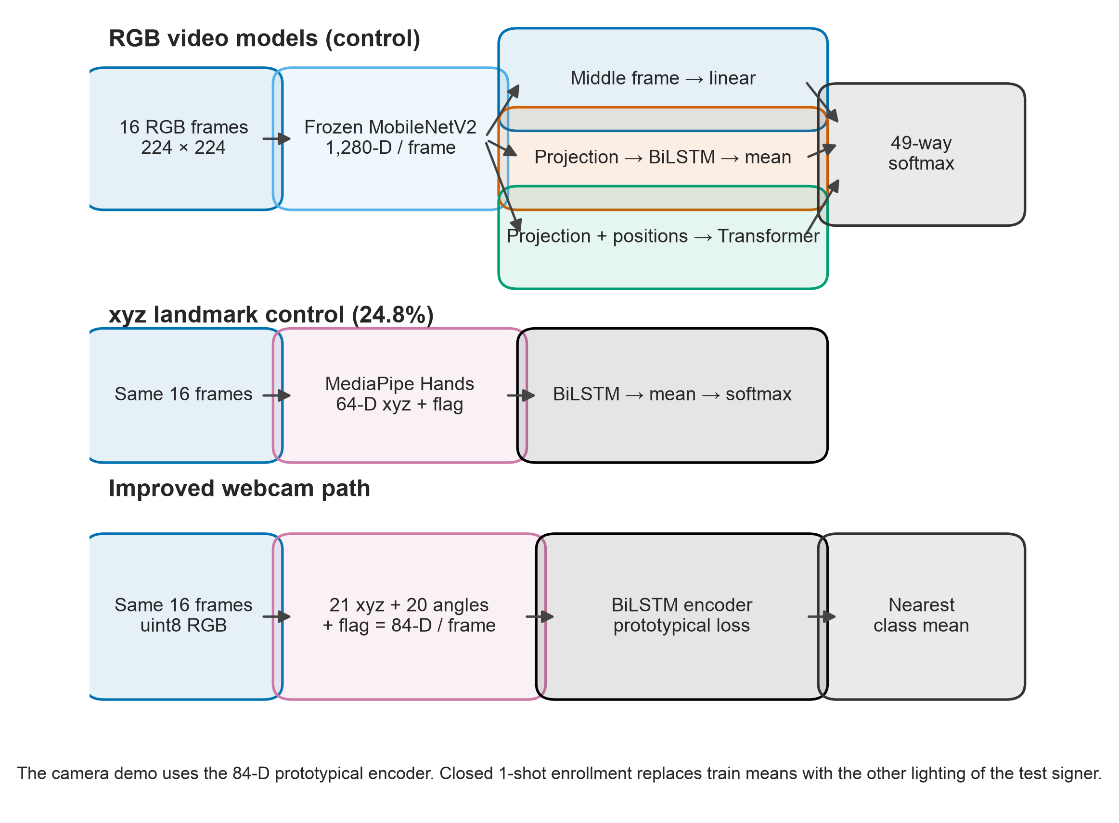
Figure 2. The paper’s RGB, landmark-softmax, and improved prototype pipelines. All operate on 16-frame clips.

5. What each model is doing
The model matrix is a controlled sequence of questions: Is one RGB frame enough? Does motion help? Do landmarks help? Do angles help? Does distance-based class structure help?
Model | Trainable parameters | Question answered
Single-frame CNN | 62,769 | Can a frozen ImageNet feature from one middle frame separate 49 classes?
CNN–BiLSTM | 736,305 | Do ordered features across 16 RGB frames help?
CNN–Transformer | 1,399,345 | Does attention across the 16 RGB frames help?
Landmark MLP | 301,617 | Are flattened normalized hand coordinates enough without a temporal recurrence?
Landmark BiLSTM | 73,137 | Does a compact temporal model over xyz landmarks generalize better?
Hand-crop CNN | 62,769 | Was the hand simply too small in the full frame?
xyz+angle BiLSTM | 83,377 | Do explicit joint angles improve the temporal landmark representation?
Proto-BiLSTM | 83,377 | Does learning an embedding around class prototypes improve cross-signer transfer?

CNN: a visual feature extractor
MobileNetV2 was pretrained on ImageNet photographs. Here its weights and batch-normalization state stay frozen. The trainable head must use those generic visual features to recognize signs. This is computationally economical and a fair low-data baseline, but ImageNet is not a hand-shape alphabet.

BiLSTM: read the clip in both directions
An LSTM maintains a gated memory while reading a sequence. A bidirectional LSTM reads frame 1→16 and 16→1, concatenates both views, normalizes them, and averages across time. Because classification happens after the full isolated clip is available, future frames are allowed; this is not a causal streaming-language model.

Transformer: compare every sampled time point
The Transformer projects each frame feature to 256 values, adds a learned time position, and uses four attention heads in two layers. Each attention head measures which time points should influence one another. With only 277 training clips per fold, a large head can fit the training sample without transferring well to another signer. The scores do not identify which visual cues it learned.

Prototypical encoder: learn a map where class means matter
A conventional softmax model learns 49 classifier weight vectors. A prototypical network instead learns an embedding space. During an episode, five support clips per class are averaged into a class prototype and two query clips per class are pulled toward the correct prototype. At final unseen-signer evaluation, prototypes are recomputed from training clips only. The test signer contributes nothing.
cᶜ = (1 / |Sᶜ|) Σ gψ(X) · P(y=c | X) = exp(−‖gψ(X)−cᶜ‖₂) / Σc′ exp(−‖gψ(X)−cᶜ′‖₂)
cᶜ is the mean embedding for class c; the closest prototype receives the largest probability.

- Every episode visits all 49 classes, so class imbalance is handled by the episode structure.
- When a class has fewer than seven clips, the five support and two query draws use replacement. A training clip can appear on both sides of an episode; the counts are draws, not distinct recordings.
- The benefit is not ‘one-shot magic’; the primary 59.4% evaluation still uses training-set prototypes and an unseen test signer.

6. Training without accidentally moving the goalposts

Primary softmax training
The five primary models use inverse-frequency class-weighted cross entropy. Vowels have only two training clips in a fold, while some consonants have more. Giving rare classes larger weights keeps the loss from being dominated by the better-represented consonants.
wᶜ ∝ 1/nᶜ, normalized so mean(wᶜ)=1 · L = −Σᶜ wᶜ yᶜ log(ŷᶜ)
nᶜ is the training count for class c. This is one example's loss; the batch mean divides summed losses by the sum of target-class weights.

Setting | Primary matrix | Prototypical follow-on
Optimizer | AdamW | AdamW
Learning rate / weight decay | 3×10⁻⁴ / 10⁻⁴ | 3×10⁻⁴ / 10⁻⁴
Learning-rate schedule | Cosine decay | Constant
Landmark feature jitter | Gaussian SD 0.02; flag unchanged | None
Epochs | 30 | 40
Batch structure | Batch size 8 | 40 all-class episodes per epoch
Seeds | 17, 42, 73 | 17, 42, 73
Validation / early stopping | None; evaluate epoch 30 | None; evaluate epoch 40
Class balancing | Inverse-frequency loss weights | Each episode visits every class

Determinism: useful, but not a time machine
The code fixes seeds and asks PyTorch for deterministic algorithms on the recorded Apple M4 host. That reduces uncontrolled variation within the supported environment. It does not guarantee bit-for-bit identical results on another PyTorch version, CPU, GPU, or MPS implementation. The strongest reproducibility evidence is therefore the stored checkpoints, primitive predictions, per-run metrics, frozen inputs, and repeatable aggregation—not a promise that every machine will recreate every floating-point bit.
Why no retraining was needed for the audit The audit recomputed paper values from 196 per-seed predictions, checked checkpoint and metrics inventories, verified frozen inputs, and regenerated figures/tables. The October scan also loaded all 60 checkpoints, replayed all landmark evaluation clips and representative RGB clips, and recomputed the separate closed-enrollment results. Retraining would answer a different question about cross-hardware repeatability and would take hours.

- Primary matrix size: 5 models × 2 folds × 3 seeds = 30 runs.
- Every run stores test predictions, metrics, per-class metrics, confusion matrices, environment information, training history, and a checkpoint.
- Seed-level summaries pool S1 and S2 predictions before computing nonlinear metrics.

7. The evaluation mathematics
The most important mathematical rule is the unit of aggregation: pool the two signer folds within each seed, compute the metric once on 196 predictions, then summarize the three seed scores.

Accuracy
Accuracy = number of correct predictions / number of evaluated clips
For 49 equally supported classes, chance top-1 accuracy is 1/49 ≈ 2.04%.

Each class has four pooled test clips per seed—two from S1 and two from S2. Equal support means overall accuracy is numerically equal to macro-recall in this specific pooled design. That equality would disappear if classes had unequal test counts.

Precision, recall, and F1
Precisionᶜ = TPᶜ/(TPᶜ+FPᶜ) · Recallᶜ = TPᶜ/(TPᶜ+FNᶜ)
Precision asks whether predictions of class c are correct; recall asks whether true class-c clips are recovered.

F1ᶜ = 2·Precisionᶜ·Recallᶜ / (Precisionᶜ+Recallᶜ) · Macro-F1 = (1/49)Σᶜ F1ᶜ
Macro-F1 gives every class equal weight after computing class-level F1.

Mean and sample standard deviation over seeds
x̄ = (x₁+x₂+x₃)/3 · s = √[ Σᵢ(xᵢ−x̄)² / (3−1) ]
The ± value in the paper is sample SD across seeds, not a 95% confidence interval.

For the strongest model, seed accuracies are 59.18%, 62.76%, and 56.12%. Their mean is 59.35% and their sample SD is 3.32 percentage points, reported as 59.4% ± 3.3%.

The macro-F1 correction found in this audit
Earlier follow-on scripts averaged the macro-F1 of the S1 fold and the macro-F1 of the S2 fold. The methods, however, say to pool all 196 predictions first. These procedures are not equivalent because F1 is nonlinear: false positives and false negatives can balance differently after pooling.
Follow-on model | Old fold-average F1 | Correct pooled F1
Hand-crop CNN | 15.9% ± 0.7% | 16.9% ± 0.9%
xyz+angle MLP | 14.6% ± 2.9% | 15.6% ± 2.7%
xyz+angle BiLSTM | 30.1% ± 2.6% | 31.5% ± 3.4%
xyz Proto-BiLSTM | 50.6% ± 2.4% | 53.4% ± 2.8%
xyz+angle Proto-BiLSTM | 54.7% ± 4.2% | 57.4% ± 3.6%

What changed—and what did not The paper, tables, summaries, figures, and audit script now use pooled macro-F1. No accuracy changed. The 59.4% headline remained exactly the same.

What the uncertainty does and does not describe
- Seed SD: variation caused by three training randomizations on the same signers and clips.
- Clip bootstrap: variation obtained by resampling these evaluated clips; useful descriptively, but it cannot invent new signers.
- Signer-population uncertainty: not estimable from only two complete evaluation people.
- A confidence statement about future Nepalese signers would require prospectively sampled, independent people and a suitable signer-level analysis.

8. Results: what improved, and what we can infer

The frozen five-model primary matrix
Model | Accuracy | Macro-F1 | Interpretation
Single-frame CNN | 5.8% ± 0.8% | 3.5% ± 0.2% | Most evaluation clips are classified incorrectly
CNN–BiLSTM | 7.0% ± 2.1% | 4.2% ± 2.1% | Adding temporal capacity barely helps cross-signer transfer
CNN–Transformer | 6.3% ± 0.8% | 4.4% ± 1.3% | The observed gain over the single-frame model is small
Landmark MLP | 18.0% ± 2.1% | 11.1% ± 1.8% | Landmark features outperform the frozen RGB baselines
Landmark BiLSTM | 24.8% ± 4.0% | 16.8% ± 3.8% | Compact temporal hand geometry is the best frozen control

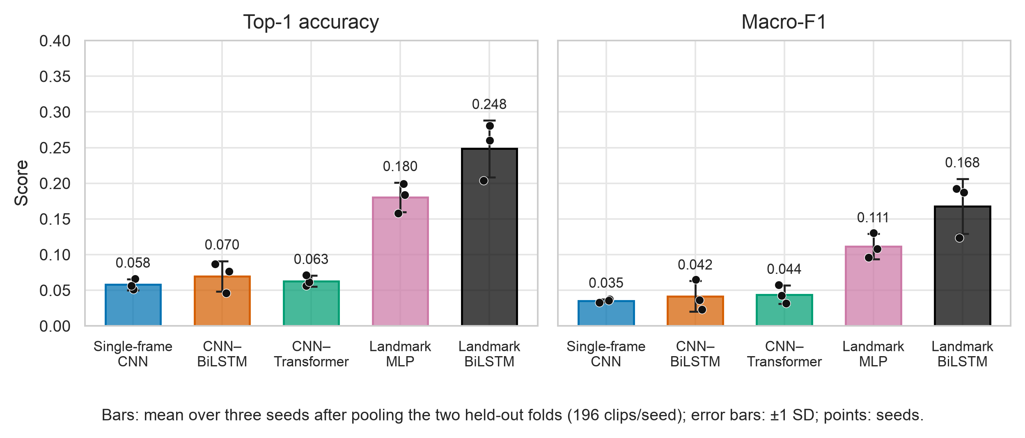
Figure 3. Frozen primary performance. Points are seed scores; error bars are sample SD across three seeds.

The RGB temporal heads overfit
The CNN–BiLSTM and CNN–Transformer reach mean training accuracy 1.00 by the final epoch, while test accuracy remains around 6–7%. This is a generalization gap: fitting the training clips did not produce reliable classification on these two unseen signers. Background, hand resolution, and feature mismatch are possible explanations, but the experiment does not isolate their effects.
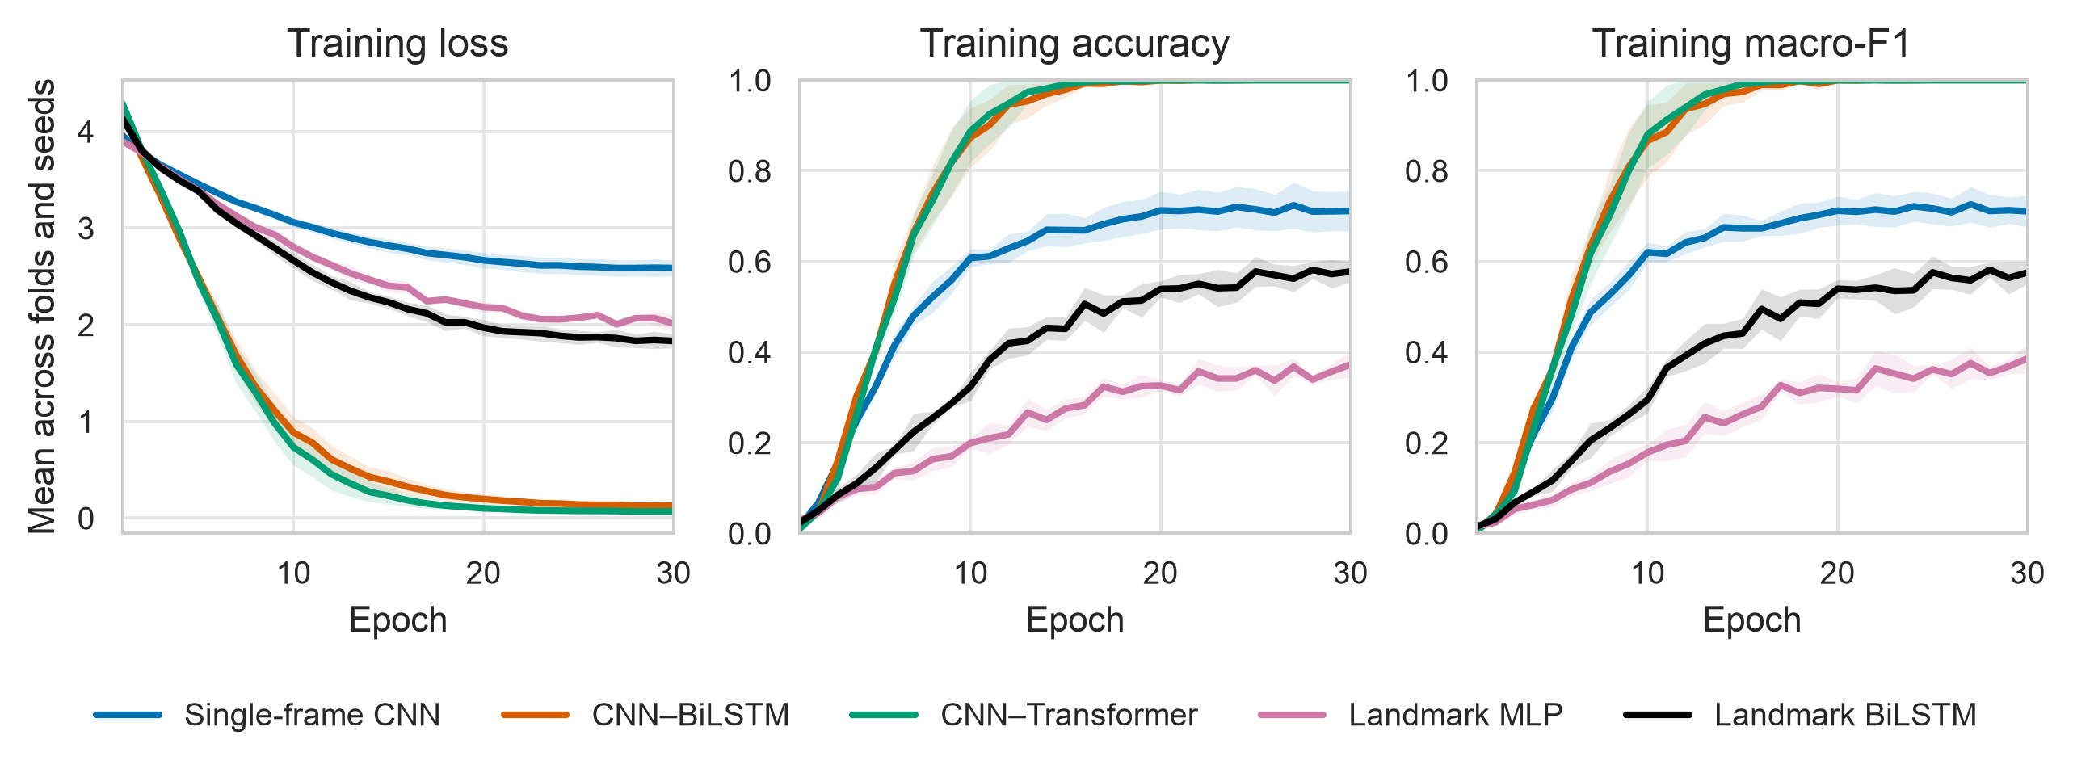
Figure 4. Mean training trajectories. Perfect training fit for the RGB temporal heads does not become unseen-signer accuracy.

Lighting and sign type reveal different problems
The xyz landmark BiLSTM scores 27.6% on bright clips and 22.1% on dark clips. Because lighting was not randomized as an intervention, this is a description, not a causal claim. The larger diagnostic is class type: the same model scores 66.0% on 13 vowels but only 10.0% on 36 consonants. Most of its 24.8% overall score comes from vowels.
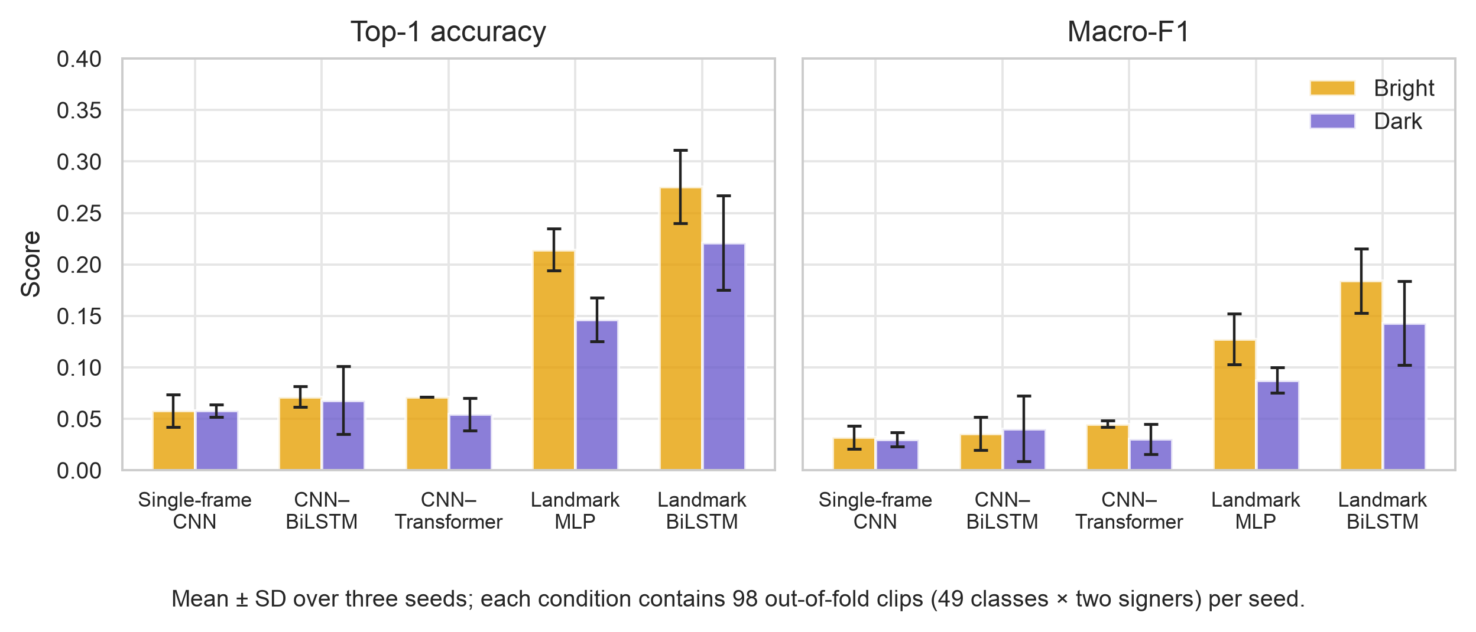
Figure 5. Bright and dark performance for the primary models. Landmark models retain the clearest advantage.

The follow-on ladder
Model | Accuracy | Pooled macro-F1 | Consonants | Vowels
xyz BiLSTM (CE control) | 24.8% ± 4.0% | 16.8% ± 3.8% | 10.0% ± 3.9% | 66.0% ± 4.0%
Hand-crop CNN | 19.2% ± 1.3% | 16.9% ± 0.9% | 15.5% ± 0.8% | 29.5% ± 2.9%
xyz+angle BiLSTM (CE) | 37.9% ± 2.4% | 31.5% ± 3.4% | 28.7% ± 4.5% | 63.5% ± 3.8%
xyz Proto-BiLSTM | 55.8% ± 1.8% | 53.4% ± 2.8% | 58.3% ± 2.5% | 48.7% ± 5.9%
xyz+angle Proto-BiLSTM | 59.4% ± 3.3% | 57.4% ± 3.6% | 61.8% ± 5.7% | 52.6% ± 4.8%

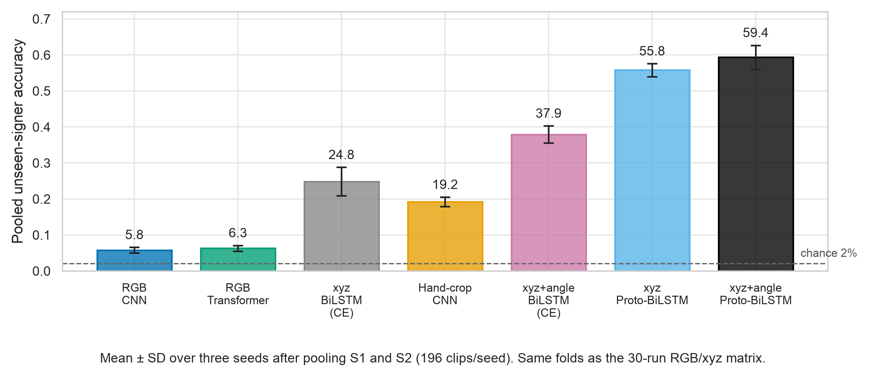
Figure 6. Follow-on unseen-signer accuracy. Angles help; prototypical training is the larger step.
The important scientific pattern is not just a taller final bar. Angles lift consonants from 10.0% to 28.7% under cross entropy. The xyz+angle prototypical model reaches 61.8% consonant accuracy, although its loss, episode sampling, and epoch count all differ from the softmax model. Vowel accuracy falls from 66.0% to 52.6%, so the final gain is a more balanced alphabet representation rather than simply becoming an even stronger vowel classifier.
Practical interpretation 59.4% still means roughly two errors in every five first-choice predictions. It is encouraging for a low-resource research prototype, but weak for an unsupervised teaching tool that must reliably tell a learner they are correct.

9. Errors, enrollment, and the danger of changing the exam

A confusion matrix is an error map
Rows represent the true class and columns represent the predicted class. A perfect model has all mass on the diagonal. Off-diagonal cells show systematic confusions. Row normalization answers: out of all true examples of this class, where did the model send them?
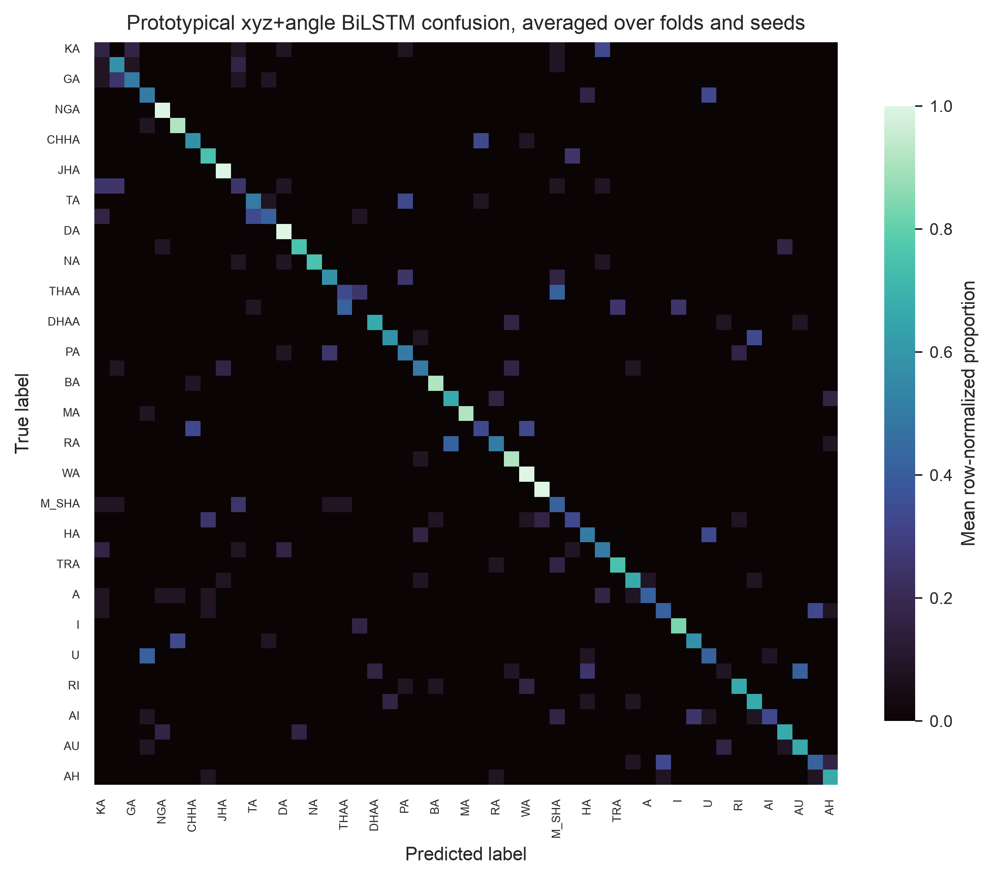
Figure 7. Row-normalized confusion matrix for the xyz+angle prototypical BiLSTM, averaged over folds and seeds.
The earlier xyz softmax BiLSTM collapsed several consonants onto vowel-like predictions—for example, BHA and RA repeatedly became AH, TA became RI, and NA became YAN. The prototypical angle model improves the diagonal but does not eliminate signer-specific ambiguity or detector noise. A confusion matrix is more informative than accuracy alone because it shows whether errors are diffuse or repeatable.

Closed 1-shot enrollment is a different product situation
Each complete signer has two clips per class: one bright and one dark. In the closed 1-shot exam, the system gets the other-lighting clip from the same signer for every class. Bright queries use 49 dark support clips and dark queries use 49 bright support clips. This is an enrolled user, not a first-time user.
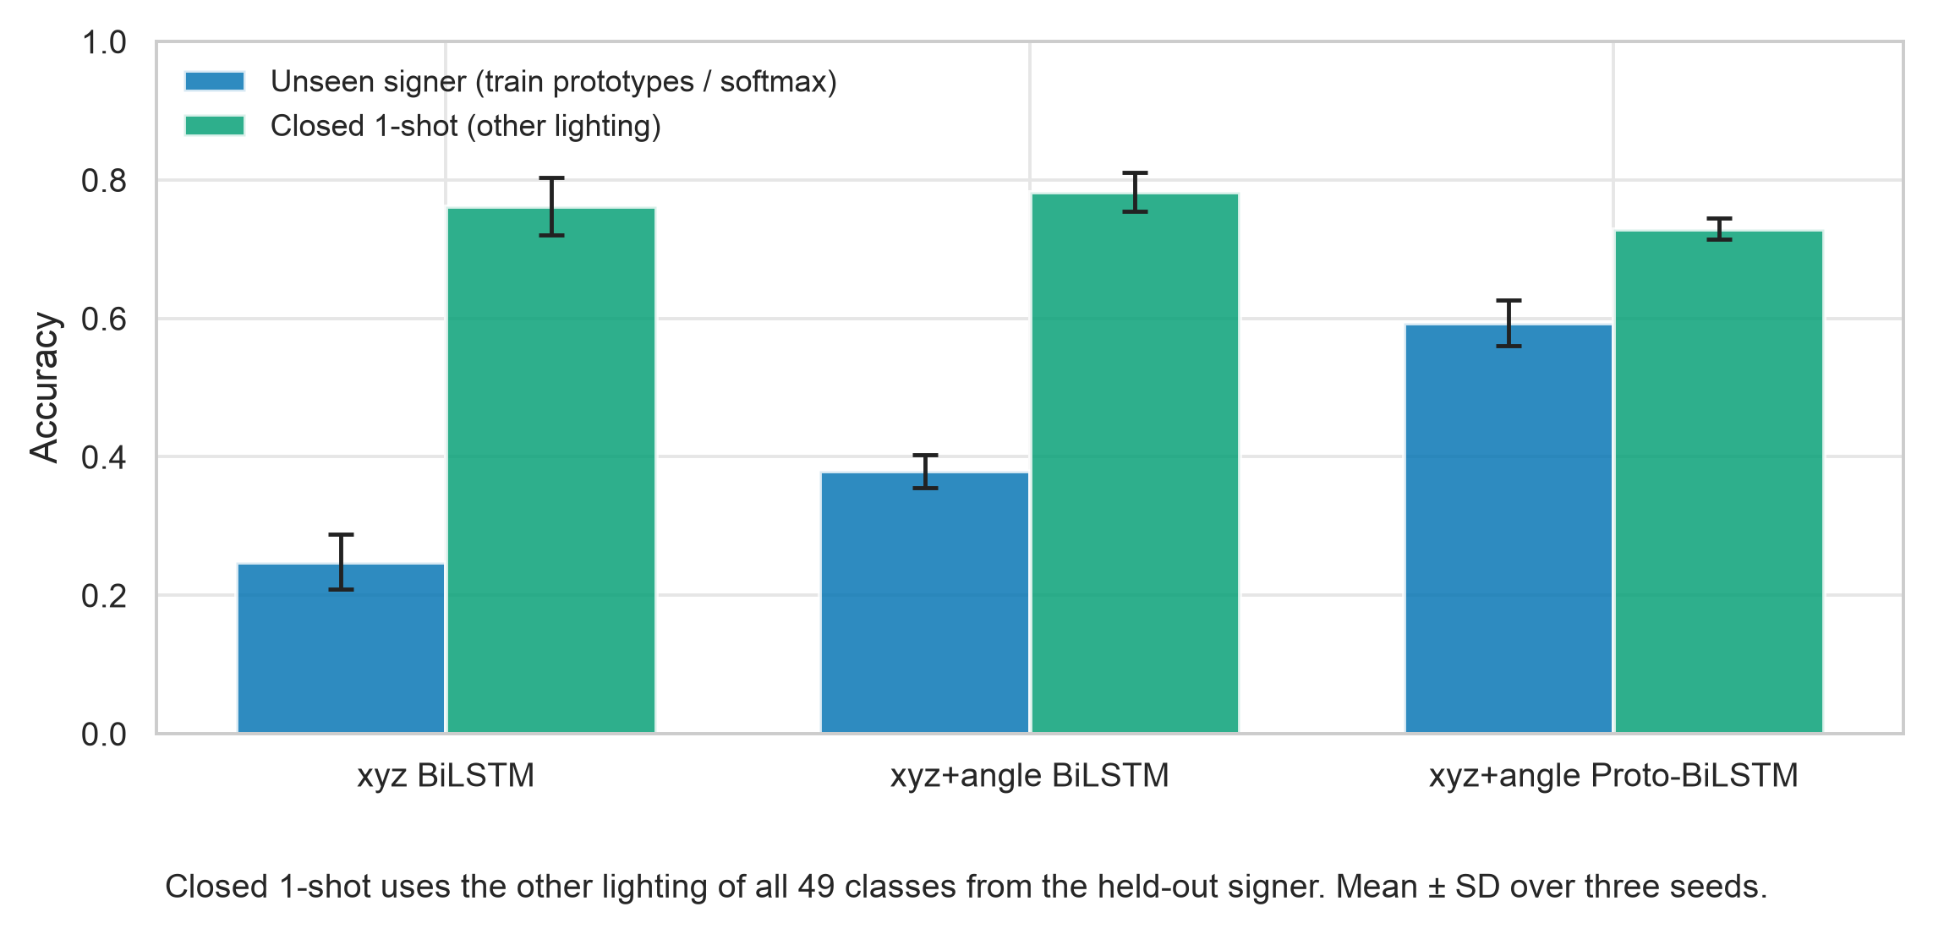
Figure 8. Unseen-signer classification compared with closed 1-shot enrollment using the held-out signer’s other lighting.
Model | No enrollment | Closed 1-shot
xyz BiLSTM | 24.8% ± 4.0% | 76.2% ± 4.2%
xyz+angle BiLSTM | 37.9% ± 2.4% | 78.2% ± 2.8%
xyz+angle Proto-BiLSTM | 59.4% ± 3.3% | 73.0% ± 1.5%

Top-k and N-way scores are different exams
Top-3 gives credit when the correct class appears anywhere among three suggestions. Top-5 gives five attempts. A 5-way episode chooses only five classes rather than all 49. These metrics can be useful for user-interface design or comparison with few-shot literature, but they cannot replace 49-way top-1.
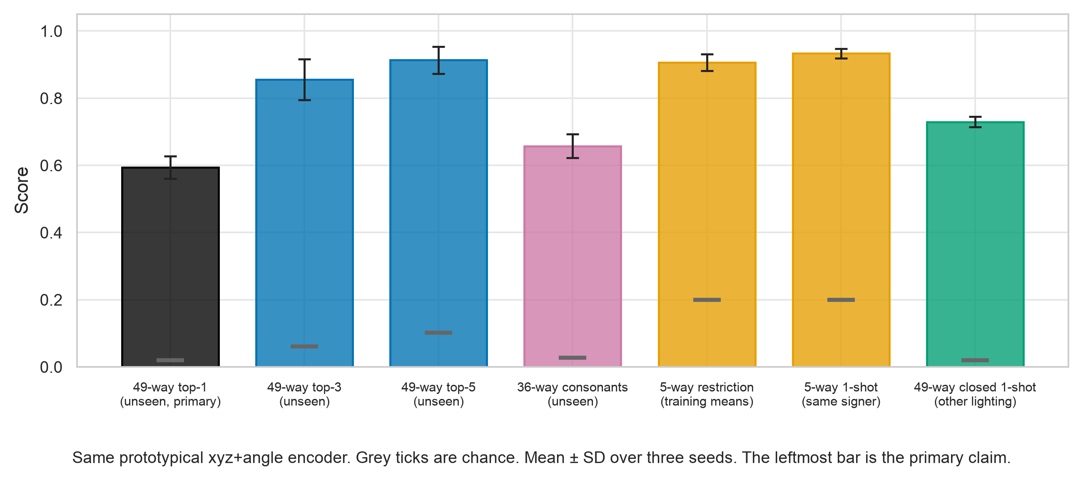
Figure 9. One encoder under different grading conventions. Higher bars partly reflect easier exams, not a newly trained model.
- 49-way unseen top-1: 59.4% ± 3.3%; chance 2.0%.
- 49-way unseen top-3: 85.5% ± 6.0%; chance 6.1%.
- 49-way unseen top-5: 91.3% ± 4.0%; chance 10.2%.
- 36-way unseen consonants: 65.7% ± 3.6%; chance 2.8%.
- 5-way restriction with full training-class means: 90.6% ± 2.5%; chance 20.0%. Each mean uses all training clips of that class, so this is not one-shot.
Reporting rule Never shorten ‘90.6% with five candidate classes’ to ‘90.6% NSL23 alphabet accuracy.’ That changes both the number of competing classes and the support information available to the model.

10. Runtime: recognition quality and speed are separate
Model | Model-only median | End-to-end median | What dominates
Single-frame CNN | 4.0 ms | 939.0 ms/clip | Original video decode and preprocessing
CNN–BiLSTM | 49.5 ms | 962.9 ms/clip | Decode plus 16 frozen CNN frame passes
CNN–Transformer | 49.7 ms | 970.9 ms/clip | Decode plus 16 frozen CNN frame passes
Landmark BiLSTM | 0.3 ms | 345.7 ms/clip | MediaPipe over 16 frames

A neural-network forward pass can be fast while the whole pipeline is slower. Loading and decoding a video, resizing frames, and running MediaPipe all take time. The table separates model-only latency from end-to-end clip processing so the paper does not call 0.3 ms a complete 16-frame system.
The rolling prototype webcam loop processed recorded NSL23 streams at roughly 33–42 frames per second on an Apple M4 CPU path, including MediaPipe. On one 90-frame S1 bright A clip it reached 39.6 FPS and the smoothed final prediction was A. This shows engineering feasibility for that replay; it is not a live recognition-accuracy study.
- FPS answers ‘Can the pipeline keep up with incoming frames on this machine?’
- Accuracy answers ‘How often is the predicted class correct under this evaluation protocol?’
- A product claim needs both, plus live-user testing, failure handling, calibration, accessibility, and a representative signer cohort.

11. What can and cannot be claimed
Safe statement | Why it is safe
The xyz+angle Proto-BiLSTM achieved 59.4% ± 3.3% accuracy on the pooled S1/S2 cross-signer development evaluation. | It names the model, metric, people, and exploratory boundary.
Wrist-relative landmarks generalized better than frozen full-frame ImageNet features on these clips. | All models used the same fixed folds and seeds; the pattern is large and consistent descriptively.
Angles and prototypical training improved consonant performance in the follow-on matrix. | The corrected artifacts support 61.8% consonant accuracy for the final model.
A replayed-video prototype ran at 33–42 FPS on an Apple M4. | It describes the timed host and task without calling it live-user accuracy.

Unsafe shortcut | What is wrong with it
‘59.4% accuracy for new NSL users’ | Only two complete signers were repeatedly used during development.
‘91.3% alphabet recognition’ | That is top-5, not top-1; the model gets five guesses.
‘90.6% 49-way recognition’ | That is a five-class restriction with full training means and 20% chance.
‘Real-time system is 39.6% accurate’ | 39.6 is FPS, not accuracy.
‘State of the art in NSL’ | Other NSL studies use different classes, files, people, and splits.
‘Works in rural Nepal’ | The study lacks an in-country deployment cohort and field conditions.

Why this can still be publishable
A paper does not need a perfect deployment-ready score to be useful. Version 1 contributes a traceable dataset audit, strict within-run signer exclusion, negative RGB results, a clear feature ablation path, corrected primitive-level statistics, reproducibility artifacts, and honest limits. The publishable framing is exploratory low-resource evidence and protocol analysis—not a claim that the final model has solved Nepali Sign Language recognition.
- Keep ‘exploratory’ or ‘development’ next to the 59.4% result in the abstract, results, discussion, and conclusion.
- Report per-signer values where space permits: approximately 63.3% on S1 and 55.4% on S2 for the final model.
- Keep the task definition explicit: isolated, manually bounded 49-way letter classification.
- Do not compare percentages across papers unless class set, split unit, signer separation, and support protocol match.

12. Why human review is necessary for Version 2
The dataset creators labelled the recordings at the file or sequence level. Version 2 needs a different annotation: exact, quality-controlled temporal segments inside long aggregate tapes.

What is already known versus what is missing
Already supplied by the dataset | Still needed for Version 2
Which signer and recording a tape belongs to | Exact start and end of each usable letter performance
The intended class sequence or file-level label context | Whether a motion proposal truly contains the claimed sign
The source video itself | Whether the gesture is complete, clear, and suitable as an isolated sample
Aggregate recordings with multiple gestures | Detector misses, false proposals, repeats, transitions, and ambiguous motions

A motion detector has proposed 691 candidate intervals across 21 aggregate tapes. It detects change; it does not understand NSL. A candidate can begin late, end early, capture a transition between signs, contain a repeat, or miss a low-motion sign. Training directly on those proposals would convert detector mistakes into training labels and could make test coverage depend on an unverified algorithm.
The reviewer’s actual job Watch each proposed interval in its source-video context, identify the signed letter, correct the temporal boundaries, choose a defined decision, and sweep the entire tape for missed gestures. The reviewer is not re-labelling the 375 isolated Version 1 files.

Why two independent passes
One knowledgeable person can make an honest mistake or inherit a subtle bias from the proposal order. Pass 2 therefore starts from the original detector proposal and hides pass-1 class, decision, bounds, and accept/reject outcome. For the sealed test-hierarchy tapes S5, S14, S4, and S6, the two passes must come from two different named reviewers. Disagreements are measured before an adjudicator resolves them.
- Independence makes agreement meaningful; copying pass 1 would create artificial agreement.
- Two reviewers reduce the chance that an incorrect boundary becomes frozen truth.
- Adjudication may resolve a disagreement only after both passes exist; it cannot replace a missing second pass.
- The project owner may serve as a reviewer only if they genuinely recognize all 49 NSL alphabet signs and follow the same blinded protocol.

The four decisions
Decision | Use it when… | What happens
Accept | One complete, recognizable target sign is visible and its start/end can be bounded | Keep the corrected segment for later agreement/freeze
Reject | The proposal is not a usable target sign: transition, duplicate, non-sign motion, or wrong proposal | Exclude the proposal, while preserving the review record
Incomplete | The target sign is cut off or never reaches a complete form | Do not use it as a verified sample
Ambiguous | A qualified reviewer cannot confidently determine class or boundary | Flag for adjudication; never force certainty

What you need to do as coordinator
- Recruit qualified NSL alphabet reviewers and record their names consistently. Annotation alone normally belongs in acknowledgements unless a reviewer later contributes intellectually to study design, analysis, interpretation, or writing.
- Run a disposable S3 calibration pilot. Discuss boundary examples and decision definitions, but do not merge pilot decisions into the real master annotation file.
- Lock any policy correction before real reviews begin. If the boundary policy changes, create a new protocol lock rather than silently moving the old one.
- Complete pass 1, then create a sealed pass-2 export for the second reviewer. Never send the master CSV to an outside pass-2 reviewer.
- Import pass 2, save the pre-adjudication agreement artifact, adjudicate completed disagreements, run coverage validation, and freeze only when every gate passes.

13. The Version 2 route to a confirmatory result
Version 2 is deliberately boring in the best scientific sense: test identities, features, trials, seeds, endpoint, and stop conditions are written down before the test data can influence the model.

Current inventory and gate
Item | Current state
Aggregate review tapes | 21 tapes; 22.13 source minutes; about 3.47 GiB
Motion proposals | 691 unlabeled candidate intervals
Pass-1 decisions | 0
Pass-2 decisions | 0
Verified segments | 0
Frozen V2 manifests | None
Permission to train | No—human annotation is the active gate

Permanent hierarchy
Role | Signers / rule
Sealed test candidates | S5, S14, S4, S6. Never release them into development, even if incomplete.
Development | S1 and S2; S3 is validation only if it becomes complete.
Other incomplete non-test signers | May contribute verified/original training clips under the frozen rules.
Minimum confirmatory Stage 4 | At least two sealed candidates must have verified coverage for all 49 classes.
Failure path | Freeze/publish the annotation resource and Version 1 exploration without a confirmatory 49-way claim.

The hierarchy hash in configs/v2_protocol.json is 09a2b7b2cb3a580c6cf3e3cd0c952a04ec4a793863ab27212c0cdeb55c5ab009. It binds the predeclared roles.

The gated sequence
- Calibration: two reviewers practice on disposable S3 proposals and align on the written boundary policy.
- Independent annotation: complete pass 1 and blinded pass 2, including full-tape sweeps for detector misses.
- Agreement and adjudication: save the hash-bound pre-adjudication report, then resolve completed disagreements.
- Coverage and freeze: validate hashes, durations, overlap, reviewer identities, and per-signer 49-class coverage; freeze the protocol and manifests.
- Stage 2 diagnostic: run the existing xyz+angle prototypical image model on S1/S2 development data only.
- Stage 3 selection: if S3 is complete, run exactly three preregistered geometry trials, selecting mean per-signer macro-recall across development LOSO folds and seeds. If S3 is incomplete, skip the search and carry the Stage 2 specification.
- Final retrain: train seeds 17/42/73 once on every permitted non-test sample, including validation data; tester rows are rejected by code.
- Stage 4 evaluation: run the three frozen checkpoints on the sealed test cohort once, with no adaptation or selection.
- Manuscript: report the equal-weight per-signer macro-recall endpoint, each tester separately, agreement, coverage, and every failure gate.

Primary Version 2 estimand
For each seed, average all verified clips within a signer × class cell. Then average the 49 class recalls within each signer, and average signers equally. Finally report the mean and sample SD over the three seeds. This prevents a signer with more accepted clips from dominating the headline. Clip-pooled accuracy remains a secondary diagnostic.
Seed score = mean over frozen signers [ mean over 49 classes ( recall within signer × class ) ]
Every signer and every class receives equal weight in the primary Stage 4 endpoint.

Hard stop conditions
- Do not train, build prototypes, compare features, or select checkpoints until the V2 protocol is frozen.
- Never use configs/signer_split.json for V2; it is obsolete and places sealed people in training.
- Never train on S5, S14, S4, or S6—even when a candidate lacks complete coverage.
- Never use model performance to decide which signer becomes a tester.
- Never force the detector output to contain exactly 13 vowels or 36 consonants.
- Never run or report a confirmatory 49-way Stage 4 when fewer than two sealed testers are complete.

14. Reproducing and auditing the project

Evidence hierarchy
Layer | What it proves
Source manifests and protocol files | Which videos, classes, signers, folds, settings, and exclusions were intended
Historical freeze snapshot | The exact Version 1 input bytes and chronology anchor
Per-run predictions and metrics | The primitive outcomes from which paper values can be recomputed
Aggregation scripts | How folds, seeds, classes, and conditions become tables and figures
Machine audit JSON | A repeatable record of claim checks and corrected values
Paper PDF | The human-readable scientific narrative, visually checked page by page

Five checks to run before submission
PYTHONPATH=src .venv/bin/python scripts/verify_protocol_freeze.py
PYTHONPATH=src .venv/bin/python scripts/verify_primary_protocol.py --verify-v1-freeze
PYTHONPATH=src .venv/bin/python scripts/audit_paper_numbers.py
PYTHONPATH=src .venv/bin/python -m unittest discover -s tests -p 'test_*.py' -v
PYTHONPATH=src .venv/bin/python scripts/validate_primary_claims.py

The strict verifier checks the 630-row manifest, 375 primary clips, fold sizes, test identities, class coverage, source existence, RGB caches, and the historical freeze. The numerical audit reads stored predictions and verifies the central manuscript tables. The claim validator checks several primary artifacts and that a compiled PDF exists; PDF text and page layout are checked separately.

The files a future collaborator should read first
File | Purpose
PAPER_DIRECTION.md | Live dashboard: status, locks, next action, and stop conditions
manuscript/nsl23_low_resource.pdf | Current Version 1 exploratory paper
docs/FINAL_SCAN_2026-10-11.md | Latest corrections, checkpoint replay, source checks, and verification limits
README_REPRODUCIBILITY.md | Environment, artifacts, rerun boundary, and bundle instructions
annotations/v2/REVIEWER_HANDOFF.md | Recruitment text, exact tapes, workload, definitions, and safe transfer
annotations/v2/ANNOTATION_GUIDE.md | Operational annotation and freeze procedure
VERSION2.md | Full prospective Version 2 scientific protocol

Storage discipline
The workspace had grown to roughly 23 GiB because it held both 9.6 GiB of official ZIP archives and 9.7 GiB of extracted videos, plus caches and checkpoints. After all four ZIP MD5 hashes and all 630 extracted paths were verified, only the duplicate ZIP copies were removed. The extracted videos remain, and the archives can be downloaded again from Zenodo DOI 10.5281/zenodo.10478554.
- Do not commit source videos, downloaded archives, temporary review exports, smoke checkpoints, render scratch folders, or duplicate results trees.
- Keep authoritative predictions, metrics, compact checkpoints, manifests, protocols, audit receipts, manuscript figures, and final deliverables.
- Use scripts/manage_workspace_storage.py to verify before deleting recoverable archive duplicates.
- Build review tapes selectively with scripts/extract_v2_review_tapes.py instead of unpacking every archive again.

15. Publication-readiness checklist

Version 1 submission
- Keep the title, abstract, results, discussion, and conclusion explicit that the study is exploratory development evidence.
- Preserve 59.4% ± 3.3% accuracy and corrected 57.4% ± 3.6% pooled macro-F1 for the final model.
- Report that ± is sample SD across seeds, not a signer confidence interval.
- Keep Table 4’s supported class sets explicit: 36 consonants and 13 vowels.
- Retain the task boundary: isolated, manually bounded letters—not spotting, continuous recognition, or live-user accuracy.
- Run all five integrity commands, rebuild the PDF, and inspect every page after journal formatting.
- Adapt word count, anonymous-review details, citation style, and figure placement only after selecting a target journal.

Version 2 before annotation
- Use the S3 pilot for calibration; keep pilot outcomes disposable.
- Make any policy correction before real outcomes and record a new immutable lock.
- Confirm two different qualified reviewers for each sealed test-hierarchy tape.
- Use the pass-2 export/import package for work on another computer; never send the master CSV.
- Back up the master annotation file and hash-bound sidecars after each completed milestone.

Version 2 after annotation
- Save agreement before adjudication and report the agreement statistics honestly.
- Run duration, overlap, hash, identity, coverage, and hierarchy validators.
- Freeze even if coverage fails; a negative coverage result is data, not permission to move a sealed signer into training.
- Proceed to Stage 4 only with at least two complete sealed testers.
- Report every tester separately and the equal-weight primary endpoint.
- Do enrollment, top-k, broader LOSO, or webcam follow-ups only after the confirmatory batch is sealed and evaluated.
Final readiness verdict Version 1 is scientifically defensible for submission as an exploratory/negative-results paper, subject to journal fit. Version 2 is scientifically well specified but remains blocked—correctly—by zero human reviews. The next evidence-producing step is annotation, not training.

Glossary
Term | Meaning in this project
Aggregate tape | A longer recording containing multiple gesture performances rather than one already bounded class clip.
Annotation | A human-created record of class, temporal start/end, decision, reviewer, and related quality information.
BiLSTM | A recurrent network that reads a sequence forward and backward before combining both directions.
Cache | A derived local array saved so expensive video decoding or landmark detection need not be repeated.
Class | One of the 49 alphabet labels: 36 consonants or 13 vowels.
Closed 1-shot | An exam where one support example per class from the same enrolled signer is available; here it is the other lighting.
Confirmatory | An evaluation whose method and test cohort were frozen before test outcomes could guide development.
Cross entropy | A loss that penalizes assigning low probability to the true class.
Cross-signer | Training and evaluation use different people within a run.
Fold | One train/test arrangement. This study has held-out-S1 and held-out-S2 folds.
Hierarchy hash | A cryptographic digest binding the fixed V2 signer roles and protocol state.
Landmark | A detector-estimated anatomical point on the hand; MediaPipe supplies 21 per detected hand.
Leakage | Information from an evaluation performance, person, or derivative entering training or model selection improperly.
Macro-F1 | The arithmetic mean of per-class F1 values, giving each class equal importance.
Manifest | A structured table that says which source files exist and how each sample is classified or assigned.
MPS | Apple’s GPU acceleration backend used for the RGB training runs.
Pass 1 / pass 2 | Two independent reviews of the same original proposal, with pass-1 information hidden from pass 2.
Prototype | The mean embedding of the support or training examples for one class.
Seed | A number fixing permitted pseudorandom choices so training can be repeated in a controlled way.
Signer | A person performing the signs.
Temporal boundary | The start and end time/frame of one usable gesture inside a longer recording.
Top-k | An evaluation that counts success when the correct class appears among the model’s k highest-ranked choices.
Unseen signer | A test person whose clips were not used to train that run’s model or prototypes.

One-page mental model
Data Audit first: 375 independent original isolated clips for Version 1; 21 aggregate tapes need temporal annotation for Version 2.

Representation Full-frame RGB scored poorly on these two signers. Wrist-relative landmarks removed direct background pixels; joint angles added finger geometry.

Learning A BiLSTM encodes 16 frames. Prototypical episodes shape the embedding so class means become useful decision anchors.

Evidence 59.4% ± 3.3% is the honest Version 1 development result; it is not a population or deployment guarantee.

Next gate Two independent NSL-aware reviews, agreement, adjudication, coverage, and freeze—then and only then train Version 2.

Source trail
This guide was updated after the repository scan on 11 October 2026. Numerical anchors trace to artifacts/results, artifacts/audit/full_paper_audit.json, and the manuscript. Operational Version 2 details trace to PAPER_DIRECTION.md, VERSION2.md, configs/v2_protocol.json, and annotations/v2. For formal citations to NSL23, MediaPipe, MobileNetV2, LSTM, Transformer, prototypical networks, metrics, and related NSL work, use the bibliography in manuscript/nsl23_low_resource.pdf.

