**Founder Name:** Justin Aaron Chappell, Emmanuel A. Martinez Ortiz.

**Email:** J-C.99@outlook.com

**Company:** twasmaloop();

**Date:** 19/06/2016

**1.** I **Emmanuel A. Martinez Ortiz** accept all ideas and concepts that are built up by other members of the game development team for void, and therefore will be following the CC-BY copy right infringement to respect the work of others. Breaking this infringement will result in legal action and will be dealt with through the federal court system.

**[Profit before the game is in production]**

**2.** All employees at this point do not have any rate of income from this project until profit is made. All donations will be put into funding the creators of the game with professional licences of software that is being used.

**[Profit after the game is in production]**

**3.** After the game is in production, income made from the game will be spread out to the team depending on how much work they did to how much they get. (Detail how much work is enough work?[Will be fixed in next agreement]).

Signing this agreement will make you a part of the team for this project. This agreement is valid until re-written in a more formal format.

**Founder Signature (Justin Aaron Chappell):**

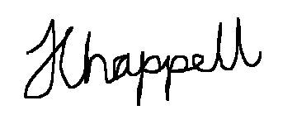

**Your Name: Emmanuel A. Martinez Ortiz**

**Founder Signature (Emmanuel A. Martinez Ortiz):**